Blessing Every Day

A project from the Mission Theology Advisory Group

The Mission Theology Advisory Group is an ecumenical group formed in partnership between Churches Together in Britain and Ireland and the Church of England We provide resources in the areas of Spirituality, Theology, Reconciliation, Evangelism and Mission.

This resource belongs to our Spirituality series. Please print and share. You can adapt the text or customise it to your own situation in any way you like.

More information from www.churchofengland.org/more/church-resources/deeper-god-mission-theology

https://ctbi.org.uk/mission-theology-advisory-group-resources/

A Blessing for a Leave-Taking and a Journey

Sunil Soundarapandian/flickr

Introduction
All may say what they are grateful for, as we begin to take leave of one another or make preparations to set out together

Thanksgiving
Loving and eternal God, We thank you for friendship and fellowship together. Thank you for time spent in company For all we have said and done. Send us out now In the power of your Spirit To be your faithful followers Bearing the light of Christ On our different roads.
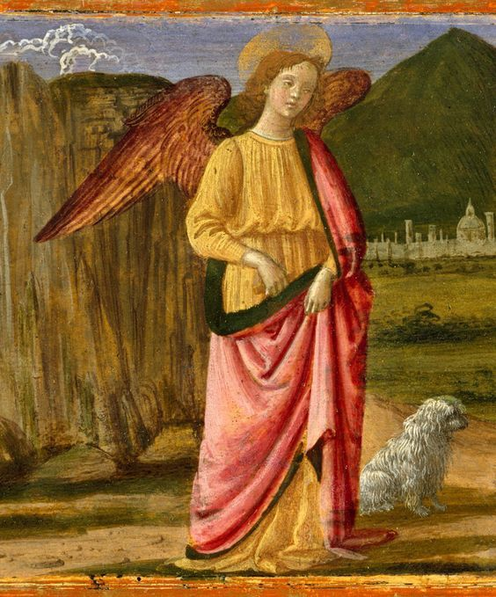
Amen

A Story: Tobit, 5.16-17; 6.1
In the story of Tobit in one of the apocryphal books of the Bible, Tobit’s son Tobias sets out on a journey for his father. It is a dangerous journey and his parents, Tobit and Anna, pray for his safety. God hears them and sends them the angel Raphael to go with Tobias and to keep him safe on the way. But they do not know that it is an angel who is offering to guard and guide their son:
‘Raphael answered. “I will go with him: so do not fear. We shall leave in good health and return to you in good health, because the way is safe.” So Tobit said to him, “Blessings be upon you, brother.” Then he called his son and said to him, “Son, prepare supplies for the journey and set out with your brother, May God in heaven bring you safely there and return you in good health to me: and may his angel, my son, accompany you both for your safety.” ...The young man went out and the angel went with him.’

Reflection
Every journey is a new beginning. When we make our preparations and set out we have at our backs all that we have seen and done and we move towards an unknown future. Let us go in hope.
Every journey is full of potential, even if we have gone the same road many times before. There are new things to notice, new people to meet, new experiences on the way. Let us pay attention.
Every journey has its own story, and each story, whether joyful or sorrowful, is precious to God. This is the day that God has made, let us rejoice and be glad in it. Psalm 118 24

Blessing
As we start out on our journeys, we ask God to watch over us and keep us safe on our travels. We ask for a calm road and God speed. We ask for God’s guidance, God’s presence and for God’s peace on our way ahead. We ask for God’s blessing and angels’ keeping on our journey.
All may name their destination or the next place on their ongoing journey. All may keep a time of silence.

Departure
Psalm 119.105 says Your word is a lamp to my feet and a light to my path. May it be so for all of us. Amen

