Blessing Every Day
A project from the Mission Theology Advisory Group
The Mission Theology Advisory Group is an ecumenical group formed in partnership between Churches Together in Britain and Ireland and the Church of England We provide resources in the areas of Spirituality, Theology, Reconciliation, Evangelism and Mission.
This resource belongs to our Spirituality series. Please print and share.
More information from
www.churchofengland.org/more/church-resources/deeper-god-mission-theology
https://ctbi.org.uk/mission-theology-advisory-group-resources/

A Blessing for Decorating a Christmas Tree

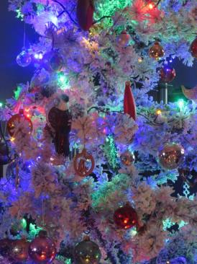

Whether you have struggled with getting a sweet-smelling evergreen into your car, or you have to reassemble an artificial tree which has been crammed awkwardly into its box, setting up the Tree can be a Christmas highlight which everyone in the family enjoys.
But often, it’s when you get out the box of decorations year on year, filled with memories, which really prompts deep emotions. Perhaps it’s because of the decorations the children made at school when they were little; the ones which commemorate a special occasion; decorations which belonged to parents or even grandparents; which speak most strongly of family and friends at Christmas-time, especially if some of those family members are no longer around. How often do you find you have forgotten a particular one which emerges like treasure from the box and renews delight?
Hanging the decorations has its own solemnity and pattern, as the tree is dressed and transformed from plain branches to sparkling beauty. The act of decorating it speaks to the creativity and imagination in each of us and the deep satisfaction in making something beautiful. Decorations don’t have to be flashy or expensive either.
For Christians, that satisfaction can be enhanced by finding something in the decoration of a Christmas Tree that speaks of faith, whether that is reminders of the Christmas story in stars and angels, or in decorations which speak of the Nativity. The beauty of the tree can be a pointer to the mystery and beauty of God the creator, telling the story, something to be shared with neighbours and friends.

A Prayer of Blessing

When the tree is put up...
Loving God, Bless this tree to us. As we begin to decorate our Christmas Tree May we pause to remember all those we love and have loved.
When the decorations are put on...
Lord Jesus Christ, Bless the hands which dress this tree Bless the eyes which behold it Bless the hearts which delight in it.
When the tree is finished and lit...
Spirit of the Living God, May this tree be a source of wonder in our home, A sign of our faith, festivity and thankfulness. Bless all who look upon it, That they may be drawn to your light, And hear for themselves the song of the angels ‘Peace on Earth, goodwill to all people’.
Amen

