In Heaven, My Mother is a Gardener

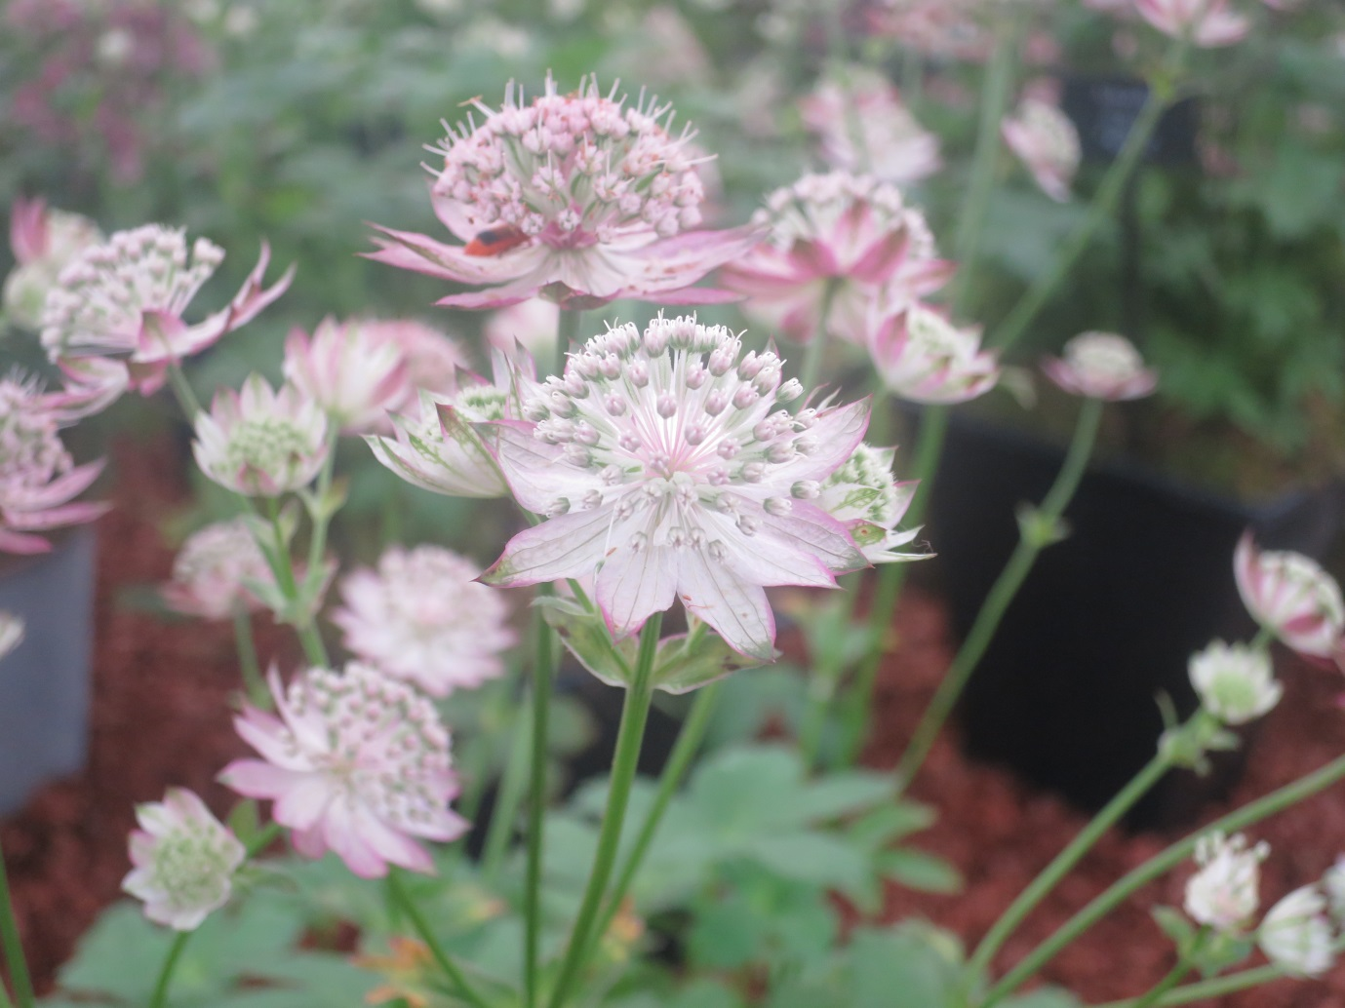

Come the fall the seraphs are a menace:
hid beneath deep stones, camouflaged on bark.
She dips to see, on undersides of leaves,
the stiffening and drying of their several wings.

‘Tsk’ she says, trowelling in, her sun-hat shading
her face from the shekinah. Fingers search
soiled with moist myrrh-mulches, the turned sod.
Dominions, powers and thrones buzz, drone and fly.

Double digging done, she lifts a scion,
rosa ‘Angel-face’, all dark shining leaves
and lavender blooms, shot with fired-scored scarlet.
She teases roots soft-soaked in crystal water

meant for the redeemed (in trouble later!)
She forks muck in, the boned curve of her shoulder
hefting it, ties off to willow stakes
with broken harp-string. Graceful to the last

she straightens, pressing her lost face deep into
a basket of harvest fruit, inhaling
risen swells of peach and pomegranate,
royal purple plums, the waxy skins

of citrus, greengage, translucent gooseberry.
First fruits all and meant for many feasts
in many mansions. Not for her, the idle
rewards of faith, or water, wine, just

torn- up invitations and a time
spent raising love-lies –bleeding,
Passion flower and pumpkin in the
bright celestial greenhouse of the blessed.

In Heaven, my mother is a gardener.
Her memory fades like caught-in- amber
flakes of silvery leaf, an insect’s eye.
It’s all I can do now to half-remember

the person that she was: I cannot see her.
But, sometimes in these faded lights of summer,
as spiders lace the corner of a window,
I think of her, uneasy in a blanket

shifting against her pain, the old cancer
composting her body for the beech tree
she wanted over. The last thing she said:
‘Tomorrow I shall go into the garden’.

Some comments about this poem
My mother has been dead for many years, but I love her and miss her still. I wrote this poem about her because I wanted to ‘fix’ a memory of her dying and couple it with the hope of heaven.
Some people might have a very clear idea of heaven but I don’t. So I have begun with something that really happened. The day before my mother died of cancer, she was asked if she had been outside (it was June and the grounds were beautiful). She said no, but that she would go tomorrow. She was no longer able to walk and the hospice staff had been wheeling her outside, but it seemed to me that she wasn’t talking about being taken outside to the garden, but of going there herself. It also seemed to me that she wasn’t talking about ‘here’ but had her eyes fixed on some other kind of reality that she could see quite clearly and was looking forward to. I have witnessed others talk about their life after their impending death and find it moving and hopeful. So I have used that as a threshold moment for this poem.
My mother loved gardening and growing things. Her favourite colour was green. She was fascinated by plants and was only sorry that she had a tiny garden at her home. She asked that there be no memorial to her after death but that some trees be planted instead. So in imagining her risen life I think of her being in a kind of Garden of Eden, doing the maintenance work necessary to make it paradise. I have rather mischievously imagined the angels as insects, fertilising heaven but also a bit of a nuisance if you are trying to do planting in a rose garden! I have also faithfully rendered my mother’s spirituality – she felt she wasn’t good enough for God and that the Church had given up on her. So I find her wearing a hat and looking downwards into the earth using the ‘muck’ left over from God’s reconciling work as useful fertiliser, tearing up invitations to God’s feast, but fulfilled in providing the food for it. My children remember how granny always set out a sumptuous meal for them and beamed as they consumed the delights she made for them. She rarely ate any of it herself. And I have remembered her quirky, naughty streak by suggesting that she has diverted the crystal stream of Revelation 22.1 for her gardening activities!
This is a poem and not a piece of theology. But acts of imagination can make theology clearer to us. My intention was quite literally to ‘overwrite’ the sad memory of what cancer did to my mother’s body with a picture of her restored by grace, actively working away, content, peaceful and blessed. I also had in mind how Mary mistook the risen Jesus for the ‘gardener’ and I too am that Mary, still waiting for the full impact of the mystery beyond the confines of the poem. For now, my mother as a gardener will have to do...
Anne Richards

