Reflective Prayer for All Hallows Eve, All Saints Day, All Souls Day

All Hallows Eve
31st October (Hallowe’en)
Lord, tonight,
We will face all that most concerns us: our fears, the shadowed places of the mind; the coming of winter darkness; the cold thin place between waking and sleep.
We call to mind the powerless, the lonely, those who most fear the knock at the door; all those deceived by the world’s empty promises; all those cowed by menaces or threats. We stand with those weak in body, mind or spirit and those seduced by treats or hurt by tricks.
Lord, your light shines into every darkness. You told us: pray ‘deliver us from evil’. Your Spirit gives us hope, gives us courage, a candle in the window unhurt by the wind.

All Saints Day
1st November
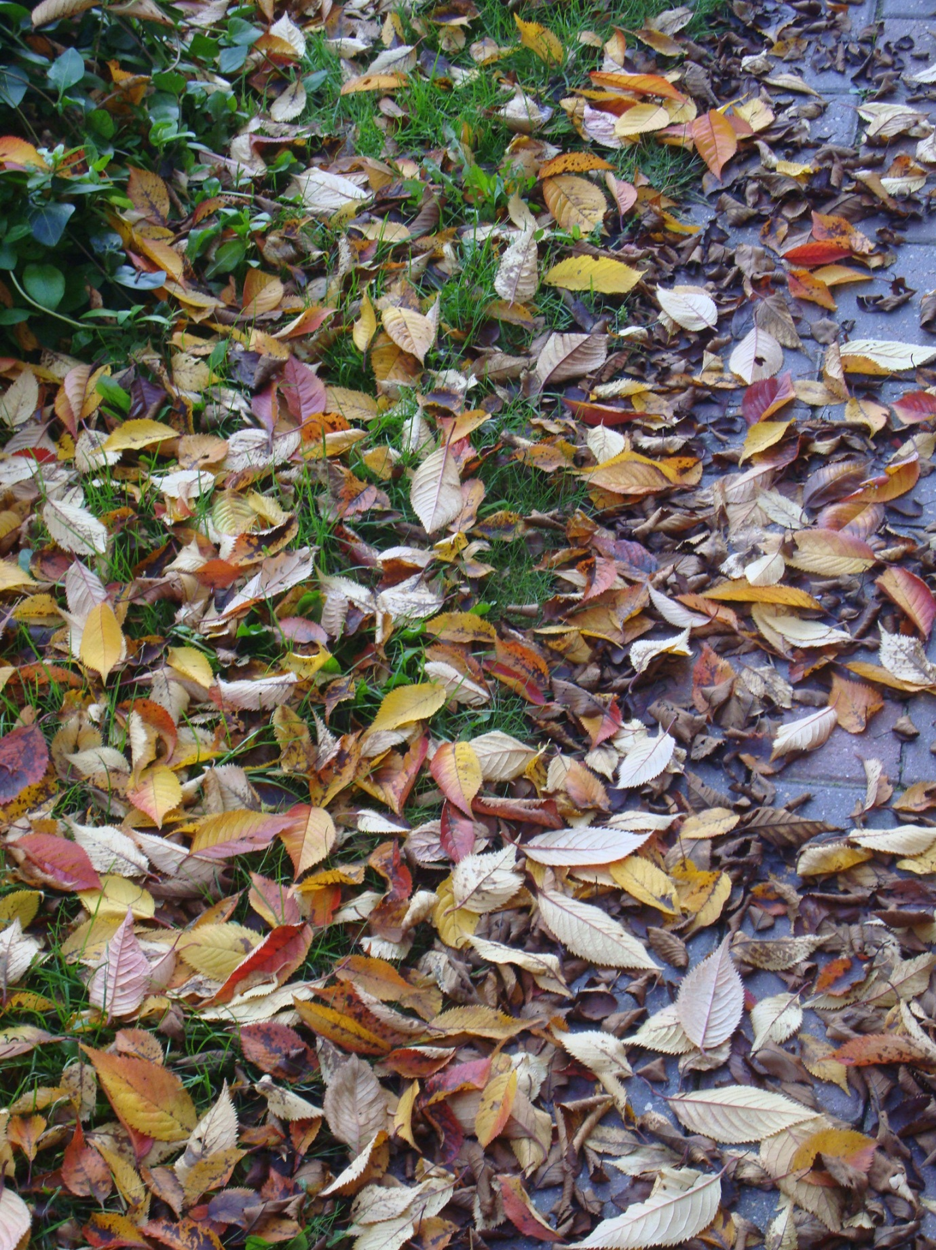

Lord, today,
We thank you for the Saints now gone before us whose faith defined their living and their dying; those who loved you more than their own lives; those who are still mirrors of your love.
We celebrate the saints who walk among us rejoicing while they walk in your footsteps, making your name known in a fractured world, against injustice, prejudice, hatred, evil. We stand with those who sacrifice themselves to bring about your kingdom here on earth.
Lord, your grace shines in the lives of Saints. We thank you for their example, their holy words. Your Spirit inspired them. Come Holy Spirit inspire us to be saints in your Church now.

All Souls Day
2nd November
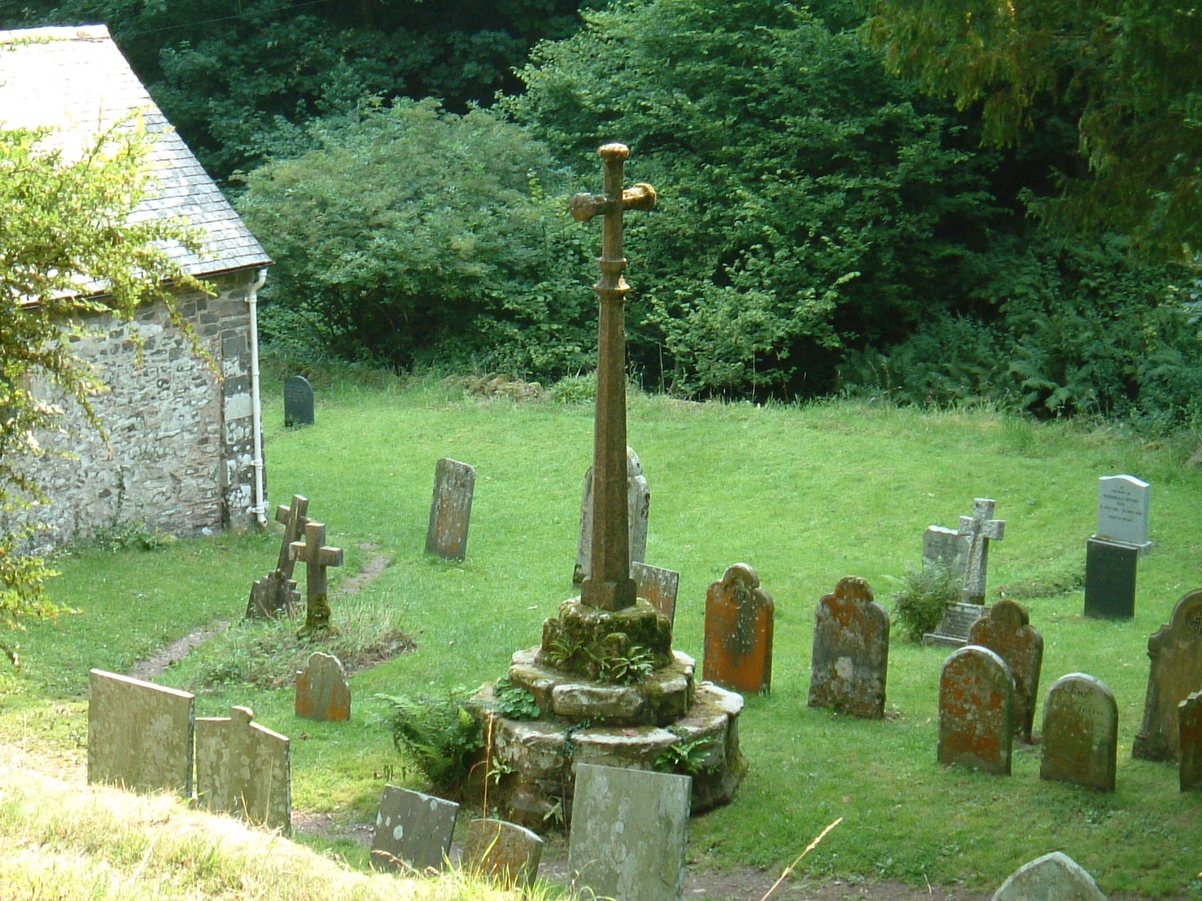

Lord, in November,
We call to mind all those whose lives are done. We thank you that their time, now completed, however short or long, sad or joyful, is gathered up, looked on and known by you.
We offer up remembrance: those whose absence we feel daily; those who have shaped us; those who have nurtured us; the people we are grateful to have walked with; all those we hardly knew but wished we’d known better. We give thanks for all they gave and all the future owes them.
Lord, your love embraces every person who has ever lived; you promised that you lost none. May your Spirit make us always thankful for all our gifts of love and cherished memory.

