Reading and Hearing the Bible if you have never opened a Bible before

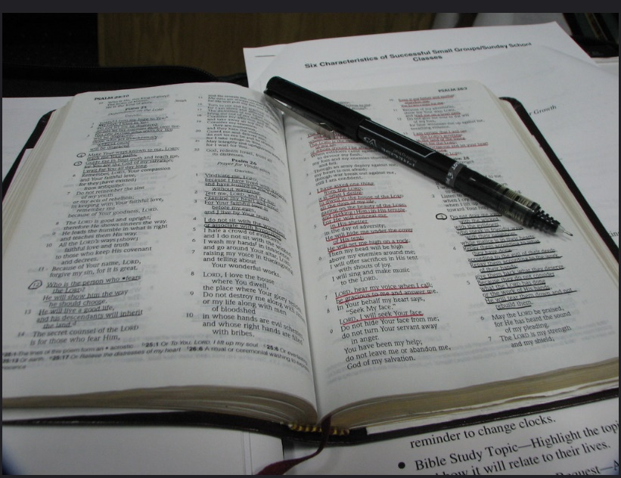
George Bannister/flickr

With so many online resources available during the COVID-19 pandemic when the churches are closed, more and more people are coming across Christian services, prayer times, conversation groups and Bible studies. But for some people, the readings and use of the Bible are hard to understand. This resource is just to help you understand a bit about the Bible if you have never opened one.
The Bible is the most read and most translated volume of writing in the world. But the Bible isn’t one book but a collection of very varied books. The biggest section of the Bible is usually called the Old Testament and this comes first. The second section towards the back is called The New Testament. Some Bibles have another section called Apocrypha which includes other religious writings not considered part of the ‘official’ Bible.

Old Testament
The Old Testament is a collection of books detailing the history, laws, poetry and religious writings of the ancient people of Israel. So these writings are sacred to Jewish people as well as Christians. Written in Hebrew, these writings are therefore often called the Hebrew Scriptures.
New Testament
The New Testament consists of four books called Gospels (Good News) of Matthew, Mark, Luke and John, which give separate, but similar, accounts of the life of Jesus Christ. This is followed by the Book of Acts which carries on the story of what Jesus’ followers did after he died and rose from the dead, and how they spread the Christian faith. The New Testament also contains a series of letters (epistles) about the new churches which were set up. It concludes with a book called Revelation (or Apocalypse) which is full of complex symbolic writing, encouraging persecuted Christians to hold the faith. The New Testament was written in an old form of Greek.
Different translations
This means that everything you hear or read from the Bible comes from a translation. There are very many different translations, so you may hear the same passages on different occasions with slightly different words. Some translations try to stick very close to the original language; others try to make the language flow more easily or change the words to make the sense clearer.
Parts of the Bible can be hard to understand, especially if you have never heard it, or read it before. That’s why Christian ministers often give a talk explaining the passages, and why there are so many commentaries and Bible scholars helping to explain the meaning. They do this, because Scripture is one of the main ways Christians learn about Christian faith and Christian living, and learn more about God. But there are many stories, especially from the Gospels, which are easy to understand and immediately accessible. You may already know some of the stories Jesus told, like ‘The Good Samaritan’ or ‘The Prodigal Son’.
Bible Readings in Church services
When passages from the Bible are read out, the reader may announce ‘chapter and verse’. What this means is that the book of the Bible is identified, then what chapter of the book you can find the passage in and then what sections of the chapter. The sections are called ‘verses’. You may find the selection of the passage a bit strange and it can help a lot to read what comes before and after the selected reading, to set it in context and to find out some more of what’s going on. [We have other resources on this site to help you find out ‘what’s going on’ for set Sunday worship]. If you have a Bible, it can help a lot to follow the passage being read or studied for yourself. The layout may be unfamiliar as many Bibles set the text out in columns.
There are plenty of downloadable Bibles as well which set out the text in a block. Resources for this are given at the end of this document.
There are lots of commentaries and notes to help you if you are not familiar with the Bible or what the different books are about. Local churches near you may offer online Bible study groups if you want to explore further or just listen to how people read and discuss the Bible.
Church services differ in how many passages from the Bible they use. But in a Church of England main service for example, there might be one reading from the Old Testament, a Psalm (a song-poem from a collection in the Old Testament), a reading from one of the Gospels, and a reading from another book of the New Testament. These readings are usually chosen to highlight a particular theme. If the leader of the service (priest/pastor/minister/leader) gives a talk, they may use one or more of the passages to explain more of the theme. Some churches follow the common ‘lectionary’ (readings) which tells the story of God and Jesus throughout the year [see the ‘Hear’ section of this website). You might be aware of the story of the birth of Jesus at Christmas and the story of his death and rising to new life (resurrection) at Easter, but the story of what Jesus said and did is carried on throughout the rest of the year too.

Online Bibles at www.biblegateway.com
www.biblesociety.com
www.biblica.com
www.bible.oremus.org
Help to understand the Bible through notes and commentary
https://www.brfonline.org.uk/pages/bible-reading-notes-at-a-glance
https://content.scriptureunion.org.uk/bible-reading-guides

