***Green 1 Websites as Tools for Mission***

**Book pp. 21-32; pp. 114-115**

On important area of enquiry *in Foundations for Mission* was to look at the website of well-known mission agencies and bodies and at the websites of national churches, looking for material about mission. One of the important findings was that often the language used about mission wasn’t supported by the pictures, so what the site said about mission was not reinforced by what the website showed the church of agency to be doing. Another finding was that statements of belief about the place of mission and what it means were hidden away and hard to find, so that it was hard to work out what the church of agency actually thought mission was.

**Activity: Research**

Either: have a look at one of more of the Church Mission Society, USPG, Baptist Missionary Society or St Joseph’s Missionary Society websites

[www.cms-uk.org/](http://www.cms-uk.org/)

[www.uspg.org.uk/](http://www.uspg.org.uk/)

[www.bmsworldmission.org/](http://www.bmsworldmission.org/)

[www.millhillmissionaries.com/](http://www.millhillmissionaries.com/)

Or your own church website, if you have one.

Start by browsing the site generally and make notes about what you generally find most interesting/attractive and what you find uninteresting or irrelevant.

After this:

* Look at the pictures on the website and make a few notes about what they mean to you.
* Are there any pictures in which you’re not sure what’s going on?
* What do you think someone who knows nothing about the Church or Christian faith would learn from the pictures?
* Are there ways in which the pictures match your ideas about mission?
* If the site has a search engine, search for the word ‘mission’. Does the search lead you to useful information about mission?
* How does the site communicate through networks? Is there a way to get messages about the mission of the Church out to a wide network of others?
* Are there any words from the Bible on the site – do these relate to mission?
* How can visitors to the site find out more about the church/agency’s priorities in mission?
* Are there any interactive sections, or clips, podcasts or videos to watch?

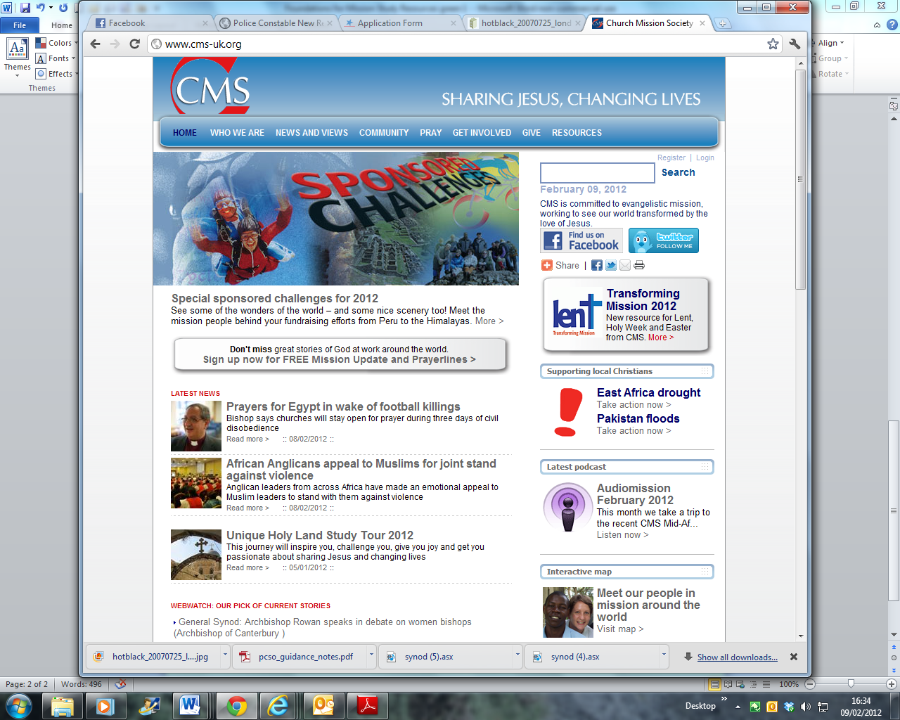

**Activity: Designing better mission messages**

In groups, compare your impressions and findings about the website(s)

Using anything you found inspiring or interesting, design a page either for your own website, or as a flyer or notice for your church which has the following elements:

* A mission-focussed title
* A mission-related strapline
* Some words from Scripture about mission
* A striking image about your church’s mission
* A story about mission. This can illustrate the image if you like
* Something about your mission priority/priorities
* Some links for people to find out more about what your church does in mission.

**For Further Work**

Think about using your designs to inspire, inform and reach out to other people in your church and outside the Church. You could do this either by adding your designs to your existing website, or by producing a leaflet, inset or poster to be distributed in your church and the wider area.

***Green 2: Ask Your Minister***

The third leg of the Foundations for Mission Research involved a series of in-depth interviews with leaders of local churches in the Anglican Diocese of Southwell and Nottingham. This enabled those leaders to have more chance to think in detail about their personal understanding of mission and to tell stories about their experience of mission.

**Activity: Interview**

Ask your church leader or leader(s) to join your group to talk about their understanding of mission in a relaxed and informal setting. Or you could ask them to preach on it.

Here are some suggested questions (although you can agree your own)

* Where in the Bible do you think we learn most about mission?
* What sort of activities do you think constitute ‘mission’?
* Do you think our church does enough mission work?
* What do you think about the work of the missionary societies and how should we support them?
* What do you think successful mission looks like?
* Which of the five marks of mission do you think should be the first priority?
* What would you most like to see this church doing to devote more energy to mission?
* Can you tell us about your personal theology of mission? Where do you see God in all this?

If you prefer, you can have a general discussion in the group.



**Activity: Strategy**

After you have interviewed or discussed with your church leader(s), think about what they have said and see if you can agree **one** thing to take place in your church which would improve your commitment to mission. This might be a project, an event, a community-based action or strategy, a commitment to setting up a fresh expression of church or more support for a mission society. Draw up an action plan which is sensible and within your church’s people-based and financial capabilities. Do not draw up a plan which is too ambitious or will cripple your resources. If your church is very small and poorly resource, think about making a mission action plan as an ecumenical project with your neighbours.

Here is one such plan as an illustration, from St Mary’s Church, Ellesmere.

**Growing Together through Worship and Prayer**

* Using the Children's Bible at Family Services
* Wider advertising of Mothering Sunday, Christingle and Family Services
* Involving children and families more in our worship
* Producing a single services sheet to cover the whole of the baptism service

**Growing up Through Teaching and Nurture**

* Bible Sunday in November
* Organising a Quiet Day at Corwen
* Bible Study Group on Genesis
* Provide Certificates for those who attend courses
* Growing through Outreach and Evangelism

**Establish a website**

* Create a Welcome Information Pack
* Publish our Mission Action Plan
* Find an editor for the Magazine
* Growing through Justice and Care

**Fair-Trade goods available in Church**

* Advertising and promoting Fair-Trade in the Magazine
* Pastoral visiting and follow-up for Baptism families

**For Further Work**

Repeat the meeting with your church leader(s) in a year’s time to review your mission action plan and to see whether you all feel that your church has grown in its engagement and deepened its understanding of mission.

***Green 3 - The ‘problem’ of Justice***

**Book p.39.**

One of the important issues uncovered by the research was what people made of the word ‘justice’ in relation to mission. First of all, what kind of justice do we mean? Does mission relate to God’s justice and if so does that refer to what God wants for human beings now, or does it mean some idea of Judgement or end of the world scenario? Or maybe justice is the same as social justice, working to provide equality for all, eliminating poverty and oppression and standing up for those who are powerless and voiceless. If that’s the case, how does social justice relate to mission?

Another question which arises is whether the issue of justice for all people comes before mission? Do people have to be lifted out of their suffering or poverty before they can become truly receptive to God’s love for them? Or is mission tangled up with justice for all, so that you can’t have one without the other?

**Activity: Image**



<http://www.morguefile.com/archive/display/175322>

Look at the woman in the picture

Choose one of these scenarios for why she has covered her face with her hands:

* She has just finalised her divorce
* She has just been evicted from her home
* She has been the victim of a crime
* She has just been told she has a serious illness
* She has just realised she is in terrible debt
* She has just failed the exam she needs for her chosen career
* She has just been told a loved one has died

You might like to improvise the scenario with two or three people from your group. One person should improvise the role of the woman and one or two others the deliverers of the bad news.

In groups make a list of all the agencies you can think of which exist to help people who experience these life crises. Use a telephone directory or the internet to find out which of these operate in your area.

You could create a list of organisations with contact details to put on the noticeboard or for your church leaders to use.

Discuss in your group how and where you and/or your church can do more to help people in these situations. Choose **one** thing you could do to help people a little bit more.

**Activity: Good News; Bad News**

Think about some stories from Scripture which engage with the ‘bad news’ in the previous exercise. For example, the story of the Prodigal son, the Good Samaritan or Jesus being told about the death of John the Baptist.

You might like to improvise or role play the passage you choose.

In groups, talk together about how the bad news gets turned into good news when Jesus is at the heart of the story. What needs to happen for the Good News to come about?

 Office.com

**For Further Work**

You might like to involve members of your church and community in a ‘Good Newspaper’, or Good News section of your existing magazine or newsletter, focussing on ways in which problems and difficulties have been overcome, how help and good neighbourliness helps people and what difference it makes when people find the Good News operating in their own lives. Good News could also include notices about weddings and baptisms or other celebrations in your area.

***Green 4 – Hospitality and Openness***

**Book pp. 36-37; 46-47**

The statement survey showed that the church leaders and mission agency personnel who took the survey during the research for *Foundations for Mission*, responded very strongly to ideas that the mission of the Church is founded in hospitality, openness, welcome and reconciliation.

**Activity: Ministries**

In groups divide a large piece of paper into four sections. List together ways in which your church offers;

* Hospitality (eg Alpha meals; Christmas lunch for the elderly; coffee after services; summer fete etc)
* Openness (eg parent and toddler groups; crèche; community groups meeting in the church hall; coffee mornings; house groups; music groups, concerts etc)
* Welcome (eg greeters at the service; open house occasions; house groups and meetings; tourist materials etc)
* Reconciliation (eg healing or penitential services; community issue group meetings; church leaders counselling and pastoral advice etc)

Review the contribution of each of these four categories to the mission of your church. How else might these ministries be developed? How might these ministries be extended to daily life and life in the workplace?



<http://www.morguefile.com/archive/display/169967>

**Activity: Media**

In pairs or small groups, think of a film, TV episode, music track, play, book or piece of art which speaks to you about the idea of reconciliation. Tell each other about the idea you have chosen and about its message of reconciliation. Or you could prepare and bring along something to watch together or listen to. When you have done this, think together about how you could use things you have in common to share with people outside the church about reconciliation in Christ.

**For Further Work**

Think together about designing an event (perhaps an event you do already, like a carol service or a fete) which will send a message of hospitality and openness to your community.



<http://www.morguefile.com/archive/display/707796>