Foundations for Mission Study Resource
Yellow 1
Introduction for group leaders: How to use these resources
Background to the report

Foundations for Mission was a study project undertaken by representatives drawn from the then Global Mission Network of Churches Together in Britain and Ireland, the British and Irish Association of Mission Studies and Global Connections. Its purpose was to address one of the study streams of the Edinburgh 2010 mission conference on the role of theology in mission understanding. The research group realised that this was a complicated academic subject, but wanted to find out more about actual practice of mission as well.
The research group wanted to test whether the things we say about mission, match up to the kind of things we do in mission. To find out what the relationship is between mission language and mission activity, the project members undertook three pieces of research. The first was a look at the websites of a variety of churches and mission agencies to see what kinds of words and images were used to convey mission thinking and mission practice. The second piece of research was a survey of mission attitudes sent out to all the mission leaders of churches and agencies, and the third piece of research was a local in-depth study undertaken by the Revd Canon Dr Nigel Rooms in the Anglican diocese of Southwell and Nottingham using interviews with a range of clergy.
The entire project was commented on by the members of the Mission Theology Advisory Group (MTAG) who have now produced these group-based resources to help you explore the issues raised in Foundations for Mission for yourselves. Each one is based on one of the findings from the resource material and contains activities to help groups engage more deeply with those findings. The resources are also designed to help you identify things you can do to make your Christian community more mission focused.
The resources are designed for use at congregational level. We use the MTAG activity pattern, which is: three more (yellow) resources which are based on text for groups which enjoy discussions; four (green) activity-based resources for groups which enjoy performing activities with reflection; four (blue) scripture and worship based resources for groups which want to engage in Bible study and combine reflection with prayer and hospitality; and four (pink) spirituality based resources four groups who want to move towards deep spiritual growth and development around specific issues. You may like to look through them and mix and match the resources which are most appropriate for your group.
The resources are, briefly:
Yellow 1 Introduction (this resource)
Yellow 2 ‘Significant’ words from mission websites – what do they mean to you?
Yellow 3 Three kinds of mission theology- which one does your church favour most?
Yellow 4 Survey – a version of the statement survey used in the research adapted for congregations

Green 1 Website as tools for mission – could your church website say more about what mission means to you?
Green 2 Ask your minister – what’s their view of what mission is really about?
Green 3 The ‘problem’ of justice – can mission and justice be held together?
Green 4 Hospitality and Openness – is this what we really want?

Blue 1 Bible study – what are the foundational mission texts?
Blue 2 Objects for meditation – using objects as a focus for re-imagining mission
Blue 3 Prayers for mission - meditation on the five marks of mission
Blue 4 Reflections on mission - for theological reflection

Pink 1 Doing and Being
Pink 2 ‘Is’ and ‘Ought’
Pink 3 Mission or Social Action?
Pink 4 Foundations for Mission - exit
Yellow 2
What words do you associate with mission?
The research looked at a number of websites and analysed them to find what were the most common words used in their language about mission. The most popular words were:
Book pp. 21-22
Activity: Discussion
Divide into groups. Assign one of these words to each group and ask people to say what they think each word means to them. The following questions might help the discussion:
- Where do you see this word happening in your church?
- Where do you see this word happening in the Bible?
- What do you think God wants us to do when we engage in this word?
- What would you expect to see when Christians are involved in this word?
- What do you think this word has to do with mission?
Activity: Decision
Make a list of events and activities in your church where these words are happening. Are there any words which you have difficulty finding events and activities for? See if you can change one thing in your church’s life which will make one of the words really stand out as part of the church’s life. For example, if you think your church is not doing enough for Creation, then find out what you can do to make a difference to your church’s environmental impact or carbon footprint.
For Further Work
Are you surprised that other words did not seem popular? What words would you associate with mission and why?
Yellow Journey 3
Mission Theology
Book p.51 and pp. 52-92
The Research Project drew on three approaches to mission, based on Bevans and Schroeder’s three ‘types’ of mission theology in their book Constants in Context: a theology of mission for today (Maryknoll: Orbis) 2004., which are:
Mission as the proclamation of Jesus Christ as Universal Saviour (proclamation)
Mission as participation in the Triune God (following the mission of God)
Mission as liberating service of the Reign of God, or Kingdom mission (transformation)
Purpose: to find out what ‘lens’ of mission your church most favours and to see if your mission focus could benefit from looking through the other ‘lenses’ as well.
Activity: Discussion
Divide into groups. Give each of the groups one of the approaches to mission as follows:
Mission is…..proclaiming Jesus to the world
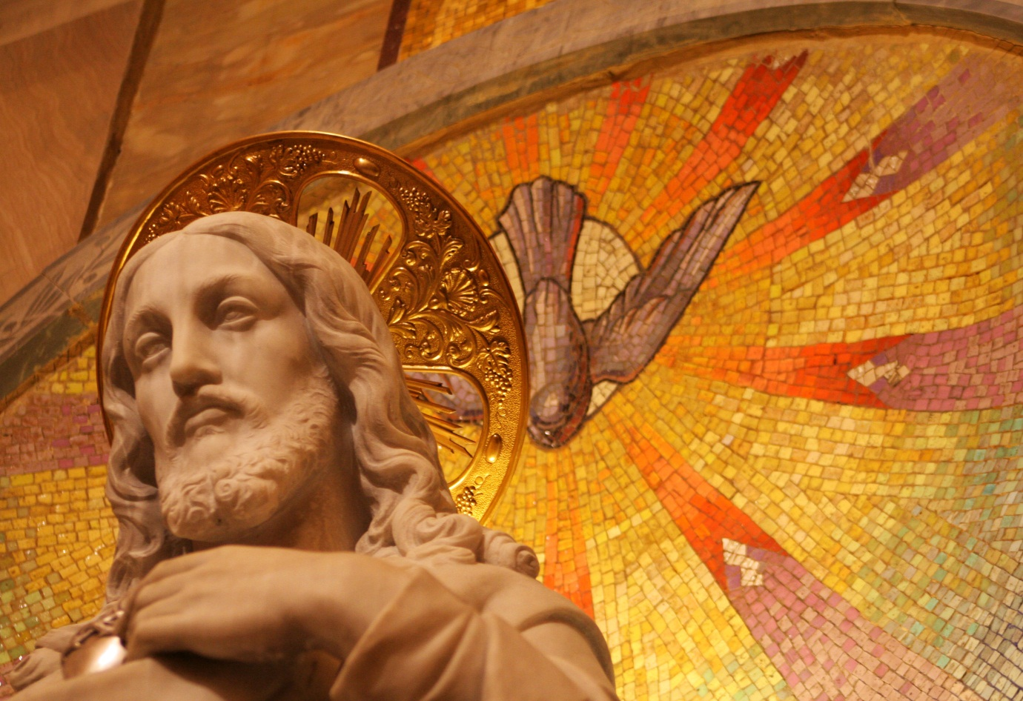
http://www.morguefile.com/archive/display/145369
Mission is…..finding out what God is doing and joining in
http://www.morguefile.com/archive/display/700061
Mission is….changing the world to be a better place
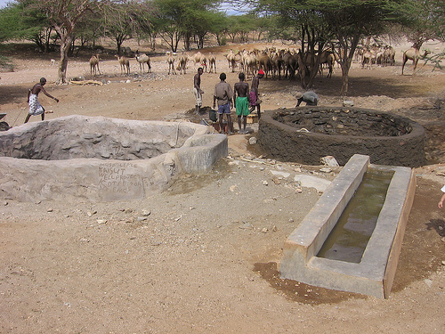
http://www.flickr.com/photos/whiteafrican/162677865/sizes/m/in/photostream/
Photo: Eric Hersman
Ask the groups to discuss what these approaches to mission might mean and try to find concrete examples where this kind of mission might be taking place in your church.
Activity: Decision
In plenary, get feedback from the groups about the kinds of mission your church is involved in. Does your church favour one approach more than another? Find out if your church could benefit by broadening its mission agenda into some of the other areas. Identify one thing you could do to use another mission lens in your church.

For Further Work
The research found that the ‘default’ mode for churches was to regard mission as proclamation, the first of the five marks of mission. Why do you think this might be so?

Yellow 4
Statement Survey
In Foundations for Mission, a statement survey was produced for leaders of churches and mission agencies to consider and the results were collected and analysed.
What was interesting was that most people who took the survey found the statements challenging, even the very simple ones. Some of the respondents wrote lengthy notes explaining exactly why they had responded as they did and talking about their struggle with finding an answer.
Activity: Discussion
Below is a simplified version of the statement survey.
There are no right or wrong answers.

- Mission is about finding out what God is doing and joining in
- We have a lot to learn from people of other faiths
- Mission is about changing people’s lives for the better
- Everybody is responsible for mission in their community
- Mission should be left to professionals
- Mission is mostly about telling people overseas about Christian faith
- We should respect other faiths, but Christianity is the only true faith
- Mission is about making churches grow in numbers
- Mission can’t happen without justice Mission is mostly about conversion
- God works through everybody
- Mission is mostly about openness
- God works mostly through Christians
- Mission is about telling other people about Jesus
- Mission is mostly about hospitality
- Other faiths have nothing to teach us
- Mission is mostly about reconciliation

http://www.morguefile.com/archive/display/175041

- God works through devout people of any faith
- All Christians should be involved in mission
- Mission is mostly about welcome
- Mission is about being church first

In groups have a look through the statements and pick three to discuss. Some questions to help the discussion might include:
- What might this statement mean or imply?
- How does your faith help you to agree or disagree with the statement?
- What is difficult or puzzling about the statement?
Limit the discussion to about 20 minutes.
After this, look again at the three statements you have chosen and look at where the statements might be working out in the life of your church.
Activity: Decision
In plenary look at one thing you could change to address any statement you find particularly challenging.

For Further Work
Why do you think the people at the head of mission organisations found these kinds of statements so challenging?

