Myths, Miracles, Mysteries, Mission – following the Saints
Introduction

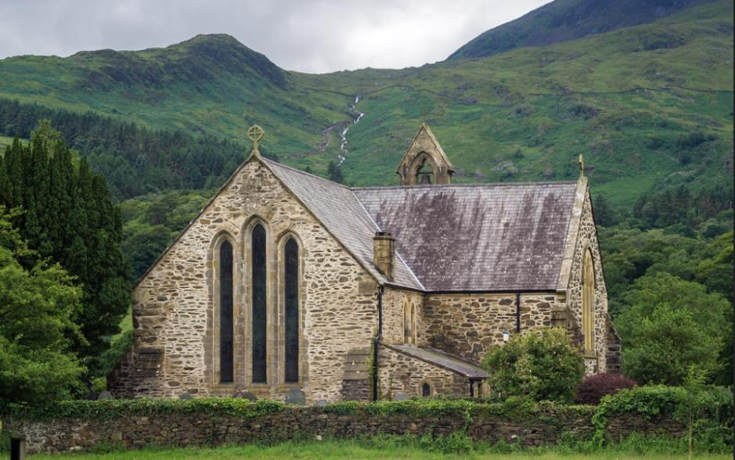
Adam Court/flickr St Mary’s Church, Beddgelert, Wales, UK
Have you ever walked past a church and noticed that its name is that of a saint? And have you ever wondered why so many churches seem to be called after saints?
By the fourth century, it began to be the practice to dedicate new churches to a ‘patron’ saint. Images of that person were often displayed in the churches and the name of the saint would be displayed. Today, many churches are dedicated to all kinds of saints, but some Christian denominations now do not use them to dedicate their buildings.
The Christian creeds, our statements of what we believe, say that ‘we believe in the communion of saints’, - holy women and men who have been faithful followers of Jesus Christ and who have often lost their lives through persecution of the Christian faith. Some Christian denominations recognise saints ‘days’ in the Christian calendar when particular saints are especially remembered and churches dedicated to particular saints hold special services, ‘patronal festivals’, on those particular days. Across the world, some of these dates are very well known outside the Church, such as St Valentine’s Day on February 14th or the St Patrick’s Day celebrations on March 17th.
Some saints are said to be ‘patron saints’ of particular groups of people, sometimes because of some event or legend about their own story. In the UK there are four ‘nation’ saints, St George for England, St David for Wales, St Patrick for Ireland, and St Andrew for Scotland.
This set of sixteen resources is designed to offer you a range of ways of finding out more about a saint called St Winefride (Winifred or Gwenffrewi) and finding out about the mission, myths, miracles, and mysteries associated with her and to ask how we understand these things today.
There are four ‘pathways’ for you to follow, and you can mix and match them if you like. They are:
YELLOW JOURNEY – word-based resources for people who like to read information, talk about things and consider questions, perhaps in a study group. The Yellow Journey also guides you through the best information we have (eg the Bible for biblical saints) moving on to how we learn from, evaluate and use other traditions about the saints.
BLUE JOURNEY – for people who like to engage with Scripture, use prayers, and use Christian reflections. The Blue Journey also begins from the best information we have (eg the Bible) through to prayers and traditions associated with particular saints.
GREEN JOURNEY – image and activity based for people who like to explore, create, look at images and get out and about. The Green Journey also delves into things like the traditions of saints around the world, seeing them through the eyes of other Christians.
PINK JOURNEY – for people who want to explore Christian faith more deeply, find out more about following Jesus, and using the ‘lens’ of the saints to create opportunities for thinking about how we live our lives.
Another way to mix and match the resources is to follow the information across the four journeys about the person first and as much factual material as is available, then think about the mission of that person and where and how that was recorded, then move on to the miracles associated with that person and finally the mystery of the saints and what their stories might mean for us today.
You can use these resources whether you are a Christian or not, as an individual study or in a group of friends.

This grid shows you the range of the resources for St Winefride and how you can mix them:

 | The Woman | The Mission | The Miracles | The Mystery
Yellow Journey | Winefride | Winefride and Beuno | Winefride is Restored | The New Spring of Water
Blue Journey | Susanna – faithfulness and obedience to God | Mary’s obedience brings Jesus into the World | The Pool of Bethesda | Tabitha – a disciple restored to life
Green Journey | Seeing Winefride | Dedication to Christ | Death and Restoration to Life | Healing and New Life
Pink Journey | Safety and Harassment | Living a Consecrated Life | Bringing Healing to the Hurt | Inspiring and Transforming the World

The Woman: Winefride
(Also Winifred, Welsh: Gwenfrewi/Gwenffrewi)

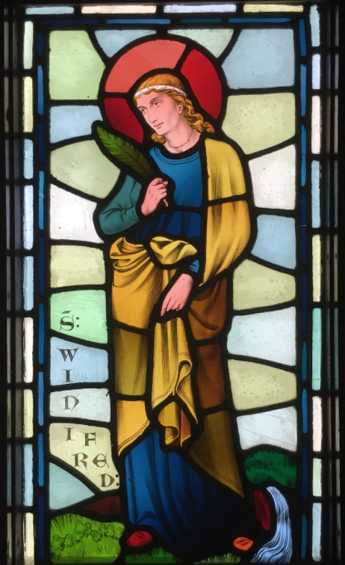
St Winifred, Castell Coch stained glass panel designed by William Burges. Hchc2009 Creative Commons Attribution-Share Alike 4.0
Some people have doubted that St Winefride actually ever existed, because writing about her started so late after the time she was actually supposed to have lived (7th century). However, other historical evidence of her reliquary (a structure with some part of her remains) dated from the 8th century has come to light, showing that she was revered as a saint quite soon after her death and that a church dedicated to her memory was established containing these relics. In this resource we go on a journey to discover the woman behind the saint and the legends associated with her and why her life is so relevant to women today.
The various written accounts of the life of Saint Winefride date first from around the 12th century. She is thought to have been the daughter of a Welsh nobleman, Tyfid ap Eiludd, the chief of a people living in what is now the border country between England and Wales, in Flintshire. Her mother was called Wenlo, sister to Beuno (St Beuno) and also part of an important Welsh family. She was their only child.
Her story is a sad one. She is said to have been a faithful Christian who wanted to know more and more about Christ and to follow him as diligently as she could, encouraged and taught by her uncle, Beuno. In those days the relationship between an uncle and a niece or nephew was an important one, and Winefride would have been under his protection and care as if she were his daughter. Eventually she decided that she wanted to devote her whole life to Christ and become a nun.
Unfortunately, a man called Caradoc wanted her. He also came from an aristocratic family and wanted to marry her, probably to form an alliance with other aristocratic families. The story says that he came to her and insisted that she give herself to him. She refused but he would not listen and she feared that he would immediately rape her. Pretending to give in, she said she would go to her bedroom and get ready, but escaped through another door and tried to run away to the church. However Caradoc followed her, caught her and said that if she didn’t allow him to have sex with her immediately, he would kill her. Winefride said she would choose death rather than give in and so he decapitated her.
[This was not the end of the story – which you can continue in the Miracle section]
What do we learn about Winefride from this part of her story?
First, we have to set her in her context. As the only daughter of a noble family she would have been seen as a useful asset. Her marriage into to another aristocratic family would have offered importance alliances, protections for her father’s position and estate and any children of the marriage would have enabled further consolidation of power structures, territory and heritage. Women were political pawns in the feudal structures and politics of the time and she would have been brought up within this mindset and aware of the precarious nature of the social structure in which she lived. Her mother was doubtless the subject of such an alliance and her own position and path in life would have been expected within her own family,
Secondly, we can see that Winefride was an unusual person in seeking instead to learn and grow in faith and in her decision to dedicate herself to a single life and turn away at a young age from the expected path of marriage and children in order to serve God. This was particularly unusual, since she was an only child, and also because many women entered the religious life after having been widowed; marriage and family came first as necessary and the convent was available if their husbands died. So it wasn’t an either/or choice. Yet Winefride was clear that her vocation as a young person was set and that she would refuse her suitor. Beuno appears as her ‘spiritual’ parent.
Thirdly, we learn that Winefride was absolutely determined that this choice was absolute and without compromise. Although she must have been terrified at being attacked, she was willing to die rather than compromise her ideals and life choice. We learn of her trying to negotiate and to escape and her refusal to give up her essential sense of self and vocation even when overpowered and about to be killed.
Some questions to think or talk about:
- What do you think it was like to be brought up the daughter of a Welsh aristocrat in those days? What would life have been like?
- What reasons might have Winefride had for choosing the religious life over marriage and family?
- What can we learn about the exercise of power in those times? Where do we see power being misused today and what can we do about it?

Steve Johnson/flickr
The Mission: Winefride and Beuno

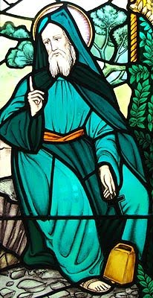
In the Golden Legend, the story of St Winefride delves into the relationship between Winefride and her mentor and guide St Beuno. St Beuno is about to depart for Ireland, but he wants to remain in contact with her. He tells her that even though she will be living as a nun and not actually going anywhere, if she makes and sends something for him, she can use the power of the natural world, the well that sprang up at her attack. The water will take it to the sea and from there across to Ireland where he will receive it.
The story says:
Then after, this holy maid Winefride was veiled and consecrate into religion by the hands of this holy man Beuno. And he commanded her to abide in the same church that he had do make there by the space of seven years, and there to assemble to her virgins of honest and holy conversation whom she should inform in the laws of God. And after the seven years to go to some holy place of religion, and there to abide the residue of her life. And when this holy man should depart from her and go into Ireland, she followed him, till she came to the foresaid well, where they stood talking a long while of heavenly things. And when they should depart, this holy man said: It is the will of our Lord that thou send to me every year some token, which thou shalt put into the stream of this well, and from hence it shall by the stream be brought into the sea, and so by the purveyance of God it shall be brought over the sea the space of fifty miles, to the place where I shall dwell. And after they were departed, she with her virgins made a chasuble of silk work, and the next year following she wrapt it in a white mantle and laid it upon the stream of the said well, and from thence it was brought unto this holy man Beuno, through the waves of the sea, by the purveyance of God. After this, the blessed virgin Winefride increased from day to day in great virtue and goodness, and specially in holy contemplation with her sisters, moving them into great devotion and love of Almighty God.
This story is interesting in that it looks at the relationship between a man and a woman through the filter of holiness and devotion to God. Winefride has become a nun, a bride of Christ, dedicated now to ‘honest and holy conversation’ with others as a practice of evangelism and then to dedicate herself to her religious order. Yet with all that has happened to her, reconciliation and relationship have still to be worked out. This can be done if the context of relationship is seen through the filter of dedication to God. St Beuno, her uncle and protector, has restored her, but the power relationships could still be unequal and restricting for her. It is interesting, then, that she follows him to the place of her attack, with its well of life-giving water, and there they speak as equals of ‘heavenly things’.
Although they are to live their separate lives, they can remain in touch with one another. St Beuno says that by the agency of the water, carrying it by stream and sea, a message can be sent to him in Ireland. Although on the surface this looks like doing something ‘for’ him, with no promise of return, yet it is left in Winefride’s hands to choose what to send, and what creativity to put into it. She sends him a chasuble (a tunic worn during a service of Holy Communion) which she and her companions have sewn, to encourage her uncle in his own priestly ministry. Just as Beuno rescued and consecrated Winefride to ministry, so she in her turn chooses to encourage his. In all this, God blesses and enables the communication and the encouragement and the ability to grow in holiness, trust and discipleship.
What this means for us today
We may learn a number of important things from this story. First, friendships and relationships between men and women can be mutually enriching and can exist without unequal power relations. But where women have been traumatised and have suffered at the hands of violent partners or other family members, it can be difficult to get to that place of trust and respect.
There is also here a message about gifts and gift giving. As Winefride and Beuno stand by the well, Beuno asks her for a token, offering up a place of lack in himself which needs to be filled. He is not her patron any longer, but the one who needs something from her. This version of the story does not say that she has to provide this or that, but leaves the question of what is appropriate to send, and whether she does it or not, with her.
Finally, we may see in this story something about how we can all encourage each other in mission, evangelism and discipleship. We can remember missionaries who work overseas and seek to encourage and resource them. Yet staying at home does not mean we have no agency in mission, prayer and creativity and communication are important in sustaining relationships and helping those who work in mission to being the Good News of Jesus Christ into the lives of others.
Some things to think or talk about:
- What do you know about the people who work for mission agencies?
- What sort of thing could you make or give to your local clergy to encourage them in their life and faith?
- What sort of heavenly things do you think Winefride and Beuno talked about?

Sjensen~/flickr
The Miracles: Winefride is restored

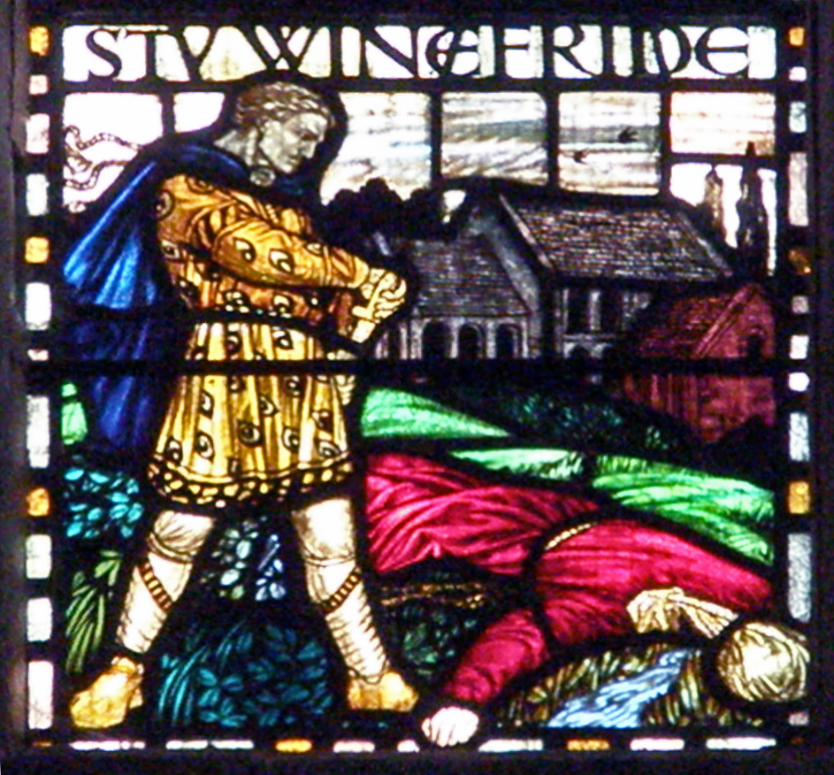
Amanda Slater, Coventry

The Golden Legend goes on to say that St Beuno found Winefride decapitated and cursed Caradoc so that he immediately died. He was popularly supposed to have melted and been swallowed up by the ground. After this, Beuno asked all the horrified people who have gathered around to join him in prayer:
And after, took up the head in his hands, and set it to the place where it was cut off, and desired all the people that were there present to kneel down and pray devoutly to Almighty God that it might please him to raise her again unto life, and not only for the comfort of father and mother, but for to accomplish the vow of religion. And when they arose from prayer, this holy virgin arose with them also; made by a miracle alive again by the power of Almighty God. Wherefore all the people gave laud and praising unto his holy name for this great miracle. And ever, as long as she lived after, there appeared about her neck a redness round about, like to a red thread of silk, in sign and token of her martyrdom.
So Winefride is miraculously restored to her parents and to her religious vow, by the power of prayer. She lives out her life consecrated to that vow and bears her promise to God and her story forward into the future as an example to all.
What this story tells us goes far beyond the ‘miracle’ itself, not least because we are all too sadly aware from atrocities reported in the news, that beheaded people do not come back to life. Rather we learn from an extraordinary picture of utter destruction that nothing is impossible for God and that no life, no matter how long or short, is devoid of meaning or purpose. On one level the story is about a powerless young woman, subject to extreme, devasting violence; on another level, the evil that is done to her is destroyed and borne away and her contribution to the richness and fullness of God’s world is restored, such that her story percolates as a source of inspiration through the ages and is still with us today.
Many of us bear the scars of pain and violence and the picture of this young woman walking about with the thin red line on her neck sends an important message about not being ashamed of the scars we bear, whether those are of physical violence, or impaired mental or physical health. The mark like a thread of silk externalises the suffering of oppressed women, of those trafficked for sex, victims of domestic abuse, who are often made to feel worthless and less than human. The transformation of corpse into a person of dignity, symbolises for us the transformation we should seek for all oppressed human beings, so that we can rejoice with them and learn from them. Their stories, like that of Winefride, should change us all.

Some things to think or talk about:
- How can we work to restore dignity and worth to those who have been abused or to the memory of those killed?
- How important, do you think, is the picture of a crowd of people praying together for a miracle?
- How do we help people not to be ashamed of their scars and the bad things that have happened to them in life?

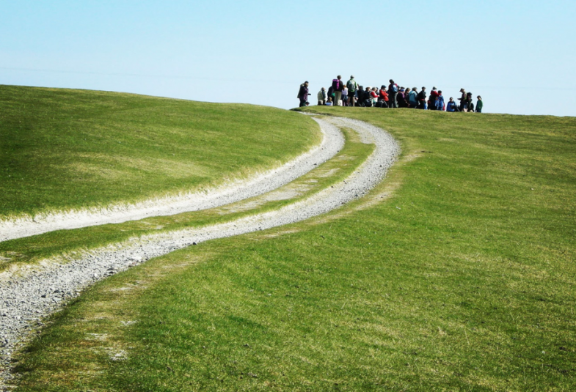
Stew Dean/flickr praying at Iona
The Mystery – the New Spring of Water

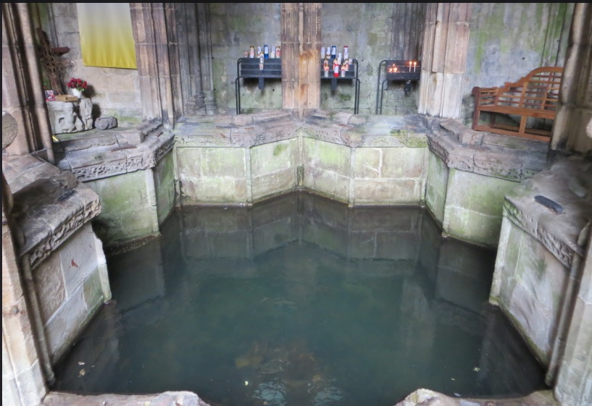
Alex Liivet/flickr St Winefride’s Well

The Golden Legend says that when St Winefride was killed by her angry suitor, Caradoc, something miraculous happened:
And in the same place whereas the head fell to the ground, there sprang up a fair well giving out abundantly fair clear water, where our Lord God yet daily showeth many miracles. And many sick people having divers diseases have been there cured and healed by the merits of this blessed virgin, Saint Winefride. And in the said well appear yet stones besprinkled and speckled as it were with blood, which cannot be had away by no means, and the moss that groweth on these stones is of a marvellous sweet odour, and that endureth unto this day.

The appearance, or discovery, of a spring in relation to a supernatural event or the death of an especially holy or devoted person, is a common occurrence. It is as though the natural world, responding to a ‘thin place’ created by the event, offers something which can be read by humans as a symbol of hope and life. More to the point, in cases like this, the horror of unjust, violent, death is countered by people finding something which offers life and hope. For this reason, such springs and holy wells can become places where people do indeed find life and hope and healing.
Another important point is that the violence done to Winefride is countered by transformation and beauty – the blood disappears but is replaced by speckled stones, the stench of death is replaced by sweet moss and the horror is transformed by the cleansing water, literally washing the dread away and replacing it with beauty, growth and cleanness.
Why should we care about this when so much violent death today goes untouched by transformation and remains as a scene of horror and grief? Why would anyone whose loved one has been murdered, not to mention the scenes at Auschwitz or the mass graves of Srebrenica, or the killing fields of Cambodia, be impressed by a spring of water and the death of a young Welsh woman so long ago?
The thing is, even in today’s more sceptical and perhaps cynical times, we do try to bring beauty and hope into tragedy and horror. The roadside shrines at the sites of accidents or the masses of flowers brought by complete strangers to the sites of terrorist bombings or tragedies, show a pull in the human heart to remember, and change grief at untimely death into something that takes us forward in hope.
So when we donate money, or join a fun run in memory of someone, when we pray for situations where someone has been killed or many people have died, we create different kinds of springs, - springs of hope and reconciliation and peace. When we become creative in someone’s memory, such as setting up a charity or a foundation to make future life better for others, we create speckled stones and sweet moss. We have many more opportunities for doing this than the people of 8th century Wales and every day we create thin places for the Lord to work miracles by the merits of Christians, of people of faith and hope everywhere.
And the healing miracles do matter, because each person who has found relief at a holy well becomes a testimony to the healing power and strength of the God of creation, who, in the Christian tradition, at the end, wipes all our tears away (Rev 21.21)

Some things to talk and think about:
- Why do you think water is such a powerful symbol of life?
- Where so you see people trying to make something good and pure come out of violence and death?
- What do you think people felt when they associated the story and the spring of water and what might we make of it today?
- What does this story tell us about holiness and how evil can be overcome?

Jose Nicdao/flickr stone and water

The Woman: Susanna – faithfulness and obedience to God
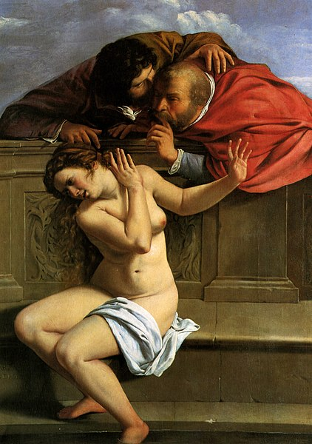
Artemisia Gentileschi, Susanna and the Elders, 1610, Schloss Weißenstein, Bavaria, Germany
Susanna (sometimes called Daniel 13) 15-23
The story of Susanna is included in some Bibles as Daniel 13 but elsewhere is an apocryphal book which can be found easily enough in online Bible sites. The story of Susanna may help us to think about the story of St Winefride, and the story of St Winefride may help us reflect further about the story of Susanna.
Susanna is the faithful wife of a rich man who had a large house and garden and who was often visited by Jewish elders. Susanna often goes into the garden to walk and to bathe and the wicked elders spy on her and are overcome with lust. They therefore plan to force her, by blackmailing her into doing what they want or being put to death for adultery.
Once, while they were watching for an opportune day, she went in as before with only two maids, and wished to bathe in the garden, for it was a hot day. No one was there except the two elders, who had hidden themselves and were watching her. She said to her maids, “Bring me olive oil and ointments, and shut the garden doors so that I can bathe.” They did as she told them: they shut the doors of the garden and went out by the side doors to bring what they had been commanded; they did not see the elders, because they were hiding.
When the maids had gone out, the two elders got up and ran to her. They said, “Look, the garden doors are shut, and no one can see us. We are burning with desire for you; so give your consent, and lie with us. If you refuse, we will testify against you that a young man was with you, and this was why you sent your maids away.”
Susanna groaned and said, “I am completely trapped. For if I do this, it will mean death for me; if I do not, I cannot escape your hands. I choose not to do it; I will fall into your hands, rather than sin in the sight of the Lord.”
Susanna chooses to refuse the elders and let them do their worst. She chooses to remain faithful to her husband and to God and to keep the commandments, trusting in God to vindicate her. The young Daniel is moved to stand up for her and to question the elders separately, exposing their lies and confirming the truth of her faithfulness and steadfastness.
Some questions to think about:
- How do you think the story of Susanna illuminates the story of St Winefride or vice versa?
- How does the famous classical painting above (by a female artist) get across the emotions and power of the story?
- Have a look at the painting of Susanna by Fancesco Hayez (below). Who is looking at her? How does this painting make you feel?
- How do you think the stories of Susanna and Winefride could be used as ways into discussing difficult issues about power, sex and sexual faithfulness with young people today?
- While Susanna is a story about lust, power and lies, it is also a story about faithfulness and obedience to God. How can we make our discussions about power and sex in today’s society also include the importance of keeping God’s commandments and being obedient to God’s will for us?
- Who are the Daniels of today in speaking up for victims and enabling women (other others) to tell their stories?
- How do you think the stories of Susanna and Winefride open up questions today about how men treat women, and difficult issues around things like consent, faithfulness, rape, and revenge porn?

Francesco Hayez – Susanna at her Bath 1850 The Yorck Project (2002)
The Mission: Mary’s obedience brings Jesus into the world
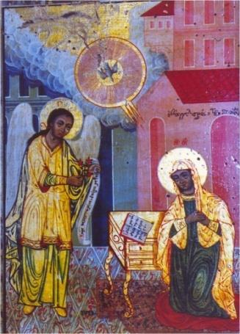
The Annunciation (Evangelismos). Orthodox style icon by anonymous, 1825, Church Museum of the Bishopry of Thessaloniki https://repository.kallipos.gr/bitstream/11419/3927/1/05_chapter_3.pdf
One of the pivotal moments in the story of St Winefride is her decision to follow God’s will for her and dedicate herself to holy chastity, -which costs her her life. In Luke’s account of the Annunciation we hear another account of a woman called by God to dedicate her life to God’s service. Mary is asked by God to become the mother of Jesus, also possibly putting her life at risk if Joseph decides to denounce her.
Luke 1. 26-38
In the sixth month the angel Gabriel was sent by God to a town in Galilee called Nazareth, to a virgin engaged to a man whose name was Joseph, of the house of David. The virgin’s name was Mary. And he came to her and said, “Greetings, favoured one! The Lord is with you.” But she was much perplexed by his words and pondered what sort of greeting this might be. The angel said to her, “Do not be afraid, Mary, for you have found favour with God. And now, you will conceive in your womb and bear a son, and you will name him Jesus. He will be great, and will be called the Son of the Most High, and the Lord God will give to him the throne of his ancestor David. He will reign over the house of Jacob forever, and of his kingdom there will be no end.” Mary said to the angel, “How can this be, since I am a virgin?” The angel said to her, “The Holy Spirit will come upon you, and the power of the Most High will overshadow you; therefore the child to be born will be holy; he will be called Son of God. And now, your relative Elizabeth in her old age has also conceived a son; and this is the sixth month for her who was said to be barren. For nothing will be impossible with God.” Then Mary said, “Here am I, the servant of the Lord; let it be with me according to your word.” Then the angel departed from her.
Some questions to think about:
- In the Annunciation, Mary, who is betrothed to Joseph and expects to get married, is asked to conceive and bear Jesus. How hard do you suppose it was for Mary and for Winefride, as women seeking to serve God, to follow God’s will against the expectations and pressures of their societies?
- Mary was visited by an angel of God. Winefride was guided by St Beuno. How do you think people today hear God’s call and invitation to them?
- Although Scripture refers to Jesus’s brothers and sisters, Christian tradition refers to Mary as a virgin perpetually dedicated and faithful to God. What do you think this tradition, and the story of St Winefride, tells us about the beauty and purpose of a single life in a society which pressures people to have sexual relationships as a matter of course?
- The angel explains to Mary how Jesus is to come into the world and she agrees; Caradoc tries to force violence on Winefride and then kills her. What does this tell us about human minds and bodies and how God relates to our physical, mental and spiritual selves?
- Mary’s ‘yes’ to God brought Jesus into the world. St Winefride’s faithfulness to God led to a tradition of pilgrimage, healing and peace. How can we use these examples to witness to people today about how listening to God and acting in accordance to God’s will can radically challenge and change the world? What other examples of saying ‘yes’ to God can you think of?
- What does the photo (below) make you think about if we imagine a calling from God in the life of young people today? What could God be saying to the person in the photo?
Nenad Stojkovic/flickr

The Miracles: The Pool of Bethesda
St Winefride’s well is associated with miracle healing, but what does this really mean? Maybe we can think more deeply about this by finding Jesus in the place of ‘miracle waters’.

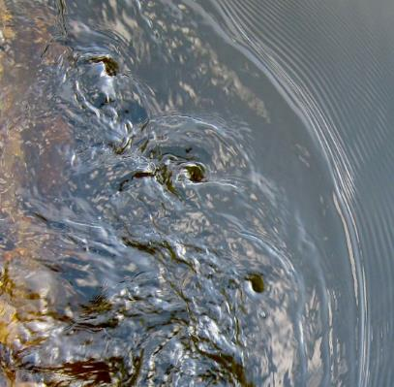
Underthesamemoon/flickr
John 5.1-9
Now in Jerusalem by the Sheep Gate there is a pool, called in Hebrew Beth-zatha, which has five porticoes. In these lay many invalids—blind, lame, and paralysed. One man was there who had been ill for thirty-eight years [waiting for the stirring of the water; for an angel of the Lord went down at certain seasons into the pool, and stirred up the water; whoever stepped in first after the stirring of the water was made well from whatever disease that person had.] When Jesus saw him lying there and knew that he had been there a long time, he said to him, ‘Do you want to be made well?’ The sick man answered him, ‘Sir, I have no one to put me into the pool when the water is stirred up; and while I am making my way, someone else steps down ahead of me.’ Jesus said to him, ‘Stand up, take your mat and walk.’ At once the man was made well, and he took up his mat and began to walk.
In this account the sick man is lying hopelessly by a pool that is thought to provide miraculous healing. The section in brackets is an explanation added by some authorities to explain why the man was there. When the water began to stir this was seen as an indication that divine power was passing into the pool for healing.
Jesus, however, does not need to put the man into the pool and doesn’t try to. Instead, he asks him a very pertinent question – do you want to be made well? Bishop John V Taylor once pointed out that this was a completely critical question -Jesus doesn’t just randomly act to help people – they have to have agency in their own transformation and decision to follow Jesus.
But we might notice that while Jesus doesn’t need the pool, he is present where the pool is. The people go there because it is a physical location with a tradition of healing and change. So perhaps those who seek out such places are precisely those who may well meet Jesus in those places and find more than just what they thought they were looking for. Places where miracles are supposed to happen can be places where Jesus meets us and tells us get up and get going for the sake of his kingdom.

Some questions to think and talk about:
- Many people seek out places of miracle healing even if they do not have a faith. Why do you think they might be drawn to such places?
- What do you think Jesus was actually doing at the Pool of Bethesda?
- Why do you think Jesus first asked if the man wanted to be healed?
- How do you think people might encounter Jesus at St Winefride’s well and what could we do to help that happen?

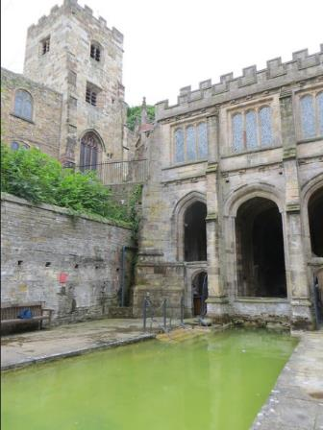
Alex Liivet/flickr
The Mystery: Tabitha - a disciple restored to life

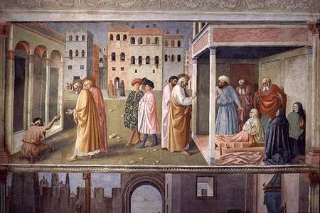
The raising of Tabitha (rh side) by Masolino, Yorck Project (2002)
In the story of St Winefride, we hear how she was horribly murdered by Prince Caradog but restored to life by St Beuno. Seems incredible? Surely such tremendous acts could only be done by Jesus – as in the raising of Lazarus and of Jairus’s daughter. Yet with God nothing is impossible and in Acts, we hear the extraordinary account of how Peter’s prayers to God enabled a holy woman called Tabitha to be restored to life and how this mystery of God’s grace brought many people to believe in Jesus Christ.
Acts 9. 36-42
Now in Joppa there was a disciple whose name was Tabitha, which in Greek is Dorcas. She was devoted to good works and acts of charity. At that time she became ill and died. When they had washed her, they laid her in a room upstairs. Since Lydda was near Joppa, the disciples, who heard that Peter was there, sent two men to him with the request, “Please come to us without delay.” So Peter got up and went with them; and when he arrived, they took him to the room upstairs. All the widows stood beside him, weeping and showing tunics and other clothing that Dorcas had made while she was with them. Peter put all of them outside, and then he knelt down and prayed. He turned to the body and said, “Tabitha, get up.” Then she opened her eyes, and seeing Peter, she sat up. He gave her his hand and helped her up. Then calling the saints and widows, he showed her to be alive. This became known throughout Joppa, and many believed in the Lord.
Some things to talk and think about:
- What does this story tell us about the power of prayer and about witness to God?
- Why do you think the disciples wanted Peter to come and see Tabitha’s body? What do you think they expected and thought would happen?
- Why do you think hearing about this brought many people to belief in Jesus?
- How does this account in Acts illuminate the story of St Winefride, or vice versa?

Jules and Jenny/flickr
A Prayer
Lord Jesus Christ,
We thank you for the example of holy women and men
Who have kept the faith and witnessed to others that they might believe.
Watch over all who seek to serve you,
And over all who are persecuted and die for your name’s sake.

We thank you for the mystery of grace and miracles of healing,
We ask your blessing on all who seek you
That they might meet you through prophets in places of injustice;
Through your loving invitation and call to serve you;
At places where people come for healing and salvation;
At places where all hope seems lost.

Amen

The Woman: Seeing Winefride
Writing about the saints is called hagiography – a way of presenting holy women and men as marvellous individuals for all their human faults, who can be sources of inspiration to Christians as they follow Jesus Christ in their daily lives.
Also important are the traditions of art and representation. Saints are often portrayed with items relating to their stories and to their Christian witness, which provides a way of finding out about them without words. This is a tradition which may feel unfamiliar, but it can be very rewarding just using our eyes and think about what the colours, shapes and symbols mean. Many people are drawn to, and love looking at, stained-glass in churches, for example.
St. Winefride's Well, Holywell, Flintshire, UK. Stained glass window showing Saint Winefride.

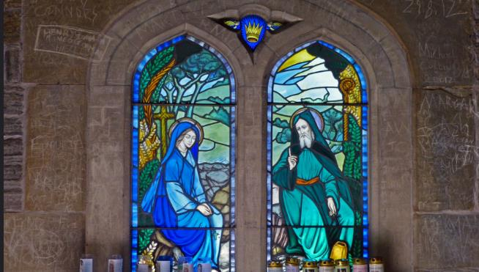
Original photo: Andrew/flickr
In this stained-glass representation, St Winefride is represented in long, flowing blue clothing and quietly listening to St Beuno. They sit together, but also apart, in a pastoral landscape of fields and trees and by the spring of water that sprang from the place where St Winefride died and was restored to life. Nature is green and flourishing and becoming fruitful around them, just as the nourishing words of Jesus bear fruit in people’s hearts when they become Christians and seek to follow him.
Both figures are dressed in the clothing of a religious order, showing their dedication to Christ and St Winefride holds a rosary (the prayer beads with a cross), showing the importance to her of prayer. As is traditional, both figures have haloes, showing that they are holy persons who can inspire us.
Behind St Winefride is the cross of Jesus, seemingly supporting her, part of her background, and what is rather more difficult to see here (but see the detail below) is the faint broken line across her neck which tells us, visually, what happened to her.
The colours also tell us something. If you have ever looked at other stained-glass windows you will often see that Mary, the Mother of Jesus, is often represented in blue. This colour is often used by the makers of stained-glass to represent faithfulness, chastity, and hopefulness in faith. The greens in the glass and the nature images speak of hope, rebirth and restoration.
Some things to do:
- How do you imagine St Winefride if you were going to describe her to someone else? (You could look at some of the pictures on some of the other resources for ideas or at the detail reproduced below.)
- If you were going to produce a picture of St Winefride to encapsulate her life and story for others, what would you put into the picture and why? You even could try icon making, tapestry or painting if you wanted to make something more elaborate than just a drawing.
- Try to visit a church or place associated with St Winefride (or look online) and find out how St Winefride is celebrated visually there.

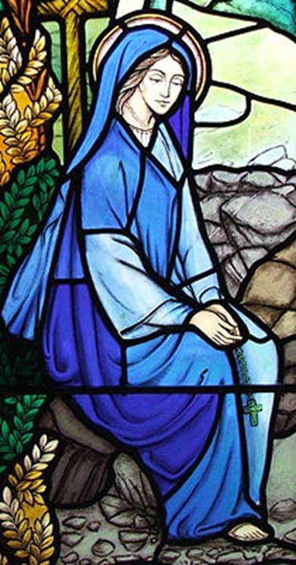

The Mission: Dedication to Christ
Xinem/flickr

In Butler’s Lives of the Saints, we find the following written about St Winefride:
When the holy priest preached to the people, Wenefride was placed at his feet, and her tender soul eagerly imbibed his heavenly doctrine, and was wonderfully affected with the great truths which he delivered, or rather which God addressed to her by his mouth. The love of the sovereign and infinite good growing daily in her heart, her affections were quite weaned from all the things of this world: and it was her earnest desire to consecrate her virginity by vow to God, and, instead of an earthly bridegroom, to choose Jesus Christ for her spouse. Her parents readily gave their consent, shedding tears of joy, and thanking God for her holy resolution.
People become Christians in many different ways, but this account of St Winefride’s decision to consecrate herself to a religious life, echoes what people still testify to today about evangelism and discipleship, - how people are called by God to be Christians and determine to follow Jesus Christ. It is important that we have people to help us understand the Gospel, the good news about Jesus, and that we enter into a journey of learning and growing in Christian faith. The worshipping community is important. And it is important that we come to learn that it is God that calls us and converts us.
For many people today, the idea that we could turn away from earthly things like money and possessions to concentrate on God is difficult to comprehend. It seems that so much of modern life puts the emphasis on possessions and partners, so the idea of doing without them can seem scandalous, impossible.
But this is precisely what Jesus asks people to do in the Gospels. He tells the rich young man that he needs to get rid of his many possessions if he really wants to love God and follow him. He tells his followers not to get hung up on family affairs and to leave their busyness and their worldly attachments in order to hear and understand more clearly what he has to tell them about God’s purposes for them and about the nature of the kingdom of God.
Today’s monks and nuns continue to live the same consecrated life as St Winefride and many people seek out their wisdom and presence with things like retreats or study days among those communities; even people who have little or no faith will visit for rest and refreshment. Such people value the rhythm of life, the constancy of prayer and the dedicated faith of those living in those religious communities, even if they don’t understand it or the choices that are made by those who choose a single life totally dedicated to Jesus Christ.
Digging into the Mission – some things to do
- Find out about monks and nuns living in religious orders today. What different kinds of religious orders are there? Where and how do they live? What do they offer to people?
- Find out about things like living by a rule of life and the cycles of prayer. Could you live by a simple rule of life which shaped your day? Why not have a look for one?
- ‘Decluttering’ is quite a fashionable idea these days. If you were going to ‘declutter’ your life, what would you get rid of and why? What could you not bear to part with? Why not?
- What examples of famous preachers can you think of? Who are the most important teachers and helpers in your life? How have they shaped your ideas, thoughts and decisions? Have you ever thought about finding a spiritual director, spiritual companion or soul friend?
- Look at the picture below? Who is listening? What do you think the two people might be talking about?

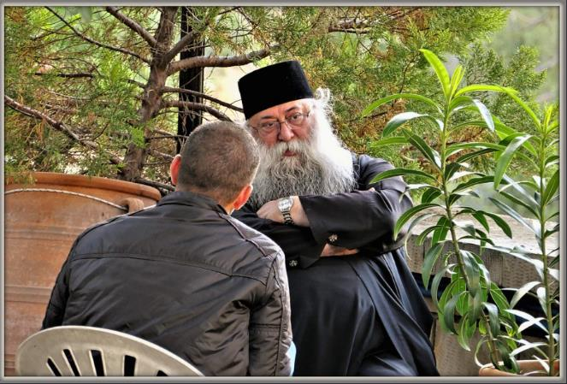
Rolf Dietrich Brecher/flickr Listening

The Miracles: Death and Restoration to Life
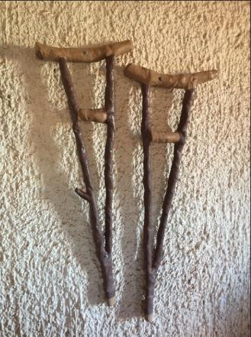
Ben Churchill/flickr
The poet Gerard Manley Hopkins began writing a dramatised poem about St Winefride although it was never finished and only fragments of the writing remain. In one section of the poem, he gives St Beuno a monologue as the saint looks forward into the future and sees in his mind’s eye what Winefride’s death and restoration to life, and the establishment of the holy well, will mean for people yet to come:
As long as men are mortal and God merciful,
So long to this sweet spot, this leafy lean-over,
This Dry Dene, now no longer dry nor dumb, but moist and musical
With the uproll and the downcarol of day and night delivering
Water, which keeps thy name, (for not in róck wrítten,
But in pale water, frail water, wild rash and reeling water,
That will not wear a print, that will not stain a pen,
Thy venerable record, virgin, is recorded).
Here to this holy well shall pilgrimages be,
And not from purple Wales only nor from elmy England,
But from beyond seas, Erin, France and Flanders, everywhere,
Pilgrims, still pilgrims, móre pílgrims, still more poor pilgrims.
(St Winefred’s Well, Fragment C, ll. 10-14, 18-23)

It is easy to be challenged by accounts of miracles. And a miracle like having a decapitated head restored to a body can be so completely extraordinary that it’s impossible to imagine. But we can see from the poem that there is much more to it than that. Accounts of miracles cut through space and time to bring people face to face with the fact that God can and does work in the world, the very world that we experience. God’s love, pouring into the world, brings us hope, transformation and healing. So Hopkins imagines people coming to the special place where St Winefride’s miracle happened from many countries, coming in hope of change and remedy, - and finding it, witnesses to the reality of God’s work in people’s lives.
Many people from different churches make pilgrimages to Jerusalem or to Galilee. It can be humbling and amazing to walk in the same places Jesus walked and to think about him performing miracles and healing people in those places, changing lives for ever. Similarly, people are drawn to other places of miracle because of the sense of awe and wonder in God’s power and love that they can feel there.
Digging into the Miracle – something to do
- Do some research and find out about places where miracles are supposed to take place, or ‘thin places’ where people might go to feel close to God. See if you can find one near to where you live and go for a visit. Otherwise, why not just visit a local church (or a church you don’t normally visit) and see what about it speaks to you of a living faith.
- How would you start a conversation about miracles? How might telling the story of St Winefride and the holy well create a good framework for talking about faith?
- Miracles and prayer are closely related. People pray for something to change, - perhaps for help, or healing, or direction. How might God answer our prayers, but in a different way from what we expected?
- Many people pray in words, write down what they want to say and leave it at a particular place, or they might light a candle. But there are lots of other ways to pray, - creating visual prayers in a drawing or sewing, or painting a pebble, or singing or chanting or playing an instrument. Some people like to create visual prayers which show what is being prayed for but leave spaces to show how God has responded afterwards, so the prayer is completed later, possibly much later. Why not have a go at doing prayer differently?

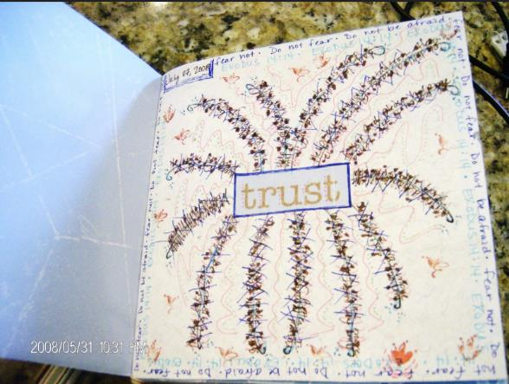
MichellePendergrass/flickr Visual Prayer - Trust
The Mystery: Healing and New Life

Reimagining Relics and Shrines
In the early centuries of Christianity, the remains of holy men and women were considered especially precious and capable of working miracles. These relics were powerful objects to be treated with the utmost care and veneration. Wherever they rested, the place of their rest was to be considered holy and so very often became a place of pilgrimage as people sought out that holiness, often for superstitious reasons as well as genuine expressions of faith.
Today, we might wonder why Christians of the past set such store by bits of bone and human remains that may or may or not have belonged to a particular person from long ago, and why those Christians wanted to create shrines where people could start or end a pilgrimage, or kneel in prayer. The holy well at Holywell has been a place of pilgrimage for a very long time, at least since 1115! It may be the oldest continually visited pilgrimage site in Britain. You can see how old the image of St Winefrede is in the picture above, and this is part of an ancient stone panel in Shrewsbury Abbey where St Winefrede’s remains were said to have been brought.
So how can we reimagine relics for today?
It might help to think about how relics point us to a physical body and a real person, and remind us that the saints are not some work of fiction or shadowy myth. In a sense, it doesn’t matter whether we can prove that such a relic actually belonged to this or that person; rather the relic points backwards in time to a human being made and loved by God, who lived and died and who can set us an example. Relics create linkages between miracle stories and the hard facts of our existence, - that we are creatures who live and die, and the fact that so many Christians have died because they loved God and were true to their faith – something which is still going on in the world today.
So what about shrines? Why does having a shrine to some person in an abbey or a cathedral have anything to do with modern Christian faith?
People still feel the urge to make temporary shrines today. If we read in the newspapers about people who have died by violence, who should have been safe and happy, you will doubtless see that many people come out in public to grieve and leave flowers, candles, gifts and messages at the places where they died, even if they did not know the people concerned. There is a powerful human urge to express solidarity and sadness when tragedies occur, as well as the need to look for change and hope. Shrines dedicated to saints do not tell us that the saint was more deserving of attention, but become fixed locations where people can pray, find solace and a more focused direction for the journey of faith. That is why pilgrimage as a physical journey can be a good way to reflect and ponder on where next in the Christian life you might want to go.
Some people find it helpful as part of their tradition to believe that saints can pray for us. But you don’t have to believe that to find praying at a shrine meaningful. Just the idea that we are part of an ancient tradition of pilgrimage and prayer can connect us, not just to our own Christian community but to so many who have gone before and believed that prayer is not an empty gesture but that God does hear us and respond to us, and that the Holy Spirit directs us and inspires us.
So the physical locations associated with the body of St Winefride as a physical person who lived and died for her faith, have become places where people find inspiration for their own lives, healing and a sense of new life as they discover, through prayer and pilgrimage, what wonderful things God has in store for them.
Digging into the Mystery – something to do
- Imagine you are an archaeologist and have just discovered a small human bone from the 7th century. Now imagine the body the bone belonged to, and then imagine that body as a living, breathing person. Now imagine that person’s family around them, and their daily lives. What might they have eaten for dinner? What clothes might they have worn? How would they travel around and what dangers might they have faced? If you find it difficult to imagine, do a bit of research to find out about life in those days long ago.
- Now imagine having a conversation with St Winefride or St Beuno back then. What might you want to talk about? What might you want to ask them?
- Or: imagine meeting some pilgrims from the early days of the shrine. Where might they have come from and what might they have hoped for?
- Or: go and visit one of the locations associated with St Winefride and talk to some of the other visitors about what they are doing there and what the visit means to them? See if that enables you to say something about your own faith and faith-journey.

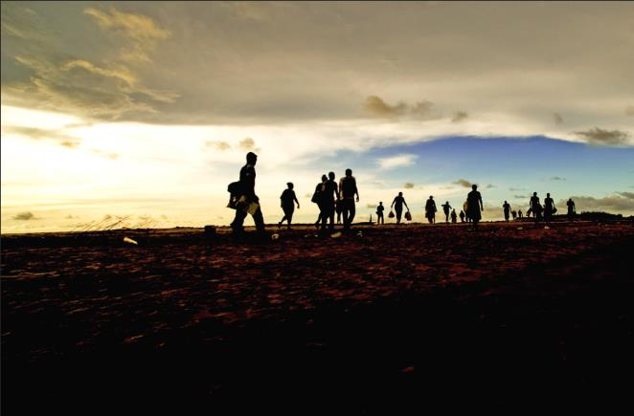
Jairo/flickr Pilgrims

The Woman: Following in the Footsteps of St Winefride - Safety and Harassment

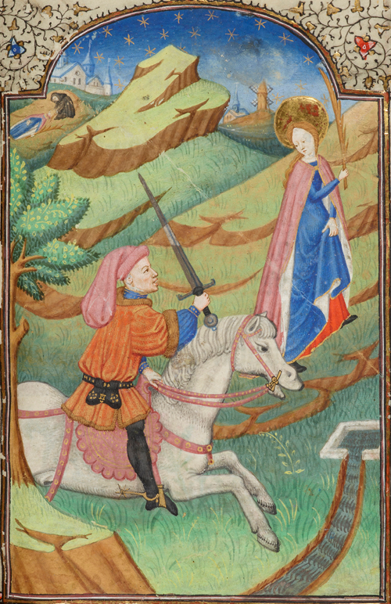
Martyrdom of St. Winifred, by the Fastolf Master. Hours of William Porter; France, Rouen, ca. 1420-25. Pierpont Morgan Library, MS M.105, f. 73 (detail). https://www.themorgan.org/collection/Illuminating-Fashion/22#
Many people have heard of the #MeToo movement in which women in particular have registered publicly the way they have suffered unwanted advances, or have been sexually harassed by others. Today, this issue has become increasingly acute as people have reacted with horror to the murders of women such as Sarah Everard and Sabina Nessa in 2021. There has been heated debate about whether such terrible events mean that women have to behave differently to protect themselves (such as not walking by themselves at night) or whether more has to be done to prevent others from ever intending harm and harassment. And there are many questions and outright disputes about how as a society we could do more to educate, protect and look out for one another.
This current debate shows that St Winefride’s own story is entirely relevant and contemporary. As a woman harassed, overpowered and killed by someone who thought he could just force her to do what he wanted, her death shows that this kind of behaviour has affected all kinds of people down the ages. But St Winefride’s story shows us more than just a story of lust and deadly violence; it is also a story of recovery, determination and flourishing, - with God’s help.
In the illustrated manuscript above, we see Winefride on foot, hastening away by herself, trying to climb a slope towards the sanctuary of buildings and church which seem impossibly far away. Her attacker rides a powerful horse and carries a raised sword which he obviously intends to use on her.
Although we can read about people like Sarah and Sabina in newspapers and see the pictures of those smiling, confident, young women, it can be difficult to know how to approach their stories, how to honour them, mourn for them and face the horror of their deaths. Our proper emotions of sadness and revulsion and compassion for their families can make it difficult to think about the wider consequences and issues around how we trust one another and keep each other safe. But a picture like the one above, from a medieval manuscript filled with symbolism, may give us a different way in to think about and reflect on matters of power, lust and brutality against people who should be safe and free. For all its horror, the picture also contains images of hope and overcoming with the healing water of the well and St Beuno in the very top of the picture restoring his niece to life.
The picture, then, makes an entire sequence of events present and while it does not deny death and horror it offers against them hope and restoration, that good change and restitution should come out of evil acts.
So perhaps we could use what we learn from letting this illustration soak into us to be more mindful of people around us who have been silent about their experiences and who might need a safe space to begin to come forward and talk about them. The Church is often accused of being bad at this and not helping people enough or taking them seriously. Perhaps through the story of St Winefride we could make spaces for more people to feel able to say that things have happened to them, some of which may have been sources of anxiety and pain for a long time.
Of course, #MeToo or other campaigns shouldn’t just be about particular situations, but about caring for, and solidarity with, anyone who has ever suffered from being bullied or coerced. Because in Winefride’s story there is also a message of deep and lasting hope, - that anyone who has suffered in this way is permitted to tell their story, to be heard, to be held by the Church and they and their friends and families, should be offered genuine listening, care, encouragement, support and help for as long as they need and want it.
And perhaps the story of St Winefride could help us confront our own experiences, positive and negative, including any times when we have tried to dominate or control others, and look more deeply into our own spiritual lives?
Responding to the challenge St Winefride sets us:
- How could reflecting on the story of St Winefride make us better at recognising and responding compassionately to people who have been harassed or have had inappropriate advances made to them? Would you know how to receive such a story and how you should respond? Do you know about safeguarding in the church?
- How can we encourage respect for others, ways of looking out for others and being aware of our safety and that of people around us? What does Jesus tell us about this?
- What more could we do to remember victims of violence and work with those charities and agencies which are trying to stop violence happening?
- Why not start a conversation with someone you know and tell them something interesting about St Winefride?

The Mission: Following in the Footsteps of St Winefride – Living a Consecrated Life
Jules and Jenny/flickr Warwick, St Mary's church, Beauchamp Chapel, East Window detail
St Winefride is example of a Christian who decided that marriage and family was not for her, but that she would rather dedicate herself to God.
Many people in today’s society find that idea simply odd. We are encouraged to see sex and relationships as fulfilling, and chat about love, sex and relationships is everywhere in popular culture.
But what about a dedication to a celibate, single life? Where does that get talked about as a good, confident and right choice for a person?
In her book, Single-Minded: Being Single, Whole and Living Life to the Full, the Rev’d Kate Wharton comments on how strange it is that married people or people in a relationship talk easily about ‘my other half’ as if they were only one half of a person to start with, and that many pop songs talk about finding someone to ‘complete’ them as though there was always a piece missing. So it can be easy to view single people, or widowed people, as somehow incomplete, waiting for ‘the one’, having lost ‘the one’, or simply missing out on what life has to offer.
And life can seem biased against single people: travel can be more expensive (single person supplement), or it’s less easy to get a table for just one in a restaurant. Life can seem designed for couples and families and not for people on their own who are encouraged to join up with others in order to enjoy themselves.
In the Church, single people are sometimes whispered about – they must have a secret life, an undisclosed sexual preference, or are hiding something, instead of being allowed to be who they are – single, celibate people living their lives faithfully.
Nor is it true that single people who dedicate themselves to living a Christian life without a partner are cold, disinterested, or haters of relationships. Single people are at liberty to fall in love, but also may find fulfilment in loving others as uncles and aunts, siblings, godparents and friends. And single people may love Jesus and want to dedicate themselves to living a faithful life in his service, which is after all what members of religious communities do, undergirding the ministry and mission of us all by praying for the Church and for all Christians every day and working tirelessly in all kinds of ways in the service of God.
So what can people who are married and in relationships actually learn from St Winefride and all those who follow a life dedicated only to God? And how could that way of living help us know more about how we grow in faith?
Responding to the Challenge:
- How could we be more like St Winefride in offering our whole selves to God?
- How can we better honour the (other) single people we know and what they have to offer ourselves, our families and the Church? Do we have to say sorry for any gossip or speculation about unmarried people whom we know?
- How can we talk positively about sex and relationships with young people to make space for the possibility that they might wish to remain single? And how can we make space for young people to tell us how they feel about it?
- How can we counter ideas that single people are unfulfilled, incomplete or simply lacking?
- What story do you have to tell about your own single life, or the time when you were single before being married or in a relationship?

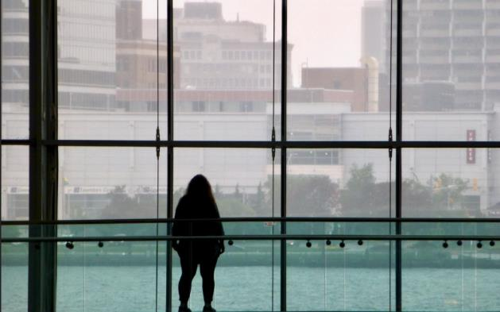
Judith Jackson/flickr Single Soul

The Miracles: Following in the Footsteps of St Winefride – bringing healing to the hurt

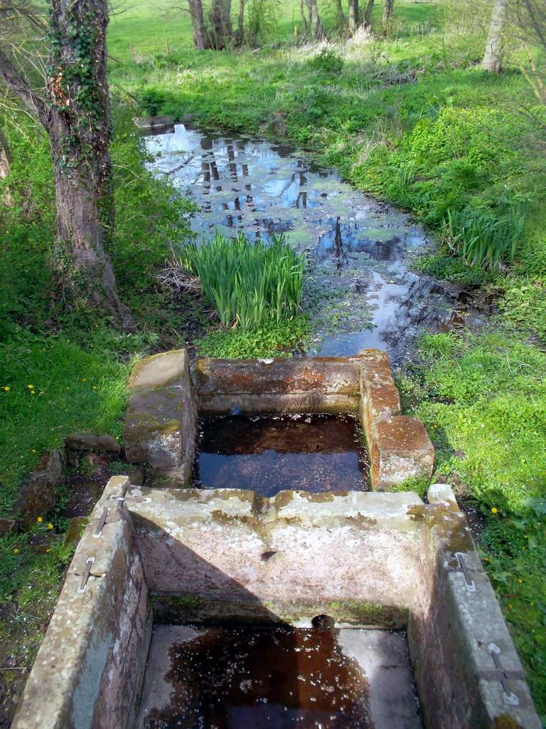
The Baths at St. Winifred's Well, near Woolston, Shropshire cc-by-sa/2.0 - © Des Blenkinsopp - geograph.org.uk/p/2945521
Healing traditions are associated with a variety of places associated with St Winefride, such as the holy well at Holywell, the baths at Woolston, near Oswestry, and at Shrewsbury Abbey, although exactly how and why such associations came about are sometimes lost in the mists of time. But what is interesting is how many people seek out places of healing, and seek out springs and wells, out of interest in the myths and legends that go alongside them as well as actively searching for healing for themselves. For example, the Facebook Group ‘Holy Wells and Springs of Britain’ has more than 12,000 members and within the group people post pictures and discuss local knowledge and folklore as well as spiritual matters and accounts of healing. Water connects us intimately to God’s creation, to our baptism, to the idea of cleanness, refreshment or new start, so it is not surprising that people are attracted by the idea of water as a spiritual marker of change, to go alongside the chance we all have, to start again with Jesus.
In addition, the idea that there is a long history or tradition where people have prayed and found peace, reconciliation and healing as well as encounter with God has a powerful pull for many people who feel they need to go somewhere to have that transforming experience for themselves.
So how can the story of St Winefride and the presence of these ‘thin’ or holy places, inspire us to be instruments of bringing healing to others?
Responding to the Challenge:
- How might the story of St Winefride inspire us to think about the significance of baptism – in our own lives and in those we hope might come to faith?
- What might we learn from reflecting on the story of St Winefride about how God brings healing, peace and reconciliation into our lives?
- Places of miraculous healing are often marked by gifts of gratitude or by walking instruments or other aids left behind. What kinds of ‘crutches’ have we been using in our daily lives and in our spiritual lives, which now need to be left behind?
- How do we say thank you to God for acts of healing and hope in our own lives and how can we be agents of healing and hope towards others?

Luke Peterson/flickr

The Mystery: Following in the Footsteps of St Winefride - Inspiring and Transforming the world
How can we respond to what we have learned and thought about concerning the story of St Winefride and use that to refresh and inspire our continuing Christian life? How might we be challenged and changed in order to offer more witness to Christ and more loving service to the world?
Below is a picture of an icon of St Winefride. Icons are often considered to be windows into the heavenly world. They are not so much representations of people as ways of engaging a spiritual response of prayer and devotion in the viewer. So this picture is followed by a meditation on the icon above which might help us to consider more deeply the story of St Winefride and how she is relevant to all of us who are trying to follow Jesus more faithfully day by day.

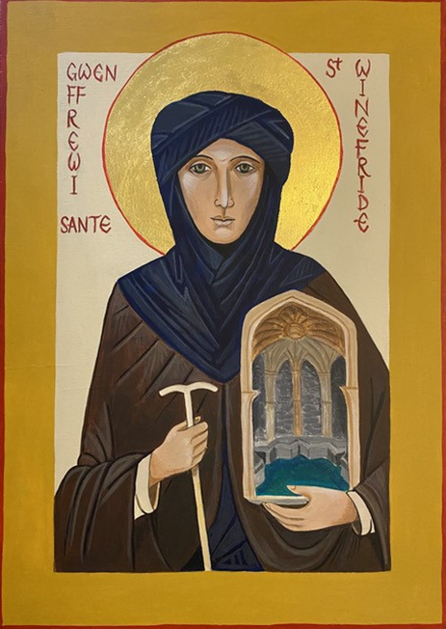

As we invite you to contemplate the icon of St Winefride, please take a moment to pause, take a deep breath and be still, as you are comfortable and it is practical to do so.
As you gaze upon the icon imagine yourself entering the picture.
As you look upon the well, imagine its refreshing waters reviving you. Where are the wells in your life? Where do you find refreshment and nourishment?
Imagine yourself wearing St Winefride’s clothing. Clothing that enfolds you, protecting you from the elements. Where do you feel safe? Protected? Loved?
Can you see Christ hanging on the cross in the details of Winefride’s face? A reminder that God redeems the worst events in our lives and restores us.
Spend a few moments more in quiet. Allow God to speak to you, to heal you, restore you and reclaim you.
Our prayer is that this icon will be a continuing inspiration to you.

Responding to the Challenge:
A place to go further…. An invitation from the community of St Chad.
We hope that exploring the life of St Winefride has been enriching and encouraging for you. If you would like to continue exploring faith through the life of the Saints, then the Community of St Chad welcomes you.
Drawing inspiration from the life of St Chad, the 7th century missionary bishop of Lichfield, the Community of Saint Chad is an expression of modern-day monasticism. It has a geographically dispersed membership united by a common commitment to a spiritual lifestyle shaped by five Rhythms of Grace, and by participation in a Spiritual Companion Group.
The Community of Saint Chad welcomes any Christian who longs to grow in depth of discipleship and who is prepared to journey with others in a quest of a life-changing faith.
To find out more please contact The Revd Rosanne Wilshire revrosst@gmail.com or The Revd Chris Precious revdchrisprecious@gmail.com Please visit our website https://www.lichfield.anglican.org/our-faith/community-st-chad/ and our Facebook page: https://www.facebook.com/CommunityOfStChad
