Blessing Every Day

A project from the Mission Theology Advisory Group

The Mission Theology Advisory Group is an ecumenical group formed in partnership between Churches Together in Britain and Ireland and the Church of England We provide resources in the areas of Spirituality, Theology, Reconciliation, Evangelism and Mission.

This resource belongs to our Spirituality series. Please print and share.

More information from

www.churchofengland.org/more/church-resources/deeper-god-mission-theology

https://ctbi.org.uk/mission-theology-advisory-group-resources/

A Blessing for the Lighting of a Christmas Tree

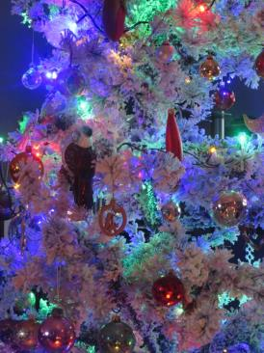

A Blessing for the Lighting of a Christmas Tree
(compiled from a service for Ely Cathedral by Rev’d Canon Dr Victoria Johnson)
For use during a carol service or at any Advent occasion with switching on of tree lights.

Introduction
Leader:
In earlier times, evergreens were thought by Christians to symbolise things like eternal life, the Holy Trinity, and the tree of life in the Garden of Eden. Today, Christmas trees are often decorated with stars and angels to remind us of the star of Bethlehem and the angel Gabriel who brought glad tidings of the Saviour’s birth
Now we will hear God’s Word and say a prayer of blessing as we switch on the lights of our Christmas Tree for the first time.

Scripture (Ezekiel 17. 22-24)
Thus says the Lord God:
I myself will take a sprig
from the lofty top of a cedar;
I will set it out.
I will break off a tender one
from the topmost of its young twigs;
I myself will plant it
on a high and lofty mountain.
On the mountain height of Israel
I will plant it,
in order that it may produce boughs and bear fruit,
and become a noble cedar.
Under it every kind of bird will live;
in the shade of its branches will nest
winged creatures of every kind.
All the trees of the field shall know
that I am the Lord.
I bring low the high tree,
I make high the low tree;
I dry up the green tree
and make the dry tree flourish.
I the Lord have spoken;

Prayer and Blessing
Leader:
Now let us pray together:
Loving God, we stand before you once again. We stand here ready to celebrate the birth of your Son, Jesus. Bless this tree, this sign of perseverance in our midst. It stands as a reminder that you are born anew in us each day.
The tree can be sprinkled, dressed or completed
Bless our family and friends as we celebrate this joyous season. Keep us safe in our travels, kind in our conversations, and gracious in our giving and receiving. We ask you this in confidence, because we know you love us through your Son, our Saviour Jesus Christ. Amen

Conclusion:
Lord God, let your blessing come upon us as we illumine this tree. May the light and cheer it gives be a sign of the joy that fills our hearts. May all who delight in this tree come to the knowledge and joy of salvation. We ask this through Christ our Lord. Amen
The tree is lit. Each person can be given a copy of the prayer or a small fairtrade tree decoration to keep at home.

