Doctor Who

Twice Upon a Time

Christmas Day 2017

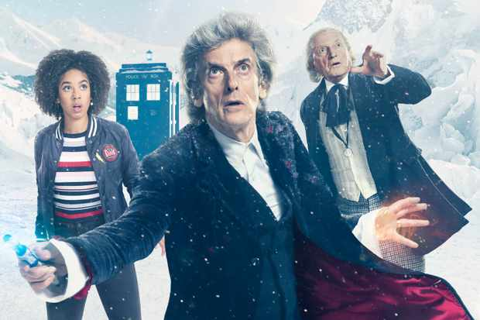
Radio Times

Themes:
Death and Resurrection; Afterlife; Heaven and Hall; Sacrifice; Salvation; Good and Evil; Memories; Being Human; Love; Hope; Fear; Reconciliation; War and Peace.
This is an episode packed full of theological themes and big questions about life, the universe and everything.
Synopsis
The first Doctor (originally played by William Hartnell but here played by David Bradley) and the latest Doctor (played by Peter Capaldi) meet at the South Pole. They are both facing death but they don’t want to die and are resisting what comes next. It is cold and snowing. They discuss their decisions about death: ‘I have the courage and the right to live and die as I choose’. The current Doctor remarks ‘We are both in a state of grace’ and everything around them stops as time is suspended.
A First World War soldier appears from nowhere. And the scene becomes Ypres 1914. He is in a crater with a German soldier and each is pointing a gun at the other. It is the point of death. The soldier doesn’t want to kill his adversary. He says ‘war is hell’. Time stops but he continues.
At the South Pole an alien being made of glass arrives. The current Doctor reminds it that Earth is protected. The Doctors and the soldier go into the Tardis where the current Doctor gives away to the soldier that he comes from World War One –giving him a glimpse into the future. If there is a One there must be a Two. The Doctor tells the first Doctor that he is his future self and notes how politically incorrect and old fashioned his predecessor is. Meanwhile, the TARDIS is grabbed by an alien spaceship and lifted into the Chamber of Death.
Here the Doctors are addressed as the Doctor of War, but the first Doctor says ‘never’. The alien offers the Doctor the chance to speak to ‘her’ again. Bill, his former companion appears, and hugs him. The Doctor says he knows she died and gave her life for others. Bill says she was rescued by Heather but doesn’t remember how she got to where she is. The Doctor says she is a duplicate but Bill insists she is the real thing.
The alien explains that ‘we are what awaits at the end of every life’. The alien says ‘we are Testimony’ and what they do is travel in time and recover people’s memories before returning their bodies to the point of death. The soldier is to be returned to the point of his death; he has fallen out of the timeline. Bill can be exchanged for his life but he says he won’t hear of it – he will die for her.
The Doctor insists they will escape and take Bill and the soldier with them. But Testimony runs through the different Doctor incarnations and some of the epithets applied to him throughout time – ‘Destroyer’, Shadow’, ‘Butcher’ and again names him Doctor of War. They escape in the first Doctor’s Tardis – which the first Doctor suggests Bill should clean.
They go to look for Testimony’s face in the centre of the universe in the ‘land of the dispossessed’ where the first Doctor admits that he refused to regenerate out of fear. The Doctor goes to the Good Dalek to access the Daleks’ Hive Mind, telling the Dalek that he is dying. The Good Dalek also called the Doctor a ‘Good Dalek’. Here he discovers who the alien avatar is. Meanwhile, Bill is upset that the Doctor doesn’t know her, while the first Doctor tells her off for her language and threatens to spank her. But when she goes to get brandy for the soldier her glass arms can be seen. The soldier is sad for his family and says he is now not ready to die. It seemed to be a miracle when he didn’t die and now he’s not ready because he found hope. The hope has brought him back to fear.
The glass alien returns and the first Doctor and Bill talk. Bill asks what he was running to when he stole the TARDIS and ran away. The first Doctor muses on good and evil. Evil should win in the universe, but good is about loyalty, self-sacrifice and love. Why does Good prevail? Is it about balance? Is it brought about by some mysterious force? Bill suggests that it might simply be brought about by ‘a bloke’ putting everything right when things have gone wrong. The first Doctor says it’s not a fairy tale, but Bill says the Doctors can never see how it works, but the people who know them can see it. She hugs him. She is glass.
The Doctor now understands what Testimony is about. People have their memories preserved at the time of death and are returned to die without pain or distress. Their memories are collected in glass avatars. This is Heaven on a new Earth. The aliens are not evil, but beneficent. Bill says that everyone is just a bunch of memories and again asks why the Doctor is refusing to regenerate.
The Doctor says there has to be an end. Just like the soldier has to die. He is tired of losing people. The refusal to regenerate in both Doctors caused the time anomaly that has brought the soldier to them. The Doctor remarks that everyone is important at some time and some place.
The soldier returns to Ypres. He returns to the crater and thanks the Doctors. He asks that they look in on his family and reveals that he is a Lethbridge-Stewart who of course the Doctors encounter throughout their work on Earth. They promise and he is ready to die. Time resumes but instead of a shoot-out, the soldier hears the Germans begin to sing Silent Night, then the English join in. The soldier has come back a couple of hours later at the beginning of the Christmas Day Armistice. The soldiers get out of their trenches and shake hands and play football. Lethbridge-Stewart calls for help for his German adversary. Both are saved and it is snowing. They realise that this is what it means to be a Doctor of War – healing, reconciliation. The Doctors too shake hands and the first Doctor says he is prepared to die. He goes to his TARDIS and starts to regenerate.
The Doctor looks at his lives as a battlefield which is now empty. Bill and he go for a last stroll. Bill kisses his cheek and wishes him a Merry Christmas. Then Clara appears and he remembers her and then Nardole who says the Doctor mustn’t die. The Doctor says he wants peace and rest. They tell him that it’s his choice. He reflects that he has lived such a long time that he would shatter their glass avatars. He thanks Bill and Nardole for what they meant to him and says he must make his choice alone. They hug him. Nardole says ‘cuddle’, then they disappear, leaving him alone.
He says it is time to leave the battlefield. In his TARDIS he notes that the more he saves the universe, the more it needs saving: ‘they’ll get it all wrong without me’. He agrees to one more lifetime. He gives his future self some advice – never be cruel or cowardly, hate is foolish, love is wise. Be nice and always kind. His name must not be spoken, but children can sometimes hear it if their hearts are in the right place, but no one else. He repeats the need to be kind. He says to his incarnation that he lets him go and regenerates. His new incarnation is a woman. She falls out of the TARDIS into space.

Some excerpts to watch:
The Christmas Day Armistice
Bill and Nardole saying goodbye to the Doctor
The current Doctor’s last speech to his future self

Some conversation starters:
- Why do you think the current Doctor is sceptical about whether he meets the ‘real’ Bill?
- What do you think this episode tells us about being prepared for death?
- What does the episode suggest about ‘heaven/hell on earth’?
- Why is the Doctor called the ‘Doctor of War’?
- What do you make of the Doctor’s last advice to himself?
- In what way does the episode reflect the spirit of Christmas?
- What sort of things in the episode can offer us hope?
- What do we learn about the Doctor as a Saviour figure?
- What do we learn about the importance of love and goodness?

