Dr Who
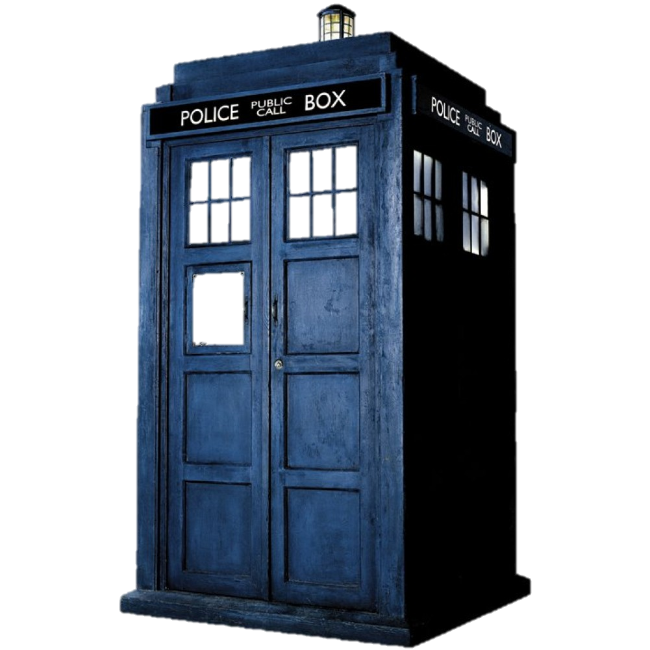Series 8 episode 4 Listen
This episode considers the issue of fear
Synopsis
Clara, the Doctor’s companion, goes out for a first date with Danny Pink, an ex-soldier and fellow teacher. Things do not go well, especially when they talk about his past as a soldier.
The Doctor comes to Clara to ask her help. He’s started to wonder whether every person is shadowed by something they can’t see but which is always there. He says it’s a common dream to be grabbed by something that hides under the bed. Clara agrees to use her telepathic link with the TARDIS to return to childhood to investigate but she starts thinking about Danny and ends up in his past instead.
Here we meet Rupert Pink who is the young Danny, living in a children’s home. Rupert is frightened, convinced that there’s a monster under his bed. To show him there isn’t. Clara and Rupert crawl underneath, only to have something sit on the bed above them instead. A shape is sitting under the blankets. The Doctor says they must turn away from it and not look at it and when they turn their backs the ‘thing’ leaves. The Doctor says it could have been another child pretending, but it could also be something else, something not meant to be seen.
But then the Doctor tells Rupert that he must acknowledge his fears. Fear can be a good thing, marshalling adrenaline, making you ready for what happens next. Fear can be a superpower. It can help you get past enemies and things in your way. Fear equips you for the worst. Clara meanwhile puts toy soldiers under Rupert’s bed to protect him and Rupert calls one of them Dan. The Doctor puts Rupert to sleep, emptying his memory and leaving him a dream of Dan the soldier – which is of course what he becomes.
This entry into her boyfriend’s past and the shaping of his future does nothing for Clara’s relationship with Danny when she accidentally calls him Rupert. As he storms out Clara meets Orson Pink in the TARDIS, from 100 years in her future and a time traveller. The Doctor found him at the end of the universe, stranded. He is clearly one of Danny’s (and Clara’s?) descendants, since his grandparents told him all about time travel and he has Dan the toy soldier. He gives it to her as a ‘family heirloom’.
Back at the end of the universe, we discover that Orson was afraid that despite being at the end of everything he was still not alone but that ‘something’ was trying to get into his ship. The Doctor wonders what ‘it’ is – something that cannot be alone, that will seek out and cling to life, or just a fear, an hallucination? The Doctor tries to confront whatever ‘it’ is but the ship is damaged and the Doctor becomes unconscious. Clara uses the telepathic circuit in the TARDIS to get out.
Arriving at an unknown place, Clara makes her way to a barn where a child is crying, hiding in his bed. Clara gets under the bed when two people arrive. The people try to persuade the child to go back to the house but he won’t move. Clara hears them say that the child will never make a Time Lord; he’ll have to become a soldier. So this child is in fact the Doctor. When the child gets up hearing his older self calling out from the TARDIS, Clara grabs his leg from under the bed, creating the Doctor’s own monster experience. She convinces him he’s dreaming, and tells him that fear is a companion that can bring out the best in us. She also tells him that he will come back to the barn when he is most afraid.
Clara goes back to the TARDIS and makes the Doctor leave without knowing what happened there.
Clara and Orson return to their own times and the Doctor shakes off the concern about the unseen companion. Clara and Danny then apologise and make up.

Issues for Discussion
- What were your childhood fears?
- What does this episode say about fear and how we face it?
- What do you think the military theme means in this episode?
- How does the story help us face our own past and our own future?
- Can fear be a good thing?
- What does this episode say about the things we imagine if we are left alone?
- What does the story tell us about the nature of companionship?

