November Season

Reconciling Mission through Prayer and Reflection

4: Being at Peace

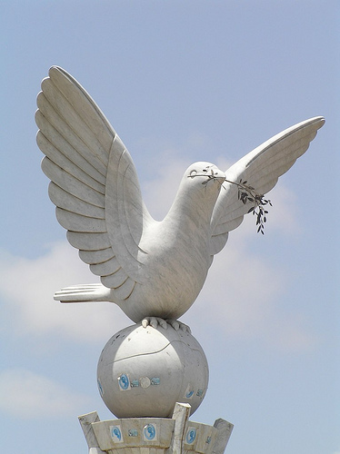

Photo: Jeff Attaway

Reflection

For many years, Estonia lived under Soviet rule. But in 1989, Estonians began a ‘Singing Revolution’ singing on street corners about their country and their hope. Mass singing demonstrations included both national songs and hymns which had been forbidden by the Soviets. As a result of this, they gained in confidence and began to feel that they could stand up against the oppressiveness of the Soviet regime.

In Advent, there is a ceremonial lighting of the Christmas tree in the town squares. This Christmas tree ritual has been enacted for centuries, apart from during the years of Soviet occupation. The lit candle is at the bottom of the tree and people come and light their own candles from it and take the flames away with them. The living flame in the tree was symbolically significant as the days got shorter and light became more and more important. Homes and shops displayed the living flames, - and this showed that they had not been taken over by the night.
This act of keeping the flame alive took on a new significance in the 1990s as Estonia got its independence although the Soviet army did not leave Estonia until 1994 after which it was free. So the lights also came to celebrate the freedom when the last of the old regime left. An old tradition became a new one, though both showed that this was a time of hope. Light also became equated with hope in people’s homes. So the hope of Advent became the hope and celebration of freedom. This tremendously powerful symbol motivated and inspired people, - yet Estonia is not a specifically religious country. During the occupation pastors and other Christians were killed. Yet now religious freedom and liberation from occupation went together, linked in a secular way. This reminds us to consider how traditions speak to each other and can create a powerful and moving dialogue between them.

Pause for thought, or for group discussion:
What symbols of speak to secular traditions in your family or community in the run up to Advent and to Christmas?

Eddie’s story

Eddie came to Britain from Estonia with his family during the Second World War and became a gardener, tidying up people’s flower beds and mowing lawns. Whenever Eddie was found working on a flowerbed, you could hear him muttering under his breath. When he was asked what he was talking about to himself, Eddy said that every weed he pulled from the border was one of the occupying forces and that by ‘pulling them out’ he was allowing the ‘Estonian’ flowers to breathe and reveal their beauty. When Estonia became independent, Eddy continued to weed people’s borders with his customary vigour. But now he sang.

Pause for thought, or for group discussion:
If you had been Eddie’s employer how would you have gone about learning his story? What would his song have meant to you?

Exploring Scripture

Matthew 5.14-16
14 ‘You are the light of the world. A town built on a hill cannot be hidden. 15 Neither do people light a lamp and put it under a bowl. Instead they put it on its stand, and it gives light to everyone in the house. 16 In the same way, let your light shine before others, that they may see your good deeds and glorify your Father in heaven.

Food for thought or for group discussion
Where are the lights of hope in your community? Are there any lights which are being hidden, which need to be revealed?

Prayer

Lord of light and darkness,

We thank you for the lights of faithful people,
both secular and sacred.

We thank you for the power and gift of song
and for the words and music of hope and freedom.

Help us always to seek to keep flames of love alive
for all who live under occupation or oppression.

Help us always to listen for songs of liberation
and to join our voices to those who stand against injustice.

We thank you for the gift of being at peace
and pray for all nations where the gift is not yet given.

Amen

If you are going on to the next resource you might want to start thinking about this: where do you see hope for the future?

