November Season

Reconciling Mission through Prayer and Reflection

1: Remembering the Dead (All Saints/All Souls)

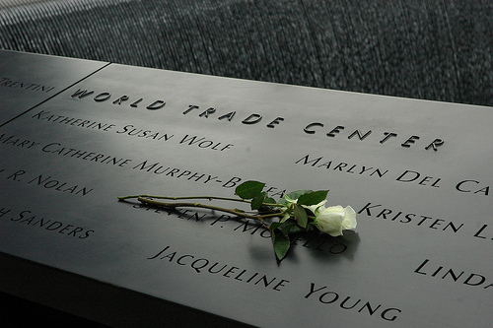

Photo: Tom Hannigan

Reflection

On September 11th 2001, four aircraft were hijacked and two of them deliberately flown into the twin towers of the World Trade Center, causing both buildings to collapse. Another plane was flown into the Pentagon and yet another crashed. Almost 3000 people died in the attacks. Many of the people who died left no trace of their bodies; the fire and the collapse of the buildings vaporised or crushed them so that they could not be recovered.

Everyone knows the basic facts about 9/11 and about its political aftermath, but the magnitude of another question is perhaps not so appreciated, - how do you commemorate an event like this; how do you remember so many dead people? Even more important, how do you create a memorial which will enable the dead to be remembered as once living, breathing, loved, human beings, when perhaps nothing of their earthly bodies remains to bury? And further, what part can such a memorial play in enabling us to move forward, not trapped by thoughts of vengeance, hatred or despair, but in the liberation of hope and expectation?

Food for thought or for group discussion:
Suppose it was your job to plan such a memorial, what would you do?

The memorial to the people who died in the 9/11 attacks which is called Reflecting Absence is laid out as a pair of reflecting pools around the sites of north and south towers, but unlike most war memorials (such as the ones you see in churches, or in town centres) which usually list names alphabetically, the names are laid out with careful thought as to their arrangement. The names are organised so that they are grouped with those they were with when they died; they are arranged as communities, rather than just individuals. This reminds us that bonds of human contact - being work colleagues, working as a team of fire-fighters, or even sitting next to someone you don’t know on a plane, - create relationships which are meaningful. The President of the Memorial, Joe Daniels, said ‘what matters most is the relationships that were had in life rather than just how these people died.’ The sheer number of dead should not become an ‘abstraction’ but resolve into real people who are mourned by the families and friends they loved and who loved them.

The names are also not carved into stone but the letters are cut outs, set in a piece of bronze, so that they cannot weather or fade and at night, the cut out letters are illuminated so that the names of the dead shine out into the night. The darkness does not overshadow them or take them away. The absent is made present.

http://nsm-911memorial.cloudapp.net/

But there are also those who find the memorial less liberating, such as Stephen Prothero, writing that he does not find the memorial either moving or sacred enough, not least because there isn’t the space for mourners to leave things behind.

http://religion.blogs.cnn.com/2012/02/27/my-take-911-memorial-not-sacred-enough/

Food for thought or group discussion:
What do you think has to be present (or absent) for a memorial for someone you love to be ‘sacred enough’?

Exploring Scripture

Mark 12.26-27

26 Now about the dead rising – have you not read in the Book of Moses, in the account of the burning bush, how God said to him, “I am the God of Abraham, the God of Isaac, and the God of Jacob”? 27 He is not the God of the dead, but of the living. You are badly mistaken!’

Food for thought or for group discussion
What do you think Jesus meant by saying that God is a God of the living? How do we reflect that in the way we commemorate the dead?

Prayer

Lord of the living and the dead,
All creation is present to you
And you call each of us by name.
Today we recall to you,
in letters of blazing light,
all those whose love we miss,
whose lives are ended
but whom we entrust
to your eternal, reconciling love.
Amen.

If you are going on to the next resource you might want to start thinking about this: where (if anywhere) do you think the names of the 9/11 hijackers should be included?

