Paul Butler, Bishop of Durham

Easter message 2016 – The Smells of Easter
Listen to Bishop Paul read here https://www.youtube.com/watch?v=_mr-pJdSJDs&w=600
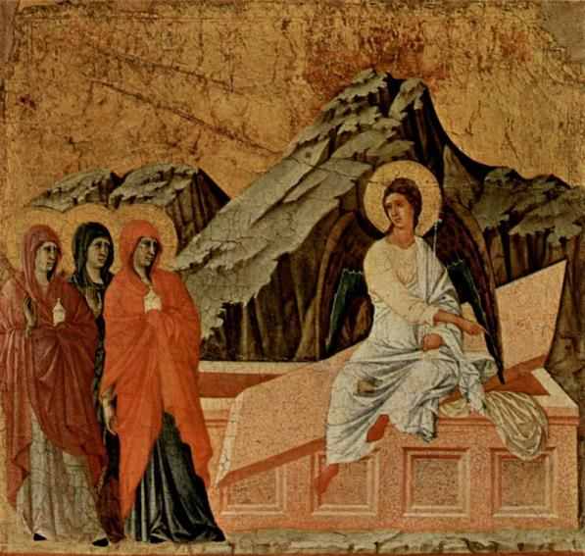
Duccio di Buoninsegna - The Yorck Project (2002) 10.000 Meisterwerke der Malerei (DVD-ROM), distributed by DIRECTMEDIA Publishing GmbH. ISBN: 3936122202.

‘It smells wonderful’ were the words uttered as the aroma of the Sunday roast hit us when we opened the front door. It’s horrible when we are so full of cold that we can’t smell. Smell matters; aromas remind us of people, of places and of events. We like to smell nice. Our region used to be filled with the smells of coal and heavy industry alongside those of farming.
There are smells that I associate with Easter. I love the smell of the spices in hot cross buns. Really good chocolate smells wonderful, as well as tasting good. And then for me there is the smell of scented oil poured on the heads of those I confirm at the dawn service in Durham cathedral.
It is this last smell that takes me back into the Easter story itself. During his last few days Jesus spent the day in Jerusalem teaching but each evening he went out to stay with his friends in the village of Bethany. On one evening Mary, the sister of Martha and Lazarus did something that was unexpected, and which scandalised Jesus’ disciples. She took a jar of expensive perfume and poured it out on Jesus’ head and feet. The whole house was filled with the aroma. It was like she had taken a whole large bottle of Chanel and in one go used the whole bottle. It was extravagant. It was an act of love. Whilst Jesus’ disciples all thought about how the money it was worth could have been used to help the poor Jesus welcomed it as a love token ahead of his death. Somehow Mary, unlike almost everyone else, had some sense of the imminence of Jesus’ death. Jesus interpreted it as his being anointed ready for burial.
The quantity was so great that it might be that as he hung on the cross something of that aroma, now mixed with sweat, blood and dust, was still in his hair and still rising from his feet. The aroma still spoke to him.
Jesus’ burial had to be rushed at the end of the Friday. So as soon as the Sabbath was over some of the women closest to Jesus went to the tomb carrying more anointing oil and spices ready to finish the burial rites. They wanted the body to smell good. This too was to be an act of love for the one who had taught them, led them, freed them, and forgiven them. The one in whom they had found life and hope had been taken but they were determined to pay their last respects well. They never got to use those oils and spices on Jesus’ body for the body had gone. Jesus was risen.
Jesus’ death, his giving up of his life for us all, is the most extravagant love gift the world has ever known. Like the perfume poured out he poured out his life in love for us all, to bring us back into friendship with God.
It is this extravagance of love that I reflect on this Easter. We all need to know that we are loved, loved extravagantly. We all need to be people who love extravagantly. In an era when we hear so much about austerity, about reducing and cutting we need to smell the joy and life of abundance, generosity and extravagance. Love which gives and gives and gives again. Love towards those in deepest need in our world, whether they be asylum seekers and refugees, the severely disabled, those caught up in violence or trapped in abusive relationships, we need to recover the place and value of generosity and extravagance.
We need to smell the aroma of God’s love and let it bring us to life.

