House of Bols

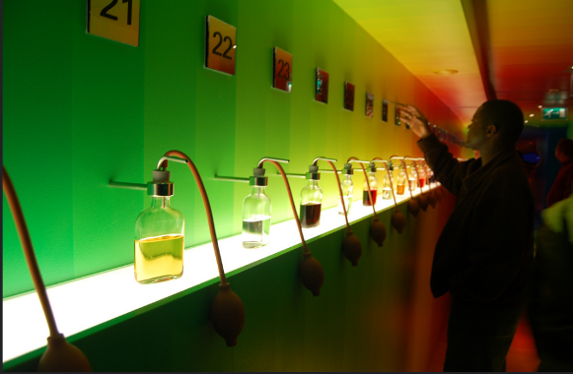
choking sun/flickr

When John and Olive Drane visited the House of Bols in Amsterdam, they tried out the Hall of Taste and Smell. A visit there is an amazing experience when it comes to testing your sense of smell. Bols is a Dutch liqueur that comes in many different flavours and which is a basic ingredient of many exotic cocktails. Its history goes back to the days when Dutch adventurers travelled the world and returned home laden with what to them were previously unknown tastes and fragrances. So a visit to the House of Bols naturally includes a chance to encounter the key flavours that are now included in this special range of drinks. Part of the experience is to guess the identity of as many as you can. John thought it was going to be easy, as virtually all of them are derived from ingredients with which he was already familiar: things like strawberry, mint, coffee, chocolate, kiwi fruit, peaches, and dozens more. They all look pretty much alike, so the only way to tell them apart is by smell, and rows of bottles with puffers allow you to do that without being sprayed by the liquid. It’s the sort of thing that invites competitiveness and he and Olive were soon tracking how long it took to guess what the smells were, and who was better at it. Olive was soon well ahead, and even when she told John what some of them were, it still took a while for him to ‘get’ them. By the time they got to the end, John had only a handful of correct guesses while Olive got almost all of them right straight away. They soon realised that they actually smell things differently, and that in turn made them more aware of the fact that some people have no sense of smell at all. And they then started to wonder if people are all having the same experience when they talk about smelling fear, or danger, or love.

