Covid Day of Reflection – resources for churches
Welcome to these resources which you might like to use during the Covid Day of Reflection or at any other time during the year when it seems appropriate to think about what we went through as a society, as a community, and individually, during the pandemic. How did we cope with the impact of Covid on our lives; what did we learn? What would we do better for ourselves and for our neighbours if there was a similar national emergency?
How to use these resources
There are 16 one-page resources, divided into four ‘pathways’ with four suggestions in each, and you can choose the pathways which appeal to you, or mix and match the different sections.
The Yellow Journey is for people who like to have a conversation starter and to have a chat, perhaps in a small group, to think about the issues and share memories, stories and reflections. There are four different suggestions in the Yellow Journey.
The Green Journey is for people who like to explore, research and find out information. You could do this individually for your own information, or again within a group, perhaps by researching beforehand and then getting together to talk about what you have learned.
The Blue Journey is for people who like to look at issues through the lens of Scripture or approach memories and thoughts through prayer. Sometimes, churches like to convene a Day of Prayer or a quiet time to use the Blue Journey for reflection.
The Pink Journey is for people who like to think about spiritual growth and Christian discipleship, drawing on issues in our modern society and our wider world. If we are to challenge ourselves and change as a result, what could that change and development be like?
You can concentrate on one Journey as a guide or mix your reflections across the columns below:
Resource Headings
Yellow Journey  Talk about | The Virus | The World of Work | The World of Church | Testing, Infection and Long Covid
Green Journey  Find Out | How people spread Covid | Where did Covid come from? | Treating Covid-19 | Vaccination
Blue Journey  Bible and Prayer Reflection | Matthew 24.2-8 | A Prayer in Worrying Times | Remembering those who are sick and those who have died | Lockdown and hope in Christ
Pink Journey  Spiritual Growth | What we learned about the need to mourn | How did we change? | What can I do to be prepared? | Where do we go from here?

Yellow Journey 1 for conversation - the Virus
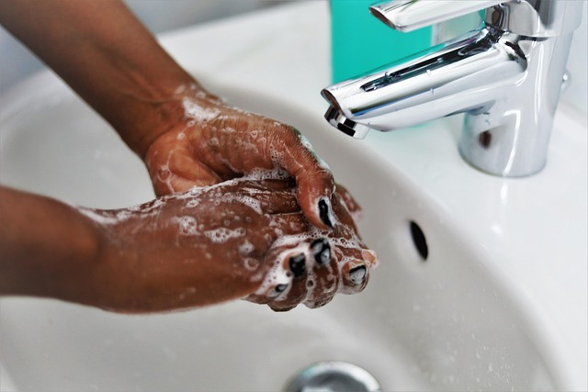
Handwashing
Do you remember?
- Self-isolating
- Being in a Bubble
- 6 ft apart rule shopping
- Exercise time
- Lockdown
- Sanitising everything
- Singing Happy Birthday while washing hands
- Not shaking hands at church
- Masking
- Restrictions on travel
- Track and Trace
- Advice on Coughing and sneezing
https://www.bbc.co.uk/news/health-52720089
Many people remember government advice, especially Boris Johnson saying ‘you MUST stay at home’ https://www.gov.uk/government/speeches/pm-address-to-the-nation-on-coronavirus-23-march-2020 and seeing Professor Chris Whitty on the television. But others remember Dominic Cummings and the famous ‘Barnard Castle’ incident https://www.bbc.co.uk/news/uk-politics-52784290 and feelings of confusion about the latest rules and regulations intended to keep people safe.
Talk about:
Your memories of Covid rules and regulations and which ones made most impact on you. Did you keep all the rules all the time?
How did you feel about reports that people in leadership were flouting the rules?

Yellow Journey 2 for conversation – The World of Work
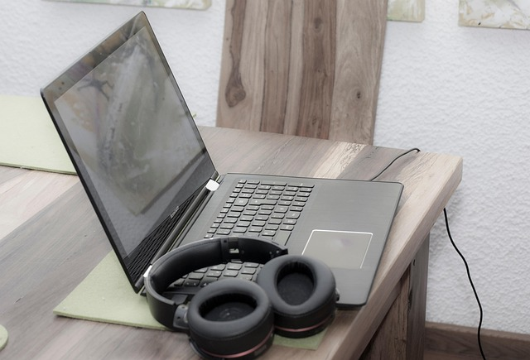
Zoom meeting
Do you remember:
- Furlough
- Learning to Zoom
- Hybrid working
- Food delivery services multiplying
- Home schoolwork
Many people remember the funny moments, like the Dean of Canterbury’s cat drinking all the milk behind him as he talked on video https://www.youtube.com/watch?v=VWKiKqynEC4 , or the ‘BBC dad incident’ when children burst in on a news segment. https://www.youtube.com/watch?v=Mh4f9AYRCZY
But Covid changed the world of work in ways we could not have foreseen. Some people coped well if they had adequate space and technology and many even set up successful online businesses. But trying to work at a job or do schoolwork had particular impact on those on low incomes, hands-on jobs, and those without relevant access to technology or resources. Enforced home-working meant carving out office space from domestic space and had mental health implications for many people, blurring the boundaries between ‘work’ and ‘life’.
Talk about:
How changes to the world of work may have affected you and your family. What might have been beneficial in the long run? What may have changed the way we work for the worse?
How do you feel about the fact that many firms are now requiring people to return to the office to work?
How do you think schoolchildren were impacted by lockdown and homeworking?

Yellow Journey 3 for conversation – The World of Church

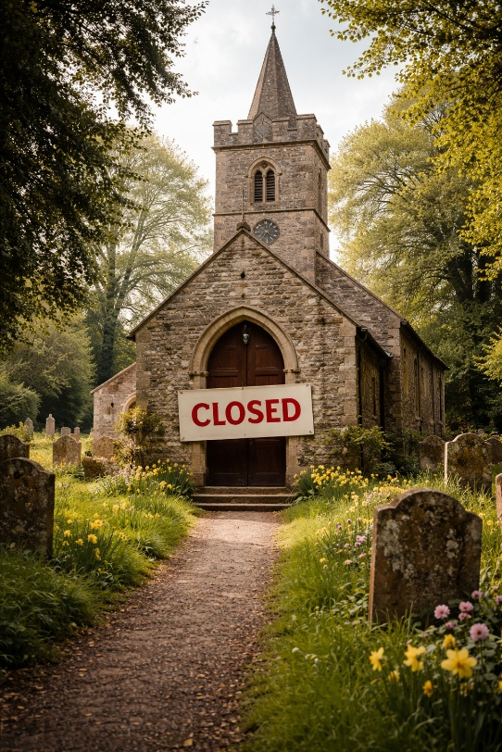
Church closure
Do you remember:
- Churches being shut
- Services being live streamed
- Phone calls from the clergy to check on people
- Social distancing in church
- Waving instead of shaking hands in services
- The arguments for dangers of infection from singing
- The ‘water pistol’ baptism video
The closure of churches has been hotly contested with many people feeling that church closure did more harm than good, while others saw the arguments about the difficulty of sanitising large communal spaces like churches and concerns about keeping people safe. Interestingly, there were also many people who never went inside a church who were also distressed by the closure of churches and felt that the ‘soul’ of community had somehow been lost.
Talk about:
How did the closure of churches during Covid affect you?
What was it like to worship online without the closeness of physical proximity?
What do you think the government or church leadership should do about worship if there were a future pandemic?

Yellow Journey 4 for conversation – Testing, Infection and Long Covid
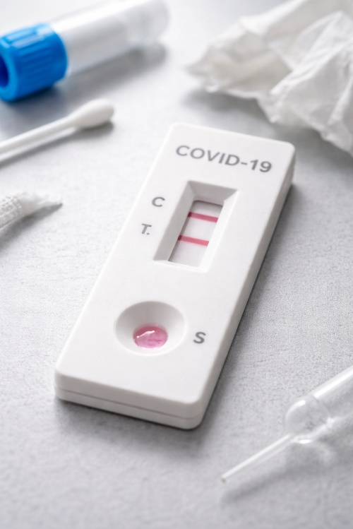
Testing for Covid
Do you remember:
- The symptoms of possible Covid to watch out for
- Tables of local infection rates issued daily
- Covid testing stations
- Covid testing home kits
- Advice about what to do if you were positive for Covid
- The rollout of vaccinations
- The diagnosis of Long Covid in some people

Of course people were worried about symptoms that might mean they had Covid and fear of infecting others. Others struggled with the tests and the need to report the infections. Yet others were worried about the safety and efficiency of the new vaccines. And for some people catching one of the Covid variants meant that they were left with diffuse and sometimes severe symptoms which may persist to this day – Long Covid.
Talk about:
What was your experience of Covid if you, or your family members caught it?
How did you feel about the testing, reporting and vaccination programme?
Do you, or anyone you know still struggle with the after effects of Covid?
Green Journey 1 to find out– How people spread Covid
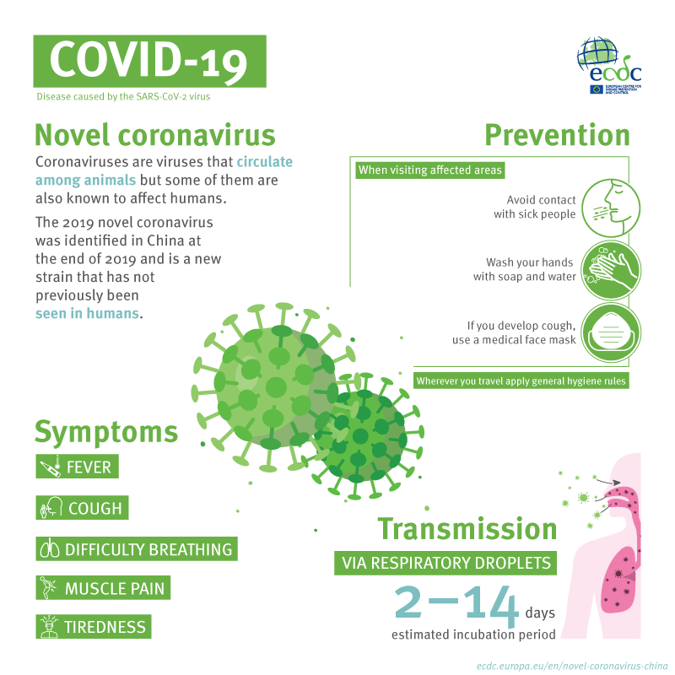
Infographic about spread and prevention of Covid
Scientists studying pandemics who are also concerned about the pandemics of the future have to think about how viruses are acquired and how they spread. It is important always to work out how people can pass on infections so as to give advice on how to protect others.
When the Covid rules came in other virally transmitted infections also went down. This was due to:
- Social Distancing – not being too close to other people
- Mask-Wearing – stopping droplets getting into public space
- Increased Hygiene – more hand washing and being careful about coughs and sneezes helps
- Travel Restrictions – fewer people moving around helped stop spread
People with compromised immune systems were advised to avoid all contact, but some members of the public thought the virus should be allowed to spread to build up natural immunity in the population and some refused to wear masks because they didn’t like the government telling them what to do.
Covid isolation also had a particular impact on people in prison, many of whom were locked up for much longer periods in order to try and stop the virus ripping through the prison population.
Something to do:
Find out some basic information about how viruses are spread. For example, https://www.nhs.uk/conditions/common-cold/ ; https://www.youtube.com/watch?v=KJXKJjvl0E8 Operation Ouch science for children.
In reflecting on Covid, how did your understanding of how people get Covid develop?
Has it made you more careful about protecting yourself and others from viruses in the future?
Do you remember reports about R numbers? And superspreaders? Research what these mean.
Green Journey 2 to find out- Where did Covid come from?

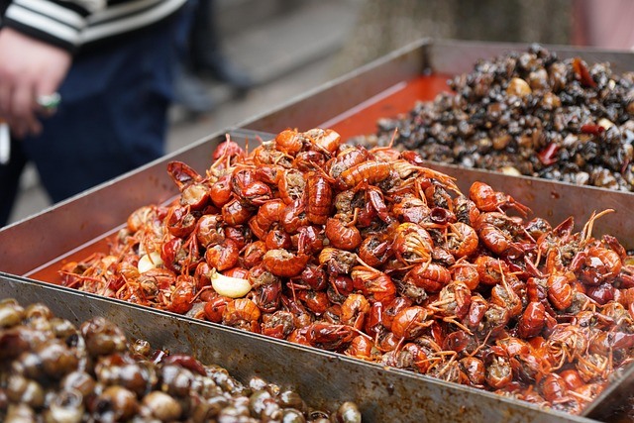
Wuhan Gourmet Market.
No one is absolutely sure where the virus came from, or who was the first infected person. And because there is no clear understanding, many conspiracy theories have arisen, including that Covid was a manufactured biological weapon.
So where could it have come from?
Many scientists and The World Health Organisation think Covid-19 was present in animals first, because other coronaviruses are known to have passed to people from animals (zoonosis). They think, because of cases identified at the Huanan Seafood Wholesale Market in Wuhan, China, that the virus may have been present in animals sold there.
Another theory is that there was a leak from a laboratory at the Wuhan Institute of Virology. Such a possibility hasn’t been ruled out, but there isn’t anything much in the way of evidence.
Although we may never know for sure, understanding where Covid-19 came from and how it infected others initially is crucial for preventing future pandemics.
Something to do:
What did you think at the time about how the virus might have appeared? Have a look at reports online about what scientists now think might have happened. https://www.who.int/news/item/27-06-2025-who-scientific-advisory-group-issues-report-on-origins-of-covid-19 ; https://www.ihv.org/news/2021-archives/slate-a-very-calm-guide-to-the-lab-leak-theory.html
There were some unpleasant things said and done towards Chinese people when Wuhan was identified as a source. What could we do today to make sure our neighbours are not unfairly targeted by reports in the press about things like disease? How can we combat prejudice?

Green Journey 3 to find out – treating Covid-19

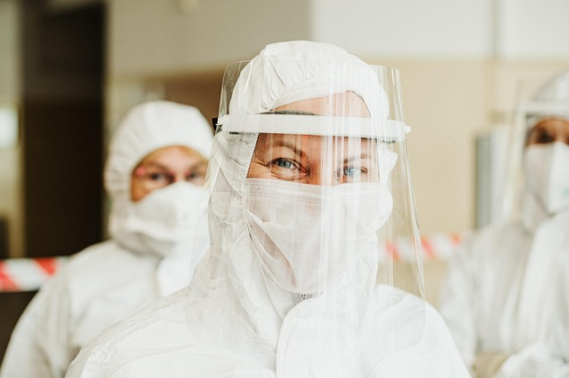
Personal Protective Equipment (PPE)
The pandemic was of course a huge challenge for doctors and nurses working in the NHS. Do you remember the ‘clap for the NHS’ moments, when people stood on their doorsteps to give medical workers a round of applause?
One of the challenges for any hospital is infection control. And with Covid special wards had to be set aside for people with the virus, and special measures introduced to try and prevent ill people with other conditions getting it. Doctors and nurses treating patients with Covid were themselves at risk and so there was a big emphasis on personal protective equipment (PPE) to prevent medical personnel themselves spreading the virus.
Since Covid, there have been a lot of questions about whether PPE was of proper quality and who made money from providing it. But it is worth considering afresh the risks to doctors and nurses taking care of people in hospital every day and trying to make sure ill people do not get infections in hospital.
Another thing which people noted was that people like the Prime Minister Boris Johnson ended up very sick in hospital and that Prince Charles (now King Charles III) also got the virus. So money, privilege and position were no protection against Covid. Some frightened people also paid for charms or amulets or prayers on the internet believing this would be protection against the virus.
Something to do:
Find out more about PPE and hospital infection control. https://www.kch.nhs.uk/patients-and-visitors/visiting/preventing-infection/; https://www.youtube.com/shorts/0dNSrn5zbxg If in the future you are visiting a sick relative in hospital, how might you think about making sure you are not a source of infection?
We don’t clap for the NHS any more, but how might we be more appreciative of what medical personnel do in difficult circumstances?
Green Journey 4 to find out - Vaccination
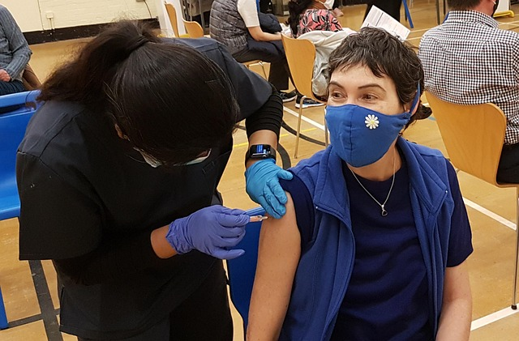
Covid vaccination
Do you remember going to a local health centre to be vaccinated against Covid and get your ‘passport’ stamped? Do you remember the volunteers at Covid vaccination stations and being told which maker of the vaccination you were getting? Are you currently eligible for the latest booster? Do you remember social media posts and badges saying ‘I’ve had my Covid vaccination’ to try and encourage others to have it?
Although most of us have routinely received vaccinations and are not concerned about it, there are still people who worry about the safety and purpose of vaccination and even vaccination conspiracy worries that vaccinating a population could be a method of government control. Yet others have worried about side effects or mortality associated with fast vaccine roll-out. For some people it is a matter of finding out whom to trust and how to get good information.
Something to do:
Find out about how vaccines work. https://www.nhs.uk/vaccinations/why-vaccination-is-important-and-the-safest-way-to-protect-yourself/ ; https://www.youtube.com/watch?v=-muIoWofsCE
Find out more about anti-vaccination movements and why some people are worried about vaccines and how they are made https://historyofvaccines.org/vaccines-101/misconceptions-about-vaccines/history-anti-vaccination-movements
Regardless of your position on vaccination, what would you say in a conversation with someone who felt differently from you about it?
Blue Journey 1 Bible and prayer reflection - Matthew 24.3-8
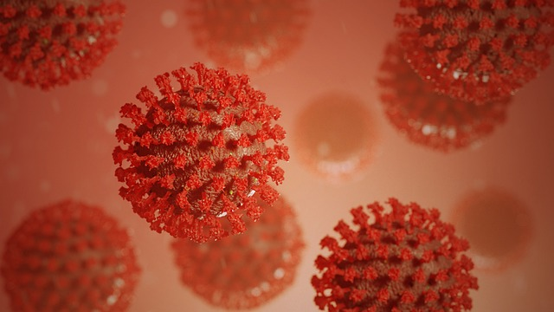
Virus
When he was sitting on the Mount of Olives, the disciples came to him privately, saying, ‘Tell us, when will this be, and what will be the sign of your coming and of the end of the age?’ Jesus answered them, ‘Beware that no one leads you astray. For many will come in my name, saying, “I am the Messiah!” and they will lead many astray. And you will hear of wars and rumours of wars; see that you are not alarmed; for this must take place, but the end is not yet. For nation will rise against nation, and kingdom against kingdom, and there will be famines [and pestilences] and earthquakes in various places: all this is but the beginning of the birth pangs. (Matthew 24.3-8)
When people first learned about Covid and before there was a vaccine, many people who had had no contact with Church at all, asked whether this marked the beginning of the end of the world and whether Covid meant God was coming in Judgement (as in Hosea 13.14) or whether Satan had actually triumphed. Many people also asked whether if they prayed harder, or better, God would spare them.
What do you think Jesus’ core message was to the disciples in the Matthew passage above?
How should the people frightened by Covid have been guided and helped?
How important was prayer to you during the pandemic?

Blue Journey 2 Bible and prayer reflection - A Prayer in Worrying Times
This prayer was written for general use during the Coronavirus epidemic. For whom might we pray these prayers today? You might like to spend some time with prayer and what it implies for today’s journey in faith, before adding your own thoughts, words or songs to God.

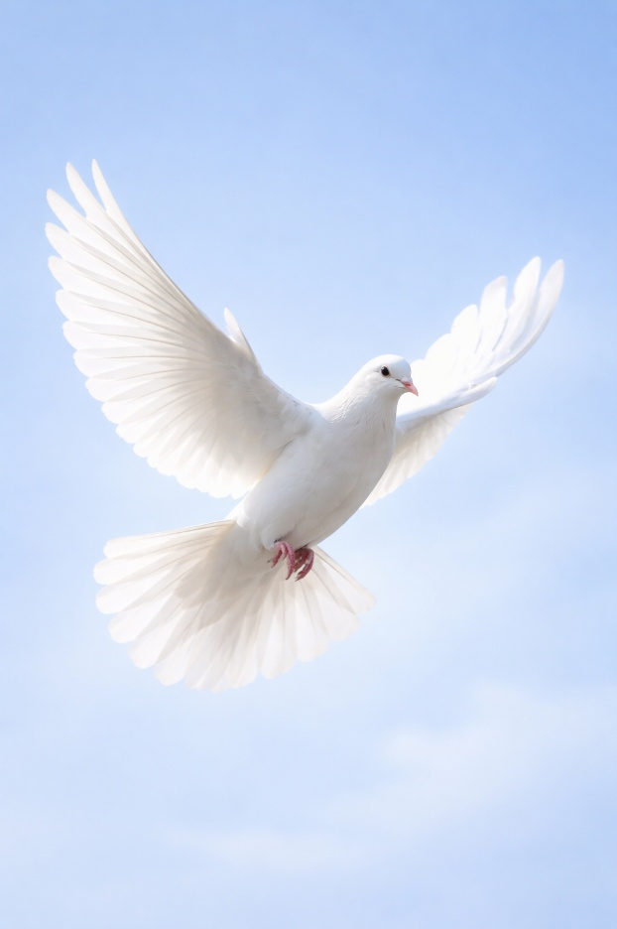
(Based on Psalm 91.1-6)
God of love and compassion,
we live in the shelter of your love,
we settle in your beautiful shadow.
We trust that the earth and all that is in it,
is always in your loving embrace.
You deliver us from the traps of our own making;
you sustain us in times of dreadful disease.
You cover us with your great and mighty wings;
you defend us when we are weak and afraid.
In faith, we will put aside our fear;
we will look out for others in daytime and darkness.
We will not give in to hopelessness or despair;
even if we fall ill, your love will support us.

Amen

Blue Journey 3 Bible and prayer reflection - remembering those who are sick and those who have died
This prayer was created for people to pray when loved ones fell ill, or sadly died. Covid is still with us, and of course there are still viruses around, not least seasonal flu, which can be very severe. Who is in need of God’s blessing in the context of sickness and death today, not just in the UK but around the world. This prayer may help us to reflect.
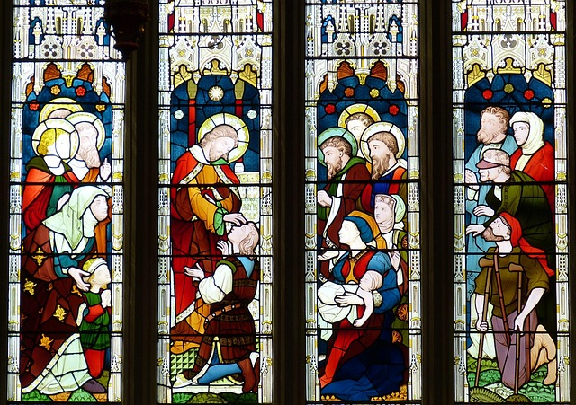
Jesus healing people

A Prayer for God’s blessing
Loving God, bless and receive all who are affected by Coronavirus:

Especially:
Those who are sick and afraid
Those who are especially vulnerable
Those for whom home is not safe or available
Those who have lost their livelihoods
Those who have lost their lives.
Bless all people caring for the sick
Give them strength, wisdom, endurance
Grant them healing hands
Surround them with your love.

Spare us in the time of trial
Deliver us from evil.
Amen
Blue Journey 4 Bible and prayer reflection - lockdown and hope in Christ

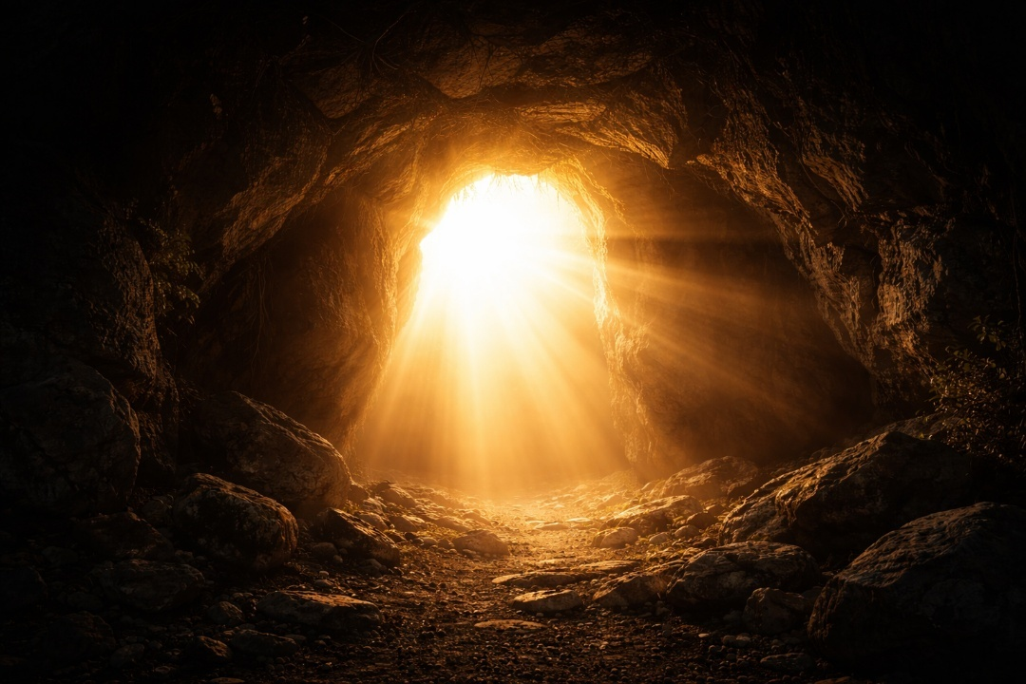
Resurrection
‘The disciples were shut in for fear of reprisal after Jesus died on the cross. Their Lord was alone, locked in, silenced, humiliated, crucified, dead. The hopes and promises were stopped in their tracks. But the truth of God’s salvation burst out, unstoppable. It burst out of the grave’s tight bindings; it burst out of the tomb, shoving the stone aside, letting in heaven’s light to the darkest places. The blazing truth of it, the reality of it, was revealed to the women, burst in on the disciples, Jesus appearing offering words of evidence, comfort and peace. And giving them the task of speaking God’s truth to others, showing it to others. The worst of the world cannot contain, change or halt God’s love. God’s truth cannot be hidden, broken, locked up or destroyed. The Lord is risen indeed. Out of this: proclamation, teaching, loving in service, changing the world in pursuit of God’s kingdom, honouring the creation for this age and all the ages to come. Out of this, the witness of Christians living and dying. An inextinguishable hope in bewildering times. Our Confidence.’
Source https://www.churchofengland.org/resources/deeper-god-mission-theology ‘Evangelism-Confidence’
For reflection:
Where do you think you can find renewed confidence in God’s justice, truth and mercy, after Covid?
Where would you help people who have suffered materially or spiritually during the pandemic to find sources of new life and hope?
How can these experiences be the catalyst for spiritual growth and what might that mean for you?
Pink Journey 1 Spiritual Growth– What we learned about the need to mourn
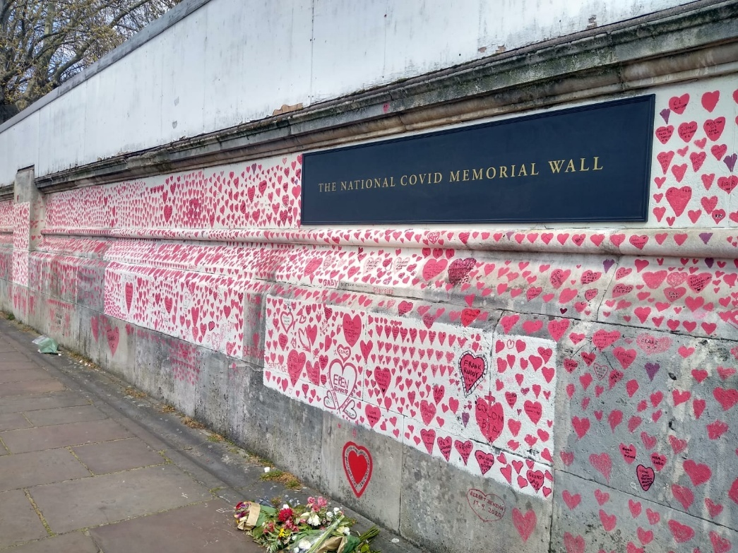

Perhaps one of the saddest things about the pandemic was the way it separated those who became desperately ill from loved ones who had no chance to stay with them or even attend their funerals because of a restriction on numbers. Some people had to say their goodbyes down a phone held by a nurse and many felt that such restrictions had a lasting impact on their need to make a good parting in death and their need to make their last journey with their deceased loved ones at their funeral. Many people remember Her late Majesty the Queen Elizabeth II sitting alone in a black mask during the funeral for her husband Prince Philip.
The National Covid Memorial Wall https://www.nationalcovidmemorialwall.org/ contains thousands of tributes and messages of love and loss. It has been created by bereaved families in solidarity with other bereaved families and is maintained by a small group of volunteers who refresh any fading. It represents the 240,000 people who died as a direct result of Covid-19 (at July 2024).
For reflection:
How did restrictions on visiting sick loved ones and attending funerals impact you?
What did such restrictions tell us about human bereavement, our faith, and the need to mourn?
How could we make sure people have ‘good’ deaths and appropriate funeral rites in the future?

Pink Journey 2 Spiritual Growth - How did we change?


A story, from a Parochial Church Council member in the Church of England
‘The first thing I felt when the churches were shut was a sense of loss and grief. For a while I was angry with the hierarchy who shut my church against me. Then our vicar suggested we could phone some of the parishioners and our neighbours and see how they were and if there was anything we could do to help. I got on the phone and everyone was so grateful – I was talking to people I barely spoke to at church. And after a while, you know, I found I was really gaining confidence in talking about faith. It came naturally, not because I was thinking about it, but because the people I phoned were leading me to places where- I just did it! People were asking me to pray for them. People were asking where God was in all this. And I did pray for them. And I did find God there and said so. I would have gone to church and said ‘Happy Easter’ to everyone. I would never have done this, or thought to do so.’
Source https://www.churchofengland.org/resources/deeper-god-mission-theology ‘Evangelism -Confidence’
For reflection:
How did the experience of living through the pandemic impact your faith?
How did Covid-19 affect your sense of neighbour and/or neighbourhood?
How did your local church(es) go about maintaining care and contact with people and how are those contacts being continued today?
Something to read: https://relationalchurch.uk/loving-our-neighbours-in-the-street
Pink Journey 3 Spiritual Growth- What can I do to be prepared?
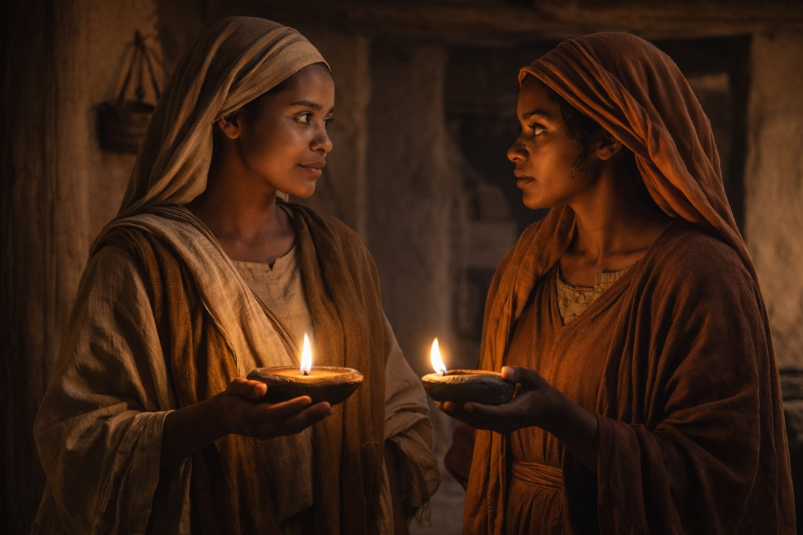

Then the kingdom of heaven will be like this. Ten bridesmaids took their lamps and went to meet the bridegroom. Five of them were foolish, and five were wise. When the foolish took their lamps, they took no oil with them; but the wise took flasks of oil with their lamps. As the bridegroom was delayed, all of them became drowsy and slept. But at midnight there was a shout, “Look! Here is the bridegroom! Come out to meet him.” Then all those bridesmaids got up and trimmed their lamps. The foolish said to the wise, “Give us some of your oil, for our lamps are going out.” But the wise replied, “No! there will not be enough for you and for us; you had better go to the dealers and buy some for yourselves.” And while they went to buy it, the bridegroom came, and those who were ready went with him into the wedding banquet; and the door was shut. Later the other bridesmaids came also, saying, “Lord, lord, open to us.” But he replied, “Truly I tell you, I do not know you.” Keep awake therefore, for you know neither the day nor the hour.
Matthew 25.1-13
You may remember reports of COBR (Cabinet Office Briefing Rooms) which exists to consider national emergencies like pandemics. Disaster Planning involves learning from existing knowledge but also thinking about what resources might be necessary in a future disaster. There are many practical considerations such as the provision of protective equipment in hospitals, measures for infection control and expanded hospital facilities.
However, while we might understand the need for practical preparedness, what about future spiritual preparedness?
For reflection:
How might Christians, and people of faith generally, develop watchfulness, remain alert to God’s promptings and be prepared for Jesus?
What does it mean to be spiritually prepared?
Pink Journey 4 Spiritual Growth -Where do we go from here?

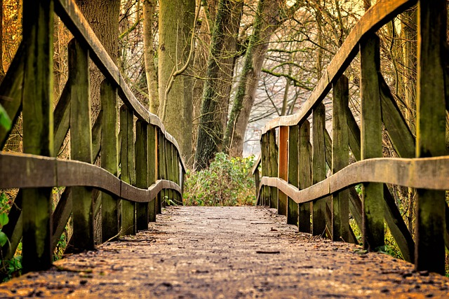
Onward journey
Information on the Covid Day of Reflection. https://dayofreflection.campaign.gov.uk/about/
This site says:
‘Why we mark the Day of Reflection
The UK Commission on Covid Commemoration was set up to find appropriate ways to remember those who lost their lives since the pandemic began, and to explore how we mark this period of our history.
The Commission held an in depth consultation with those most impacted by the pandemic, including representatives from bereaved family organisations. In September 2023 it published its final report, recommending an annual UK-wide day of reflection.
By continuing to hold a Day of Reflection, in line with previous years, we hope to offer communities across the country the opportunity to join together in commemoration of those who lost their lives.
On Sunday 9 March 2025, people came together to:
remember and commemorate those who lost their lives since the pandemic began
reflect on the sacrifices made by many, and on the impact of the pandemic on us all
pay tribute to the work of health and social care staff, frontline workers and researchers
appreciate those who volunteered and showed acts of kindness during this unprecedented time
The next COVID-19 Day of Reflection will take place on Sunday 8 March 2026.’
Having used these resources for reflection, what would you and/or your church like to take forward from this day or in the coming time?
https://relationalchurch.uk/category/a-more-relational-church/reflection
https://www.faithaction.net/blog/health-and-care/2026/02/05/46962/
Image Credits
P 2 Image by Jeyaratnam Caniceus from Pixabay
P 3 Image by Regina Störk from Pixabay
P 4 Image generated by ChatGPT
P 5 Image generated by ChatGPT
P 6 https://www.ecdc.europa.eu/en/publications-data/infographic-covid-19 https://creativecommons.org/licenses/by/4.0/legalcode.en.
P 7 Image by linjun0421 from Pixabay
P 8 Image by Helena Jankovičová Kováčová from Pixabay
P 9 Image by VGC-Group from Pixabay
P 10 Image by visuals3Dde from Pixabay
P 11 Image generated by ChatGPT
P 12 Image by falco from Pixabay
P 13 Image generated by ChatGPT
P 14 Image by Kellie Foster Kelly Foster, CC BY-SA 4.0 https://creativecommons.org/licenses/by-sa/4.0 , via Wikimedia Commons
P 15 Image generated by ChatGPT
P 16 Image generated by ChatGPT
P 17 Image by Peter H from Pixabay

