Blue 1 Bible Study
Book p.96
One of the things which emerged from the third part of the research conducted by Dr Rooms, was the prominence of Matthew 28 19-20 as the ‘foundational’ mission text most often cited by his interviewees. That text, and some of the others from the gospels associated with the biblical basis for mission are offered below with questions as the basis of Bible study.
Matthew 28. 16-20
Now the eleven disciples went to Galilee, to the mountain to which Jesus had directed them. When they saw him, they worshipped him; but some doubted. And Jesus came and said to them, ‘All authority in heaven and on earth has been given to me. Go therefore and make disciples of all nations, baptizing them in the name of the Father and of the Son and of the Holy Spirit, and teaching them to obey everything that I have commanded you. And remember, I am with you always, to the end of the age.’
- Why do you think the respondents particularly thought of this passage as underlying their understanding of mission?
- What do you think Jesus’ message to the disciples actually means?
- What outcome would you expect to see happening in your church if we respond to this passage?
- What else do you think belongs to the idea of mission which is not included in this passage?

John 21.15-17
When they had finished breakfast, Jesus said to Simon Peter, ‘Simon son of John, do you love me more than these?’ He said to him, ‘Yes, Lord; you know that I love you.’ Jesus said to him, ‘Feed my lambs.’ A second time he said to him, ‘Simon son of John, do you love me?’ He said to him, ‘Yes, Lord; you know that I love you.’ Jesus said to him, ‘Tend my sheep.’ He said to him the third time, ‘Simon son of John, do you love me?’ Peter felt hurt because he said to him the third time, ‘Do you love me?’ And he said to him, ‘Lord, you know everything; you know that I love you.’ Jesus said to him, ‘Feed my sheep.’
http://www.morguefile.com/archive/display/136867

- What do you think Jesus is doing in this passage?
- What do you think Peter would have understood from this dialogue with Jesus?
- In what ways might this passage be relevant to what your church does in mission?
- What else do you think belongs to the idea of mission which is not included in this passage?

Mark 16.14-20
‘Later he appeared to the eleven themselves as they were sitting at the table; and he upbraided them for their lack of faith and stubbornness, because they had not believed those who saw him after he had risen. And he said to them, ‘Go into all the world and proclaim the good news to the whole creation. The one who believes and is baptized will be saved; but the one who does not believe will be condemned. And these signs will accompany those who believe: by using my name they will cast out demons; they will speak in new tongues; they will pick up snakes in their hands, and if they drink any deadly thing, it will not hurt them; they will lay their hands on the sick, and they will recover.’
So then the Lord Jesus, after he had spoken to them, was taken up into heaven and sat down at the right hand of God. And they went out and proclaimed the good news everywhere, while the Lord worked with them and confirmed the message by the signs that accompanied it.’

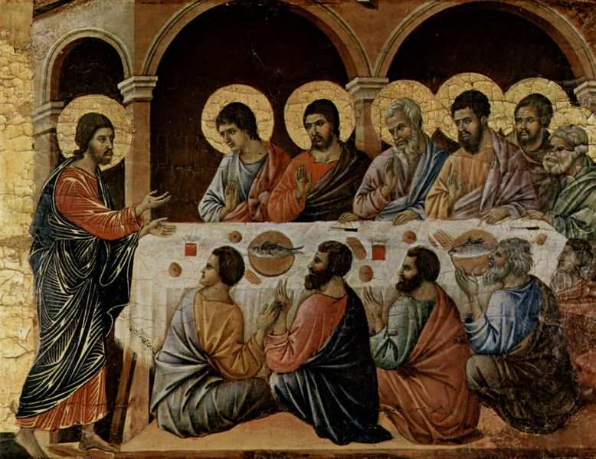
Duccio (Yorck Project) http://commons.wikimedia.org/wiki/File:Duccio_di_Buoninsegna_017.jpg

- What do you think this passage tells us about mission?
- What do you think the disciples made of this appearance of Jesus to them?
- Where do you think these things might be happening in your church?
- What else do you think belongs to the idea of mission which is not included in this passage?
Luke 24:44-49
Then he said to them, ‘These are my words that I spoke to you while I was still with you—that everything written about me in the law of Moses, the prophets, and the psalms must be fulfilled.’ Then he opened their minds to understand the scriptures, and he said to them, ‘Thus it is written, that the Messiah is to suffer and to rise from the dead on the third day, and that repentance and forgiveness of sins is to be proclaimed in his name to all nations, beginning from Jerusalem. You are witnesses of these things. And see, I am sending upon you what my Father promised; so stay here in the city until you have been clothed with power from on high.’
- What do you Jesus means by these words?
- What do you think the disciples understood by what Jesus was telling them?
- How is this passage reflected in the life of your church?
- What else do you think belongs to the idea of mission which is not included in this passage?
Blue 2 Objects for meditation
Activity: Objects
Bring to the group the following objects:
Some photocopied pages of Isaiah 65. 21-end
A few coins (1p, 2p, 5p)
A few stones or pebbles
A few tea lights
A cup (or cups) of water
Ask each person in the group to choose whichever of the objects they think is the most useful for mission, to hold their object and briefly to say why. There are no right or wrong answers. People may also choose something else altogether if they wish.
http://www.morguefile.com/archive/display/1263

Activity: Objects
Invite people to use the objects as a focus for meditation (perhaps placing the objects in the centre in a circle) and to offer a time of prayer for the mission of your church. You might prefer to use the Blue 3 resource instead.
http://www.morguefile.com/archive/display/82503
For Further Work
Ask people in the group to choose one more object to remind them to pray and support all those involved in the work of the mission agencies at home and overseas.
Blue 3 Prayers for the Mission of the Church
A meditation on the five marks of mission

Book p.15

http://www.flickr.com/photos/30975003@N06/3243099726/sizes/m/in/photostream/

Photo: Matthew Cua

To proclaim the Good News of the Kingdom

Lord of Love,
We ask you to help us
Proclaim your Good News;
To be firm in faith
Strong in conviction
Confident in you.

Help us to share our love for you with others
To witness to your compassion and great mercy
And to show all who search for you
The path to your Kingdom

Amen

To teach, baptise and nurture new believers

Photo Robert Beijil

http://www.flickr.com/photos/robnas/4061799399/sizes/m/in/photostream/

Lord of Life,
We ask you to help us
Love and cherish your disciples;
To rejoice in their faith
Watch over their growth.

Help us to bring before you in baptism
All those who long for the healing water;
To stand by them in faith
As they set out joyfully on the Christian journey.

Amen

To respond to human need by loving service

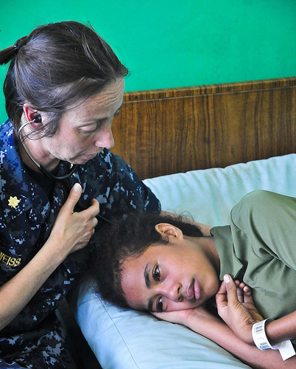

http://www.flickr.com/photos/dvids/5621932296/sizes/m/in/photostream/

Photo by DVIDSHUB

Lord of Compassion,
We ask you to help us
Care for the suffering,
Reach out to the poor,
Bring back the dispossessed.

Help us to reach out hands of friendship
To all who are sick, lonely or lost;
To share all we have with those who have nothing,
To find you there among all who have need.

Amen

To seek to transform unjust structures of society

Lord of Justice,
We ask you to help us
Challenge unjust structures;
To stand up to exploitation
To resist manipulation

Help us to keep before the world a vision of your Kingdom:
The justice and righteousness of living by your will;
To stand beside those who are broken,
Ill-treated or oppressed.

Amen

To strive to safeguard the integrity of creation and sustain and renew the life of the earth
http://www.flickr.com/photos/28misguidedsouls/6203825072/sizes/m/in/photostream/

Photo: Alex Murphy

Lord of Heaven and Earth,

We ask you to help us
Care for your creation
To cherish its resources
To take no more than we need.

Help us remember to treat the world gently
To treasure living creatures, the rocks and soil;
To tread lightly on the earth
To respect all you have made.

Amen

Blue 4 Reflections on Mission
Book pp. 148, 149, 151-152
In this resource, we offer some of the comments which were made by church leaders in the local survey conducted by Dr Rooms, in the course of his in-depth interviews about what mission meant to them. You might like to discuss their comments in a group or to spend some time in prayerful reflection on their different perspectives as suggested below. All these people were deeply committed to mission, but, as it worked out in their own experience of leading churches, a questions about their own understanding of mission prompted them to think about different things.
Activity: Reflections
In groups, look through the comments below and pick one which you feel resonates with your own sense of mission. You might like to discuss together why that comment means something to you and where you see it working out in your life or in the life or your church.
After this, choose someone in your group to pray for the church leader who made the comment and for the mission of the church he or she leads.
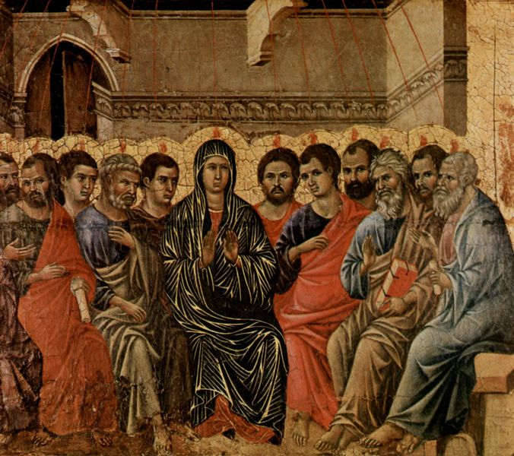
Duccio, http://en.wikipedia.org/wiki/File:Duccio_di_Buoninsegna_018.jpg
Work of the Holy Spirit…..
‘I mean we’re the hands of Christ, but the Holy Spirit is the empowerer and facilitator, he paves the way, we look for where he’s at work and then go and get stuck in’

A community of believers….
‘I always feel it as rather like and it’s a funny sort of like evangelical way as something, a community, a religious community…it’s about living together, praying together and all that, so it’s community’

The ‘core’ of church life…
‘I think mission is core to what we should be as a church. So it’s not just about Sunday services, it’s equally as much about going out in mission with God. So I would never ever want to disconnect mission from the core life of the church. It’s not an add on, it’s not something we do when we have finished fund raising or we’ve finished making our services nice, it’s an equally important part of the life of the church, it’s having communion praising God together, praying and mission it’s all a part of that.

http://www.morguefile.com/archive/display/797252

A distinctive task….
‘I was thinking there about the difference between mission, which is clearly the church’s task and the work that humanists, secularists, people who claim to have no faith at all, nevertheless, do good work…’

Wanting people to know Christ….
‘It’s about telling people who Jesus is not just providing something that’s a nice thing to do or say a social activity that actually doesn’t have anything to do with the fact that we’re doing this because we’re Christians and we want people to know Christ’

Passing on the good news to others…
‘there’s also this sort of sense of mission is a sense of achievement in spreading the good news, but also in carrying something on that it will, you can then become like the domino effect that people will then teach other people who will then bring other people who will then bring other people, so it’s that sense of achievement and when we had this confirmation a few weeks ago and people baptised in the morning and people confirmed in the afternoon…there was a great sense of celebration in the community and when I was talking to Paul who is our evangelist afterwards we were both saying this was actually as good as it gets, this is what we are doing this for.’

Activity: Reflections (2)
In groups, look through the comments again and choose the one which seems least applicable to your own situation. Discuss together the reasons for your choice.
At the end of your discussion, choose someone in your group to pray for the church leader who made the comment and for the mission of the church he or she leads.
For Further Work
As a group put together a calendar of reflection time or prayer rota, to pray for local churches involved in mission. You might like to consider setting up a prayer partnership with another denomination in your area.

