Pink 1
Doing and Being
The Foundations for Mission research discovered that many of the words churches and mission agencies associated with mission were ‘doing’ words. The most popular language about mission were active verbs like ‘transforming’, ‘changing’, ‘sharing’ etc. Similarly, many of the stories and images on mission websites were about things being done: initiatives, strategies, projects and sheer hard work by Christians among others.
However, one of the questions about the foundations for mission surrounds whether mission also needs to be reflected in who we are as God’s people. Our prayers and worship and spiritual growth are also related to being a missionary people. Lesslie Newbigin said that a congregation was ‘the hermeneutic’ of the Gospel, witnessing to people through being faithful disciples as well as doing God’s work.
The Anglican Communion website says:
‘The Five Marks stress the doing of mission. Faithful action is the measure of our response to Christ (cf. Matt. 25:31-46; James 2:14-26). However, the challenge facing us is not just to do mission but to be a people of mission. That is, we are learning to allow every dimension of church life to be shaped and directed by our identity as a sign, foretaste and instrument of God's reign in Christ. Our understanding of mission needs to make that clear.’
http://www.anglicancommunion.org/ministry/mission/fivemarks.cfm

Activity: Doing and Being

How do you think people who live in your community but who are not part of your church would know what your church means by ‘mission’?

Make a list or a series of drawings ways in which your church ‘does’ mission and ways in which it expresses ‘being’ in mission. Is there a mismatch between the two lists and could you identify one thing to improve the shorter list?

What do you think the relationship is between ‘doing’ mission and ‘being’ in mission?

Activity: Stories

On the cold wintry morning that I visit, the sky is black and the wind moans through the trees. For the two seafarers accompanying me, it is an emotional journey as we arrive alongside the ship which has cause theme and their families so much heartache. Five months previously, George and Florin took jobs as watchkeepers, but their employers failed to pay their wages, leaving them in a no-man’s land of foreign bureaucracy with no money, no food and no familiar support network.

‘The generator kept breaking down so we didn’t have any electricity, and we had to use rainwater for washing’ says George. ‘It was so cold at night that it was hard for us to sleep. We had no fridge and so our food didn’t stay fresh. When we found a rod on board, we began catching fish from the river because the chandler stopped coming as the bill hadn’t been paid.

Flying Angel News Winter 2012 issue 3 p 4

The Mission to Seafarers helped George and Florin

- What do you suppose needed to be done to help them and what kind of support so you think they would need. Why would those things be considered mission?

http://www.morguefile.com/archive/display/132073

For Further Work:

Find out what kinds of organisations are ‘doing’ things to help your community flourish. What kinds of organisations are helping just by ‘being’ there? Could you support one or more of those organisations through a link to your church?
Pink 2

‘Is’ and ‘Ought’
One of the struggles which emerged from the research was that mission agency and church leaders found it difficult to decide whether they should be talking about mission as it is experienced with all the drawbacks and messiness of the human experience or mission as it ‘ought’ to be or as God wants it. Quite often those respondents were aware of quite a wide gap between the work that is done in mission and their desires or plans for their church or agency.
Activity: Ought
Ask the group to dream some dreams about what the ‘end’ of successful mission would look like. You might like to have a discussion and then write down some words or phrases or draw images which represent that vision, for example ‘world peace’ or ‘doing God’s will’ or whatever comes to mind. Place the ideas on the floor and ask the group to consider whether any of these are achievable goals for one lifetime, for several generations, or never.
Pick one of these goals and choose one thing your church could do to make a single step towards one of the goals. For example, if the goal is world peace, choose an evening to pray for politicians and church workers who are working to bring peace to war torn areas. You could also perhaps look into finding out what Christian charities and mission agencies are doing to promote peace and reconciliation and support them.
http://www.morguefile.com/archive/display/156693

Activity: Is
Ask the group to think about some of the things your church is doing, even if there is little activity or the congregation is really small. Make a list or draw images of what your church has achieved in mission in the past year. This could include things like baptisms and weddings and even funerals and be rooted in the faithfulness of Christian worship.
Pick one thing your church has done in the past year which has contributed to the mission of your church. Design a short prayer, song, poster or event which will celebrate the difference your church makes to the community in mission.
For Further Work

Identify one more thing you or your church would like to do to realise a vision of what God wants for your community. What resources will you need to make it real?

http://www.morguefile.com/archive/display/149116
Pink 3

Mission or Social Action?

One of the questions which also emerged from the research was whether there are priorities in God’s love to the world. For example, is it more important to tell people about Jesus and share our faith with them, or it is more important to make sure that they are not struggling to live, dying from poverty or disease or suffering sickness or starvation? Is it right to assume people can make up their minds about Jesus without access to education? Is it right to refrain from sharing faith in order to get better access to suffering people? Is it right to treat people’s needs as secondary in the proclamation of the Gospel?

Many leaders of churches and agencies found these kind of questions quite difficult to answer.

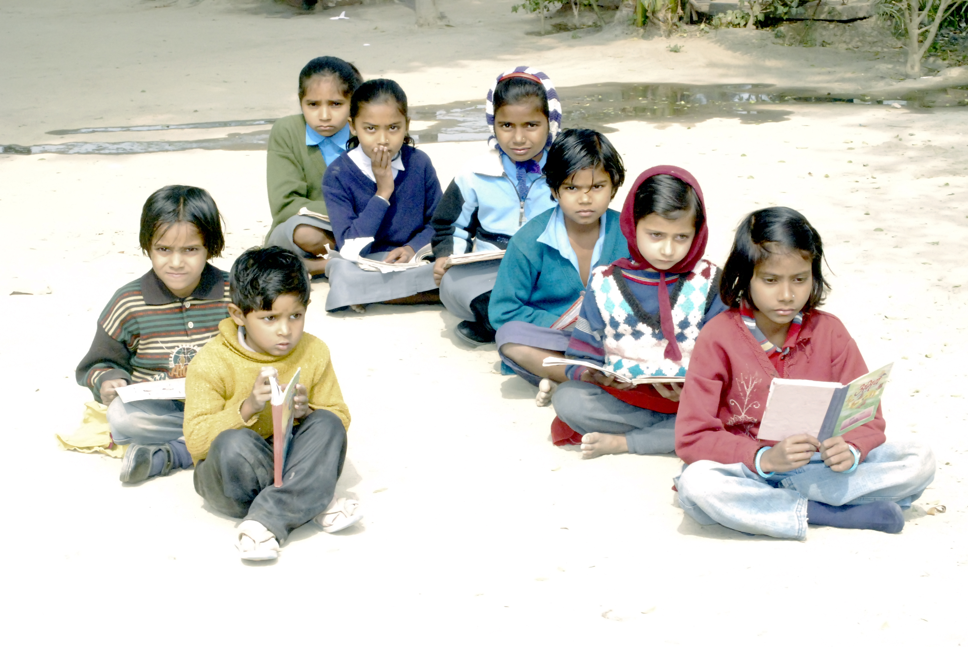

http://www.morguefile.com/archive/display/221148

Activity: Scenarios

Below are some scenarios which illustrate these kinds of questions, which you might like to ponder in your groups

A mission team from a very active and thriving church set up a ‘fresh expression’ on a housing estate. When they canvassed people in the neighbourhood, they found that many people were very enthusiastic and so they were encouraged. But when they started their new church, almost no one attended and the members of the team were very disappointed. When they asked local people who had been interested why they did not come to the service, they were told that the venue they had chosen was dangerous after dark and no one would go there.

- What does this story tell you about mission priorities?
- What advice would you want to give the mission team about setting up a fresh expression in the future?
- What would you do if you were reaching out to people living in that neighbourhood?

A very charismatic and popular Christian was very successful in befriending people and bringing them to church. Over a period of a year she brought 24 new people into the church. But she became discouraged when, after a few months, the people she brought to church started to drift away and didn’t stay. 18 months later, not one of the 24 people was still attending.

- Why do you think the people didn’t find a permanent home in the church?
- What else do you think the people were looking for which they didn’t find?
- What do you think those people might say if they were asked about their faith?
- What advice and encouragement would you give the evangelist for her mission work in the future?

A church team was working in their local community, providing a drop-in centre for homeless people. Together with providing washing facilities and food, some of the team made a point of sharing faith with some of the people using the centre. Two of the homeless people got very angry and said they didn’t want to hear about Christian faith, and if the team members persisted they would never come back.

- Why do you think the homeless people reacted the way they did?
- Do you think the drop-in centre was a truly missionary activity?
- What advice would you give the church team for the way they might develop the drop-in centre in the future?

http://www.morguefile.com/archive/display/123592

Activity: Parables

In your group, think about the well-known parables of the Good Samaritan, the Prodigal Son, and the Parable of the Sower.

What can we learn from these parables of Jesus about what God wants for human beings?

For Further Work

Identify one thing which you have learned from this reflection which could improve your, or your church’s work in the community.

Pink 4

Foundations for Mission - exit

This resource can be used as a conclusion to the work that has been done using the other resources in this study process. It is a designed as a reflective exit to this exploration of the Foundations for Mission which complements the findings of the research.

Activity

In groups take a few moments to reflect on the work you have done using these resources. The following questions might help you:

- How do the things we say about mission and do in mission match up to one another?

- What kinds of things do you find difficult or baffling about the missionary task?

- How far does your church put effort into mission work?

- Where do you see yourself contributing to God’s mission outside the church?

- What results can you/have you seen from the mission work of your church?

Activity

Gather up any of the things you have identified from the ‘further work’ sections of each resource. Which ones might you want to take further and how? Fix a date to review your decisions and to see what progress you have made. Stick to do-able projects, which can be properly shared, without becoming a burden on particular people. Aim to celebrate and reward your projects, perhaps with a shared meal.

For Final Reflection

The research project Foundations for Mission concluded that there was often a difference between the ‘talk’ about mission and the things that we actually do to make disciples and share faith in Christ. The research group noted that many people wanted to move away from statements about mission to rooting their understanding of mission in experience. Many shared stories about how mission can be life-changing for everyone. The group noted that many people struggled with making sense of how justice for all and the transformation of the world to be as God desires it fits into the missionary purpose and many found it difficult to understand the breadth and depth of the way God calls us to be involved in the mission of love to the world.

At the local level some clergy reported that the Christians who go to their churches sometimes seem cut off from an active role in making mission happen and sometimes congregations thought only in terms of sending others off to foreign lands, without seeing any role for themselves in the sharing of faith and making of disciples.

We hope that in using these resources you will have had a chance to think actively about God’s call to everyone to be involved in mission and that you will have found ways to deepen that understanding for yourselves and for your churches.

If you would like more ideas or have comments or reflections on these resources, you are welcome to get in touch with the Mission Theology Advisory Group through its convener Anne Richards at anne.richards@churchofengland.org.

MTAG is on Facebook at http://www.facebook.com/pages/Mission-Theology-Advisory-Group/166777073421218?v=wall

MTAG is on CT Connect at www.ctbi.org.uk

Mission Theology Pages at http://www.churchofengland.org/our-faith/mission/mission-theology.aspx

[MTAG on Stream image; logo ]

