Ancient Wisdom, Modern Mission
Following Christ in the Footsteps of the Saints
Introduction

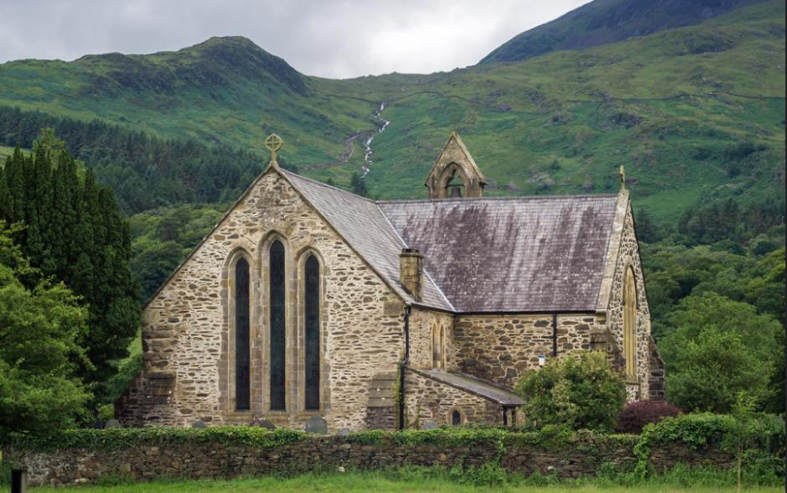
Adam Court/flickr St Mary’s Church, Beddgelert, Wales, UK
Have you ever walked past a church and noticed that its name is that of a saint? And have you ever wondered why so many churches seem to be called after saints?
By the fourth century, it began to be the practice to dedicate new churches to a ‘patron’ saint. Images of that person were often displayed in the churches and the name of the saint would be displayed. Today, many churches are dedicated to all kinds of saints, but some Christian denominations now do not use them to dedicate their buildings.
The Christian creeds, our statements of what we believe, say that ‘we believe in the communion of saints’, - holy women and men who have been faithful followers of Jesus Christ and who have often lost their lives through persecution of the Christian faith. Some Christian denominations recognise saints ‘days’ in the Christian calendar when particular saints are especially remembered and churches dedicated to particular saints hold special services, ‘patronal festivals’, on those particular days. Across the world, some of these dates are very well known outside the Church, such as St Valentine’s Day on February 14th or the St Patrick’s Day celebrations on March 17th.
Some saints are said to be ‘patron saints’ of particular groups of people, sometimes because of some event or legend about their own story. In the UK there are four ‘nation’ saints, St George for England, St David for Wales, St Patrick for Ireland, and St Andrew for Scotland.
This resource is designed to offer you a range of ways of finding out more about the mission, myths, miracles, and mysteries associated with the saints and to ask how we understand these things today. It enables you to go on a spiritual pilgrimage, a sacred journey, ‘following in the footsteps’ of a particular saint, so you can be inspired by their stories and develop your own Christian life. If circumstances permit, you might enjoy visiting some of the places mentioned or find churches associated with the particular saint and find out more about their living Christian witness.
There are four ‘pathways’ for you to follow, and you can mix and match them if you like. They are:
YELLOW JOURNEY – word-based resources for people who like to read information, talk about things and consider questions, perhaps in a study group. The Yellow Journey also guides you through the best information we have (eg the Bible) moving on to how we learn from, evaluate and use other traditions about the saints.
BLUE JOURNEY – for people who like to engage with Scripture, use prayers, and use Christian reflections. The Blue Journey also begins from the best information we have (eg the Bible) through to prayers and traditions associated with particular saints.
GREEN JOURNEY – image and activity based for people who like to explore, create, look at images and get out and about. The Green Journey also delves into things like the traditions of saints around the world, seeing them through the eyes of other Christians.
PINK JOURNEY – for people who want to explore Christian faith more deeply, find out more about following Jesus, and using the ‘lens’ of the saints to create opportunities for thinking about how we live our lives.
Another way to mix and match the resources is to follow the information across the four journeys about the person first and as much factual material as is available, then think about the mission of that person and where and how that was recorded, then move on to the miracles associated with that person and finally the mystery of the saints and what their stories might mean for us today.
You can use these resources whether you are a Christian or not, as an individual study or in a group of friends.
This resource is about St Andrew, apostle. Here are the resources.
ST ANDREW | The Man | The Mission | The Miracles | The Mystery
YELLOW: WORD BASED | Andrew son of Jonah | Andrew as a Fisher of People | The Acts of Andrew | St Andrew in The Golden Legend
BLUE: SCRIPTURE BASED | The Call of Andrew | Fishers of People | The Feeding of the Five Thousand | St Andrew in Prayer and Celebration
GREEN: ACTIVITY BASED | Seeing Andrew | The Traditions and Travels of Andrew | The Death of St Andrew | St Andrew, Scotland’s Saint
PINK: SPIRITUALITY BASED | First Called | Bringing others to God | Doing as Jesus Did | Inspiring and Transforming the World

The Man: Andrew, Son of Jonah
Kyle Taylor/flickr – Sea of Galilee

Scripture gives us some interesting details about Andrew the disciple of Jesus. We are told he came from a town called Bethsaida somewhere on the northern side of the great lake through which the river Jordan passes, the ‘sea’ of Galilee. Bethsaida means house of hunting (or fishing) and it is apparent that the place was a fishing village, so it is not surprising that Andrew and his brother Simon (Peter) were fishermen. Because they went out in boats with nets, it is probable that they mostly brought in hauls of species of tilapia, large, dense fish, which were good for market. Fishing was a significant occupation around the lake and Andrew and Peter would have spent their time on the upkeep of their boat and mending their nets as well as all the business of catching, landing and selling on their hauls of fish. The geography of the lake creates particular spots where the fish gather and the fishermen would know where the fish were likely to shoal.
Andrew’s name (Andreas) isn’t a Hebrew name in origin but a Greek one, meaning ‘manly’ or ‘brave’. That name wasn’t uncommon in first century but it suggests that the town from which he came had contact with different languages and cultures. Andrew’s family were Jews living under the Roman occupation, but they would also likely be in contact with traders and travellers and a variety of other peoples and cultures. Although people have sometimes thought of Andrew and Peter as ‘poor’ fishermen, they might well have been relatively prosperous and well-connected. They would have been observers of Jewish laws, customs, rituals and festivals.
John’s gospel tells us that Andrew was first a disciple of John the Baptist, so perhaps we can say that he was a person on a spiritual search, listening earnestly to John and looking out for signs of the Messiah, a descendant of King David, and the anointed one God would send to liberate the Jewish people from their occupation and the bringer of peace and unity. John the Baptist preached this vision and said that the Messiah was coming. Andrew would have been filled with this hope and expectation of radical change.
Some questions to think or talk about:
- How do you imagine Andrew and his brother Peter?
- What do you think it would have been like making a living catching and selling fish? What skills and challenges would be involved?
- What do you think Andrew learned from following John the Baptist?
- What do you think it would have been like to live in Bethsaida in those days? What might daily life have been like?
- What do you think Jewish believers thought the Messiah would do?

Jeremy Keith/flickr

The Mission: Andrew as a ‘Fisher of People’

Julia Maudlin/flickr Nets at Sunset, Essaouira, Morocco

Another way in which we discover Andrew the man in the gospels is in another account of the call of the first disciples, told in the gospels of Mark (16.1-17) and Matthew (4.18-19). The scene is dynamic: Jesus is walking by, perhaps looking for these fishermen, and Andrew and Simon (Peter) are throwing a net into the lake, intent on their business and their trade and working together. Andrew is busy with work; he is not praying or pursuing some holy calling at this point. It is a typical day on the lake, and there are necessary jobs to be completed. Into this world of making a living to feed families, Jesus calls Andrew and Simon to follow him, but there is an addition to the call, to become ‘fishers for people’.
You can read the Matthew passage and look at it in more detail in Blue Journey 2.
Andrew then, is called to a mission, a call which will frame and shape his life and his death. In these gospel accounts, he is called together with his brother, already his partner.
They left what they were doing and followed Jesus, but what do you think Simon and Andrew understood by Jesus’s mission for them?

Some questions to think and talk about:
- What might Jesus have been doing down by the lake?
- Do you think Jesus might have known Andrew and Simon already?
- What ‘people’ do you think he was referring to?
- What do you think they thought Jesus would want them to do?
- Do you think this sounded like a plan for minds and hearts, or more like a revolutionary call – ‘netting’ recruits for an uprising or a revolution?
- Why was this mission so attractive that they immediately stopped their daily work and followed Jesus?
- What do you think happened after that? What did they tell their families? What did they do about their boats and nets?
- What do you think the immediate human cost of Jesus’s mission for them might have been?

Aravindan Ganesan/flickr Fishermen..

The Miracles: The Acts of Andrew
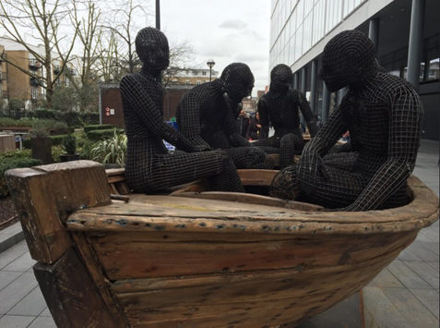
Matt Brown/flickr Migrant Boat

Have you ever wondered what happened after the New Testament accounts of the activities of the apostles ended? What did all those apostles of Jesus continue to do and where did they end up?
There are many traditions from many different countries which supply accounts of what the apostles did next, especially from those places which trace their Christian heritage back to a particular saint bringing the news of Jesus to their communities.
There is a substantial apocryphal text of collected writings about St Andrew, called The Acts of Andrew, probably from the 3rd century, which is available to read at http://www.earlychristianwritings.com/text/actsandrew.html . The Acts purport to chronicle his teaching, preaching, miracles and travels. Another text tells the story of how Andrew came to be condemned to death and how he died, preaching still, on an X shaped cross in Patras in Greece.
Many of the events closely echo biblical accounts of miracles performed by Jesus. Andrew heals a blind man, casts out many demons, finds food and clothing for the destitute, calms storms, has a shining, mysterious face, gathers followers, challenges immorality and injustice, amazes people with his teaching, and raises people from the dead. The Acts of Andrew is at pains, though, to emphasise that households became believers in Jesus and were baptised and that Andrew was instrumental at bringing these people to faith.
While these wonder stories are fascinating, they still have much resonance with issues that concern us today. For example, look at this story:
‘They sat down, with others, on the sand, and he taught. A corpse was thrown up by the sea near them. 'We must learn', said Andrew, 'what the enemy has done to him.' So he raised him, gave him a garment, and bade him tell his story. He said: 'I am the son of Sostratus, of Macedonia, lately come from Italy. On returning home I heard of a new teaching, and set forth to find out about it. On the way here we were wrecked and all drowned.' And after some thought, he realized that Andrew was the man he sought, and fell at his feet and said: 'I know that thou art the servant of the true God. I beseech thee for my companions, that they also may be raised and know him.' Then Andrew instructed him, and thereafter prayed God to show the bodies of the other drowned men: thirty-nine were washed ashore, and all there prayed for them to be raised. Philopator, the youth, said: 'My father sent me here with a great sum. Now he is blaspheming God and his teaching. Let it not be so.' Andrew ordered the bodies to be collected, and said: 'Whom will you have raised first?' He said: 'Warus my foster-brother.' So he was first raised and then the other thirty-eight. Andrew prayed over each, and then told the brethren each to take the hand of one and say: 'Jesus Christ the son of the living God raiseth thee.'
Here is the story of a tragedy as people who have left their homes to pursue the teachings of Jesus and a better way to live. The journey is filled with hope but desperately dangerous and their boat is wrecked. They all drown and their bodies are washed ashore. Andrew needs to know about the evil that has befallen them and he needs to know their story. He reinstates the world for them as it was meant to be by the power of Jesus. They were meant to live and find what they were looking for.

Going deeper into the story:
- How do all the miracles show the closeness of Andrew to Jesus?
- Why do you think people wanted to know more about the apostles and what happened to them in the end?
- What do you make of the story of the drowned people?
- What contemporary news stories does this remind you of?
- What could we learn from this resurrection story and the example of Andrew the apostle about how to advocate for suffering migrants and refugees?

Bibliojojo/flickr Shipwreck
The Miracles: St Andrew in the Golden Legend

Gajman/flickr

The Golden Legend is a medieval book in Latin by Jacobus da Voragine which collects together stories about the lives of the saints. It was widely read and extremely popular from the 13th century. It was translated into English by William Caxton and printed and reprinted many times.
Each chapter looks at a particular saint, starting with what the saint’s name is supposed to mean, then something about the day on which the saint is celebrated. Each chapter then details the saints’ lives, heroic deeds, wonder-stories and miracles attributed to them and finally ends with a list of sources.
Like fairy-tales, folktales, myths and legends, these stories both entertained and instructed people and the stories found their way into sermons and devotions.
Eventually these miracle stories and legends about the saints became less popular as their fanciful nature was challenged by Enlightenment thinking. But today more people are getting interested in ancient legends and miracle-stories as an accompaniment to their spiritual search. So what might we learn about faith by looking through the lens of these old miracle stories?
St Andrew as the Pilgrim Saviour
The following is a paraphrase of one of stories from The Golden Legend about St Andrew. In is a temptation and salvation story in which the Devil tries to divert a Christian leader of the Church away from a holy life. You can read the text and about all the miracles here: https://www.christianiconography.info/goldenLegend/andrew.htm
The story is about a bishop in ancient times who devoted himself to following the example of St Andrew and leading a holy life. This made the Devil angry, so the Devil decided to deceive and corrupt the bishop by disguising himself as a beautiful woman. The woman says she wants to make her confession to the bishop, and after trying to put her off, the bishop agrees.
The Devil in disguise tells the bishop a story about wanting to be a consecrated virgin and follow only Jesus, but her father, a King, wants to marry her off. So she has run away to seek protection from the bishop because he is so holy and righteous. The bishop is impressed by this and says he will take her in and protect her, but when later he is dining with her, he becomes so overcome by her beauty that he decides he will sin and try and get her to sleep with him.
‘Then they came to the table, and were set, that one against that other, and the other folk here and there, and the bishop entendeth much to her, and beheld her alway in the visage, and he marvelled of her great beauty. And thus as he fixed his eyes on her his courage was hurt, and the ancient enemy, when he saw the heart of him, hurt [him] with a grievous dart. And this devil apperceived it and began to increase her beauty more and more; insomuch that the bishop was then ready for to require her to sin when he might’.
At this point a pilgrim dramatically knocks at the door of the hall and asks to come in, but it is decided he has to stay outside unless he can answer three questions put by the woman.
First, she asks what is God’s greatest marvel in a little space and the pilgrim answers correctly – it is a human face. For no two human faces are exactly alike.
Secondly, she asks whether the earth can be higher than the heavens, and the pilgrim answers that the earthly body of Jesus has been taken to heaven in the Ascension and Jesus is higher than the heaven.
Finally, she asks what the distance is between the depths of hell and the highest heaven and the pilgrim answers that she knows because she fell from heaven to hell and is not a woman but the Devil in disguise.
In disgust at this wisdom, the Devil vanishes.
The bishop is horrified at his human weakness and begs forgiveness. It is then revealed to him that the pilgrim was St Andrew come to save him from committing sin and restore him to the committed Christian way.

Going deeper into the story:
- What does this story tell us about temptation? About truth and lies?
- Why does this ancient miracle story use the idea of the Devil as a seductress? What does that tell us about ancient ideas about women – and men? Have we moved on, or do we still have these ideas about women and men in popular culture?
- What do we learn about Christian hospitality and traditions of welcome and what should people expect from Christians?
- What do you think about the three questions? And the three answers?
- How does this story help us think about being a follower of Jesus and how easily we get distracted? Why might it be appropriate that the ‘pilgrim’ is revealed to be St Andrew?

The Man: The Call of Andrew

Billy Wilson/flickr Peterborough Cathedral ceiling.
Jesus and the disciples – Andrew is to the immediate left of Jesus as you look at it.

John 1:35-42
The First Disciples of Jesus
The next day John again was standing with two of his disciples, and as he watched Jesus walk by, he exclaimed, ‘Look, here is the Lamb of God!’ The two disciples heard him say this, and they followed Jesus. When Jesus turned and saw them following, he said to them, ‘What are you looking for?’ They said to him, ‘Rabbi’ (which translated means Teacher), ‘where are you staying?’ He said to them, ‘Come and see.’ They came and saw where he was staying, and they remained with him that day. It was about four o’clock in the afternoon. One of the two who heard John speak and followed him was Andrew, Simon Peter’s brother. He first found his brother Simon and said to him, ‘We have found the Messiah’ (which is translated Anointed). He brought Simon to Jesus, who looked at him and said, ‘You are Simon son of John. You are to be called Cephas’ (which is translated Peter).

In the Orthodox tradition, St Andrew is called the ‘first-called’ (Prōtoklētos/Πρωτόκλητος) - literally the first-called because of this passage from St John’s gospel and he is especially honoured for being the first to respond to Jesus. Here we learn that Andrew is first a follower of John the Baptist and is waiting for the Jewish Messiah. When John the Baptist identifies Jesus as the Lamb of God, Andrew leaves John and follows Jesus. After spending some time with Jesus, Andrew goes to find his brother Simon and tells him that he was found the Messiah. It is Andrew who brings his brother to Jesus. When Jesus meets Simon, he gives him another name -Peter, the rock.

Some questions to think about:
- How do you think being a disciple of John the Baptist might have kindled Andrew’s interest in Jesus?
- What do you think Jesus meant by his question, ‘What are you looking for?’
- Why does it matter that Andrew wanted to fetch his brother and introduce him to Jesus?
- If today there are people following other spiritual pathways who are ready to meet Jesus, how might they actually encounter him?
- How might many people today respond to the question ‘What are you looking for?’
- How much do family and friends matter in the way people come to faith?

Aravindan Ganesan/flickr Fishermen...

The Mission: Fishers of People
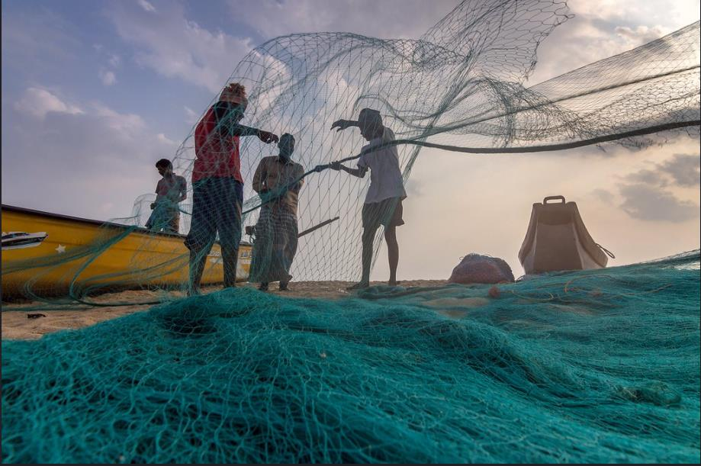
Aravindan Ganesan/flickr Fishermen.
Matthew 4. 18-19
As he walked by the Sea of Galilee, he saw two brothers, Simon, who is called Peter, and Andrew his brother, casting a net into the lake—for they were fishermen. And he said to them, ‘Follow me, and I will make you fish for people.’ Immediately they left their nets and followed him. As he went from there, he saw two other brothers, James son of Zebedee and his brother John, in the boat with their father Zebedee, mending their nets, and he called them. Immediately they left the boat and their father, and followed him.
In this passage, we have a window into the fishermen’s world. The men are busy with upkeep: James and John are mending their nets and Simon and Andrew are most likely washing their nets (compare Luke 5.2). The boats are most likely on the shore and Jesus is walking along the edge among the boats, nets and baskets, looking at what the people are doing and talking to them. The fishermen are named
What is interesting is the sense of urgency and immediacy. The men drop everything and go with Jesus. There is something about Jesus’s offer and his mission for them that is so compelling that they leave their tasks unfinished. There is a powerful invitation that cuts into daily life and sets the four new disciples off on a new journey; one that comes with task and agency: they will ‘fish for people’. In that setting, the striking image of fishing for people creates all sorts of associations – of people in the depths needing to be helped to the light, of people being rescued from drowning; of people being brought from sea to dry land, like the ark was – an image of redemption and forgiveness, and perhaps also an echo of what John the Baptist was doing in the river Jordan, immersing people in the water and bringing people up to live a new life. Perhaps when the new disciples followed Jesus, he was able to unpack all that was meant by a mission of fishing for people.
Some questions to think about:
- The two sets of brothers are called, but Zebedee does not accompany them. Why do you think that was?
- What do you think it meant to the disciples literally to follow Jesus, as they went away together?
- What do you think Andrew, Simon, James and John first talked about with Jesus?
- How do Christians like to characterise people who are not yet Christian?
- What other ways can you think of to describe the missionary promise given to the disciples to be ‘fishers of people’?
- What does the painting below make you think of?

Martin Howard/flickr jesus: sea

The Miracles: The Feeding of the Five Thousand

Mira66/flickr Loaves and Fishes by John and Helen Mary Skelton

In Scripture, the Feeding of the Five Thousand is the only miracle performed by Jesus which is reported in all four gospels (Matthew, Mark, Luke and John). In John’s gospel account, however, Andrew has a pivotal role in the miracle.
John 6.1-14
After this Jesus went to the other side of the Sea of Galilee, also called the Sea of Tiberias. A large crowd kept following him, because they saw the signs that he was doing for the sick. Jesus went up the mountain and sat down there with his disciples. Now the Passover, the festival of the Jews, was near. When he looked up and saw a large crowd coming towards him, Jesus said to Philip, ‘Where are we to buy bread for these people to eat?’ He said this to test him, for he himself knew what he was going to do. Philip answered him, ‘Six months’ wages would not buy enough bread for each of them to get a little.’ One of his disciples, Andrew, Simon Peter’s brother, said to him, ‘There is a boy here who has five barley loaves and two fish. But what are they among so many people?’ Jesus said, ‘Make the people sit down.’ Now there was a great deal of grass in the place; so they sat down, about five thousand in all. Then Jesus took the loaves, and when he had given thanks, he distributed them to those who were seated; so also the fish, as much as they wanted. When they were satisfied, he told his disciples, ‘Gather up the fragments left over, so that nothing may be lost.’ So they gathered them up, and from the fragments of the five barley loaves, left by those who had eaten, they filled twelve baskets. When the people saw the sign that he had done, they began to say, ‘This is indeed the prophet who is to come into the world.’
St Andrew is at the heart of this story. The story begins as a question of economics and practicality. Where will Jesus and the disciples buy food for crowd who have come to see him and how much will it cost. For Philip the task is beyond their means. But Andrew notices what there is to work with: the boy with five loaves and two fish and gives that information to Jesus. A basic quantity of food is brought and put before Jesus and Jesus takes that small offering and turns it into an abundance of food which not only satisfies all the people who have come to hear him, but generates more than enough. While in John’s gospel this is a sign of who Jesus is and a miracle repeated in the other gospels, there remains at the heart of it, the disciple Andrew who notices and obtains an actual concrete start for the problem of getting food to sustain the people.

Some questions to think and talk about:

- Why do you think in John’s account, Andrew was the one to bring the loaves and fish to Jesus’s attention?
- What else do we learn about Andrew’s role from the other gospel accounts? The first miracle, the "Feeding of the 5,000", is reported by all four gospels (Matthew 14-Matthew 14:13-21; Mark 6-Mark 6:31-44; Luke 9-Luke 9:12-17; John 6-John 6:1-14).
- What does this miracle tell us about what God wants to give us?
- Why do you think Andrew asked, ‘what are they among so many people?’ What do you think he hoped Jesus might say?

How does Andrew’s role in this story help us make sense of the sign Jesus gave to the people?
Something to reflect on for today:
‘St Andrew gave Jesus all that was available and Jesus miraculously fed those five thousand people and still had something left over. It is exactly the same with your own lives. Left alone to face the difficult challenges of life today, you feel conscious of your own inadequacy and afraid of what the future may hold. I say to you this: place your lives in the hands of Jesus. He will accept you and bless you, and will make such use of your lives as will be beyond your greatest expectation!”
Pope John Paul II on visiting Scotland in 1982

Ross Elliot/flickr
The Mystery: St Andrew in Prayer and Celebration

Ninac26/flickr Prayer

St Andrew’s Feast Day is on November 30th - the supposed date of his death.
Loving God,
When your Son, Jesus, walked on the shore,
amid the creaking of boats and the sharp smell of fish,
and heard the slap of water and the shouts of the workers,
we remember and give thanks for the call to St Andrew,
to his brother Peter and to James and John.

May we, in the course of our daily lives,
remember to look up and see you calling.
May we come to you as urgently, as people prompted
by the Spirit, may we follow you and cry, ‘Yes, Lord!’
Amen

Jesus, Lord of Life,
Thank you for St Andrew as an example
of faithful witness and companionship.
may we be inspired by his life
and seek to follow you as he did.
Amen

Spirit of Love,
Teach us to follow the example of Andrew;
to be the ones who see what is needed and how to get it;
to trust you to multiply it and share it with everyone,
so that those who hunger, who are tired, who are doubting,
may find their needs satisfied, their hearts overflowing.
Amen

Meditation
You might like to read Elizabeth Bishop’s poem, At the Fishhouses, for some thoughts around fishing and the lives of fishermen and women https://www.poetryfoundation.org/poems/52192/at-the-fishhouses?utm_source=twitter&utm_medium=social_media&utm_campaign=anniversary
Foreign, Commonwealth and Development Office/flickr Flying the Saltire on St Andrew’s Day
More prayers and celebration of St Andrew
https://www.churchofengland.org/prayer-and-worship/worship-texts-and-resources/book-common-prayer/collects-epistles-and-gospels-71
https://glasgowchurches.org.uk/a-prayer-for-saint-andrews-day/
https://www.praymorenovenas.com/st-andrew-novena
https://www.daily-prayers.org/angels-and-saints/prayer-to-st-andrew-the-apostle/
https://stmungomusic.org.uk/feast-of-st-andrew/
The Man: Seeing Andrew
Writing about the saints is called hagiography – a way of presenting holy women and men as marvellous individuals for all their human faults, who can be sources of inspiration to Christians in trying to follow Jesus.
Also important are the traditions of art and representation. Saints are often portrayed with items relating to their stories and their Christian witness. Such images are sources of inspiration to Christians and often to artists.

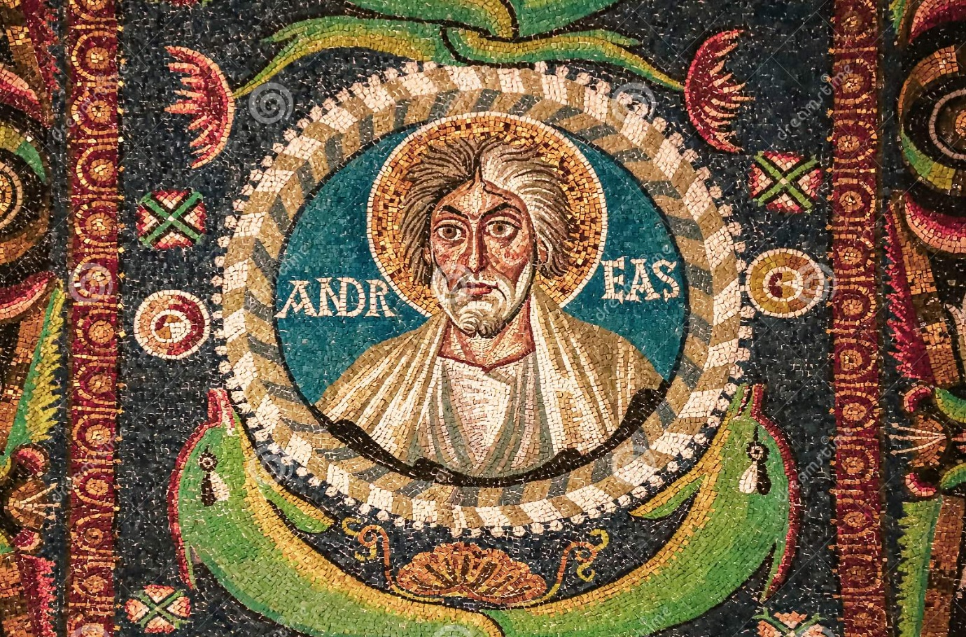
This famous mosaic is in the Church of San Vitale, in Ravenna, Italy. It has a number of typical features of how St Andrew is imagined.
St Andrew is usually portrayed as an old man with quite wild hair and beard. He has a halo around his head to show that he is a holy person.
Various attributes identify him in art and sculpture: a fishing net or a catch of fish (because he was a fisherman), a gospel (because he was a disciple of Jesus and mentioned in the gospels) and a large X shaped cross, which is recorded as the way he died by crucifixion.
Icons are often considered to be windows into the heavenly world. They are not so much representations as ways of engaging a spiritual response of prayer and devotion in the viewer.

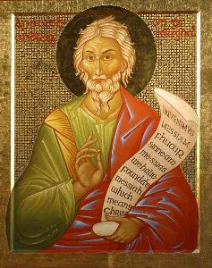

This icon, made by Sister Petra Clare, was given to the Scottish National Shrine of St Andrew in St Mary’s Cathedral, Edinburgh in 2004. The words on the scroll are the words of St Andrew to his brother Peter, ‘we have found the Messiah’ written in Latin, Gaelic and English. The saint gazes out at us making a sign of blessing upon us. The Cathedral website tells us that:
‘In eastern tradition St Andrew is shown in green, or in red to recall his martyrdom. The gilding, which forms the background of the icon, represents the mystery of God. The red line at the top of the icon reminds us that salvation has been made possible through the spilling of the Precious Blood’. .
https://www.stmaryscathedral.co.uk/standrew
More about Sister Petra Clare and icons:
https://www.exw-onlineiconcourse.org/index.html
https://www.instagram.com/sr.petraclare/?hl=en
https://www.thewayofbeauty.org/blog/2010/04/the-icons-of-catholic-painter-sr-petra-clare

Some things to do:
- How do you imagine St Andrew? (You could look at some of the pictures on some of the other resources for ideas.)
- If you were going to produce a picture of St Andrew to encapsulate his life for others, what would you put into the picture and why? You could try icon making, tapestry or painting.
- Try to visit a church dedicated to St Andrew (or look online) and find out if St Andrew is celebrated visually there.

The Mission: The Traditions and Travels of Andrew

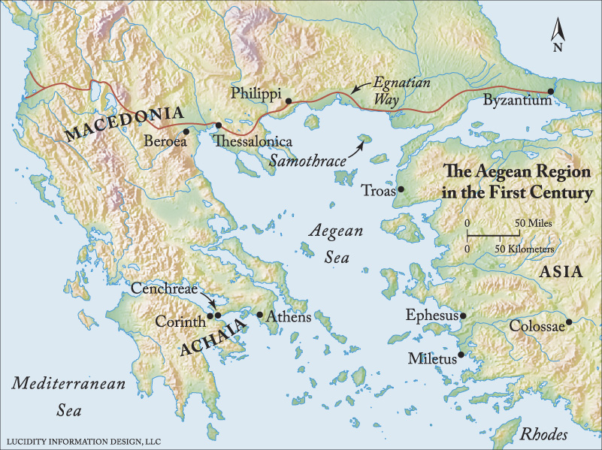

There are a huge number of traditions in many countries which tell that St Andrew visited them, preached the gospel, created disciples and established churches and communities and there are churches dedicated to St Andrew across Europe, Africa and Asia. Various separate traditions tell us that Andrew travelled extensively after the Ascension of Jesus, preaching about Jesus Christ to everyone he encountered. There are traditions from as far away as Kazakhstan, Syria and Russian people who settled in Italy.
The first missionary journey of St Andrew was said to have been from Jerusalem to Gaza and then Lydda in Palestine. Then on to Antioch and then Ankara and Edessa in what is now Turkey. He is said to have converted the King of Edessa to Christianity. Some traditions then say that Andrew travelled on to Byzantium (Constantinople/Istanbul) and appointed its first bishop there, St Stachys, who was said to have been one of the wider set of disciples of Jesus. Andrew then went on to Bythinia, Cappadochia and Galatia and into northern Turkey. Traditions about him then say that he went to Georgia, Armenia and the Caucuses before returning to Jerusalem.
The second missionary journey took St Andrew from Jerusalem into Central Asia, initially going the same route but then taking a ship from Antioch to Ephesus, intending to meet up with St John. He stopped briefly in Cyprus. Cypriot tradition says the ship needed fresh water, but there wasn’t any, so he prayed until water began to flow from a rock.
Andrew then went from Ephesus to Antioch and then to Nicea and then from Pontus to Georgia. After this a number of traditions say that he went to Persia, through Kurdistan and then on through the desert to what is now the Pakistan-Iranian border. On this trip he is said to have met the ‘dog-headed’ people who looked very frightening and were very fierce. Syriac sources say that when St Andrew first encountered them he was terrified of them and made to run away by realised after a strange scent of incense that God wanted him to go there. He discovered that underneath their fierceness they were kind, hospitable people and when they heard the gospel, they were transformed into peaceful people and stopped being terrifying and fierce.
Tradition then says that he went back through Pakistan and Afghanistan on the Silk Road to Uzbekistan and even close to the border of China. He travelled roads not usually used by traders and travellers and apparently travelled with nomads. There are even Siberian traditions about him having been there! Many Russian traditions show a belief that he was in Russian cities, preaching there. After travelling through Kurdistan, he returned to Jerusalem.
The third missionary journey is recorded in Coptic Ethiopian traditions after the first apostolic synod in 49AD. This was to have been a special journey, outside the missionary tasks shared out by the apostles. The Coptic traditions say that St Andrew travelled all over Africa including in Ethiopia, and his special task was to rescue St Matthew who had been captured by people who were supposed to eat human flesh. By contrast, St Andrew is said in these traditions to have been a strict vegetarian. Islamic traditions and memories also record this. St Andrew is supposed to have successfully freed St Matthew and fought off a demon with the help of the Archangel Michael. The people living there were so impressed by this spiritual battle that they became Christian.
St Andrew’s fourth and last missionary journey was to the north and to southern Russia, to the Crimea and Ukraine. Artefacts, such as coins, have his image on them from the region. It is then thought that he travelled around northern Europe and then went to Romania. There is cave where he is supposed to have lived for a number of years: http://www.romanianmonasteries.org/other-monasteries/dobrogea-monasteries/cave-st-apostle-andrew Romanian Orthodox Christians are especially devoted to St Andrew because the tradition says he spent more of his time resting from his travels there. Finally he is thought to have gone back to the Crimea and then on to Greece, where he was crucified in Patras.
Find out more in: George Alexandrou, The Astonishing Missionary Journeys of the Apostle Andrew (The Road to Emmaus series, 19)

Digging into the Mission
- Using a map, plot out some of the routes from these missionary journeys. How do you think Andrew travelled about and what kinds of problems and dangers might he have encountered?
- How do you think traditions about visits from the apostles develop? What kind of traditions could develop from your local area if you started with a famous person visiting today?
- Think about some places you have visited and look at some photos you have taken or souvenirs you bought. How might you tell your family about your travels and what might make them remember your stories?
- What would a St Andrew travel trail look like if you were going to highlight the different churches and places that think he is special to them. How could you create an exhibit for a church in this country to build links with these Christians?

The Miracles: The Death of St Andrew

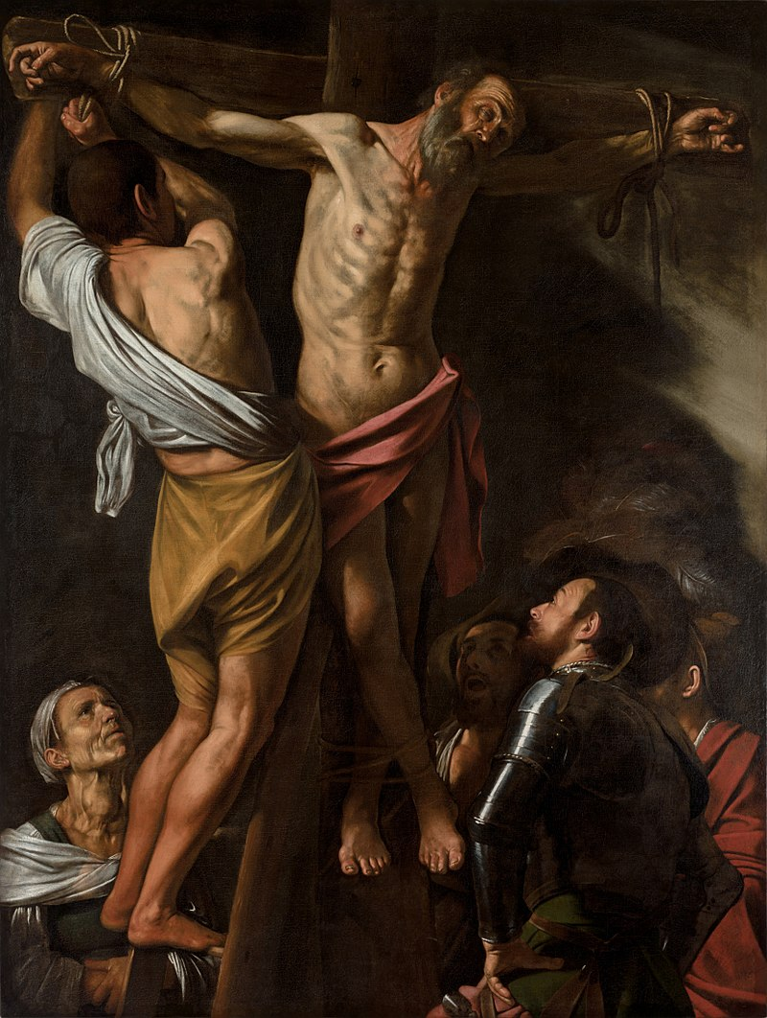
Caravaggio: the Crucifixion of St Andrew, Cleveland Museum of Art by permission

In the traditions of the saints, the reasons for which they died and the manner in which they did so are always very important. Typically, the end of a saint’s life is portrayed as a source of hope and inspiration for Christians, and sainthood vindicates their suffering and death, particularly in times of persecution of the Christian faith. Martyrdom is how saints pass into Christian tradition and memory and is often the point at which the myths, legends and wonder stories begin to accumulate around them as people think more about what their Christian lives meant. The deaths of the saints are often associated with miracles, either at the time of their death or in association with their bodies afterwards – a sign of the holiness of the person who died.
The story of the death of St Andrew, as with his life in The Acts of Andrew, mirrors that of Jesus.
Andrew falls foul of the proconsul of Patras in Greece, because he had brought the proconsul’s wife, Maximilla, to faith in Jesus Christ and she had left her husband and begun to live as a Christian. He was first imprisoned, and then sentenced to being beaten and crucified, with his legs unbroken to make sure he suffered on the cross for a long time.
A Christian called Stratocles tried to rescue Andrew (rescue attempts on people condemned to crucifixion were quite common) but Andrew says he has to go through with the crucifixion.
Seeing the cross set up on the sand by the seashore, Andrew spoke to his cross, praised it, and meditated on its significance:
‘Well done, thou that didst clothe thyself with the Lord, and didst bear the thief as a fruit, and didst call the apostle to repentance, and didst not refuse to accept us!’
Andrew was tied to it not nailed (as in Caravaggio’s painting, above). Later tradition from the Middle Ages says that the cross was X shaped and that is where the idea of the saltire comes from.
Andrew is then said to have smiled and laughed as his followers looked on. He then continued to preach to them for a day and night as there were people there looking on who did not yet believe in Jesus Christ. A crowd went back to Aegaetes the proconsul and told him to free Andrew who feared a rot and said he would let him go. But Andrew refused to be released. Aegaetes tried to cut him down but at that point, Andrew gave a final testimony and died:
‘But do thou, Jesu Christ, whom I have seen, whom I hold, whom I love, in whom I am and shall be, receive me in peace into thine everlasting tabernacles, that by my going out there may be an entering in unto thee of many that are akin to me, and that they may rest in thy majesty’.
Maximilla takes down the body, cares for it and has it buried, refusing to return to Aegaetes, who throws himself from a building.
You can read the full story here:
http://www.earlychristianwritings.com/text/actsandrew.html
Miracles are said to have occurred at the various shrines of St Andrew. For example, in Amalfi where some of his relics reside where the church there celebrates the appearance of ‘St Andrew’s manna’, a holy oil with which people are anointed on special days.
St Andrew is said to have died on 30th November and that is why his feast day falls on this day.
Digging into the Miracles
- Facts: Find out some more about the early history of the Christian church from different sources. How do you think the story of the death of St Andrew might have developed from this background?
- Explore how the death of St Andrew is celebrated and remembered in different countries and in different Christian traditions.
Lawrence OP/flickr, Icon of St Andrew https://creativecommons.org/licenses/by-nc-nd/2.0/
The Mystery: St Andrew Scotland’s Saint

MeRyan/flickr Ruins of St Andrew’s Cathedral

Reimagining Relics
In the early centuries of Christianity, the remains of holy men and women were considered especially precious and capable of working miracles. These relics were powerful objects to be treated with the utmost care and veneration. Wherever they rested, the place of their rest was to be considered holy and so very often became a place of pilgrimage as people sought out that holiness, often for superstitious reasons as well as genuine expressions of faith. Bones of the apostles, because they had been so close to Jesus, were (and often are) considered important because they span time back to when Jesus walked the earth. It means those long-remaining bones had been in his presence and can act as a sort of time bridge, through prayer and imagination, back to Jesus as a living person. A whole skeleton was not needed, just a fragment of bone would have the same sacred importance.
Of course, ordinary human corruption and religious politics has played about with many of these relics. Holy relics were traded, stolen and argued over. And it is in the midst of this kind of dealing that we learn about how some relics of St Andrew came to Scotland.
St Regulus (or St Rule), who lived in Patras in Greece where St Andrew died on the saltire cross, is said to have become worried that the remains of St Andrew were going to be taken away by invaders and removed to Constantinople (Istanbul).
A legend says that St Regulus was told by God in a dream to conceal some of the bones of the apostle and to do so ‘at the ends of the earth’. He was told to raise a church dedicated to St Andrew when he finally arrived at a destination. So St Regulus went to sea carrying a kneecap, and upper arm bone, three fingers and a tooth of St Andrew. He sailed west because that was the direction of the end of the known world. Eventually he was shipwrecked (or stopped by an angel) on the coast of Fife and so it was to Scotland that these remains of St Andrew were brought. The place where he stopped is now, appropriately, St Andrews.
In the 11th century, Robert the 1st, the prior of the monastery at St Andrew’s, built a church dedicated to St Regulus with the purpose of housing the relics of St Andrew in that church. In the picture above, the square tower is called St Rule’s tower. As word spread about St Andrew, pilgrims came from all over Britain to visit the shrine and pray there.
In reality, the relics of the apostle were probably brought to England later as part of the Augustine mission in 597 and moved to Scotland in 732.
As time went on, the idea that St Andrew, one of Jesus’s closest friends, had ‘chosen’ Scotland became politically important and so St Andrew became the ‘patron saint’ of Scotland and his manner of death, the saltire, became the flag of the nation and still is today.
In 1559, the Shrine was destroyed as a result of religious differences and wars. But in 1879 Archbishop Strain of the Roman Catholic Church in Scotland received from the Archbishop of Amalfi a large part of the shoulder of the Apostle Andrew. It was placed in St Mary’s Roman Catholic Cathedral in Edinburgh within a silver gilt shrine. Another relic of St Andrew was donated by Pope Paul VI to the Scottish Cardinal Gordon Joseph Gray, in 1969, with the words ‘Peter greets his brother Andrew’. In 1982 both relics were placed inside the altar to the north of the High Altar. This chapel now serves as the National Shrine of St Andrew. https://www.stmaryscathedral.co.uk/standrew

Digging into the Mystery:
- How do you think St Andrew is entwined with Scottish identity, history, independence and integrity?
- How do you view the relics of the saints?
- Find out more about online or in person about St Andrews in Scotland, the history of the Saltire flag, or the National Shrine of St Andrew. https://www.visitscotland.com/destinations-maps/st-andrews/see-do/ https://en.wikipedia.org/wiki/Flag_of_Scotland https://www.stmaryscathedral.co.uk/standrew
- Why do you think people go on pilgrimages to visit the shrines of saints?

The Man: Following in the Footsteps of St Andrew First Called

If we want to learn from the example of St Andrew and, as pilgrims, follow in his footsteps, one of the things we can take from finding out about him is that he recognised the truth when he saw it in the person of Jesus and had no hesitation in pursuing that truth. He didn’t go home and think about it; he didn’t form a committee; he didn’t go and ask his family what they thought. He trusted his own teacher, John the Baptist and trusted his own gut instincts and sense of rightness.
When Jesus offers him an invitation, ‘Come and see’, Andrew goes and stays with him and that first period of time spent with the teacher is enough to deepen in him the conviction that He has encountered the Messiah. This is the day that Andrew says yes to God.
After that, Andrew wants nothing more than to bring others to see Jesus, starting with his brother. He becomes an evangelist.
So, in the Orthodox tradition, Andrew is called the ‘First Called’ and he is remembered for being the first of Jesus’s disciples to hear and respond positively to the call of Jesus to follow him. Other people were more hesitant about following Jesus, wanting to have a think about it, sort out their family business, or not wanting to give up their possessions and wealth to give everything to God. Andrew however, simply stops what he is doing and goes with Jesus.
We may think that an encounter with God will give us the directions we need for our lives, when we find out the truth about the meaning, value and purpose of life. But that is not necessarily true. In reality, a faith journey usually has a lot of twists and turns in it, even if there was a decision or a cherished moment of giving a life over to become a Christian.
So Andrew the first-called is there to inspire us with his unequivocal yes to God. What might that mean for us?
Have a look at this video of a young man talking about being named after St Andrew after being born on his feast day, November 30th, which is the day St Andrew is supposed to have died after his crucifixion.
He says, ‘I live my days by how much I say yes to God’
https://www.youtube.com/watch?v=UfjEw7Pa_G0
St Andrew might have inspired others by his passion and love for Jesus. Where do you see people inspiring others in faith today?
Responding to the challenge:
- Do we really want to encounter God in our own lives?
- When God meets us and invites us, will we say yes to God wholeheartedly?
- Will that make us want to tell others about our faith in Jesus – starting with our own family and all those we love?
- How can we follow in the footsteps of St Andrew, really journeying towards Christ?
- Why not see how many people called Andrew that you know and tell them something interesting about their namesake?

Anlex Basilio/flickr Praise
The Mission: Following in the Footsteps of St Andrew Bringing Others to God

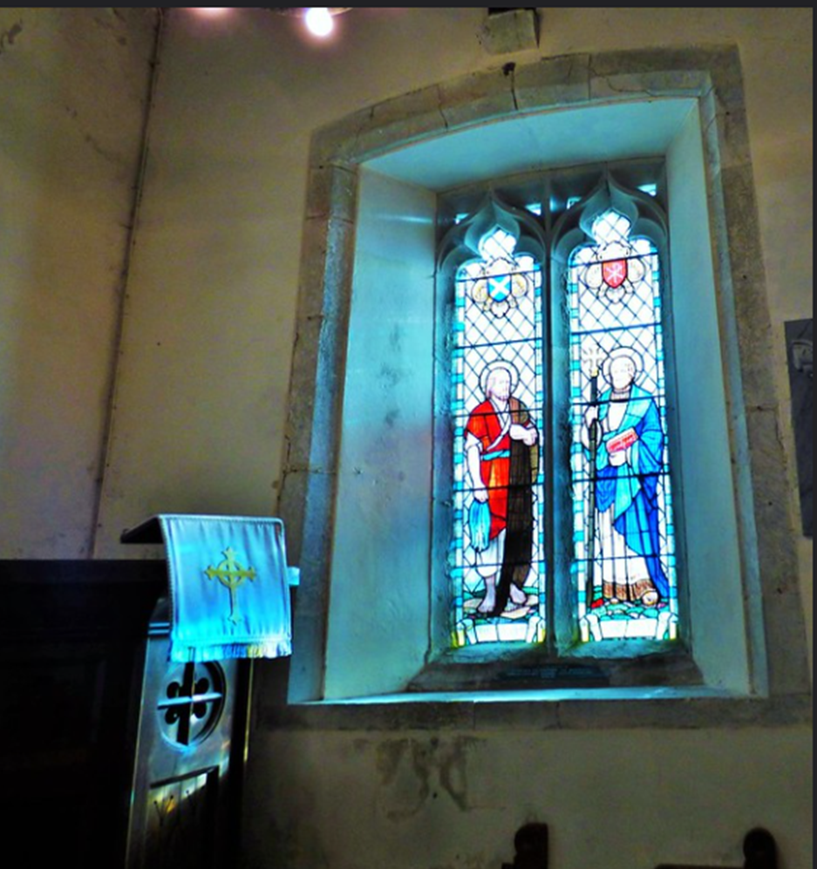
Grassrootsgroundswell/flickr St Andrew’s, Jevington

One of St Andrew’s particular attributes as a missionary for the Christian faith is his ability to bring people to God. We see this at work in telling his brother Simon Peter to come and find Jesus, in bringing the boy with the loaves and fishes to Jesus for the miracle of the feeding of the five thousand and also in John 12.20-26, which is worth considering:
Some Greeks Wish to See Jesus
‘Now among those who went up to worship at the festival were some Greeks. They came to Philip, who was from Bethsaida in Galilee, and said to him, ‘Sir, we wish to see Jesus.’ Philip went and told Andrew; then Andrew and Philip went and told Jesus. Jesus answered them, ‘The hour has come for the Son of Man to be glorified. Very truly, I tell you, unless a grain of wheat falls into the earth and dies, it remains just a single grain; but if it dies, it bears much fruit. Those who love their life lose it, and those who hate their life in this world will keep it for eternal life. Whoever serves me must follow me, and where I am, there will my servant be also. Whoever serves me, the Father will honour’.
In this passage of St John’s gospel, we learn that some Greek people are interested in meeting Jesus. They talk to Philip, who came from Bethsaida, which as we noted in Yellow Journey 1 The Man: Andrew, Son of Jonah, was a culturally diverse place. They could therefore probably converse easily with Philip (who, like Andrew, has a Greek name). It is not surprising then, that Philip tells Andrew about their request and their needs and that Andrew, together with Philip, makes it possible for them to meet with Jesus, who then answers their questions.
So Andrew as a missionary is a facilitator, a person who understands needs and then creates what is necessary to fulfil them, whether that is to bring people face to face with Jesus or to make it possible for spiritual longings and desire to hear truth to be fulfilled, or to fill the stomachs of hungry people. St Andrew is also someone who does not stay in the limelight, but having done his part, gets out of the way for Jesus to work in people’s lives.
Responding to the Challenge:
- How could we be more like St Andrew in reaching out to our families, our friends, and to strangers who are asking questions about faith?
- How can following in the footsteps of St Andrew in this way, help us meet more people as fellow searchers and pilgrims?
- How can we change to become more discerning of what people really need in their lives?
- How can we learn more humility to stop getting in the way of God’s work? What might we need to stop doing as individuals, as Christians, or indeed, as a Church?

Przemek Więch/flickr meeting on a hill
The Miracles: Following in the Footsteps of St Andrew Doing as Jesus did
In The Acts of Andrew, we hear about how St Andrew preached to people who had not heard about Christian faith, as well as healing people who were sick in mind or body, and raising people from the dead. In this sense, the miracles of Andrew draw us back to the kinds of thing Jesus did during his ministry, reminding the readers of the Acts of Andrew about the Lord whom he served. So the story of St Andrew in The Acts of Andrew is designed to inspire us to walk in the footsteps of Jesus. How can we go about that?
St Andrew as a Patron Saint
One of the ways we can do that is to delve more deeply into what Christian tradition offers us. One of those traditions is the idea of a patron saint.
Richard Mortel/flickr Rope-making display

What is a Patron Saint?
Patron saints embody the idea of heavenly advocates who attends to the prayers of those who call on them. In some Christian denominations, Christians direct prayers to a particular saint on the understanding that there is something about that saint’s earthly life and experience that frames and shapes that person’s prayers to God. Christians in some other denominations do not think advocates are necessary and so pay less attention to this aspect of sainthood within the tradition.
However, many people who are not Christians are fascinated by the idea of patron saints and the often rather strange things they seem to be patrons of. In order to understand where particular saints ended up with their list of patronages, we need to dig down into the stories about them to understand how they became associated with particular groups and people.
For example, St Andrew is the Patron Saint of:
fishermen, fishmongers and rope-makers, textile workers, singers, miners, pregnant women, butchers, and farm workers.
He is also said to be able to help with:
protection against sore throats, convulsions, fever and whooping cough.
He is also the Patron Saint of various countries including, Barbados, Romania, Russia, Scotland, and Ukraine. He is patron of individual places such as Sarrzana, Pienza and Amalfi in Italy, Esgueira in Portugal, Luqa in Malta, Parañaque in the Philippines and Patras in Greece.
St Andrew is also thought of as the founder of the Church of Byzantium and is the patron saint of the Ecumenical Patriarchate of Constantinople.

The Gospels tell us that Andrew was a fisherman so his association with all aspects of that trade makes a lot of sense, but where do the other patronages come from? Many of the associations come from the stories and legends about St Andrew as told particularly in The Acts of Andrew and The Golden Legend. For example, The Golden Legend tells a story about a woman who had terrible complications giving birth and who asked her sister to go and pray to the goddess Diana for help. But Diana replied to her sister that she was unable to help; she needed Andrew the apostle.
The sister of the unfortunate woman finds and brings Andrew just as the pregnant woman is about to die. He tells her to stop living an evil life and turn to Christ and when she does so, the baby is born. (In The Acts of Andrew, the end of the story is more gritty and perhaps more realistic - and the baby dies).
Because of this story, St Andrew became associated with the needs of pregnant woman and through that, a patron saint.
At the heart of all these stories is a central truth: that becoming a Christian and following Jesus in Christian discipleship will transform your life. Saints like Andrew, and the stories surrounding them, point the way to Jesus. By following in the footsteps of the saints, we can become more like them.
Responding to the Challenge:
If you reflect on your own life and experiences – what could you be a ‘patron’ of? It might be your job, something to do with your family or a time when you helped someone. How could your own skills, experience and memories be of help to others? Where might talking about faith come into giving that help?

The Mystery: Following in the Footsteps of St Andrew Inspiring and Transforming the World
Colby Stopa/flickr St Andrew’s Church, Kiev/Kyiv

In various resources in this series, we have looked at how St Andrew is venerated in many countries and Christian traditions and how his life and faith inspired others to give their lives to Christ, found churches and pass on the faith to others.
That inspiration takes many forms, and in this section, we look at three of them: a poem, a community and a TV programme.
The poem: Andreas
As with much Old English poetry, Andreas, is a wonder tale of a great superhero. Filled with passion for Jesus, Andrew sets forth to take part in a great spiritual battle, overcoming all sorts of evils in order to spread the word and lead by example, inspiring everyone he meets. Jesus goes with him, disguised, for example, as a helmsman of the ship on which Andrew travels, guiding him to safety and strengthening his resolve. Based probably on a translation of The Acts of Andrew, the writer creates a word-picture of detail and brilliance.
‘Then came the morning-shine, brightest of beacons over the water, holy from the gloaming. The candle of heaven gleamed over the sea-floods. Andrew found there the ship-wards, proud and glorious men, three thanes sitting in their sea-boat, such as they had come in over the sea. That was the Lord himself, the Wielder of Multitudes, the Eternal Almighty, along with two of his angels. They were in the raiment of seafarers— nobles in wave-sailors’ guise who bounce in the water’s embrace across the distant wave in ships upon the cold water.’
Read the whole poem at https://oldenglishpoetry.camden.rutgers.edu/andreas/
The poem brings the traditions of Andrew’s travels wonderfully to life. The writer enters imaginatively into the idea of the apostle setting out on this mysterious, supernatural ship. Designed to be said or sung, the poem would have brought the story of St Andrew to a wider audience.
The Community: Barbados
Although St Andrew is the patron saint of Romania, Russia, Scotland, Ukraine, he is also, amazingly, patron saint of Barbados. One of the parishes on the island is named after him and the Order of St Andrew is the country’s highest national award. The X shaped cross of St Andrew is also represented as two sugar canes on the coat of arms. When the British came to Barbados, they imagined its scenery to be like that of Scotland and so St Andrew became associated with it. The Christians of Barbados adopted St Andrew as their patron and his example inspires their Christian life and culture. You can find out about the Anglican diocese of Barbados and its life and work here, for example: http://anglican.bb/Content/?documents

The TV Video: The Chosen
The Chosen is a crowdfunded TV project which claims to show Jesus through the eyes of those who knew him. So the series includes St Andrew among the characters (played by Noah James). In the scene below, based on Luke 5.1-11, the fishermen, including Andrew are shown bringing in the great haul of fish after Jesus tells them to let down their nets. Jesus laughs at the scene. Andrew and Simon Peter are thoroughly amazed. The director takes the gospel and imagines how the scene might play out in order to bring the call of the disciples, including Andrew, to life.
https://www.youtube.com/watch?v=hWGCkovAUWM

Responding to the Challenge:
- How do you think St Andrew might inspire your own life?
- What else would you like to learn about St Andrew and where might you go to find out?
- How might you be inspired to create something or to change something to make the world a better place for everyone?
- How else might you now follow in the footsteps of St Andrew and arrive at your destination in Christ?
- Tell us how you were inspired or what you found useful in these resources. You can leave feedback at https://www.spiritualjourneys.org.uk/ask/ask_email.php

