Myths, Miracles, Mysteries, Mission – following the Saints
Introduction

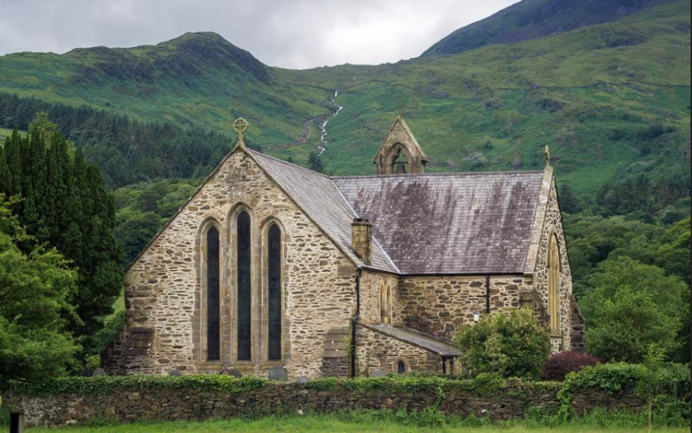
Adam Court/flickr St Mary’s Church, Beddgelert, Wales, UK
Have you ever walked past a church and noticed that its name is that of a saint? And have you ever wondered why so many churches seem to be called after saints?
By the fourth century, it began to be the practice to dedicate new churches to a ‘patron’ saint. Images of that person were often displayed in the churches and the name of the saint would be displayed. Today, many churches are dedicated to all kinds of saints, but some Christian denominations now do not use them to dedicate their buildings.
The Christian creeds, our statements of what we believe, say that ‘we believe in the communion of saints’, - holy women and men who have been faithful followers of Jesus Christ and who have often lost their lives through persecution of the Christian faith. Some Christian denominations recognise saints ‘days’ in the Christian calendar when particular saints are especially remembered and churches dedicated to particular saints hold special services, ‘patronal festivals’, on those particular days. Across the world, some of these dates are very well known outside the Church, such as St Valentine’s Day on February 14th or the St Patrick’s Day celebrations on March 17th.
Some saints are said to be ‘patron saints’ of particular groups of people, sometimes because of some event or legend about their own story. In the UK there are four ‘nation’ saints, St George for England, St David for Wales, St Patrick for Ireland, and St Andrew for Scotland.
This set of sixteen resources is designed to offer you a range of ways of finding out more about a saint called St George, the patron saint of England, and finding out about the man, martyrdom, miracles, and mysteries associated with him and to ask how we understand these things today.
There are four ‘pathways’ for you to follow, and you can mix and match them if you like. They are:
YELLOW JOURNEY – word-based resources for people who like to read information, talk about things and consider questions, perhaps in a study group. The Yellow Journey also guides you through the best information we have (eg the Bible for biblical saints) moving on to how we learn from, evaluate and use other traditions about the saints.
BLUE JOURNEY – for people who like to engage with Scripture, use prayers, and use Christian reflections. The Blue Journey also begins from the best information we have (eg the Bible) through to prayers and traditions associated with particular saints.
GREEN JOURNEY – image and activity based for people who like to explore, create, look at images and get out and about. The Green Journey also delves into things like the traditions of saints around the world, seeing them through the eyes of other Christians.
PINK JOURNEY – for people who want to explore Christian faith more deeply, find out more about following Jesus, and using the ‘lens’ of the saints to create opportunities for thinking about how we live our lives.
Another way to mix and match the resources is to follow the information across the four journeys about the person first and as much factual material as is available, then think about the mission of that person and where and how that was recorded, then move on to the miracles associated with that person and finally the mystery of the saints and what their stories might mean for us today.
You can use these resources whether you are a Christian or not, as an individual study or in a group of friends.
This grid shows you the range of the resources for St George and how you can mix them:

 | The Man | The Martyr | The Miracles | The Mystery
Yellow Journey | St George | St George is put to Death | The Unkillable faith of St George | St George and the Dragon
Blue Journey | St George as Witness | St Stephen: Protomartyr | Good and Evil | The Dragon in Revelation
Green Journey | Seeing St George | The Diocletian Persecution | The Shrine of St George | 23rd April a nation saint
Pink Journey | St George and a Rule of Life | ‘Christian Nationalism’ | Overcoming Violence | Following St George

Picture credits and links are listed at the end of the resources

The Man: St George

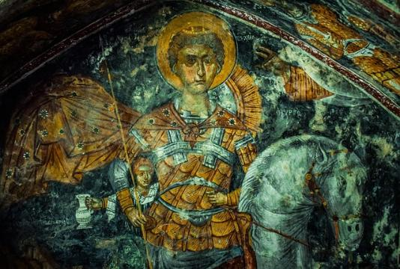
St George is thought to have been born sometime between 250 and 275AD and thought to have died on 23 April 303, although firm details about his life are not really known. He was thought to have been born in Cappadocia, an amazing rocky landscape of volcanic ash forming caves and chimneys, which is today located in modern Turkey. The Cappadocians are mentioned in Acts 2.9.
The trouble is that there is also a history of another, later, George of Cappadocia and sometimes the two get muddled up. George of Cappadocia was a heretical bishop who ended up being killed. The confusion was made worse by the famous writer Edward Gibbon calling him ‘St George of England’.
Cappadocia was at that time a province of the Roman Empire in Anatolia. It was an imperial province, meaning that its governor was directly appointed by the emperor. So the ‘real’ St George was a citizen of Rome.
His parents, Polychronia and Gerontios are thought to have come from various parts of Syria. One tradition says it was his mother who was a Christian and had St George baptised in secret as his father was not a Christian originally.
St George is traditionally said to have been a soldier in the Roman army, becoming a member of the prestigious Praetorian Guard for the Roman emperor Diocletian. He died when Diocletian ordered the persecution and death of Christians in the Roman army, but St George’s role as a soldier has made him especially venerated as a military saint. He is thought to have died at Diospolis, now Lydda/Lod. St Polychronia, his mother, is also venerated as a martyr, and is said to have been killed by Diocletian’s officers as well.

What this means for us today
When we look for information about saints and martyrs it is quite easy to find conflicting accounts or stories where other people have filled in the blanks. It can be confusing when saints have the same name or the dates and places of particular people overlap. Today, we see all kinds of people claiming St George or thinking that he represents this or that idea. But whenever St George, or any other saint, becomes an invention designed to intimidate or exclude others, we have to ask whether we need to step back and reconsider what we should learn from the stories of the saints. Hopefully, these resources will help with that!
Some questions to think or talk about:
- Without looking anything up, what do you think you already know about St George?
- What do you know about the region that was then called Cappadocia? Or about Syria? Or Lydda/Lod? What do you think it might have been like living in the Roman Empire in those times?
- What do you think are the most important features of St George the man – his ancestry? His military role? His parents? His location? His relationships with the politics of the day? His faith?

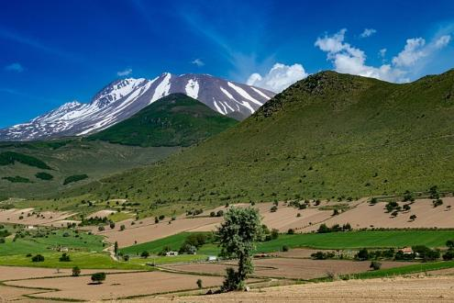
Anatolia today

The Martyrdom: St George is put to Death
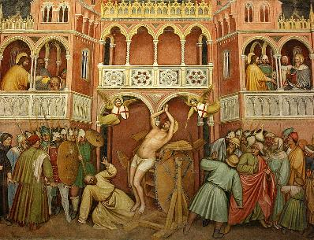
St George’s sainthood comes from his status as a martyr: someone who is persecuted and killed for their faith.
The Golden Legend, which gives an account of St George’s life and accomplishments, tells a typical story of how early martyrs were viewed. In such accounts, a faithful Christian is put to the test to see if he or she will give up their faith. These tests might be through pain and suffering or through trying to get the Christian person to worship or make a sacrifice to the gods of other religions. So there are physical, mental and spiritual tests. The tests inevitably result in the death of the Christian. Yet to endure the pain, deal with the mental stress and to keep the faith, is to pass the tests and to win the fight. The reward is a heavenly one, signalled often by an outpouring of miracles of healing and transformation, and the strengthening of faith or conversion to Christianity in those who witness the martyrdom. Death is never in vain.
Many such stories of martyrdom are about a basic power struggle, using faith as a weapon. In these sorts of stories, powerful leaders might see Christian faith as a weakness, a failure, or a threat. Power is underscored by extreme violence, but in many accounts, Christians undergoing the evil of violence are supported and comforted by God. You can see the angels helping St George bear his pain in the above painting from the Oratory of St George in Padua, which is worth a look
In the New Testament epistles and In Revelation, there is often a background of persecution and suffering, as Christians are encouraged to keep the faith and look forward to being with Jesus should they be killed.
As for you, always be sober, endure suffering, do the work of an evangelist, carry out your ministry fully. As for me, I am already being poured out as a libation, and the time of my departure has come. I have fought the good fight, I have finished the race, I have kept the faith. From now on there is reserved for me the crown of righteousness, which the Lord, the righteous judge, will give to me on that day, and not only to me but also to all who have longed for his appearing.
2 Timothy 4. 5-8

What this means for us today
Jesus warns his disciples that persecution of those who follow him will happen. But also says that the Holy Spirit will come to help them (John 15.18-26).
Stories of early Christian martyrdom aren’t just about persecution, suffering and death. They also include examination of exactly why human beings want to exert power over others, hurt them, and kill them, and why such evil will always be defeated in the end. Such stories also have another side, - of wanting to contrast what happens in our short earthly lives with the Christian hope of eternal life with God where no suffering or violence can exist.
The witness of martyrdom of course also points to Jesus’s death on the Cross and his willingness to die for all humankind, so that they might be saved.
Some things to think or talk about:
- In today’s modern world, what’s the point of being willing to die for a faith?
- Why do you think so many people are still persecuted for their faith in many nations today?
- What do you think about other-faith hatred and fear, such as antisemitism and anti-Islam rhetoric? What should Christians have to say about it?
- Jesus says, ‘For those who want to save their life will lose it, and those who lose their life for my sake will find it.’ (Matthew 16.25). What do you think he wanted the disciples to understand?

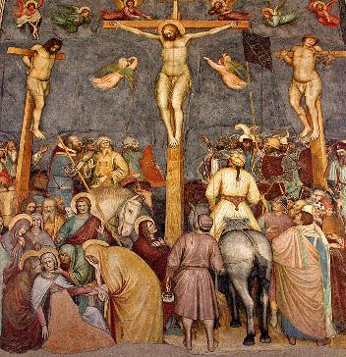

The Miracles: the unkillable faith of St George
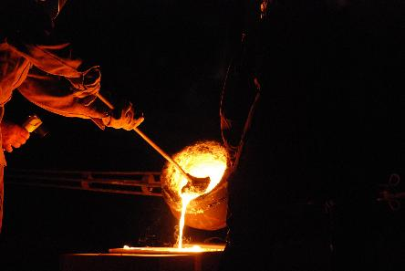
In The Golden Legend, we hear about attempts to try and make St George give up his Christian faith. First, we are told he was put on the rack and had his body torn and burned with salt rubbed into the wounds. But God comforted him and he did not feel the pain. Then he was poisoned, but because he made the sign of the cross over the cup, he did not come to harm. Then, he was plunged into a cauldron of molten lead, but George, making again the sign of the cross, experienced it as no hotter than ‘a refreshing bath’.
One of the important things in this story is about the way Christian faith enables us to deal with human evil. Evil exists, and because of it, human beings do terrible things to each other. But faith enables us to navigate our way through the dreadfulness of evil and suffering. George is tortured, poisoned, and burned but faith supports him and God comforts him.
What this means for us today
From a twenty-first century perspective, miracles of surviving physical harm and mental torture might seem laughable or offensive, given the appalling things that human beings continue to inflict on one another, and the senseless deaths so many people today are subjected to. But the deeper layer of the George story concerns how we experience hope as a consequence of living as disciples of Jesus. Early Christians understood that those who died for their faith and in imitation of Jesus himself, entered heaven and became witnesses and intercessors, saints whose deaths continue to shed meaning, healing and comfort into the fallen world. Death was therefore a source of spiritual enrichment, not a failure or humiliation. The perpetrators could not ever bring about a triumph of evil. The miracles, as in this account of St George’s tortures, underline this fact. Our hope is not in short-term possibility, or a stay from the evils of the world, but of a faith in a God who is loving and faithful. George experiences this faithfulness in the account of his trials. God does not forget us, or just let us get on with dealing with evil, but supports and comforts us, forever shaping before us the ultimate purposes of God’s mission which is that reality of the vision of the Kingdom which Jesus unforgettably puts before us.
For the time is coming when people will not put up with sound doctrine, but having itching ears, they will accumulate for themselves teachers to suit their own desires, and will turn away from listening to the truth and wander away to myths.
2 Timothy 4. 3
Some things to think or talk about:
- What do you think the stories of George’s trials are meant to tell us about Christian faith?
- What do you think George’s persecutors felt? What is the Second Letter of Timothy suggesting, do you think?
- How can we help those Christians who are being persecuted today? How should we feel about persecutors?
- Do you think some Christians are afraid of the faith of others? What would you say about those Christians who say they hate other people because of their faith?

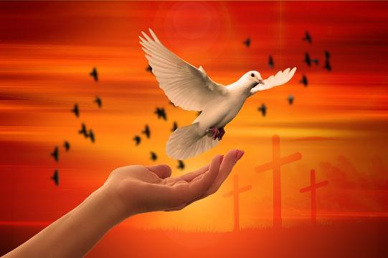
The Mystery – St George and the Dragon

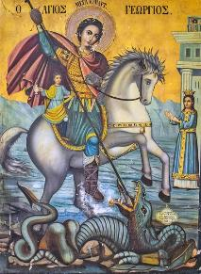
Many people who imagine St George, first think of the legend of St George and the Dragon. Maybe you have been to an English pub or hotel called The George and Dragon: there are quite a few around. The story runs like a fairytale. It begins with a terrifying dragon which wanted tribute from a village. The dragon started by demanding animals and treasure, but when these ran out, the villagers had to offer up humans to the dragon instead, which the dragon then devoured.
One day, a princess was chosen as the next sacrifice to the dragon. As she went to the dragon’s cave, crying, St George saw her and asked her why she was weeping. She told him all about the death-dealing dragon and its oppression of the village and told George to run away, lest it eat him too. But George bravely fought the dragon, killed it, and rescued the princess.
The story was first set in Cappadocia in the earliest versions of the tale, around the 11th and 12th centuries AD, but by the 13th century, the story was set in Libya. While we might think the story of St George and the Dragon is pretty unique, the story components are old and have been attributed not only to other saints but to pre-Christian myths and legends as well.
In the Lebanon, the story is told that St George killed the dragon in Beirut and this is why the Bay of St George, on which Beirut sits, was so named. Jounieh Bay, up the coast from Beirut, has a healing spring in a cave called Mar Geryes Al Bati in Arabic (the spring of St George) said to be where St George cleaned the dragon’s blood off his spear and sword. Some traditions also say it was the home of the dragon.
St George is very important to the Lebanon. Both the Greek Orthodox Cathedral and Maronite Cathedral in Beirut are dedicated to St George. One of the city’s mosques is adjacent to the Maronite Cathedral and St George has become a powerful symbol of the co-existence of the faiths.

What this means for us today
In Christian tradition, the fairy story of the handsome soldier and the beautiful princess was interpreted as an allegory of the Christian triumph over sin and evil. The dragon (or serpent) was interpreted as Satan looking for human souls to devour, with human beings powerless before the wiles of the Evil One until the Saviour Jesus comes to vanquish sin and death and deliver everyone from the grip of evil.
Even today, many films, TV series and video games play out the same sort of premise – good must struggle and ultimately triumph against evil. It is unthinkable that in God’s good world, evil, death and darkness can win. St George’s legend is timeless and appeals to people throughout the ages, in many countries and different faiths. His victory over the evils of persecution is a symbol of hope.
Some things to talk and think about:
- Why do you think the story of St George and the Dragon has such popular appeal?
- What Christian message for today might you take from the legend of St George and the Dragon?
- Why are stories of rescue and restoration so important? Where do you find such stories in Scripture?

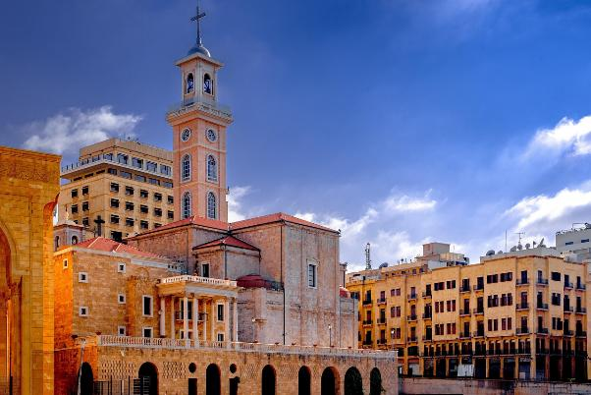
St George Maronite Cathedral, Beirut

The Man: St George as witness

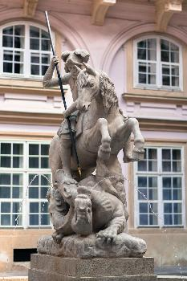
St George, Bratislava
Beloved, do not be surprised at the fiery ordeal that is taking place among you to test you, as though something strange were happening to you. But rejoice in so far as you are sharing Christ’s sufferings, so that you may also be glad and shout for joy when his glory is revealed. If you are reviled for the name of Christ, you are blessed, because the spirit of glory, which is the Spirit of God, is resting on you. But let none of you suffer as a murderer, a thief, a criminal, or even as a mischief-maker. Yet if any of you suffers as a Christian, do not consider it a disgrace, but glorify God because you bear this name. For the time has come for judgement to begin with the household of God; if it begins with us, what will be the end for those who do not obey the gospel of God?
1 Peter 4.12-17
This passage from 1 Peter makes the point that being a Christian comes with the responsibility of witness. Bearing the name of Christ is a privilege but should also say something about how we try to live, and what the standards of our Christian life should be. Our task, as followers of Jesus, is to glorify God. No-one should be a ‘mischief-maker’. We are to be bearers of Christ’s love into the world and show the fruits of the Holy Spirit. Being ignored, sneered at, or even attacked for our faith is not a disgrace; we are to rise above it, and we can do this because Jesus Christ is with us, guiding us and sustaining us.
It is interesting that so many nations and peoples find this example in St George the man and there are so many statues and stories of him to be found in different countries. There is something about his story which speaks of a larger, spiritual freedom, and a powerful witness to the Christian faith. Consequently he becomes associated with love for country, liberation from oppression and freedom for all.

Some questions to think, talk and pray about:
- How does the passage from 1 Peter speak to us about being Christian in our modern Britain?
- Why do you think St George appeals so broadly to so many people in different countries?
- If you met someone from another country that celebrates St George as a patron saint, what would you say in a conversation about George as England’s patron saint?
- How can we see being sneered at, ignored, or even attacked, as a blessing?
A Prayer for St George’s Day from the Church of England:
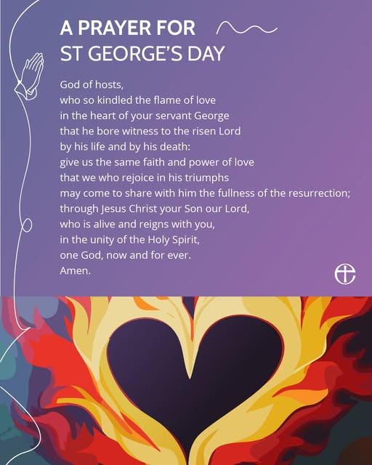
The Martyr: St Stephen, Protomartyr
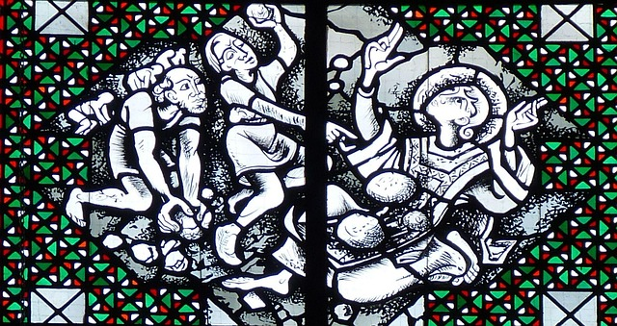
The Stoning of Stephen
When they heard these things, they became enraged and ground their teeth at Stephen. But filled with the Holy Spirit, he gazed into heaven and saw the glory of God and Jesus standing at the right hand of God. ‘Look,’ he said, ‘I see the heavens opened and the Son of Man standing at the right hand of God!’ But they covered their ears, and with a loud shout all rushed together against him. Then they dragged him out of the city and began to stone him; and the witnesses laid their coats at the feet of a young man named Saul. While they were stoning Stephen, he prayed, ‘Lord Jesus, receive my spirit.’ Then he knelt down and cried out in a loud voice, ‘Lord, do not hold this sin against them.’ When he had said this, he died.
Acts 7.54-60
This account in Acts of the death of Stephen, is thought to be the first descriptive account of Christian martyrdom, perhaps occurring around 34AD. So he is called the ‘Protomartyr’. As with the story of St George and other saints, Stephen, the steadfast Christian who is attacked for his witness to Christ, keeps eyes fixed on God and is given a vision of heavenly glory to sustain him during the ordeal.
We cannot forget that the death of Stephen is also surrounded by huge rage, violence, and horror. You might notice the ‘young man named Saul’ in the Scripture, and we can only imagine what sort of impression this act of deadly violence might have made on him, at this time himself a persecutor of Christians, as Stephen forgives his attackers to the last. In doing so, Stephen shows forth Christ who forgives from the Cross (Luke 23.34).
In Acts 9, on the road to Damascus, we hear how Saul is stunned by a divine flash of light and he and others with him hear the voice of Jesus, asking why Saul is persecuting him. Blinded, Saul is converted and becomes a follower of Jesus. He regains his sight when healed by Ananias and is then baptised as a Christian (see picture below). We can see that other stories of martyrdom follow this kind of pattern. Christian persecution at the hands of others acts as a powerful witness and results in conversion, not necessarily right at the time, but in God’s good time. In this sense, putting Christians to death is seen to be fruitless – hunting Christians down only draws more to Christ and evil is continually overcome.
Some questions to think about:
- Why do you think the story of St Stephen and other martyrs sends such a powerful message about Christian faith?
- Imagine you were in the crowd with St Paul (then Saul). What would you think and feel?
- What elements of the account from Acts do you see repeated in the story of St George?
A traditional Collect for St Stephen’s Day (December 26th)
Grant, O Lord, that in all our sufferings here upon earth, for the testimony of thy truth, we may stedfastly look up to heaven, and by faith behold the glory that shall be revealed; and, being filled with the Holy Ghost, may learn to love and bless our persecutors by the example of thy first Martyr Saint Stephen, who prayed for his murderers to thee, O blessed Jesus, who standest at the right hand of God to succour all those that suffer for thee, our only Mediator and Advocate. Amen.

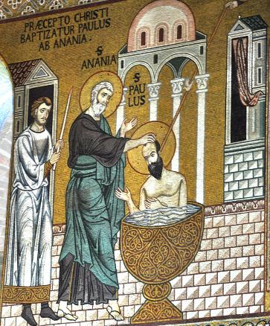
Baptism of St Paul

The Miracles: Good and Evil
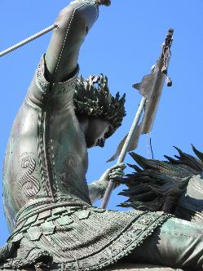
Another account of St George’s life is found in the Anglo-Saxon writer Aelfric of Eynsham, who wrote his Lives of the Saints around 993-997. You can read it here: https://projetocaedmon.wordpress.com/wp-content/uploads/2013/02/aelfric-life-of-the-saints-de-auguriis.pdf. He begins:
‘Heretics have written falsehoods in their books about the holy man who is called George. Now will we tell you that which is true about him, that their error may not secretly harm any one’.
In Aelfric’s account, there is no fairytale dragon. George is actually in a battle with the Devil himself and the account is full of devilish cunning and fiend-like attempts to get George to renounce Jesus. So the story of his trials is set against the powerful dark magic and the sorcery of an opponent called Athanasius. But the tables are turned: it is Athanasius’s faith in dark arts and sorcery that is put to the test.
‘Athanasius then speedily took; a great bowl, filled with a noxious draught, and dedicated all that drink to the devils, and gave it him (George) to drink, but it hurt him not. Then said again the magician, ‘Yet one thing will I do, and if that hurt him not, I will submit to Christ.' He took then a cup, with a death-bearing drink, and cried aloud to the black devils, and to the foremost devils, and to the most powerful, and in their names enchanted the fearful drink, and gave it to the Lord's saint to drink but the fiendish liquor harmed him not a whit. Then the sorcerer saw that he could not hurt him, and fell at his feet, praying for baptism and the holy George straightway baptised him.’
Aelfric’s account shows to us that the authority of Christ is over all and despite the best attempts of the Devil to test St George’s faith, he cannot be overcome. Instead, the evil magician is converted and saved, coming to faith through the witness to the miracles of St George under the protection of Christ.
Just as St George is often shown wearing his soldier’s armour (as in the picture) Aelfric makes his trials more of a spiritual matter – wearing the armour of God against the temptations and snares of evil. But not just holding out against evil; wiping it out so that it cannot exist anymore. Athanasius is baptised and saved.
Finally, be strong in the Lord and in the strength of his power. Put on the whole armour of God, so that you may be able to stand against the wiles of the devil. For our struggle is not against enemies of blood and flesh, but against the rulers, against the authorities, against the cosmic powers of this present darkness, against the spiritual forces of evil in the heavenly places. Therefore take up the whole armour of God, so that you may be able to withstand on that evil day, and having done everything, to stand firm. Stand therefore, and fasten the belt of truth around your waist, and put on the breastplate of righteousness. As shoes for your feet put on whatever will make you ready to proclaim the gospel of peace. With all of these, take the shield of faith, with which you will be able to quench all the flaming arrows of the evil one. Take the helmet of salvation, and the sword of the Spirit, which is the word of God.
Ephesians 6.10-17
Some questions to think, talk and pray about:
- What do you think about Aelfric’s spiritual take on St George’s story of good and evil? What other stories from Scripture does this remind you of?
- What do you make of George’s miraculous witness and Athanasius’s conversion to Christian faith? How important is it that Athanasius was baptised as a result of Christian perseverance and witness to God’s truth and love?
- How could we make the passage from Ephesians about the ‘armour of God’ more relevant to saints like St George and the focus on the ‘gospel of peace’?


Baptism

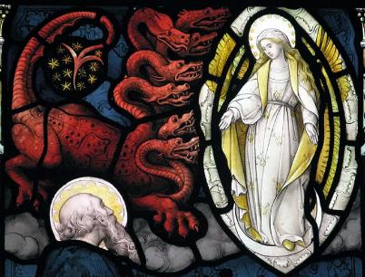
The Mystery: The Dragon in Revelation

The Woman and the Dragon
A great portent appeared in heaven: a woman clothed with the sun, with the moon under her feet, and on her head a crown of twelve stars. She was pregnant and was crying out in birth pangs, in the agony of giving birth. Then another portent appeared in heaven: a great red dragon, with seven heads and ten horns, and seven diadems on his heads. His tail swept down a third of the stars of heaven and threw them to the earth. Then the dragon stood before the woman who was about to bear a child, so that he might devour her child as soon as it was born. And she gave birth to a son, a male child, who is to rule all the nations with a rod of iron. But her child was snatched away and taken to God and to his throne; and the woman fled into the wilderness, where she has a place prepared by God, so that there she can be nourished for one thousand two hundred and sixty days.And war broke out in heaven; Michael and his angels fought against the dragon. The dragon and his angels fought back, but they were defeated, and there was no longer any place for them in heaven. The great dragon was thrown down, that ancient serpent, who is called the Devil and Satan, the deceiver of the whole world—he was thrown down to the earth, and his angels were thrown down with him. Revelation 12.1 -9
In the book of Revelation, the last book of the Bible, there is this amazing picture of a pregnant woman opposed by a terrifying devouring dragon. Traditionally, the woman is associated with the Virgin Mary, pregnant with Jesus, the Saviour of the World. The dragon is associated with Satan, who is set against God’s good purposes and wants to prevent Jesus coming to save the world. But the angels fight in a battle against the Devil and his followers and the Devil is thrown down and defeated, though his intentions to thwart God’s purposes are not.

Some things to talk, think and pray about:
- What does Revelation tell us about the larger meaning of ‘slaying the dragon’?
- Dragons and serpents feature in many mythologies and legends. In some cultures they are seen as evil, in others, as fortunate and powerful guardians. What do they mean to you?
- How does the legend of St George and the Dragon and the woman and the dragon in Revelation help us think about the meaning of what it is to be saved?
A Prayer
Lord Jesus Christ,
We thank you for the example of holy women and men
Who have kept the faith and witnessed to others that they might believe.
Watch over all who seek to serve you,
And over all who are persecuted and die for your name’s sake.
We pray for the defeat of evil and oppression,
We ask your blessing on all who fear the dragon -
Dragons of injustice, poverty, war, famine, disease;
Protect with holy angels all those whom the dragon seeks:
Dragons of temptation, serpents of sin.
We thank you that though the stars fall from the sky,
Yours is the Kingdom, the Power and the Glory.

Amen
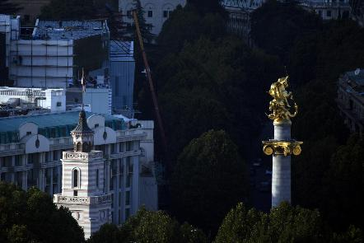
St George slaying the Dragon in Freedom Square, Tbilisi, Georgia.
The Man: Seeing George
The idea of St George as a warrior saint on horseback and killing the evil dragon is imagined in many paintings, icons, stained glass, and statuary. He appeals to the visual imagination, full of energy, his horse rearing and trampling as he overcomes the serpent-enemy.
Have a look at these pictures and see what the various artists have tried to do to represent St George.
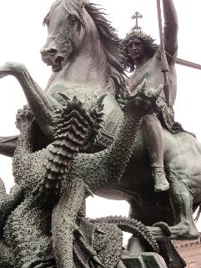
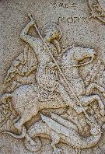
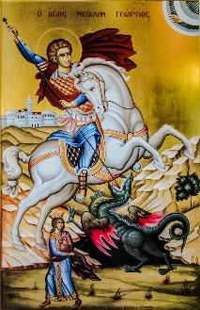
Suppose you were given a blank sheet of paper and asked to draw St George for some people, or for a class of schoolchildren. What would you try and include to tell his story and show who he might have been?
Seeing St George in the World: some things to do:
- Where does St George appear where you are? Have a look for a church that is dedicated to St George for example. What can you find out about St George from visiting the church? If you can’t find one that is local enough for a visit, have a look online at this site for St George’s Chapel, Windsor. or St George’s Roman Catholic Cathedral in Southwark, London.
- Have a look online for famous churches and monasteries around the world dedicated to St George and find out more about them. For example:
  - The Church of Saint George, Lalibela (Ethiopia)
  - St. George's Cathedral, Addis Ababa (Ethiopia)
  - St. George's Cathedral, Cape Town (South Africa)
  - St George's Greek Orthodox Cathedral, Tunis (Tunisia)
  - Saint George's Memorial Church, Ypres (Belgium)
  - St George Orthodox Syrian Church, Puthuppally (India)
  - The monastery of Mit Damsis (Ethiopia)
- Also find out about how Muslims see St George, because many also see him as an important religious figure. For some, he is associated with Al-Khadr/Khidr (the Green One, derived from the Arabic for ‘Green’). St George/Al-Khidr is also a favourite of the Druze, seeing him as a source of life, protection, a great warrior and a healer. The Druze often share veneration of St George at local places in the Lebanon, the West Bank, and Syria. For example:

‘One version of the story states that before his execution, St George was imprisoned at Al-Khader, near Beit Jala in the West Bank (though other places also claim this distinction – including the Greek Orthodox Church of St George in Cairo). A monastery now stands on the site and on St George’s Day (which in the Eastern church is celebrated on 6 May), local Christians traditionally process through the town and up to the monastery. A special service is held and bread marked with the symbol of St George is baked and given as an offering’. https://embraceme.org/blog/st-george-middle-east-links-and-legends

The chains on the site which are thought to have bound St George before his martyrdom are still in evidence. People sometimes symbolically bind themselves as a way of bringing about healing and protection. Other chains are housed in other churches and sacred sites associated with St George.

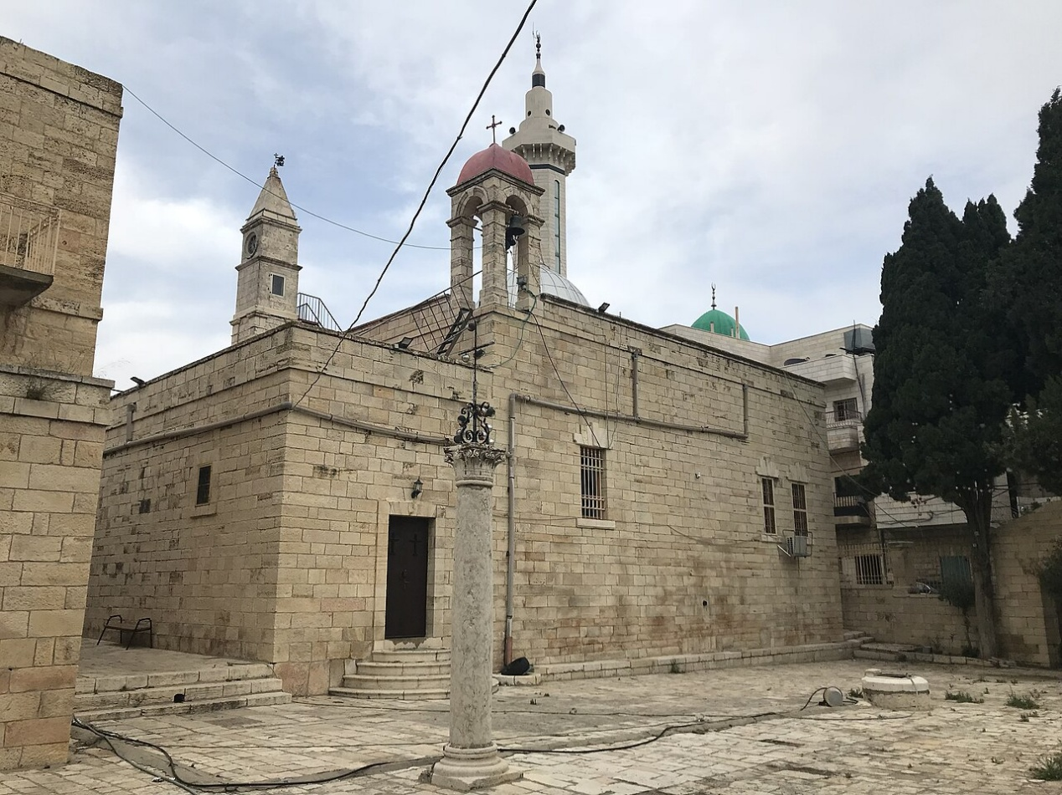
St. George's Monastery, Al-Khader

The Martyr: The Diocletian Persecution
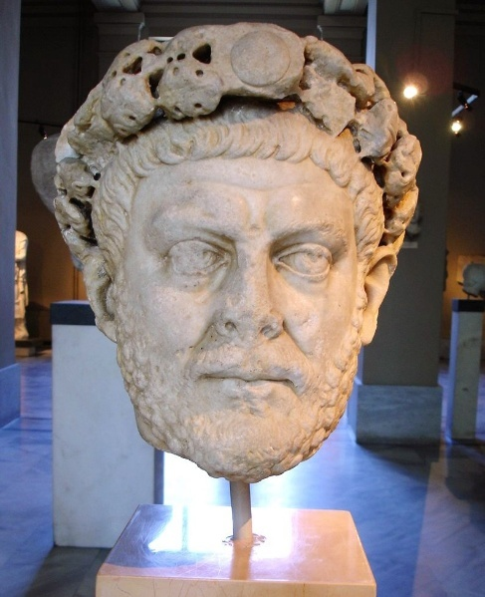
Istanbul - Archaeological Museum - Statue head of the Roman emperor Diocletian (284-305 AD)
Finding Out:
The Diocletian Persecution of Christians is sometimes called the Great Persecution, because it was the last and worst of the persecution of Christians that the Roman Empire pursued.
The persecution of Christians was not just about simply putting people to death, it was about stopping their legal rights and also about making them stop worshipping Jesus and comply with preferred Roman religious practices, like sacrificing at temples and recognising the Roman gods. Emperors issued edicts to enforce this.
The picture is complicated, however, not least because the Empire was so large, so the ways in which the edicts were enforced, varied. In Britain, the enforcement was less than elsewhere.
When Diocletian became Emperor in 284, his attitude to Christianity in relation to his political power hardened over time. He threw Christians out of the military, and got together opponents of Christianity around him, planning to create a legacy of restoring Roman glory and dominance. In 302, being urged to instigate a general persecution of Christians, Diocletian asked an oracle what to do, and received a reply that he should go ahead. A general persecution was instigated the following year.
Despite this, Christianity remained, though splits appeared in some communities according to whether they were thought to have compromised or collaborated with the Romans or accepted martyrdom. Historians disagree about whether a ‘cult’ of martyrs was exaggerated or not! But this is interesting when we consider the way the story of St George has been told and the account of his pretending to comply and then refusing. The story teases whether he is about to become a collaborator and a ‘traitor’ to the faith. He then turns the tables and shows himself one of the ‘pure’ who will not betray his faith.
However, after Diocletian, Constantine the Great (emperor 306-337) who had served under Diocletian, reversed the persecution edicts, becoming a Christian himself and Christianity was established as the religion of Empire.
Digging into the Story – some things to do
- Imagine you have a huge empire of land, people, trade and different religions to run. How would you keep everyone in order? How would you find out what was happening in different parts of your empire? How could you keep hold of your power without other people trying to take it away from you? Where would you see threats and problems arising? What would you do to keep the peace and keep people happy? How would you use your military?
- Now imagine where you can see these questions being worked out in today’s world. What are the results?
- What does Scripture tell us about nations and peoples under God?
- Find out more about Diocletian’s Palace – situated in what is now Split in Croatia.

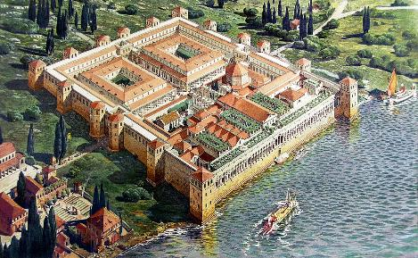
This reconstruction drawing by the French town planner Ernest Hebrard was published in 1912

The Miracles: The Shrine of St George
The Church of Saint George in Lydda, now Lod, in Israel, has a sarcophagus which is traditionally believed to contain St. George's relics. His body was said to be taken here because it was his home town and so a church was built over the place in the 5th century to honour him. That building has been destroyed and rebuilt several times but today is a Greek-Orthodox church dedicated to St George.
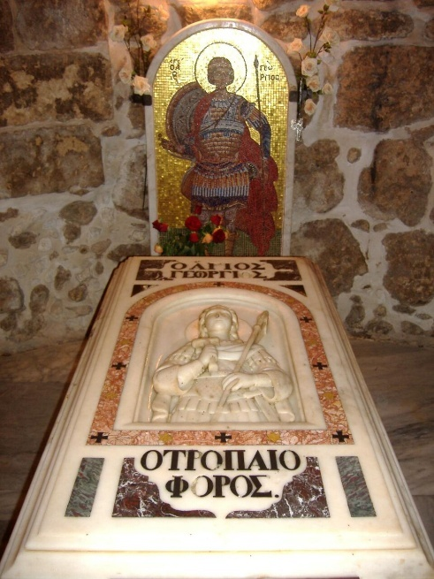
Pilgrims come to visit the tomb, which is believed to be the site of miracles of healing. Oil and myrrh are poured over the tomb and visitors often dip handkerchiefs or similar cloth in it to take home.
As with many saints, relics of St George are thought to be in a number of churches, including a part of his arm at the monastery at Mit Damsis. Other relics are in Rome, Cairo and Mount Athos. Even St George’s, Windsor, was supposed to have a piece of his skull, until it was lost at the Reformation!
What do we make of all these holy relics which are venerated by so many different Christian traditions?
Reimagining Relics and Shrines
In the early centuries of Christianity, the remains of holy men and women were considered especially precious and capable of working miracles. These relics were powerful objects to be treated with the utmost care and veneration. Wherever they rested, the place of their rest was to be considered holy and so very often became a place of pilgrimage as people sought out that holiness, often for superstitious reasons as well as genuine expressions of faith.
Today, we might wonder why Christians of the past set such store by bits of bone and human remains that may or may or not have belonged to a particular person from long ago, and why those Christians wanted to create shrines where people could start or end a pilgrimage, or kneel in prayer.
So how can we reimagine relics for today?
It might help to think about how relics point us to a physical body and a real person, and remind us that the saints are not some work of fiction or shadowy myth. In a sense, it doesn’t matter whether we can prove that such a relic actually belonged to this or that person; rather the relic points backwards in time to a human being made and loved by God, who lived and died and who can set us an example. Relics create linkages between miracle stories and the hard facts of our existence, - that we are creatures who live and die, and the fact that so many Christians have died because they loved God and were true to their faith – something which is still going on in the world today.
So what about shrines or venerated tombs? Why does having a shrine to some person in an abbey or a cathedral have anything to do with modern Christian faith?
People still feel the urge to make temporary shrines today. If we read in the newspapers about people who have died by violence, who should have been safe and happy, you will doubtless see that many people come out in public to grieve and leave flowers, candles, gifts and messages at the places where they died, even if they did not know the people concerned. There is a powerful human urge to express solidarity and sadness when tragedies occur, as well as the need to look for change and hope. Shrines dedicated to saints do not tell us that the saint was more deserving of attention, but become fixed locations where people can pray, find solace and a more focused direction for the journey of faith. That is why pilgrimage as a physical journey can be a good way to reflect and ponder on where next in the Christian life you might want to go.
Some people find it helpful as part of their tradition to believe that saints can pray for us. But you don’t have to believe that to find praying at a shrine meaningful. Just the idea that we are part of an ancient tradition of pilgrimage and prayer can connect us, not just to our own Christian community but to so many who have gone before and believed that prayer is not an empty gesture but that God does hear us and respond to us, and that the Holy Spirit directs us and inspires us.
So the physical locations associated with the body of St George as a person of flesh who lived and died as a faithful Christian, have become places where people find inspiration for their own lives, healing and a sense of new life as they discover, through prayer and pilgrimage, what wonderful things God has in store for them.
Digging into the Miracles – something to do
- Imagine you are an archaeologist and have just discovered a small human bone from the time of St George. Now imagine the body the bone belonged to, and then imagine that body as a living, breathing person. Now imagine that person’s family around them, and their daily lives. What might they have eaten for dinner? What clothes might they have worn? How would they travel around and what dangers might they have faced? If you find it difficult to imagine, do a bit of research to find out about life in those days long ago.
- Now imagine having a conversation with St George back then. What might you want to talk about? What might you want to ask him?
- Or: imagine meeting some pilgrims arriving at the monasteries founded by St George or meeting him on his journeys. Where might they have come from and what might they have hoped for?
- Or: go and visit one of the locations associated with St George, and talk to some of the other visitors about what they are doing there and what the visit means to them? See if that enables you to say something about your own faith and faith-journey.

The Mystery: 23rd April – A Nation’s Saint

23rd April is also Shakespeare’s birthday, so the Feast Day of St George and the birthday of England’s most famous playwright occur together. And many people will also remember the stirring speech from Henry V which mentions St George:

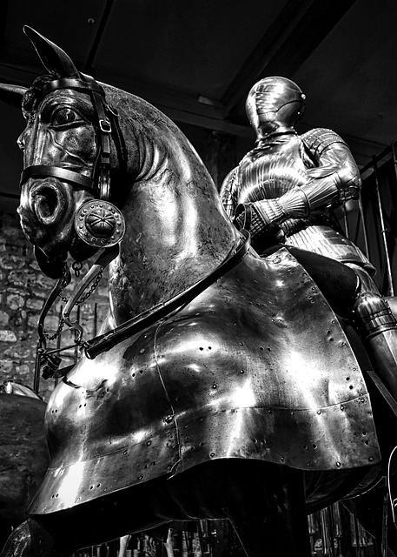
Once more unto the breach, dear friends, once more;
Or close the wall up with our English dead.
In peace there's nothing so becomes a man
As modest stillness and humility:
But when the blast of war blows in our ears,
Then imitate the action of the tiger;
Stiffen the sinews, summon up the blood,
Disguise fair nature with hard-favour'd rage;
Then lend the eye a terrible aspect;
Let pry through the portage of the head
Like the brass cannon; let the brow o'erwhelm it
As fearfully as doth a galled rock
O'erhang and jutty his confounded base,
Swill'd with the wild and wasteful ocean.
Now set the teeth and stretch the nostril wide,
Hold hard the breath and bend up every spirit
To his full height. On, on, you noblest English.
Whose blood is fet from fathers of war-proof!
Fathers that, like so many Alexanders,
Have in these parts from morn till even fought
And sheathed their swords for lack of argument:
Dishonour not your mothers; now attest
That those whom you call'd fathers did beget you.
Be copy now to men of grosser blood,
And teach them how to war. And you, good yeoman,
Whose limbs were made in England, show us here
The mettle of your pasture; let us swear
That you are worth your breeding; which I doubt not;
For there is none of you so mean and base,
That hath not noble lustre in your eyes.
I see you stand like greyhounds in the slips,
Straining upon the start. The game's afoot:
Follow your spirit, and upon this charge
Cry 'God for Harry, England, and Saint George!'

You can watch Kenneth Branagh perform this speech here: https://www.youtube.com/watch?v=VOOZDO5KDv4
This speech is often accompanied by thrilling images of knights in armour, fire, swords, war horses, and men showing eagerness to fight for their king and overcome others (in this case the French) through military might and nationalistic fervour. England has to win, to come out on top. You can imagine audiences in Shakespeare’s time being tremendously stirred by this powerful speech and filled with pride and excitement at being ‘noblest English’ called to be ‘worth their breeding’ and urged to fight or die for King, country, - and St George. It’s not surprising, then, that this speech gets rolled out for national sporting events in which England has a chance of winning – like football matches!

But of course, St George gets identified with this particular kind of English nationalism, as if Shakespeare had mysteriously simply invented him for that purpose. And so today, as England’s Patron Saint, we see similar language about being English, nationalistic bombast, and fighting for English ‘blood’ being repeated in popular rallies and online. Our current monarch and many politicians are sometimes berated online for seeking to be inclusive of all people in the United Kingdom, and churches which offer care and welcome to all in their communities are spoken about as not really embracing ‘English’ (or Shakespeare’s) Christianity.

Digging into the Mystery: some things to do

- Find films or videos of actors performing this famous speech – what do you notice about the way they perform the speech or the sets, costumes, backgrounds etc?
- Find out how different communities celebrate St George’s Day – what parades, dances and food do people enjoy?
- Find out how different churches dedicated to St George celebrate him
- If you were going to organise a day of celebration of St George as Patron Saint, what would you include, who would you invite and what would your day look like?
- Quite apart from England, many countries have St George as their nation saint. Including Portugal, Bosnia and Herzegovina, Bulgaria, Georgia, Ukraine, Malta, and Ethiopia. Additionally, the regions of Catalonia and Aragon, and even the cities of Moscow and Beirut have claimed St George as their patron saint. He is very popular! Find out how these places celebrate St George.



St George and a Rule of Life
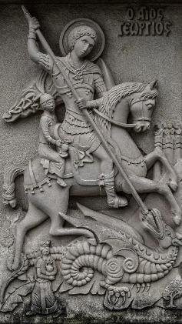
In The Golden Legend, when St George saves the princess from the Dragon, her father the king is overjoyed and offers George riches as thanks. But George refuses all honours and reward and instead gives the king a rule of life as a means of going forward from salvation from the devouring evil:
- To cherish the Church of God
- To honour the priests
- To go to Mass
- To remember the poor
The rule of life sets Christian faith as the heart of a person’s spiritual journey, nourished by worship and looking outward to helping and taking care of others.
What might it mean to live by this rule?
In the UK, there are church buildings everywhere. Some are spectacular, like so many of our cathedrals; others are simpler, smaller, many nestled at, and as, the heart of towns and villages. It is easy to take these buildings for granted, but suppose all these places of worship were closed or destroyed – how would you feel about the visual representations of Christianity and the communities and congregations they serve, being wiped out?
In some countries, church buildings, and worshipping congregations are attacked, burned and ravaged. Priests and people today are killed for their faith. In some countries where regimes have closed churches and employed a crackdown on Christian faith, Christians have gone underground, coming together in secret, to pray and read the Bible and to keep the faith alive. So does it matter if there are buildings or not? Does it matter more that Christians keep faith, teaching, and community together by any means? To keep the Word and the sacraments going by whatever means? And to continue to show Christian discipleship by helping those who are struggling, through poverty, illness or social oppression.
It's worth remembering too, that places of worship of other faiths are also routinely attacked and persecution of faith is something all major world faiths and their followers experience. https://www.mprnews.org/story/2025/10/12/grim-list-notable-attacks-on-houses-of-worship-around-the-world-in-recent-years
Responding to the challenge St George sets us:
In the UK today, there are voices which suggest that Christianity in these isles is under threat and that we have to fight back, perhaps literally. Those voices suggest that we are in a war, a spiritual battle, for our Christian heritage, our churches and our beliefs. Some of those voices describe enemies among us and raise the Cross and the flag of St George in defiance.
But in The Golden Legend, St George does not say this. He refuses power, wealth, and control and instead suggests a much more spiritual direction – that we recognise the Church as a precious gift; that we witness to our faith by worship; that we support and encourage our clergy; and that we live out the Christian vocation. It is the fruit of faith, living faithfully as Christians in obedience to Christ, that transforms the world around us, beating swords into ploughshares (Isaiah 2.4) and embracing those we are told are our enemies:
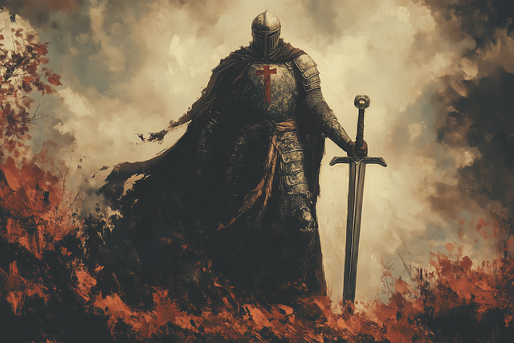
He shall judge between the nations,
and shall arbitrate for many peoples;
they shall beat their swords into ploughshares,
and their spears into pruning-hooks;
nation shall not lift up sword against nation,
neither shall they learn war any more.

- What do you think it might mean to your own Christian faith to live by a Rule of Life?
- How do you think the elements of St George’s rule relates to mission, for example the Five Marks of Mission?
- How do you feel about the viewpoint that Christianity in the UK is under threat and we need to fight for it?

The Martyr: the flag and ‘Christian Nationalism’

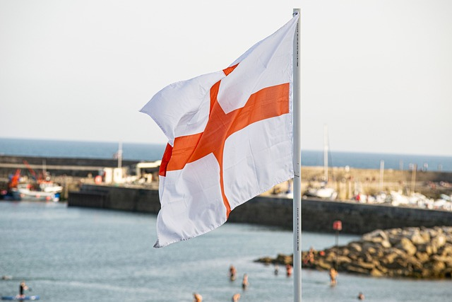

One of the most controversial issues around St George as a patron saint of England and the red cross on a white flag associated with him, is so-called ‘Christian Nationalism’ in which St George and the flag become signifiers of ‘Englishness’, ‘English Christianity’, ‘cultural’ Christianity, ‘crusading Christianity’ and even white supremacy in some conversations. This is odd, given how little, if anything, we really know about St George. But the little we do think we know about him makes him a very bad fit for an ‘English’ saint, even though he is a fascinating character.
It seems as though some people want to find a symbol of national pride in him, - something to mark sporting events, festivities, and special occasions. But other people want to use him as a more militaristic, combative, oppositional and contentious symbol. Some people get him mixed up with the red cross of the Crusades and see him as an opposer of Islam. Some people like the idea of a ‘warrior saint’ and use him to mark their ideas of fighting other faiths to preserve Christianity and beat back ‘enemies’.
For this reason, some communities fear English flags being flown around towns and cities and worry that it represents a message of hostility and unwelcome. Some people have also been hurt by being told they are not ‘English’ enough to wave the flag at, say, sporting events, and feel that the flag of St George should belong to everyone.
Other countries such as Georgia, though, also have a flag of St George, which has extra crosses on it, so the ‘English’ flag is only one version of this kind of symbol, and not exclusive.


Responding to the Challenge St George sets us:
- What do you think about when you see flags of St George being flown? Are there good places to fly the flags? Should flags be removed if they are upsetting people? What about if the cross of St George is painted on street signs and buildings or on roads? What do you think local councils might say about flying flags and expressions of patriotism?
- What do you think about what people are calling ‘Christian nationalism’ and calls for popular appropriation of what St George stands for? Where or when does pride in a country become an excuse to express prejudice and hatred?
- What might we have to do to make St George a nation saint for everyone in England and not just some people?
- How can we challenge the notion that we are in a battle with other faiths for the ‘soul’ of the nation?
- What can we do in our own communities to build bonds of trust and friendship and push back against divisiveness and hostility?

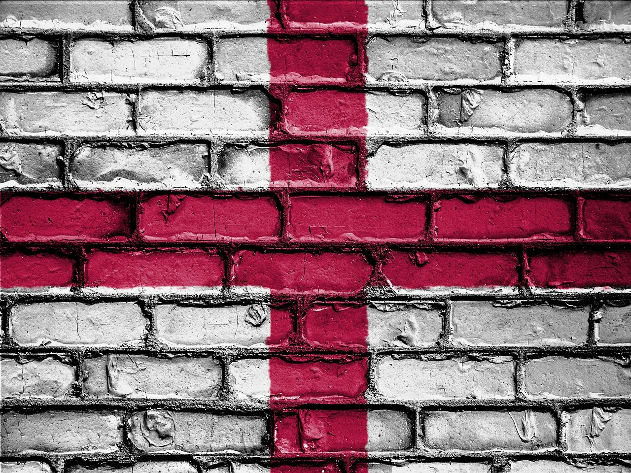
The Miracles: Overcoming Violence

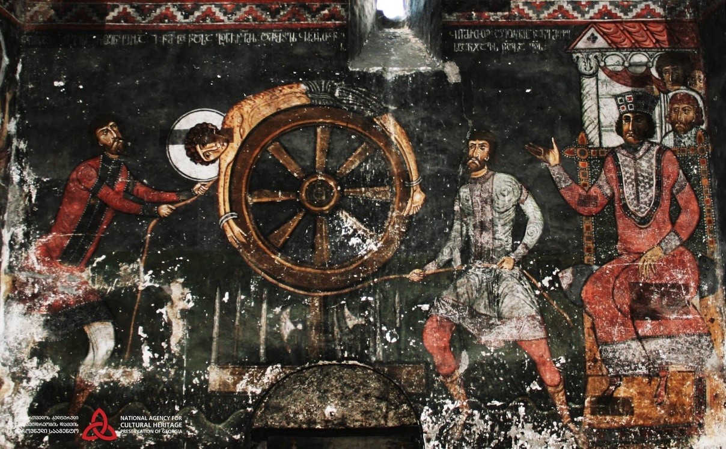
St George tortured on the wheel
St George was martyred when he was dragged through the streets and eventually beheaded, according to The Golden Legend. But before that, attempts to kill him by torture, poison, and burning all failed, as George remained strong in his faith. He also performed a miracle by witnessing to Christ in a non-Christian place of worship, where he was expected to renounce his faith. Instead, he destroyed the temple of false gods to demonstrate God’s power.
Many people today are still persecuted and tortured for their beliefs in an attempt to make them recant or as a demonstration of power. Sadly, Christians are often those persecuted and killed in different parts of the world. We do not expect them to survive by miracles.
The story of St George, as so many of the early Christian martyrs, makes the point that witness to Christian faith really does make a difference. One important factor is that faith builds up spiritual resilience to the evils of the world. It won’t save us from pain, torture or death, but it can give people hope when there appears to be none; it can tell a story of value, purpose and meaning, when all there seems to be is chaos and anarchy; it can bind communities together, when power is abused and evil seems to be in control. Above all, the story of St George tells us something about resisting evil and violence, telling the story of Christ and showing people how to live in a better way.
But there other sorts of violence besides the shedding of blood. It can start with malicious gossip, invented stories, maligning people we don’t like, trolling people online anonymously, making people’s lives deliberately difficult, ganging up on them, or just excluding them wherever possible. It is very easy to do and can make us feel powerful, on the ‘right’ side, or even justified by telling ourselves we are doing what Jesus wants us to do in his name. We can do violence to people’s mental health by making them feel uneasy and afraid. We can make them feel that we will not help them if they are in trouble.
Overcoming violence is not just about not physical violence, as the parable of the Good Samaritan makes clear. Someone has to help the stranger, and find out what they need. As Christians, seeking to follow Jesus, what more can we do to lower the sense of threat and worry and build bridges to others? Of course, this is a task for people of all faiths and none; it is not the responsibility of Christians alone. But we can show the way.
Responding to the Challenge:
- Where in Scripture do we find others powerless before the forces of evil, yet protected by God?
- How can we build up our own spiritual resilience to the evils of the world?
- What could we do in our own neighbourhoods, churches and communities, to make sure people are protected from hatred and violence?
- Where can we be more careful about how we talk about people and behave better towards them?



The Mystery: Following St George

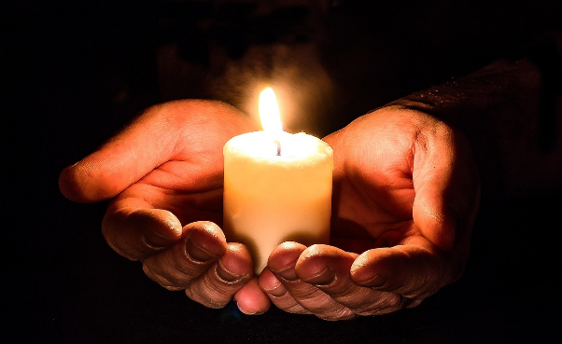

When we celebrate St George’s day, it is good to think that so many other Christians, as well as people of other faiths, such as Muslims and Druze, are celebrating him as well. For some people, St George’s Day is one of patriotism and national pride, which is fine, but nation saints do so much more for us than that! Their stories can help us in our own spiritual journeys, when we think about what they can teach us and how their example can guide us. This is a challenge to us – to let what we might find out about St George inform our own faith journey and try to live more nearly to Christ’s example.
St George offers us a model of resistance to evil in the world and our duty to protect others from evil. He also offers us a picture of endurance under trial and a steadfast faith when others try to undermine it or take it away. He represents a pathway to faith for others and is a witness to a life lived well that ends not in death but in heavenly glory.
Responding to the Challenge:
One of the things we might think about in relation to all the traditions associated with St George is how we see ‘signs’ from God about the pathway our life should take.
- Have you ever received a sign that God is prompting you in a particular direction?
- If you look back over your life, how did you make choices and decisions? Was your faith a factor in the choices you made? Did someone’s example help or encourage you in some way?
- If you come to a crisis or turning point in your life, what would convince you that you were making a good decision or know that you had come to a point of spiritual growth?
- What kinds of spiritual signs might be a blessing to people in today’s world?
- How can we be lights in the darkness for those who struggle and need companionship and kindness in their daily lives, or who feel damaged by the evil that is still in the world?
- Why not seek a spiritual companion on a walk around a church or other holy place to light a candle at the end of it for your own intentions?


Labyrinth

Picture Credits
P 3 Image by Dimitris Vetsikas from Pixabay
P4 Image by Murat Demirel from Pixabay
P5 © 'Saint George liberated by two Angels, Altichiero da Zevio' by f_snarfel is licensed under CC BY-NC 4.0
P 6 © 'Crucifixion, Altichiero da Zevio' by f_snarfel is licensed under CC BY-NC 4.0
P 7 Image by Enlightening Images from Pixabay
P 8 Image by Gerd Altmann from Pixabay
P 9 Image by Dimitris Vetsikas from Pixabay
P 10 Image by djedj from Pixabay
P 11 Image by Džoko Stach from Pixabay
P12 https://www.churchofengland.org/prayer-and-worship/topical-prayers/prayer-st-georges-day
P13 Image by falco from Pixabay
P 14 Baptism of St Paul photographed at the chapel by Richard Stracke, shared under Attribution-NonCommercial-ShareAlike license.
P15 Image by W M Pank from Pixabay
P16 https://pixabay.com/photos/christening-church-baptism-997585/
P17 Detail of a stained-glass window in the parish church of St Mary the Virgin, Henley on Thames, Oxfordshire, England. (photo: Wikimedia Commons/Public Domain)
P18 Image by mostafa meraji from Pixabay https://pixabay.com/photos/tbilisi-georgia-urban-architecture-4575705/
P19 Image by dimitrisvetsikas1969 from Pixabay and https://pixabay.com/photos/engraving-ayios-georgios-wall-1418202/ Image by Image by W M Pank from Pixabay
P20 Onceinawhile, CC BY-SA 4.0 <https://creativecommons.org/licenses/by-sa/4.0>, via Wikimedia Commons
P21 Istanbul - Archaeological Museum - Statue head of the Roman emperor Diocletian (284-305 AD) Photo: G. Dall'Orto
P22 https://www.civilization.org.uk/decline-and-fall-intro-2/decline-and-fall/diocletian/
P23 https://commons.wikimedia.org/wiki/File:La_tomba_di_San_Giorgio_%28Lod,_Israele%29_03.JPG
P25 Image by MemoryCatcher from Pixabay
P26 Image by Pete Linforth from Pixabay
P27 Image by Dimitris Vetsikas from Pixabay
P 28 AI Image by MythologyArt from Pixabay

P 29 Image by Mark Hemmings from Pixabay
P 30 Image by Peggy from Pixabay; Image by David Peterson from Pixabay
P 31 fresco from Nakipari, Georgia (public domain)
P32 Basantapur, Nepal, Landmark image. Free for use.
P 33 Image by Myriams-Fotos from Pixabay
P34 Image by Wolfgang Eckert from Pixabay
Bible quotations are from the NRSV

