Hello. What can we do for you?
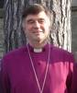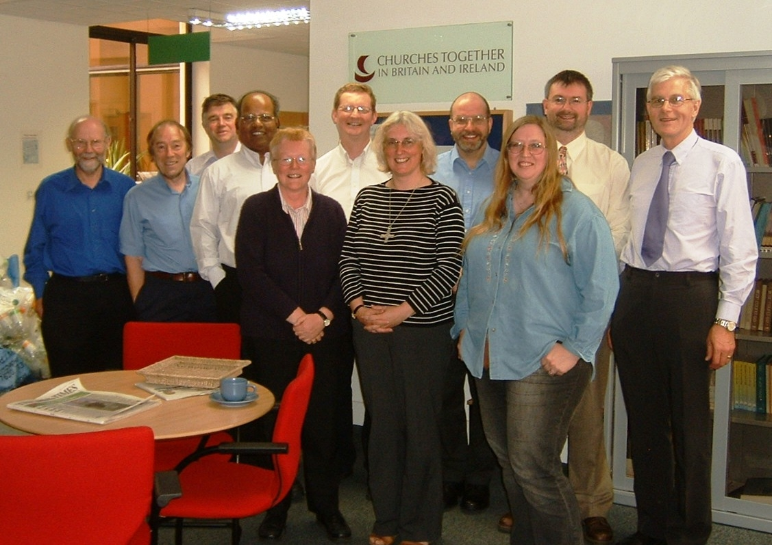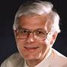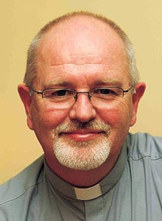

Kirsteen John Brian Jo David Alison Andrew Ben Vicky Bob

We’re the Mission Theology Advisory Group (MTAG). Our job is to provide the churches with a range of new and exciting resources for effective mission.
We specialise in producing materials to help Christians think about and share their faith sensitively with others in our fast-changing society.
We’re especially interested in engaging those people who are searching for God outside the Church.
Find out more about us and what we offer overleaf
Who are we?
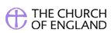
MTAG is formed through a partnership of the Church of England with Churches Together in Britain and Ireland. Chaired jointly by Revd Professor John Drane and the Rt Revd Dr Brian Castle, Bishop of Tonbridge, MTAG brings together mission practitioners and theologians to create resources for the whole Church to use, - from academic theology to interactive exploration that anyone can use, including spiritual seekers.
We work in the areas of Spirituality, Theology, Reconciliation, Evangelism and Mission (STREAM). Check out our On STREAM bulletins for more info about our projects.
MTAG is at your service. If you are interested in resources for your church or for use in your individual Christian journey, contact:


Dr Anne Richards, MPA, Church House, Great Smith Street, London, SW1P 3AZ
0207 898 1444 anne.richards@c-of-e.org.uk
Website: www.spiritualjourneys.org.uk

