
On STREAM
Spirituality, Theology, Reconciliation, Evangelism And Mission…….flowing deeper into God
UNRECONCILED? from MTAG
Unreconciled? is a new resource looking at issues in Christian reconciliation which are often not talked about or overlooked.
Is moaning at teenagers good for them?
Does your neighbour secretly wish you’d move away?
Should we really forgive those who trespass against us? More overleaf

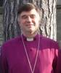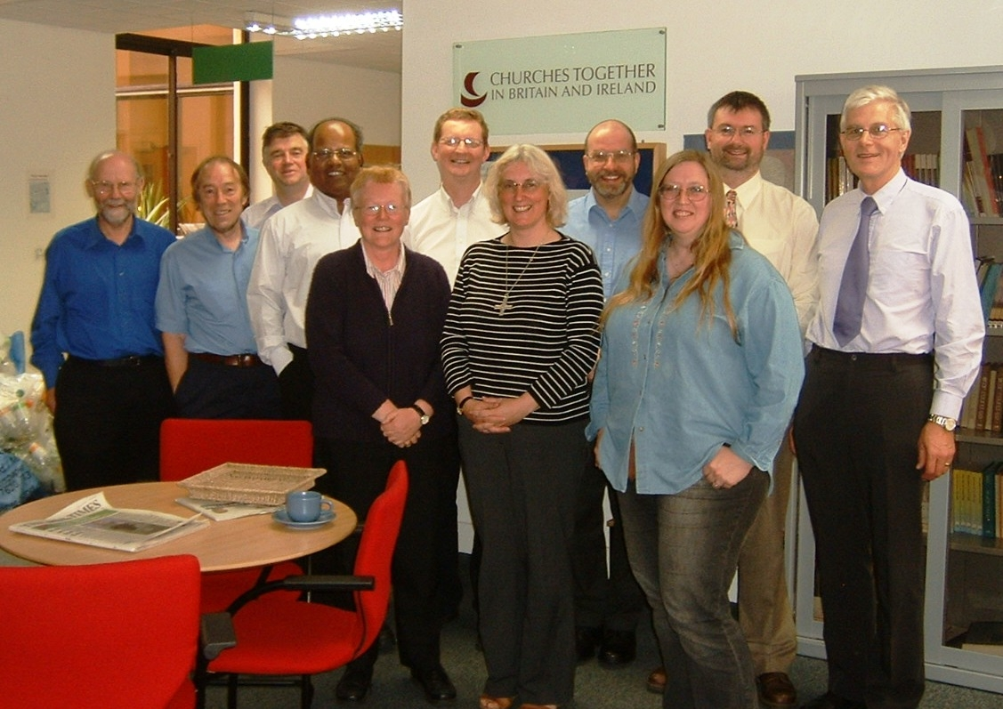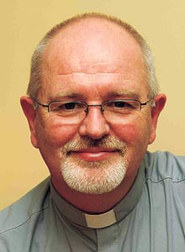

Unreconciled? looks at:
Humanity and God
Speaking and Listening
Lies and Truth
Victimised and Victimisers
Punishment and Liberation
Wounds and Healing

Otherness and Self
Separation and Unity
Condemnation and Forgiveness
Hell and Heaven

Complete with real-life stories and beautiful illustrations. Also includes activities, questions, prayer and reflection for Group work in churches.
Available in book form and pay-for-download from www.ctbi.org.uk
NEW! Unreconciled? will be the focus of the BBC Radio 4 and Local Radio Lent course for 2011

MTAG is at your service. If you are interested in resources for your church or for use in your individual Christian journey, contact:

Dr Anne Richards, MPA, Church House, Great Smith Street, London, SW1P 3AZ
0207 898 1444 anne.richards@c-of-e.org.uk Website: www.spiritualjourneys.org.uk

