
On STREAM
Spirituality, Theology, Reconciliation, Evangelism And Mission…….flowing deeper into God
SENSE MAKING FAITH from MTAG
Sense Making Faith is a beautifully illustrated series of explorations of how we experience God through sight, hearing, taste, touch and smell, and through imagination.
Each chapter invites the reader to a spiritual journey in which we can discover more of what the Christian tradition has to offer to those searching for faith. More overleaf

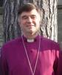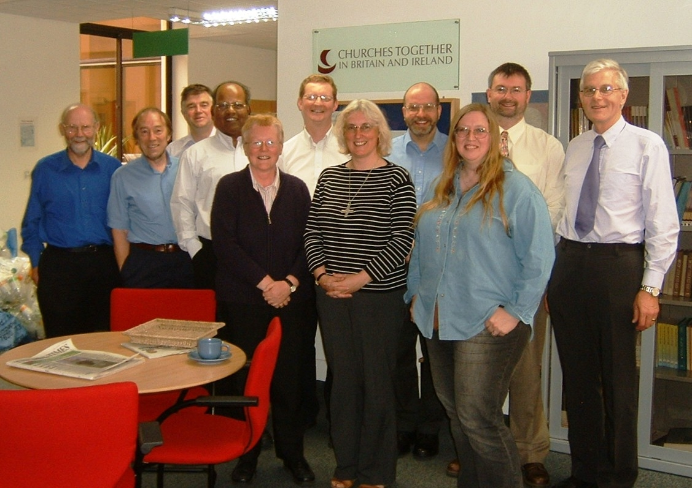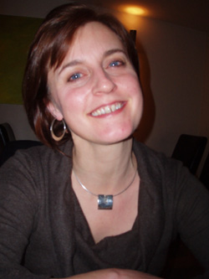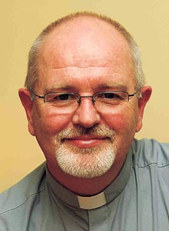

Sense Making Faith is accompanied by a website www.spiritualjourneys.org.uk continually updated with more resources for you to explore, build on, or use with groups in your church.
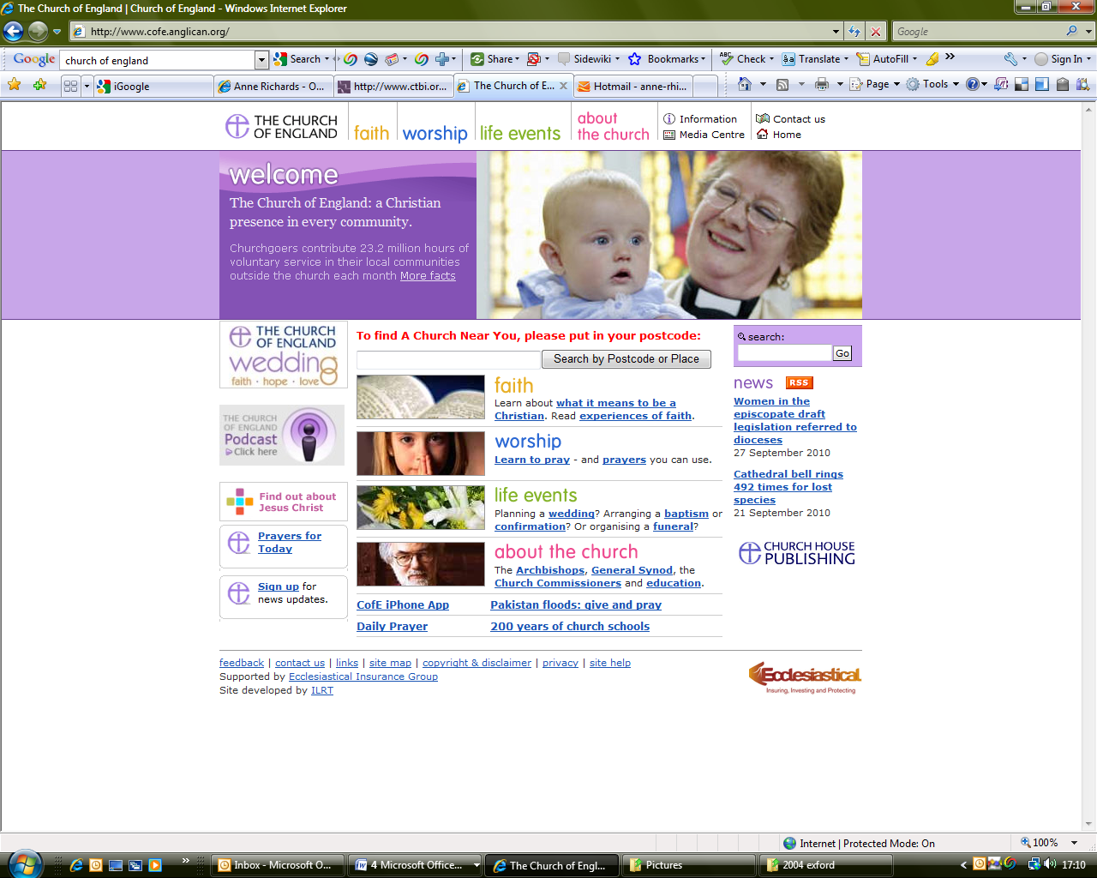
A complete set of group sessions are available within the book or separately as a download.
Sense Making Faith was the basis of the BBC Radio 4 and Local Radio’s Lent course for 2009. All the beautifully illustrated complete Lent sessions are available at www.spiritualjourneys.org.uk and on the CTBI website at www.ctbi.org.uk.

Sense Making Faith is available at from SCM-Canterbury Press, price £15.00

MTAG is at your service. If you are interested in resources for your church or for use in your individual Christian journey, contact:
Dr Anne Richards, MPA, Church House, Great Smith Street, London, SW1P 3AZ 0207 898 1444 anne.richards@c-of-e.org.uk Website:

