
On STREAM
Spirituality, Theology, Reconciliation, Evangelism And Mission…….flowing deeper into God

Spiritual Journeys
www.spiritualjourneys.org.uk is a website supporting our Sense Making Faith project. With hundreds of pages of downloadable content, there’s loads of material to support you and your church. More overleaf

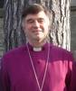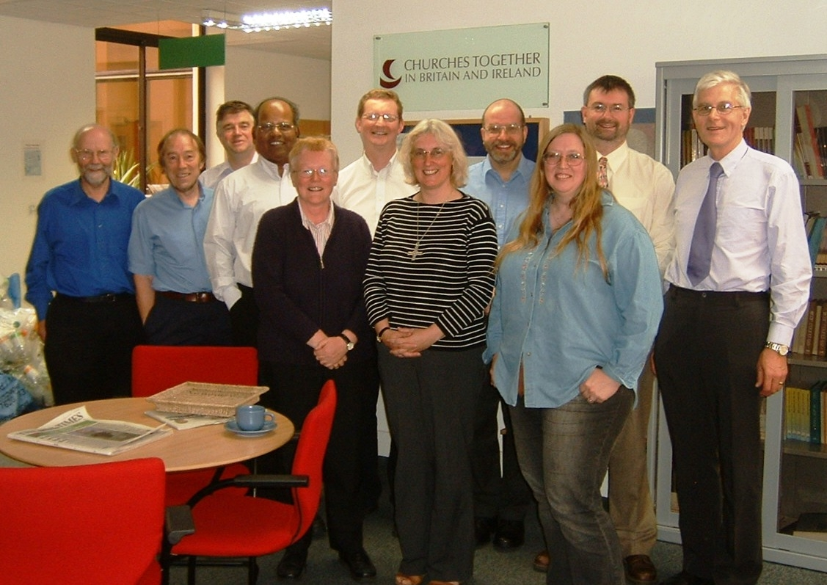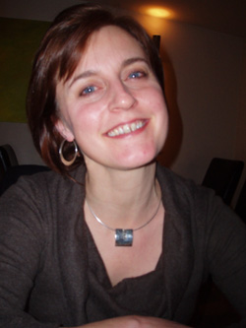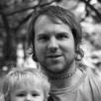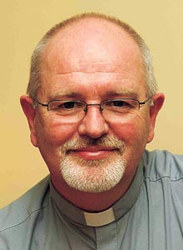

Explore: the explore pages provide resources for exploring spirituality and the Christian tradition through the physical senses and the Christian tradition. Very suitable for those on the fringes of faith and outside the Church who are spiritual seekers.
Look: the look pages offer news of events, information on new and forthcoming books, essays , sermon ideas and new writing on exploring spirituality and sharing Christian faith
Do: the do pages carry activities and group materials for you to use in your church
Ask: didn’t find what you wanted on the site? The Ask page lets you request what you were looking for. If we’ve got it, you can have it.
Dream: the dream pages contains resources for exploring spirituality through films, music, TV, poetry, pictures, bible study and other creative explorations.

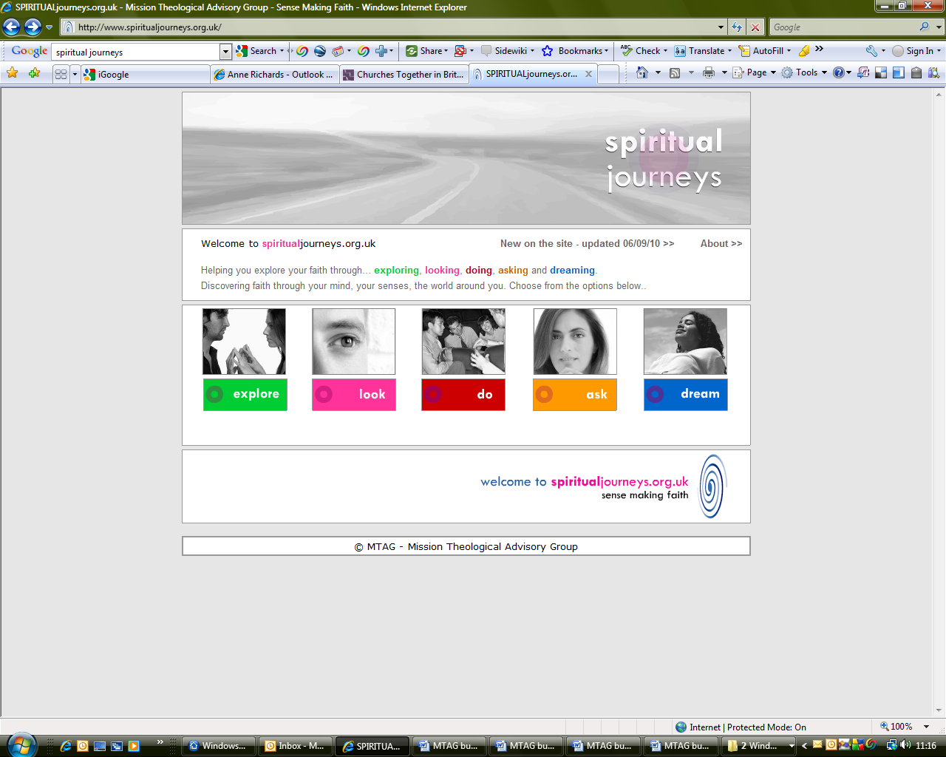

MTAG is at your service. If you are interested in resources for your church or for use in your individual Christian journey, contact:

Dr Anne Richards, MPA, Church House, Great Smith Street, London, SW1P 3AZ

0207 898 1444 anne.richards@c-of-e.org.uk

