Prayer for New Life

Comfortable and well-worn are my daily paths,
whose edges have grown grey
with constant use.

My daily speech is a collection of old words
worn down at the heels
by repeated use.

My language and deeds, addicted to habit,
prefer the taste of old wine,
the feel of weathered skin.

Come and awaken me, Spirit of the new.
Come and refresh me, Creator of green life.

Come and inspire me, Risen Son,
you who make all things new:
I am too young to be dead,
to be stagnant in spirit.
High are the walls that guard the old,
the tried and secure ways of yesterday,
that protect me from the dreaded plague,
the feared heresy of change.

For all change is a danger to the trusted order,
the threadbare traditions that are maintained
by the narrow ruts of rituals.

Yet how can an everlastingly new covenant
retain the freshness and vitality
without injections of the new,
the daring, and the untried?

Come, O you who are ever-new,
wrap my heart in a new skin,
ever flexible to be reformed by your Spirit.

Set my feet to fresh paths this day:
inspire me to speak original and life-giving words
and to creatively give shape to the new.

Come and teach me how to dance with delight
wherever you send a new melody my way.

Fr Edward Hays
More below…
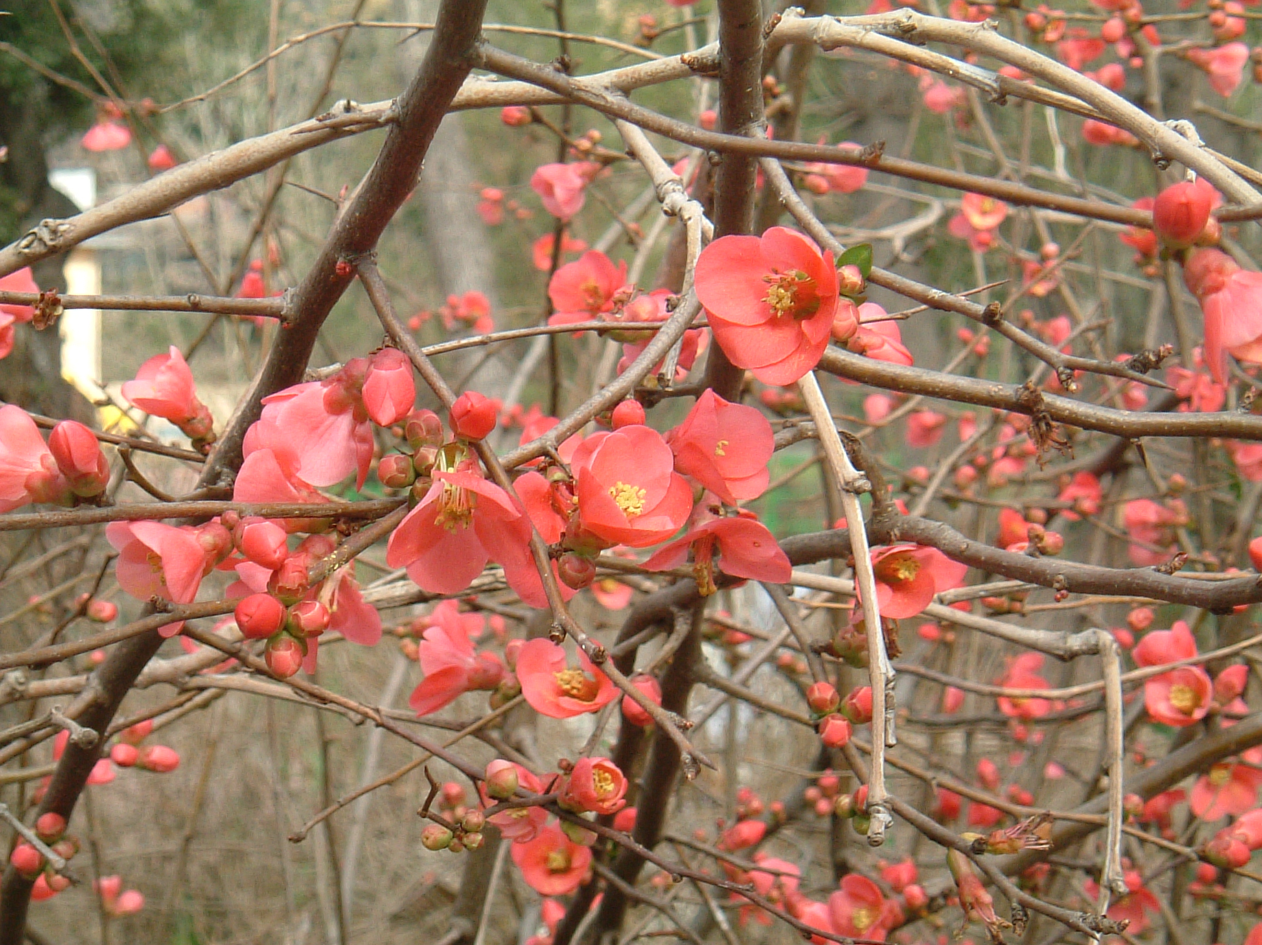

Other prayers by Fr Edward Hays can be found in:
Prayers for the Domestic Church: a Handbook for Worship in the Home, Ave Maria Press.
Pray All Ways: A Book for Daily Worship Using All Your Senses, Forest of Peace Publishing

