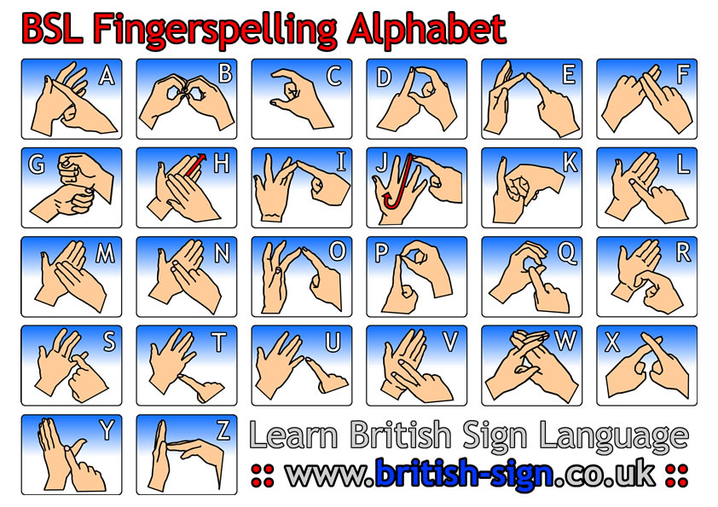

Resources for exploring deafness:

The RNID (Royal National Institute for the Deaf) www.rnid.org.uk is a good resource for queries about deafness generally.

The Magazine [on line or hard copy] 'One In Seven' http://www.rnid.org.uk/howyoucanhelp/join_rnid/one_in_seven/ is another great general resource giving the views of 'ordinary people' with articles not just covering profoundly deaf people but also hard-of-hearing and those suffering from tinnitus

RNID also has a site dealing with the problems of noisy events and the dangers of losing hearing. Check it out at: http://www.dontlosethemusic.com/home/

RNID also produce a catalogue of 'Deaf Aids' eg. Flashing Door bells, Vibrating Alarms etc. at http://www.rnid.org.uk/shop/

The NDCS ( National Deaf Children's Society) www.ndcs.org.uk is a great general resource regarding all kinds of queries to do with deaf children

Christian Deaf Link UK www.gosign.org.uk has a Hands Together http://www.jireh.demon.co.uk/signstart.htm website advertising regular events and services at deaf friendly churches www.jireh.demon.co.uk/deaf_friendly.htm around the country giving details of signed services with or without hearing people.

There are groups who 'Sign Sing' round the country.

ALS ( Association of Lipspeakers) www.lipspeaking.co.uk/ have trained lipspeakers who help the hard of hearing & deaf to learn to lipread or who provide interpreters who assist those who have difficulty in gatherings of all kinds to understand the speaker.

All Education Authorities have Support Staff / Teachers / Teaching Assistants / Interpreters for the Hearing Impaired from 0 - 100 years of age.

Some Activity Suggestions:

Just speaking to deaf/hard of hearing people in our own churches or communities is a great resource for finding out what it is like to live without sound or in a world of muffled sound. Ask them about sitting in services/ theatres, conference halls/going to the Bank etc. What is it like to use the Loop System or lack of it?

Try using 'gestures/Mime (or Sign Lang. if known) along with facial expressions to tell a short Bible story - whether it be Adam & Eve In the garden of Eden or Jesus & Zaccheus, The Anointing of Jesus' Feet etc.

- How does the lack of sound intensify the story, add or detract?

- How does it feel to watch a news item or film without the sound on or just not loud enough for one to pick up the words?

- What does 'movement' without sound tell us about ourselves, God, our world?

