Earth Matters: Stories for Reflection
Blue journey 4
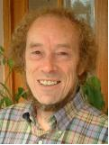

In this space, you can engage with some words from those working on the relationship between human beings and our world in the context of ecology and climate change. What will happen to people around the world if we do nothing about the fifth mark of mission? There are some questions and activities from Sharing God’s Planet, to help you reflect more deeply on the news stories.

How many people can the planet sustain?
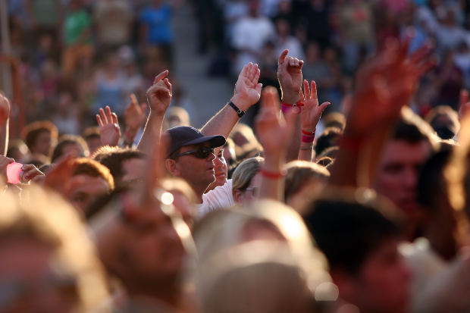

http://www.morguefile.com/archive/display/166148
As the world’s population reaches 7 billion….
‘Some demographers warn of catastrophic environmental degradation, most acute in the areas where the population grows fastest – the ecologically fragile sub-Saharan Africa – while policies to tackle poverty and disease stall. Others argue that population growth is not necessarily a bad thing: it is only 12 years since the birth of the six billionth person was announced and, for a majority of the world's population, more things have got better than worse. But in an era so shaped by the burden of human activity that scientists are calling it the anthropocene age, the explosive near-trebling of the world's population from just 2.5bn in 1950 demands at least an equal focus on reducing our environmental impact.’
Editorial Guardian online 23rd October 2011
http://www.guardian.co.uk/commentisfree/2011/oct/23/population-growth-baby-bomb-editorial?newsfeed=true

How will the poorest people cope with climate change?
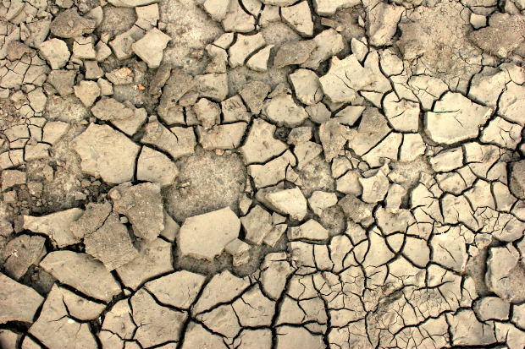

http://www.morguefile.com/archive/display/163346
Professor Sir John Beddington, the Government’s Chief Scientific Adviser and Head of the Foresight programme, said:
‘Environmental change threatens to have a profound impact on communities around the world – particularly in low income countries. However, this report finds that the nature of the global challenge goes beyond just focusing on those that might try to move away from areas of risk. Millions will migrate into - rather than away from - areas of environmental vulnerability, while an even bigger policy challenge will be the millions who will be “trapped” in dangerous conditions and unable to move to safety.
‘The evidence is also clear that under some circumstances migration, particularly in low income countries, can transform a community’s ability to cope with environmental change. The movement of individuals or small groups, even at a local or regional level, may increase the future resilience of large communities. This will reduce the risk of both humanitarian disasters and of potentially destabilising mass migration under high risk conditions.’
Press Release from Foresight 20th October 2011 http://nds.coi.gov.uk/content/detail.aspx?NewsAreaId=2&ReleaseID=421663&SubjectId=2

What happens when what we take for granted disappears?
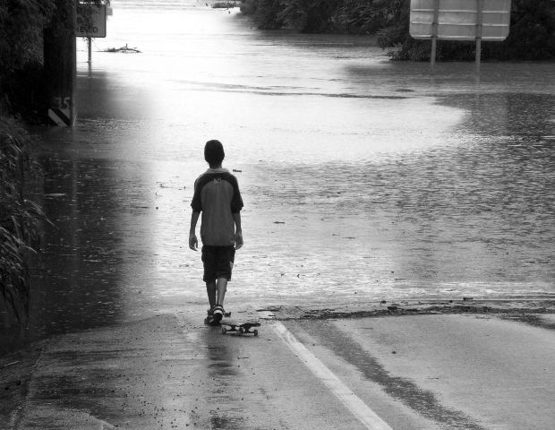

http://www.morguefile.com/archive/display/198797
Unprecedentedly, today, the world population is encountering unfamiliar human-induced changes in the lower and middle atmospheres and world-wide depletion of various other natural systems (e.g. soil fertility, aquifers, ocean fisheries, and biodiversity in general). Beyond the early recognition that such changes would affect economic activities, infrastructure and managed ecosystems, there is now recognition that global climate change poses risks to human population health.
World Health Organisation: Climate Change and Human Health Risks and Responses Summary
http://www.who.int/globalchange/environment/en/ccSCREEN.pdf

Subjects for reflection and group discussion from Sharing God’s Planet

See yourself as a citizen of the planet

Questions of poverty and environment are distorted if seen only in local or national terms.

Waste-watching

Where you have a choice:
Resist obsolescence; choose the longer-lasting
Support public transport with your feet and your vote
Resist wasteful packaging
See your discarded items not as waste but as sources of new life
work out your way of life
(The web site www.carboncalculator.org may be helpful here.)

Ask such questions as:
How can we measure our real needs (by the standards of our neighbours or by the needs of the poor)?
How can we be joyful without being greedy or flamboyant (e.g. in hospitality)?
How far does our personal way of life depend on society’s wealth?
Can our society’s way of life be made simpler? Can we ourselves work for any such change?
How can we be good stewards without being over-scrupulous?
What decisions about personal life are the decisive ones to make (e.g. budgeting)?
How can others benefit from what we have (our home, our car and other possessions)?

Points to ponder
Happiness is knowing what I can do without
My greed is another’s need
Am I detached from worldly goods if I keep what I have and want to add to them?
How in practice can I give an account to God of my stewardship of his creation?
Not my world, but his’
Question your own lifestyle, not your neighbour’s
Hopefully, having the chance to pause and reflect will have given you the chance to engage more deeply on the issues that are being grappled with here in this house. If you have thoughts and ideas about the future of our brothers and sisters make some notes in your notebook, journal or blog.
You can also read more about human food security and related issues, including what the churches are saying about climate change in Dr Charles Reed’s blog at http://ethicalcomment.wordpress.com/
Or have a look at David Shreeve’s blog at http://www.conservationfoundation.co.uk/blog.php

Where would you like to go now? Where else will your journey take you?
Yellow journey 1, 2,3,4 – text based exploration
Green journey 1,2, 3, 4 more things to do, research, look at
Blue journey 1, 2,3 scripture, prayers, music
Pink journey 1,2,3,4 spirituality based activities, following Jesus, changing our lives

