Earth Matters: Engaging with the Arts
Music and DVD resources and video clips
Green journey 3


In this space we have collected together some films and TV programmes, music and other media you can use to add to your exploration of the issues of how we can change our lives to respect the earth and the living creatures with which we share our planet. You can use the internet or watch DVDs on issues to do with ecology and caring for the environment.
You might want to pick one of the DVDs as part of a film club for children and/or young people, or use some of the resources as part of a lesson plan or project work. Or you could arrange a film showing as part of a church or fellowship activity

Some questions to think about might be:
- What message is being offered by this resource?
- What have I learned about the topic of ecology and Christian faith from the resource?
- How does the resource resonate with my ideas about Christian mission?
You could make some notes in answer to these questions in your journal, notebook or blog.
You could also see if the resources offer you something to put into your rucksack, or find something to change, such as too many plastic bags.

http://www.youtube.com/watch?v=rJVMh2-5Lr0 awareness -raising of issues
http://www.youtube.com/watch?v=cbN161yBBGA damage to reef fish from Blue Planet
http://www.youtube.com/watch?v=VqeADZgjtpY Michael Jackson –Earth Song, World Environment day
http://www.youtube.com/watch?v=EVh15aUt8-c Tim Minchin sings a wonderfully crazy song about the evils of plastic bags
http://www.youtube.com/watch?v=D6qGu4vQJFA The Archbishop of Canterbury talks about waste and care for the environment
http://www.youtube.com/watch?v=Vb_EsIss1W4 Bob White and Jubilee Centre perspective: why should Christians care for the environment?
http://www.youtube.com/watch?v=A_ut93YYZu8 about being a consumer
http://scienceblogs.com/guiltyplanet/2009/05/guilt_and_the_story_of_stuff.php video on the stuff we use and what happens to it by Greenpeace activist Annie Leonard
http://www.youtube.com/watch?v=r9GkwbbRKAg lectures by Dr Alan Knight of the Sustainable Development Commission on ‘Can shopping Change the World?’ part 1 (see also parts 2 and 3)
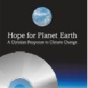 from A Rocha

Some films you might like to watch with an environment/ecology theme
Avatar (2009)
A paraplegic Marine on a mission to a planet called Pandora loves and defends the indigenous people when he discovers his own people want to destroy the beautiful planet’s habitat for minerals
Wall-E (2008)
Human beings have left earth because they have filled it up with rubbish. Wall-E is a robot left behind to clear up the mess. Humans can’t come back until they learn how to care for their planet.
The Day after Tomorrow (2004)
Climate change causes a huge wave and freezing temperatures that threaten New York
The Simpsons Movie (2007)
The group Green Day are sunk with rubbish after they mention the environment and Homer ends up polluting the lake. The solution: to encase Springfield under a dome before destroying it…
Star Trek IV: The Voyage Home (1986)
A probe is threatening to destroy the earth as it wants to talk to a hump-backed whale, but they are extinct. Captain Kirk and his crew go back in time to find whales and bring them to the future, only to find them already under threat.
An Inconvenient Truth (2006)
Al Gore's campaign to make people recognise the issue of global warming
Gorillas in the Mist (1988)
The story of Dian Fossey and her attempts to protect endangered gorillas.
Happy Feet (2006)
A penguin who doesn’t fit in, finds his feet in a world of over-fishing and dangerous plastic
Hoot (2006)
Kids join together to protect a colony of endangered owls
Fern Gully: The Last Rainforest (1992)
The fairy people of Fern Gully are threatened by humans who have come to destroy their rainforest.
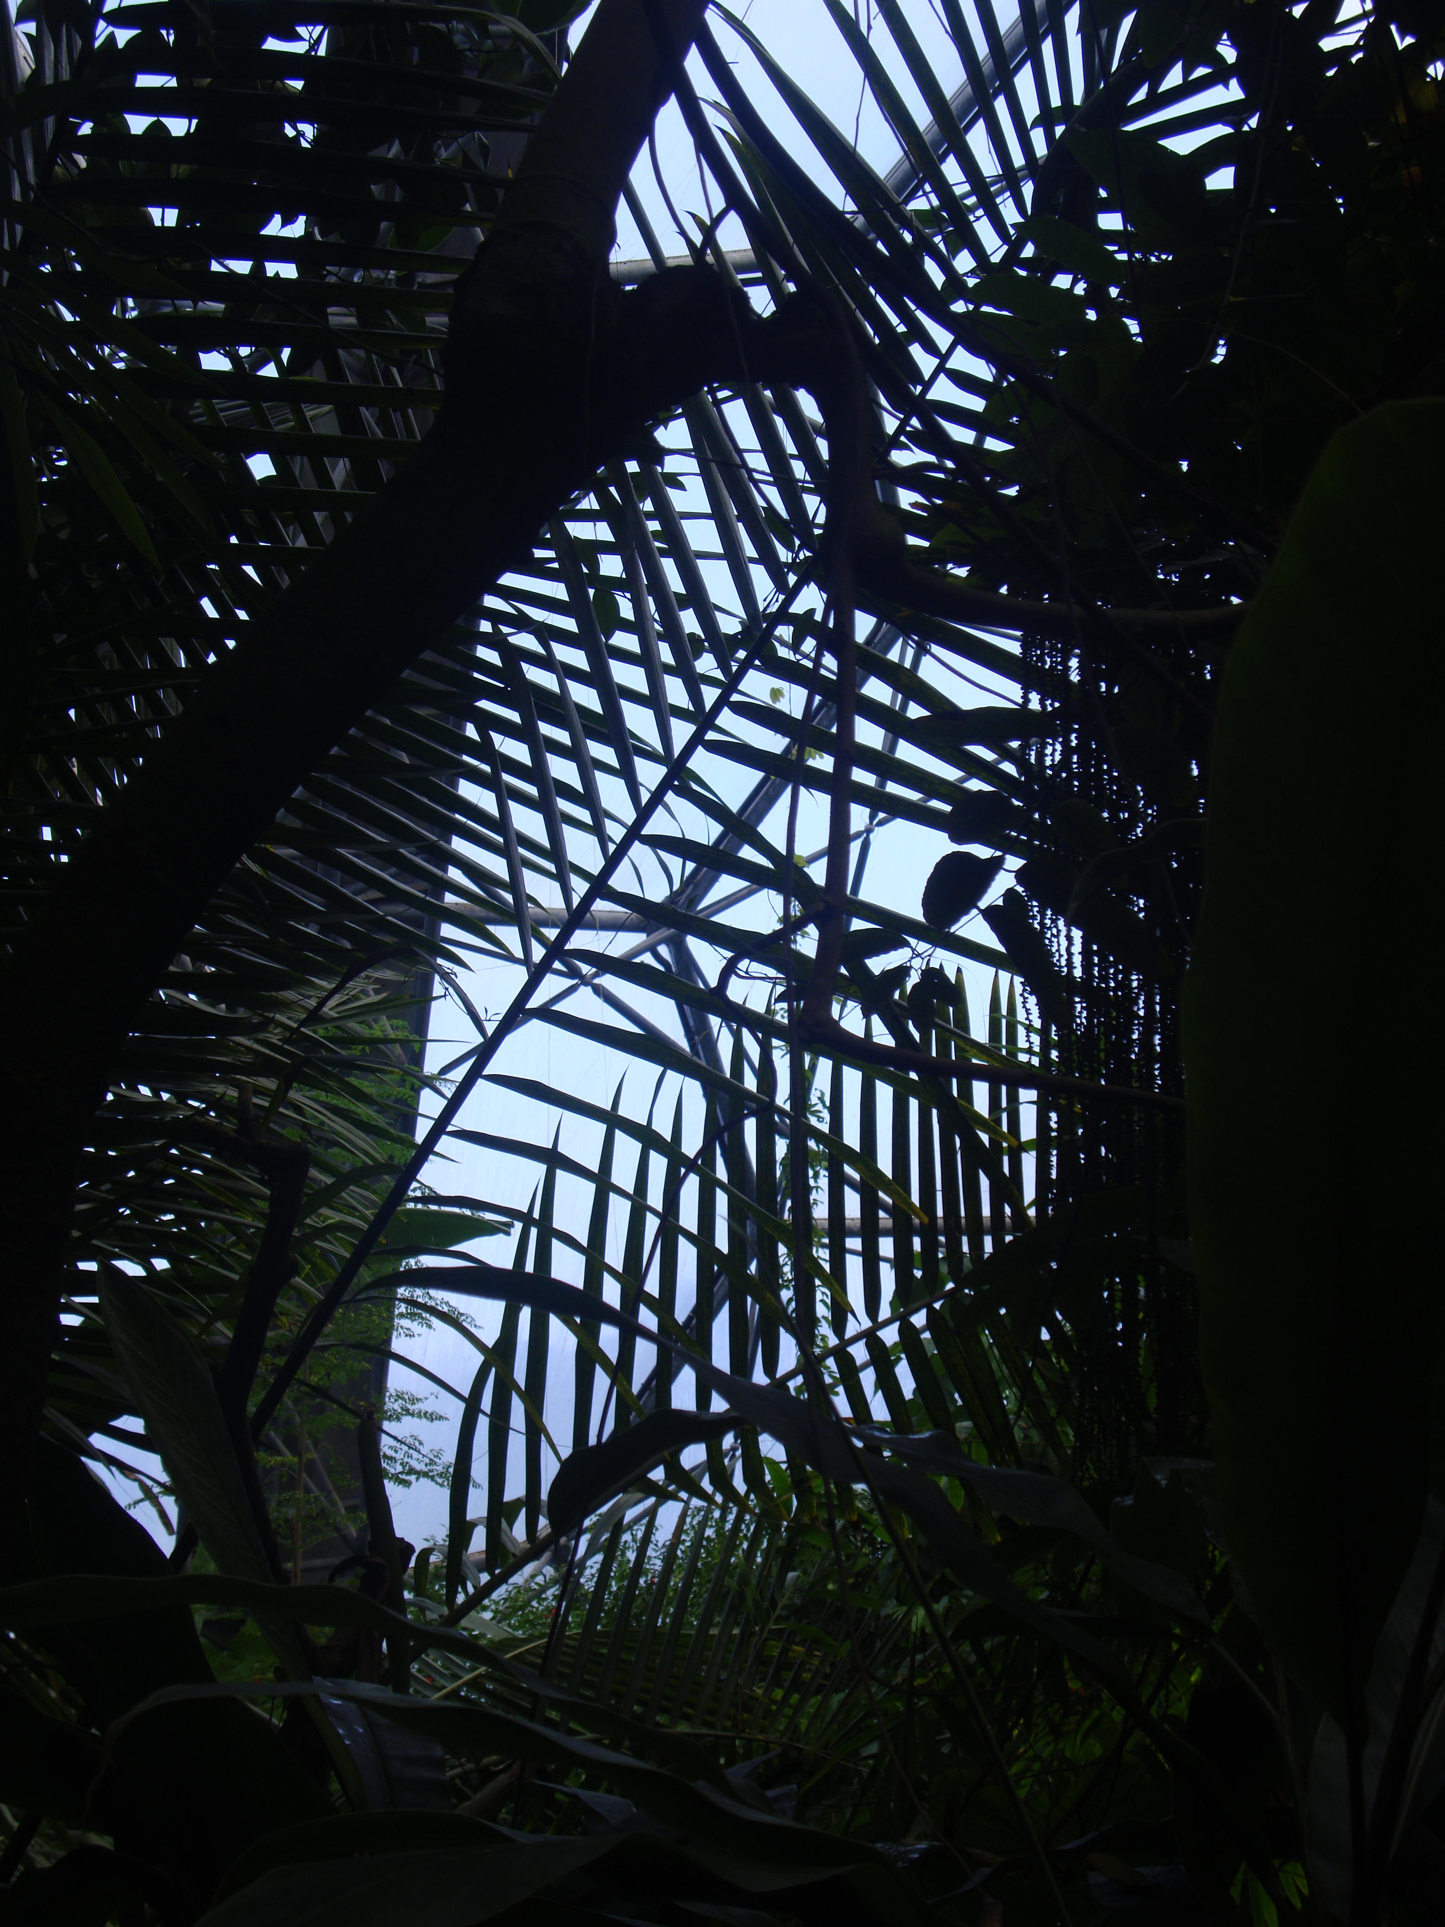
ARR
Music tracks with lyrics to think about…
Paradise Oskar, Da Da Dam (Eurovision 2011 contestant)
Michael Jackson, Earth Song from HI-istory : Past, Present and Future, Book 1
Peter Gabriel, Down to Earth (song in Wall-E)
Joni Mitchell, Big Yellow Taxi in Ladies of the Canyon
Tim Minchin, Canvas Bags
The Pixies, Monkey Gone to Heaven
Megadeth, Countdown to Extinction
Miley Cyrus, Wake up America
The Kinks, Apeman in Lola versus Powerman and the Moneygoround, part 1
Jack Johnson, The Horizon has been Defeated
Chris Rea, Road to Hell

If you find more interesting examples of music, video, TV or film on line, send your suggestions in to us

Where would you like to go now? Where else will this journey take you?
Green journey 1,2,4 more things to do, research, look at
Yellow journey 2,3,4 – text based exploration
Blue journey 1,2,3,4 scripture, prayers, music, reflection
Pink journey 1,2,3,4 spirituality based activities, following Jesus, changing our lives

