Exit: Dispossession
Pink Journey 4
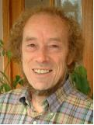
Dear Friend,
When you entered the house with its various spaces, you decided to explore the relationship between God’s mission and taking care of our planet. It is time to think about what you have experienced in the spaces you have chosen and what you are going to do with what you have learned.
As you pause upon this threshold, take a little time to reflect on what you have seen and done in the various spaces within this house. You also have a final chance to leave behind anything you don’t want from what you carry in your rucksack; re-examine your notes, take new things away with you or leave messages for the conservationists, green activists, members of eco-congregations and other people of the house.
In this final space we offer some suggestions for items you might like to take away with you; some questions you might like to think about; some activities you might like to get involved in or research further and some reflective challenges.
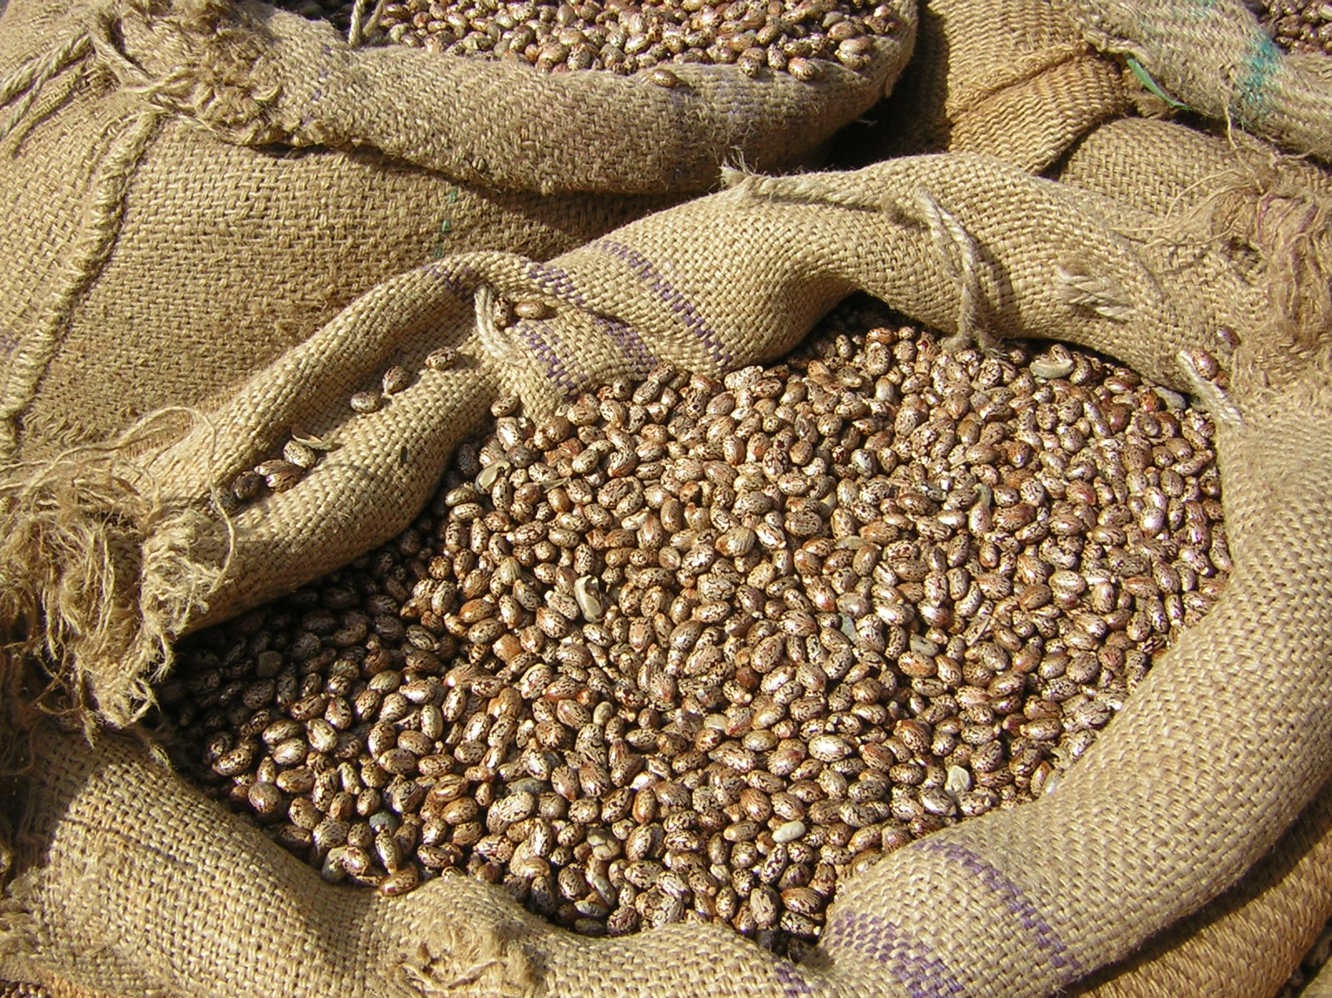
http://www.morguefile.com/archive/display/149554

Items you might like to take away with you include:
- Seeds for planting
- A rain-saver
- A composter
- Energy saving lightbulbs
- A solar panel
- A cardboard coffin

http://www.morguefile.com/archive/display/710091

Some questions you might like to think about
How have you been challenged?
Have you been changed in any way, and if so, how?
Has exploring this topic made you think differently about mission?
Do you think you will encourage your church to do more?
Have you had any thoughts you want to share?
Is there anything else you want to leave behind or get rid of?
Are there any messages you want to leave for others who use this resource?
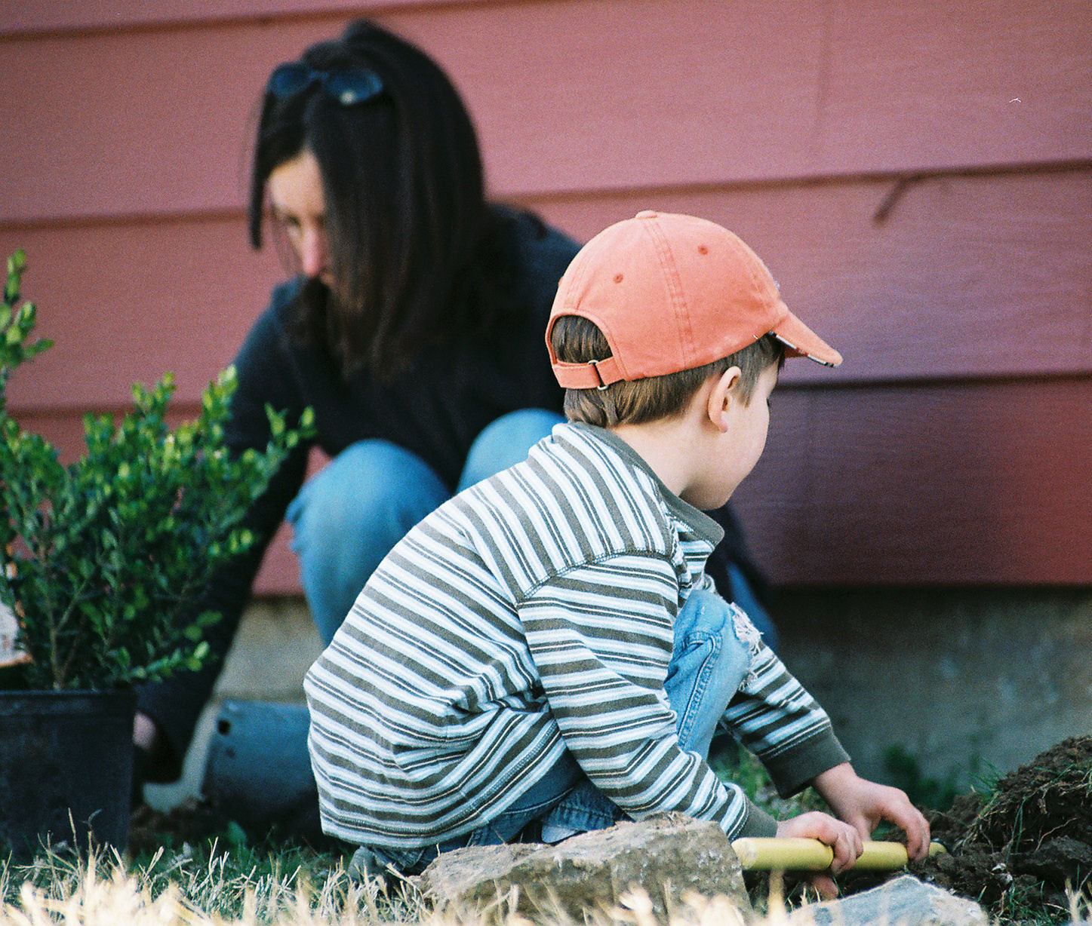
http://www.morguefile.com/archive/display/113075
A challenge: Changing the way we live

Living Lightly

Have a look at the A Rocha Living Lightly initiative http://arochalivinglightly.org.uk

See if you can think about a positive response through believing, behaving and belonging :
- Making a commitment: 'The Earth is the Lord's, and everything in it' (Psalm 24:1)
- Taking on a challenge: Living lightly in God's world
- Responding as a community : Caring for God's world together
Think about writing your own commitment, prayer or statement

And finally,……what about your own life and death as a Christian? What do you think about a carbon neutral wedding might look like, or a green funeral?

Thank you for your time spent visiting us. May God bless you on your onward journey. Goodbye!

Where would you like to go now? Where else will this journey take you?
If you’ve enjoyed exploring the resources for this topic, you might also enjoy looking at other MTAG resources. Find out about them from Churches Together in Britain and Ireland, the mission theology pages on the Church of England’s website and MTAG’s own website at www.spiritualjourneys.org.uk
If you have any questions or comments about the materials in this resource contact anne.richards@churchofengland.org

