Theological space
Yellow journey 3

In this space, extracts from writings by theologians on environmental matters are offered for you to look at and think about. You can then either: find the book or text and read more, discuss the extract in a group, or use the questions to frame a discussion about the theme or idea in the extract.
The extracts come from Dave Bookless of Aroch; the Ecumenical Patriarch speaking at a Religion, Science and Environment symposium on the Arctic; Claire Foster: Sharing God’s Planet.

Dave Bookless


‘In the past, many Christians have seen our God-given mission as, in essence, rescuing dying people from a doomed planet as this world runs out of control like a runaway train. Jesus has provided an escape plan, the church, a bit like a railway carriage that is going to be uncoupled and taken to safety when the rest of the train heads over the cliff to destruction. Mission therefore is a race against time to get people into the right carriage before it is too late.
The Bible’s radical message is that God’s mission is far bigger and far more exciting than this. Although the train, the world, and everybody on it, are indeed running out of control towards destruction, there is still hope. God’s rescue mission is not for a few passengers only, but for the train itself. To return to biblical language, it is not only people whom God made, loves and cares for and brought back into relationship with himself through Jesus, but the whole of creation.
Our task as human beings is to bring the good news of Jesus to all of creation in both word and deed. This is not about our mission to save people like us. It is God’s mission of good news for the whole created order. The biblical evidence is that mission is wider than we’ve often allowed. Humans may be the key agents of mission in the new creation that Jesus has begun, but we are not the only objects of mission. Mission is ultimately not only about people but about the renewal of all things in Christ. The transformation of individuals by the good news of the gospel still is, and always will be, central, but the biblical gospel of Jesus Christ is also good news for every creature.’
Planetwise, Inter-Varsity Press, 2008, pp136-137
Some questions:
- How does Dave’s idea of mission relate to your own views on mission?
- What evidence do we have that God is redeeming the whole creation?
- What do you think ‘good news for every creature’ would look like?

The Ecumenical Patriarch Bartholomew 1

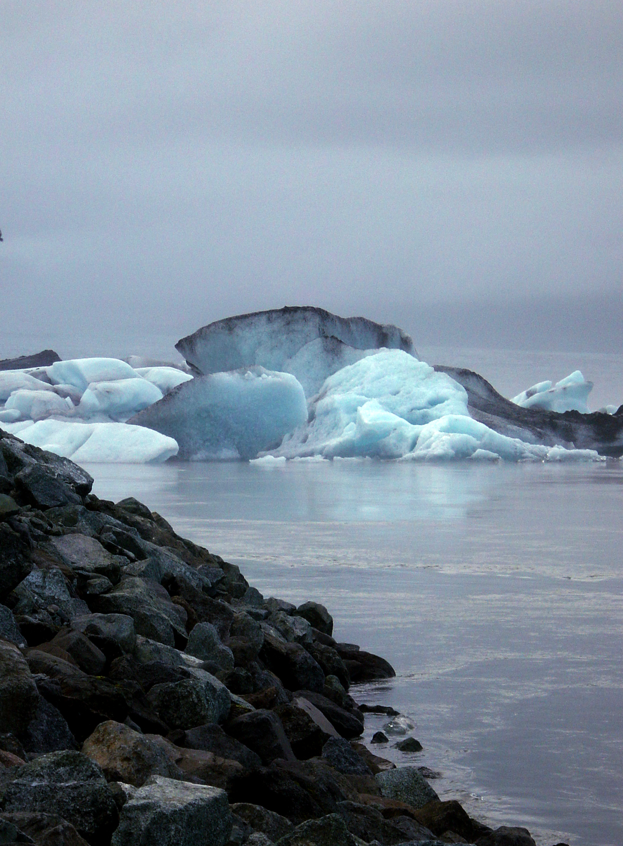
http://www.morguefile.com/archive/display/28944

‘We have called this symposium the Mirror of Life, because scientists tell us that the Arctic is a stark and vivid reflection of the state of the planet as a whole. The ecological misdeeds committed by societies further south, such as chemical contamination or nuclear radiation, are clearly visible in parts of the Arctic environment. Above all, the dramatic rise in global temperatures is having a palpable effect on the landscape of Greenland, even though it has not been caused by anything the Greenlanders have done. The societies whose industrial activities and extravagance do cause climate change are often blind to the consequences of their behaviour. But here, in the polar region, it is possible to see all manner of things much more clearly.
The idea of a mirror as a reflection of reality, which may be relatively accurate or inaccurate, is familiar to Christians. No man-made device is perfect, and in the earliest days of the Christian faith, man-made mirrors were much cruder than they are today. That is why Saint Paul warns us that in our present, fallen state, we can only see the world “in a mirror, in a puzzle” - or as one famous translation puts it, we observe reality “through a glass, darkly”. (1 Corinthians 13:12) In the same verse, Saint Paul offers us the hope that one day we will see far more clearly: we will stand “face to face” before the glory of God, and hence have a complete understanding of everything else. We will finally realise where we stand in relation to our Creator.
Saint Paul’s words refer to the spiritual hope of a Christian, that the glory of God will be fully visible to human beings. But they take on a new meaning for any human being who comes to Greenland. The Arctic is not a crude, man-made mirror; it is a brilliant and powerful one, given to us by God. Its silent beauty offers one brilliant reflection of the glory of God – while the abundance of life in the Brazilian rainforest, which we had the privilege of observing last year, offers another. At the same time, the climatic changes now taking place in the Arctic, and the contamination of certain parts of its food chain, are an accurate and unavoidable image of human thoughtlessness. When we visit this island or sail along its coast, we cannot hide our eyes, either from the beauty of God’s creation or from the changes which human folly has already caused, and may cause in the future, to this pristine place. Nor can we avoid pondering the terrible consequences for the remainder of the world, if glaciers continue to melt and sea-levels continue to rise.’
http://www.rsesymposia.org/files.php?catid=176&pcatid=162

Some questions
- What do you think the mirror of creation shows us about ourselves?
- How can we be more aware of the damage caused in other parts of the world by our own actions here?
- In what ways can we be blinded by our own behaviour and actions?

Claire Foster, Sharing God’s Planet
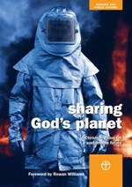

‘Humankind is easily ensnared in the culture of ownership. Even if it is understood intellectually that the world is God’s and the human role of stewardship means to have dominion only under him, people can still find themselves caught by desire, which is by its nature voracious. The desire to have possessions can consume a person’s waking hours and even his/her sleep in dreams. In the midst of this, the Christian is called to stop: completely, properly, for a period of time. Not just to pause for breath before carrying on consuming, but to take a deep dive into God’s peace. A regular practice of silence should be welcomed, because it offers the opportunity to experience freedom from the demands of a consumer society, rather than just to think that it would be a good idea.’
Sharing God’s Planet, Church House Publishing 2005, p.27
Some questions:
- In what ways can we be obsessed by possessions?
- How difficult would it be to stop, as Claire suggests, and turn away from possessions?
- How else can we free ourselves from the demands of consumer society?

Which of these would you like to take with you in your (infinitely expandable) rucksack to protect it from the effects of climate change?
A glacier
A polar bear

Write down any thoughts, insights, ideas or observations in your notebook, journal or blog.

Where would you like to go now?

Yellow journey 2,4 – text based exploration
Green journey 1,2,3,4 things to do, research, look at
Blue journey 1,2,3,4 scripture, prayers, music, reflection
Pink journey 1,2,3,4 spirituality based activities, following Jesus, changing our lives

