Words and Listening
Yellow Journey 2

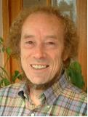

In this space, you can read and reflect on the thoughts and words of a variety of people from many different times and places. But they have all looked at the world and asked what our task is in relation to the creation. Imagine them speaking within the room and listen to their different voices. The thoughts are clustered into groups, with some questions for discussion following each group.

You are encouraged to think about these voices and note down any ideas, comments, dreams, criticisms, reactions or images which come to mind in your notebook, journal or on your blog.

CREATION
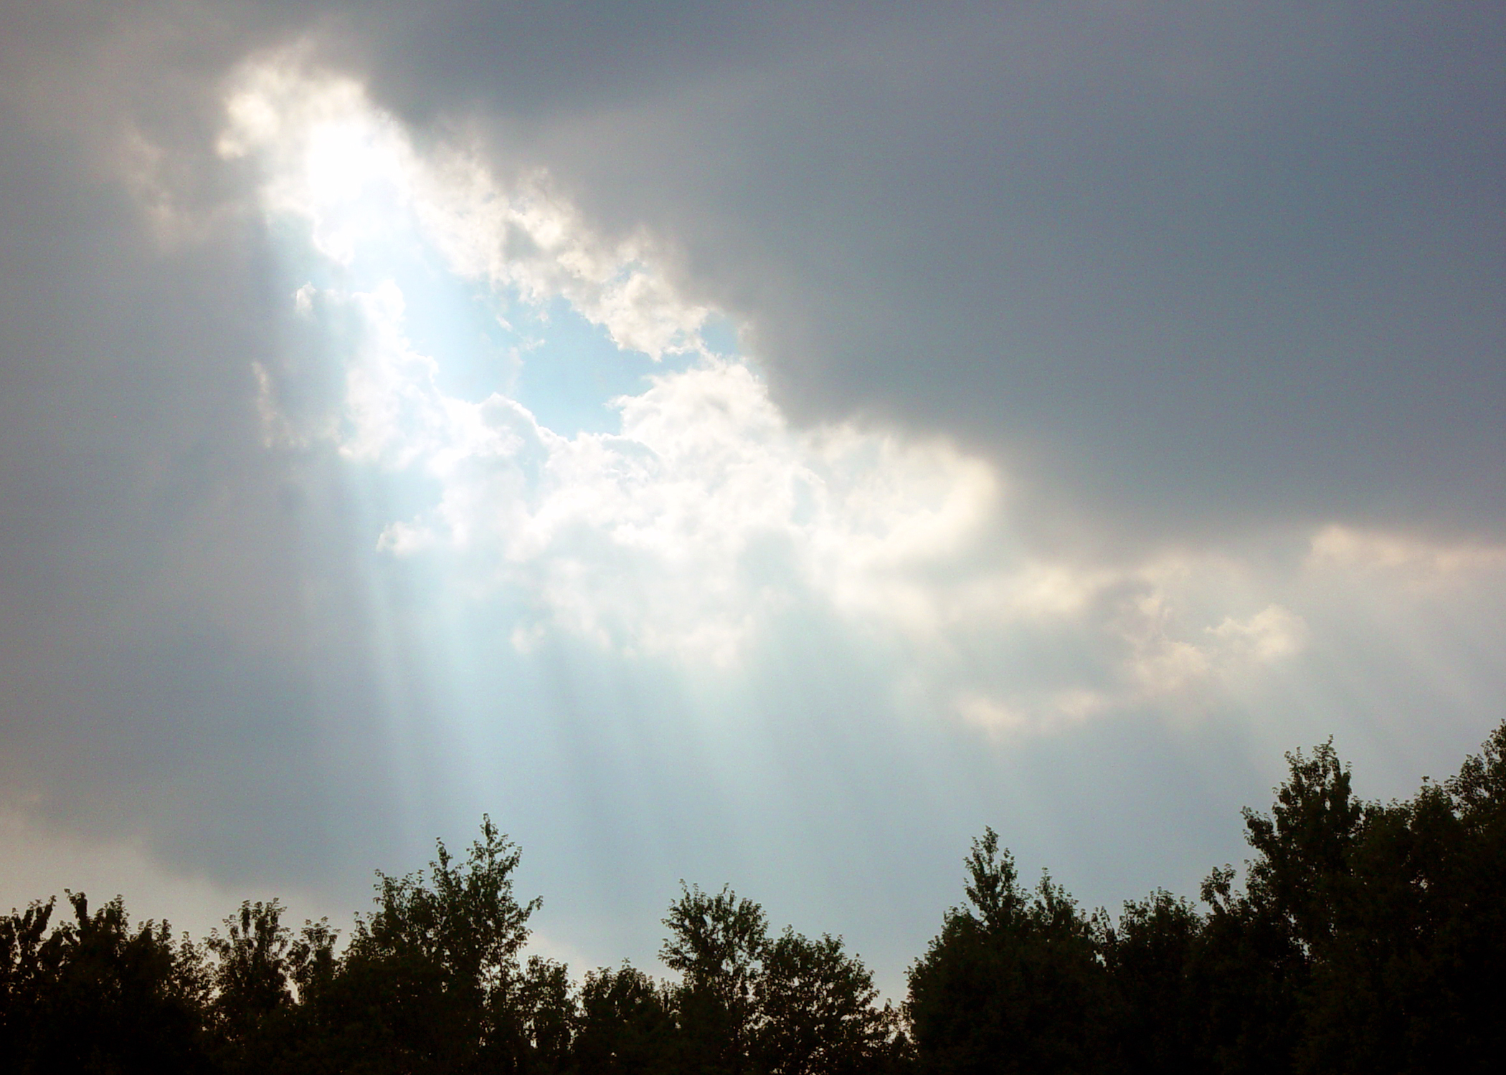
http://www.morguefile.com/archive/display/66039
‘For in the true nature of things, if we rightly consider, every green tree is far more glorious than if it were made of gold and silver.’
Martin Luther
‘If I keep a green bough in my heart, then the singing bird will come’
Chinese Proverb
‘People usually consider walking on water or in thin air a miracle. But I think the real miracle is not to walk either on water or in thin air, but to walk on earth. Every day we are engaged in a miracle which we don't even recognize: a blue sky, white clouds, green leaves, the black, curious eyes of a child -- our own two eyes. All is a miracle.’

Thich Nhat Hanh
‘By reading the scriptures I am so renewed that all nature seems renewed around me and with me. The sky seems to be a pure, a cooler blue, the trees a deeper green. The whole world is charged with the glory of God and I feel fire and music under my feet.’
Thomas Merton
- What do you feel about these thoughts?
- What do you think these voices are telling us?
- Write some thoughts of your own about creation in your journal or blog.
HUMAN RESPONSIBILITY FOR DAMAGE
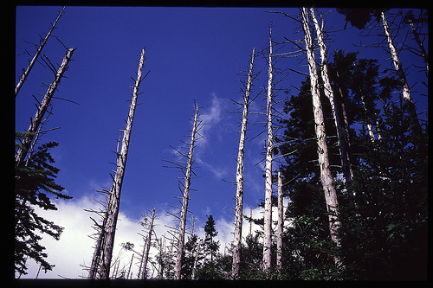
http://www.flickr.com/photos/dmason/43857005/sizes/m/in/photostream/
photo by dmason on Flickr

‘Thank God men cannot fly, and lay waste the sky as well as the earth’
Henry David Thoreau
‘The sun, the moon and the stars would have disappeared long ago... had they happened to be within the reach of predatory human hands’
Havelock Ellis, The Dance of Life, 1923
‘There is a sufficiency in the world for man's need but not for man's greed’
Mohandas K. Gandhi
‘It wasn't the Exxon Valdez captain's driving that caused the Alaskan oil spill. It was yours’ Greenpeace advertisement, New York Times, 25 February 1990
‘In America today you can murder land for private profit. You can leave the corpse for all to see, and nobody calls the cops’
Paul Brooks, The Pursuit of Wilderness, 1971
‘Don't blow it - good planets are hard to find’
Quoted in Time
‘The packaging for a microwavable "microwave" dinner is programmed for a shelf life of maybe six months, a cook time of two minutes and a landfill dead-time of centuries’
David Wann, Buzzworm, November 1990
‘So bleak is the picture... that the bulldozer and not the atomic bomb may turn out to be the most destructive invention of the 20th century’
Philip Shabecoff, New York Times Magazine, 4 June 1978
‘And Man created the plastic bag and the tin and aluminum can and the cellophane wrapper and the paper plate, and this was good because Man could then take his automobile and buy all his food in one place and He could save that which was good to eat in the refrigerator and throw away that which had no further use. And soon the earth was covered with plastic bags and aluminum cans and paper plates and disposable bottles and there was nowhere to sit down or walk, and Man shook his head and cried: "Look at this Godawful mess’
Art Buchwald, 1970
‘Suburbia is where the developer bulldozes out the trees, then names the streets after them’
Bill Vaughn
‘When you defile the pleasant streams
And the wild bird's abiding place,
You massacre a million dreams
And cast your spittle in God's face’
John Drinkwater
- How do you feel about these thoughts?
- What do you think these voices are telling us?
- Write some thoughts of your own in your diary
CARE FOR THE EARTH
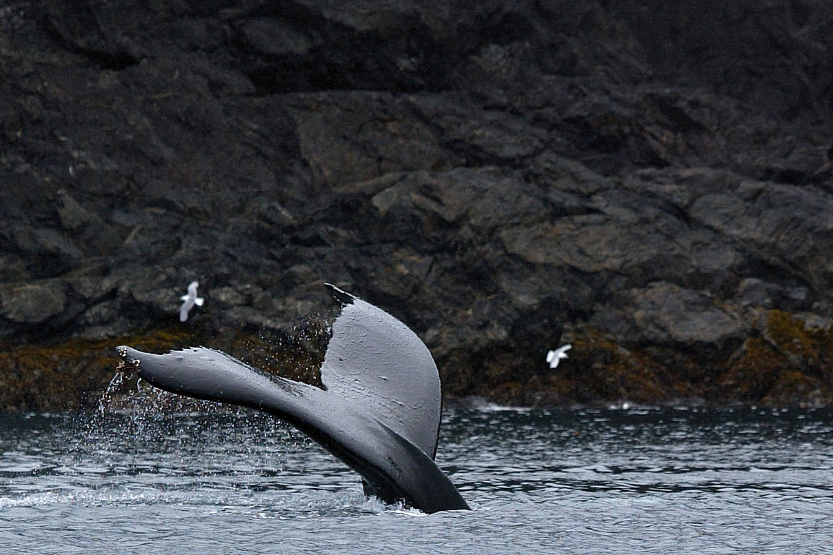
http://www.morguefile.com/archive/display/77904

‘When we heal the earth, we heal ourselves’
David Orr
‘We cannot command Nature except by obeying her’
Francis Bacon
‘We do not inherit the earth from our ancestors, we borrow it from our children’
Native American Proverb
‘Take nothing but pictures.
Leave nothing but footprints.
Kill nothing but time’
Motto of the Baltimore Grotto, a caving society
‘Humankind has not woven the web of life. We are but one thread within it. Whatever we do to the web, we do to ourselves. All things are bound together. All things connect’
Chief Seattle, 1855
‘Will urban sprawl spread so far that most people lose all touch with nature? Will the day come when the only bird a typical American child ever sees is a canary in a pet shop window? When the only wild animal he knows is a rat - glimpsed on a night drive through some city slum? When the only tree he touches is the cleverly fabricated plastic evergreen that shades his gifts on Christmas morning?’
Frank N. Ikard, North American Wildlife and Natural Resources Conference, Houston, March 1968
‘We could have saved the Earth but we were too damned cheap’
Kurt Vonnegut, Jr.
‘We never know the worth of water till the well is dry’
Thomas Fuller, Gnomologia, 1732
‘The earth we abuse and the living things we kill will, in the end, take their revenge; for in exploiting their presence we are diminishing our future’
Marya Mannes, More in Anger, 1958
‘The activist is not the man who says the river is dirty. The activist is the man who cleans up the river’
Ross Perot
‘We say we love flowers, yet we pluck them. We say we love trees, yet we cut them down. And people still wonder why some are afraid when told they are loved’
Author Unknown
‘Why should man expect his prayer for mercy to be heard by What is above him when he shows no mercy to what is under him?’
Pierre Troubetzkoy
‘Man has been endowed with reason, with the power to create, so that he can add to what he's been given. But up to now he hasn't been a creator, only a destroyer. Forests keep disappearing, rivers dry up, wild life's become extinct, the climate's ruined and the land grows poorer and uglier every day’
Anton Chekhov, Uncle Vanya, 1897
‘A human being is part of the whole, called by us "Universe," a part limited in time and space. He experiences himself, his thoughts and feelings as something separated from the rest - a kind of optical delusion of his consciousness. This delusion is a kind of prison for us, restricting us to our personal desires and to affection for a few persons nearest to us. Our task must be to free ourselves from this prison by widening our circle of compassion to embrace all living creatures and the whole [of] nature in its beauty’
Albert Einstein, 1950
- What do you think about these thoughts?
- What do you think these voices are telling us?
- Write some thoughts of your own in your diary.

DOMINION OVER CREATION?

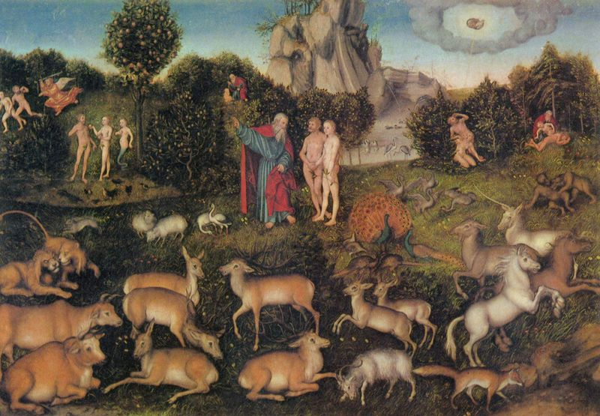 http://upload.wikimedia.org/wikipedia/commons/thumb/6/65/Lucas_Cranach_d._%C3% (Yorck Project)

‘Christianity, with its roots in Judaism, was a major factor in the development of the Western worldview.... A basic Christian belief was that God gave humans dominion over creation, with the freedom to use the environment as they saw fit. Another important Judeo-Christian belief predicted that God would bring a cataclysmic end to the Earth sometime in the future. One interpretation of this belief is that the Earth is only a temporary way station on the soul's journey to the afterlife. Because these beliefs tended to devalue the natural world, they fostered attitudes and behaviors that had a negative effect on the environment.’
Donald G. Kaufman and Cecilia M. Franz, Biosphere 2000: Protecting Our Global Environment, 1996
‘The days a man spends fishing or spends hunting should not be deducted from the time that he's on earth. In other words, if I fish today, that should be added to the amount of time I get to live. That's the way I look at recreation. That's why I'll be a big conservation, environmental President, because I plan to fish and hunt as much as I possibly can’
George Bush, quoted in Los Angeles Times, 30 December 1988
‘To live a pure unselfish life, one must count nothing as one's own in the midst of abundance’ Buddha
‘We shall continue to have a worsening ecologic crisis until we reject the Christian axiom that nature has no reason for existence save to serve man’
Lynn White, Jr., "The Historical Roots of Our Ecologic Crisis," 1967
Activity:
- What do you think about these thoughts?
- How do these voices make you feel?
- Write some thoughts of your own in your journal or blog.
Some other places to hear more thoughts about ecology, climate change and the environment

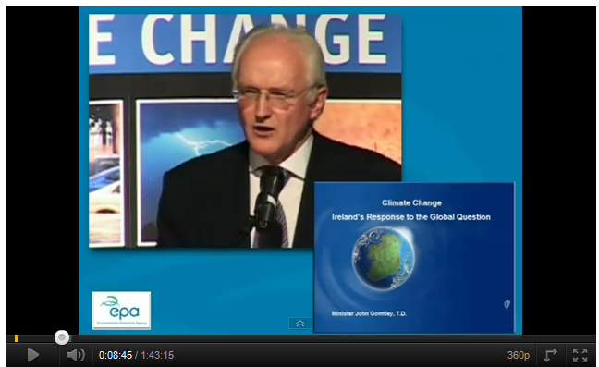
Mr. John Gormley, TD, Minister for Environment, Heritage and Local Government. Lecture given on April 8th 2008 at the Mansion House Dublin
http://www.youtube.com/watch?v=jSx7E2ep2Rs&feature=results_video&playnext=1&list=PLCDE951EB77E87100

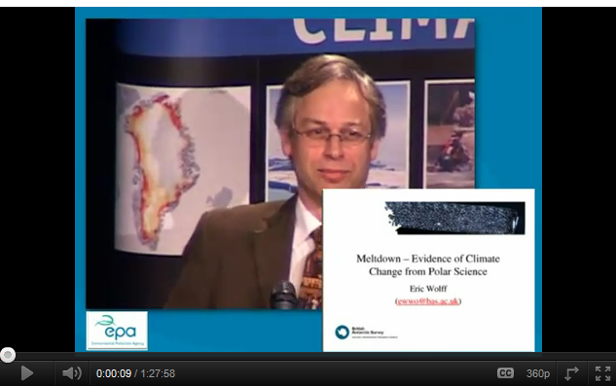
Dr. Eric Wolff, British Antarctic Survey, UK giving a lecture on January 22nd 2008, at The Mansion House, Dublin as part of the EPA's ongoing Climate Change Lecture Series.
http://www.youtube.com/watch?v=JfwE4dMKRNE

People have been talking about human impact on the environment for a long time and hopefully some of their musings have made you think some more about it. But what are we going to do to respond to God’s call to care for the Creation? It’s a mission priority.

You can now pass on to a different space to reflect more deeply on the theology of creation and the Christian response to the ecological issues of our time.
Where would you like to go now?
Yellow journey 3,4 – text based exploration
Green journey 1,2,3,4 things to do, research, look at
Blue journey 1,2,3,4 scripture, prayers, music, reflection
Pink journey 1,2,3,4 spirituality based activities, following Jesus, changing our lives

