Earth Matters: Going, Going, Gone….

Green journey1



Imagine this space as a kind of Noah’s Ark. Here we think about what we can do to preserve the biodiversity of the planet and try to find out what human beings need to do to keep the homes and habitats of animals and plants and to understand what we have already done to damage the places where they should live and flourish as God intends.

First, however, you are invited to look at some images of creatures that have recently gone extinct and to consider the impact of their loss and the manner of their passing. You are then invited to look at some of the living things on our planet which are on the brink of extinction.

If you are doing this with a group you might like to make copies of the pictures and put them up around your own group space. You might like to make a note of your thoughts about these creatures in your journal, notebook or blog, or consider what memories of our fragile planet you could carry with you in your rucksack.

Although extinction is a natural process, and mass extinctions have taken place before, many recent extinctions are different because we are directly responsible for making it impossible for animals and plants to continue to live and thrive. These creatures are dying, or have died because human beings have hunted them out of existence, ruined their habitats, interrupted their food chain or otherwise made it impossible for them to survive and flourish. Do we care? How do you think God feels about the destruction of parts of the creation?

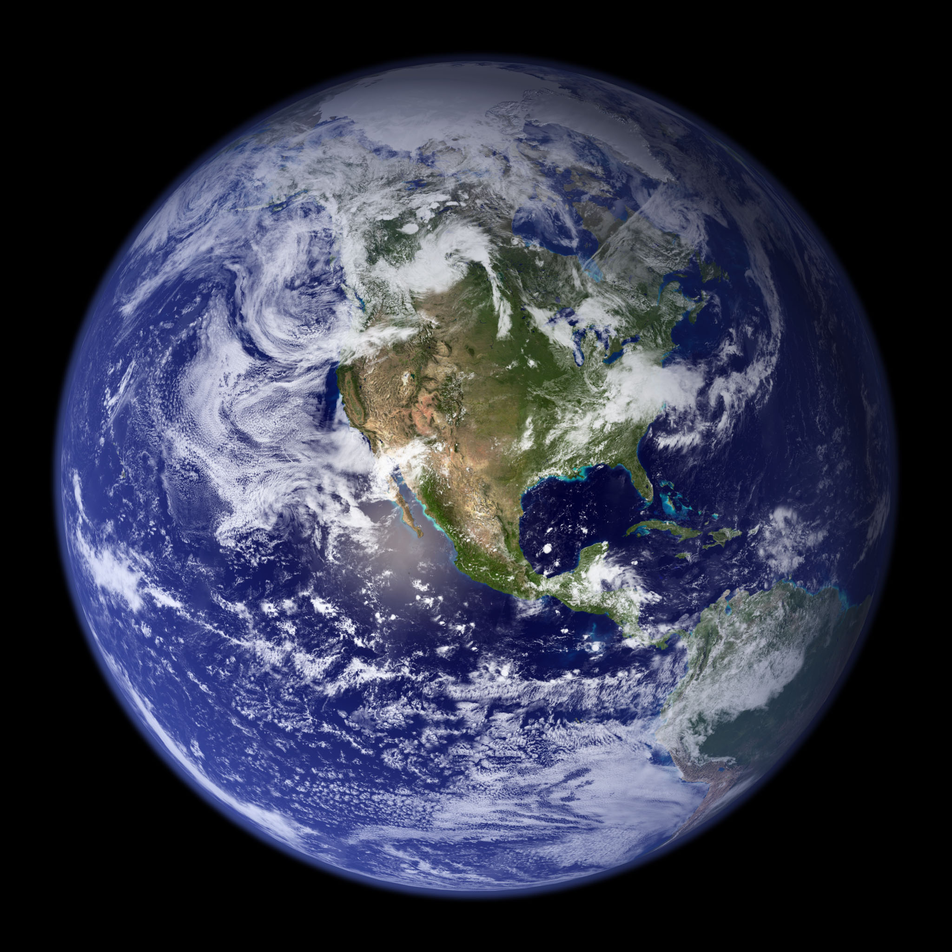

http://eoimages.gsfc.nasa.gov/ve/2429/globe_west_2048.jpg

Too Late…

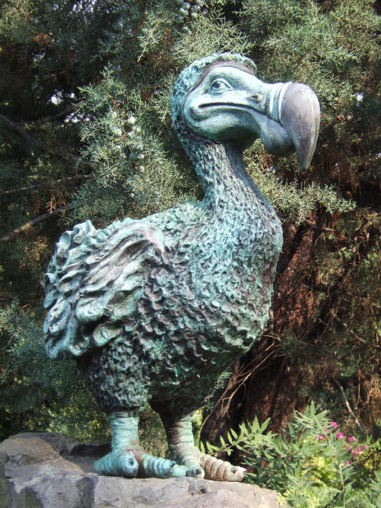

http://www.morguefile.com/archive/display/130884

Dodo
The phrase ‘as dead as a dodo’ reminds us that this extraordinary creature is really gone forever and we will never be able to see a living specimen. It has been extinct since the 17th century. The dodo was a large, heavy, flightless bird, related to the pigeon, living on the island of Mauritius. It did not know that humans were a threat to it and laid its eggs on the ground.

When people first arrived on Mauritius, they brought with them other animals such as cats, pigs, rats and monkeys. These animals killed the dodos and ate their eggs. Matters were made worse by human destruction of their forest habitat.

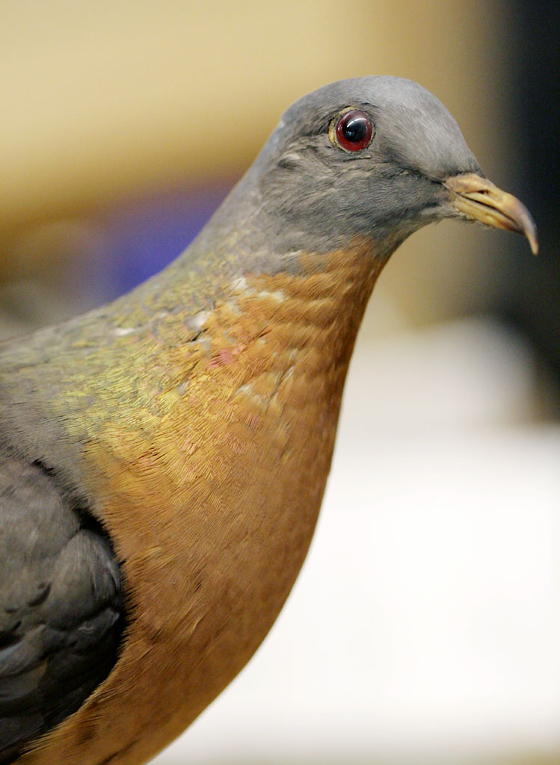

http://www.flickr.com/photos/pcoin/3199418238/sizes/o/in/photostream/

Passenger pigeon

The Passenger Pigeon once existed in America in huge numbers. But despite the billions of birds in huge flocks human beings, through hunting and destruction of the birds’ habitat managed to drive them extinct in the 20th century. Although attempts were made to preserve the species, what people did not realise was that the birds’ survival depended on living together in large flocks, so they could not be preserved by keeping a few in captivity.

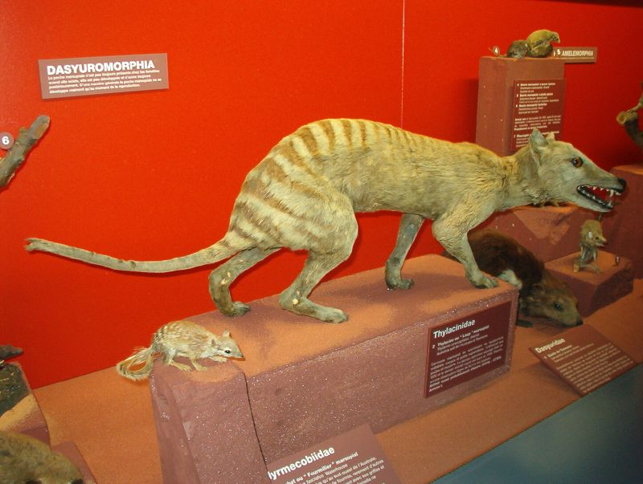

Thylacine (Tasmanian Wolf) http://www.flickr.com/photos/benandclare/1557544889/sizes/o/in/photostream/

This animal has also been extinct since the 20th century. It was a marsupial living in Australia and Tasmania and sometimes called the Tasmanian Tiger (because of its stripes) or the Tasmanian Wolf (because of its wolf-like head). Although it was a fierce predator it is likely that human beings hunting them, disease and the introduction of dogs into its habitat contributed to the animals’ eventual extinction.

Some other recently extinct creatures you might like to think about include:

The Golden Toad
The American Parakeet

Last chance to see……

Here are some examples of endangered animals
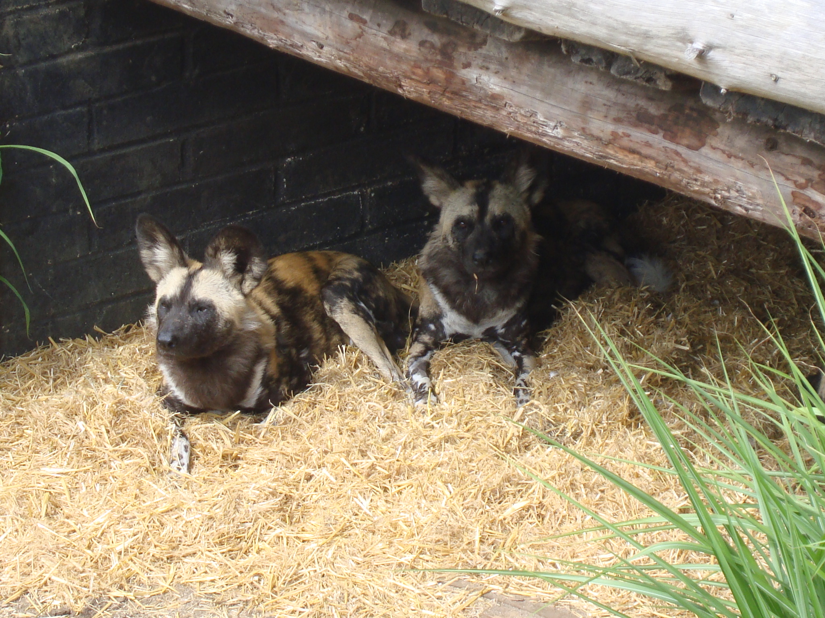
(ARR)
African Hunting Dogs
There are thought to be only a few thousand of these animals left in the wild. They have become endangered as their habitat has been lost through humans taking over their areas, they have been hunted, and they lose out when they have to compete with other animals for the same food. These animals need a large area of territory to survive and so as their territory diminishes, they become prone to disease and their numbers fall.
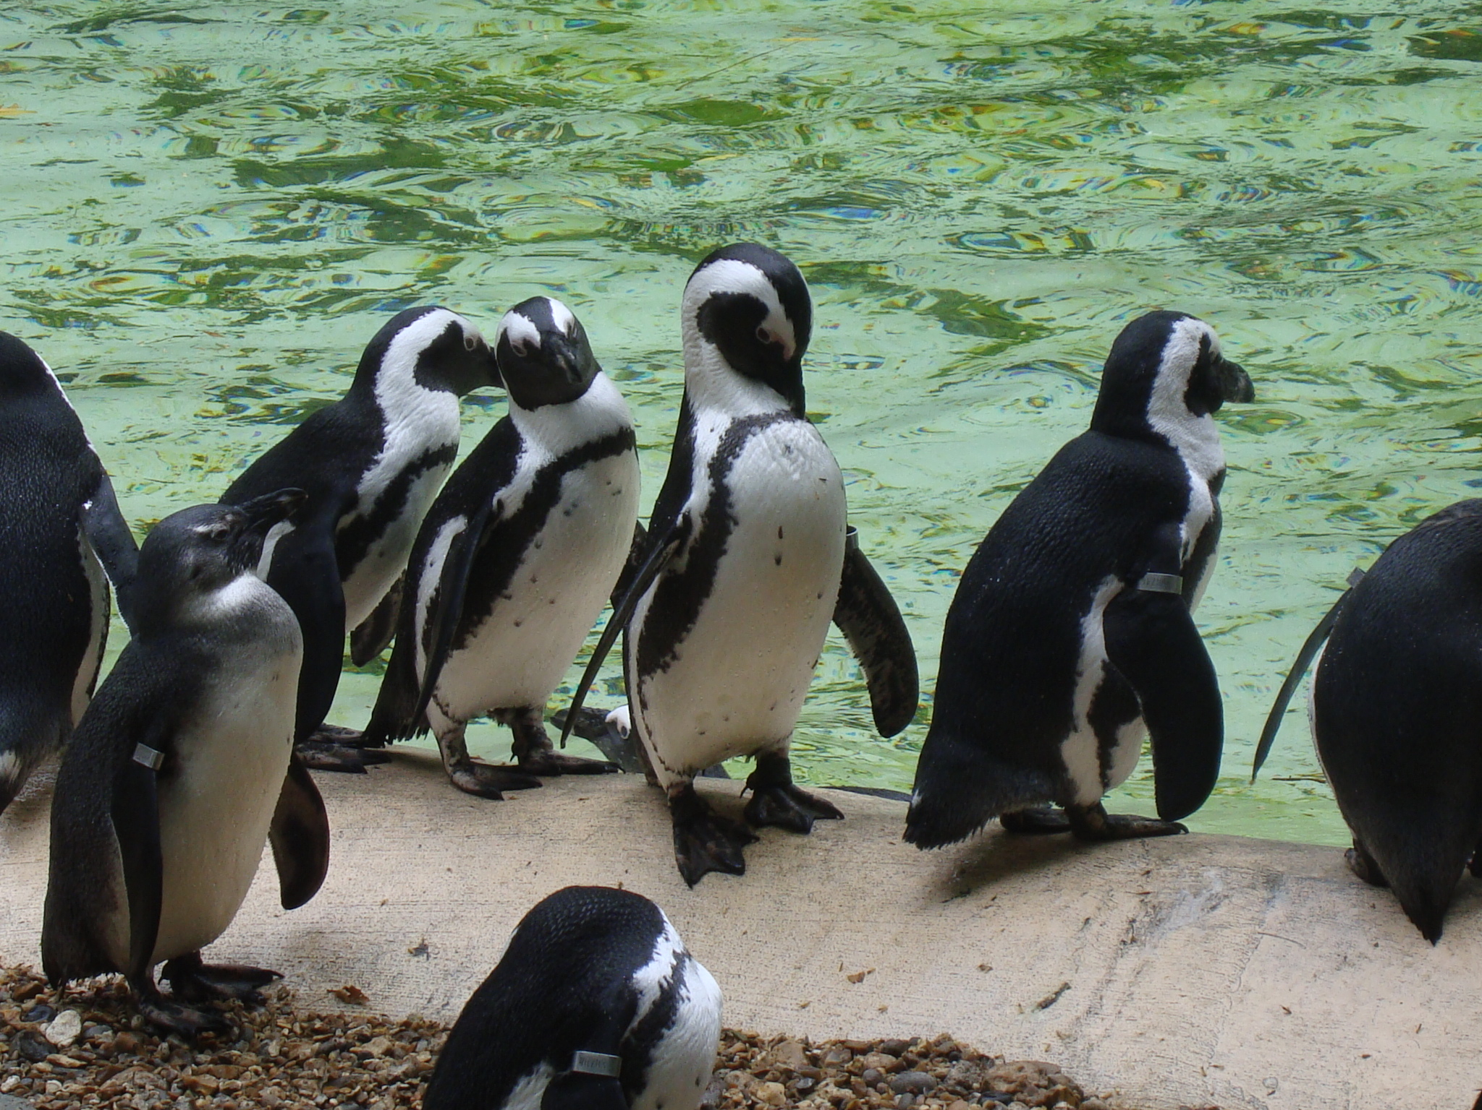
(ARR)
Black footed Penguins
These Penguins have declined in numbers by 95% since pre-industrial times and are now an endangered species. They live on the south west coast of Africa and it is thought they might become extinct in only a few years. One of the problems is that they have to compete with humans for fish. Over-fishing means the Penguins have to swim out further and further to find food and this makes them especially vulnerable to being eaten themselves. Another problem is that humans have eaten their eggs and removed their nesting material for fertiliser. Penguins are also very vulnerable to pollution and oil spills caused by human beings.

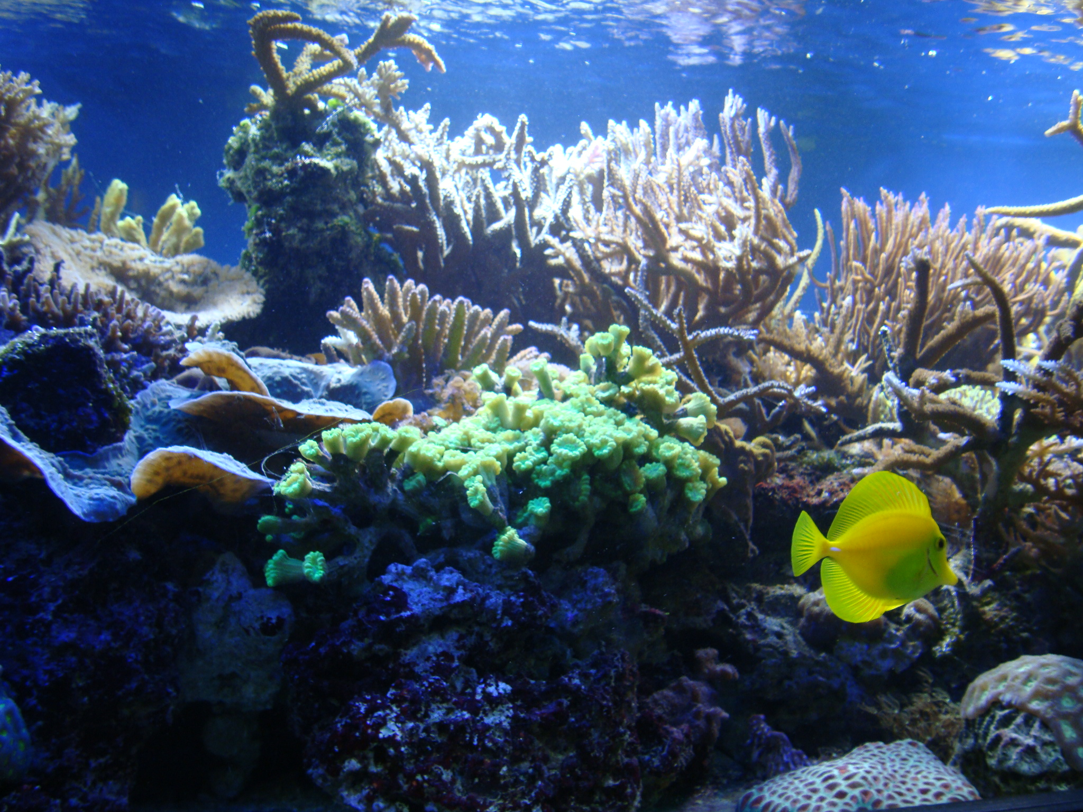
(ARR)

Coral reefs
Coral reefs are beautiful underwater ‘gardens’ of sea creatures and constitute entire eco-systems of animals feeding and depending on each other, but they are very delicate and are now seriously endangered. Human pollution of sea water, over-fishing, coral-mining, damage from tourists and changes in the chemical balance and temperature of sea water are all factors in the increasing loss of corals.

You can find out more about endangered and near extinct species by looking at the IUCN (international Union for the Conservation of Nature and Natural Resources) Red List at http://www.iucnredlist.org/

Here in our ecological house, we can create spaces for conservation, just as Scripture tells us that Noah took animals into the Ark to protect them from the Flood. The point is though, that those animals in the story were able to be released back into the wild and to flourish and prosper again. The problem we face today is that even if we keep animals and breed them in captivity, that is not the same as enabling them to co-exist with us in the wild.
Want to do something? You can find out about various projects you can be involved in through London Zoo here: http://www.zsl.org/conservation/get-involved/

Or look at this DVD: Last Chance to See with Stephen Fry and Mark Cawardine. Programme website at http://www.bbc.co.uk/programmes/b00vxzcj

What do you want to do now? Where else will your journey take you?

Green journey 2,3,4 more things to do, research, look at
Yellow journey 2,3,4 – text based exploration
Blue journey 1,2,3,4 scripture, prayers, music, reflection
Pink journey 1,2,3,4 spirituality based activities, following Jesus, changing our lives

