Conversation room
Yellow journey 4
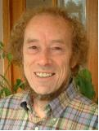

In this space, you can listen to: theologians talking about caring for creation; start your own conversation about those like TV star Jeremy Clarkson, who deny climate change is a problem; or read an extract from David Shreeve’s blog. Pick one that interests you and see what you think about what these people are saying.

A Rocha: Why should Christians care for creation? (15:28 minutes) - Melissa Ong and Daniel Tay
This video features theologians (John Stott, Alister McGrath, James Jones) and scientists (Ghillean Prance, Simon Stuart) who talk about the biblical basis for creation care.

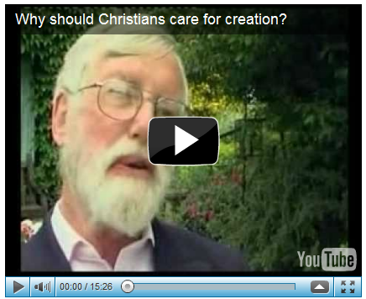

You can watch the video online at http://www.youtube.com/watch?v=cjiX0ztGUTs
Activity:
Why might a theological understanding of care for creation help in the climate change debate?
How can Scripture help us decide how to live in relation to God’s world?

Clarkson plays down dung dumping
By Fiona Pryor
Entertainment reporter, BBC News
Top Gear presenter Jeremy Clarkson has played down a recent climate change incident, calling the group of protesters "silly little girls".
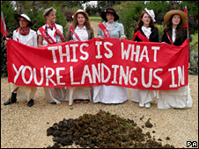
It is not the first time Clarkson has been criticised over his views
Last month Climate Rush members dumped a pile of manure on the driveway of the star's house in Oxfordshire.
Speaking about the incident, Clarkson, 49, said: "Teenage girls get into a strop about all sorts of things."
When asked what he thought about climate change, he said he found reading about it "all rather boring".
He added: "I read the reports that come in from various scientific bodies and as far as I can work out nobody actually knows whether man is contributing to global warming or not.
The star made comments at the launch of Top Gear's Live World Tour.
The tour will travel from country to country showcasing all sorts of stunts, which will include flaming rally cars and underground street racing.
"The oil will run out one day and we'll have to come up with something then, but let's not worry about it now."
He also added that he has "absolutely no guilt" about filling up his car.
At the time protesters said they were being as "blase as him" about emissions.
Known for his love of cars, Clarkson often expresses his provocative position on global warming via his newspaper column and on his BBC show.

http://news.bbc.co.uk/1/hi/8286794.stm
Activity:
What do you think about Jeremy Clarkson’s view that the protesters were ‘silly little girls’?
What would you say to Jeremy Clarkson when he says that we don’t have to worry about the oil running out at the moment?
‘Nobody knows whether man is contributing to global warming or not’. What do you think Christians should do about informing ourselves? Do you feel adequately informed?

David Shreeve: Comment - September 2011
Creation Time Blog No 2
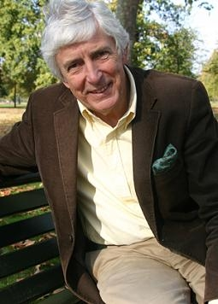
David Shreeve is the Church of England’s consultant on environmental matters
Find out more at http://www.shrinkingthefootprint.org/comment.php
In my first blog (http://www.shrinkingthefootprint.org/comment.php?id=186) I reported on how Creation Time events around the world are linked this year on issues concerning food.
Today comes news to show how not only food, but food waste should be in our thoughts at this time. A ‘biotruck' powered by restaurant waste has just arrived back in the UK after a two year around-the-world journey fuelled by used cooking oil along its 30,000km planet-circling tour across Europe, the Middle East, Asia and the Americas.
The truck was built in 2009 using an old school bus salvaged from a scrap yard, and used reclaimed materials to turn it into a cosy eco-home. It was obviously quite an adventure and as one of the organisers said "We couldn't have done it without the enthusiasm and help from the strangers we've met along the road. The random acts of kindness have given us an overwhelming faith in how great humankind is."
The figures for the amount of food wasted are huge at a time when others are suffering from hunger and starvation. Creation Time should make us think about how we use our food and the opportunities of using it even when cleared from our tables.
West London may not sound an obvious place for a harvest project, but this year's harvest of fruit has proved to be a bumper with schools and volunteer fruit pickers visiting a number of gardens in the Chiswick area to collect the crop. Anyone with surplus fruit which hasn't been collected is being encouraged to bring it to the Abundance Fruit Day which is being hosted at St Michael's and All Angels Church on 1 October. http://www.abundancelondon.com/
From Oxford comes news that the Earthing Faith website, hosted by the Diocese of Oxford, will once again be marking Creation Time by running Inspired by Creation - a chance for people to share with others how creation inspires them and share photographs that captures the place and creates inspiration. It may be a little patch of earth, a quiet spot to reflect or a view that stops you in your tracks. Maybe to keep up with Creation Time's food theme this year there will be some views of allotments nominated. There are no prizes this year, just a warm glow for knowing that others will be inspired by what you share. Find out more at www.earthingfaith.org/inspired
Activity
What do you think about David’s claim that we should think more about what we waste?
What else could we do with surplus or left over food to make sure it isn’t wasted?
What inspires you in the natural world?

Where do you want to go now? Where else will your journey take you?
Yellow journey 2,3, – text based exploration
Green journey 1,2,3,4 things to do, research, look at
Blue journey 1,2,3,4 scripture, prayers, music, reflection
Pink journey 1,2,3,4 spirituality based activities, following Jesus, changing our lives

