Earth Matters: Engaging with Scripture
Blue journey 1
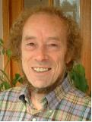
Blue journey resources can be used individually or in a group as part of your journey through the house or on their own if you want to design a day of prayer or a service to think about the fifth mark of mission: to strive to safeguard the integrity of creation and to sustain and renew the earth.
In this space, passages from Scripture are offered for study, together with some questions to think about. There are more suggestions for other places to explore for engagement with the Bible on matters of ecology and environment at the end of this resource.
Genesis 1. 26-31
Then God said, Let us make man in our image, in our likeness, and let them have dominion over the fish of the sea and over the birds of the air, and over the cattle, over all the wild animals of the earth, and over every creeping thing that creeps upon the earth. So God created humankind in his image, in the image of God he created them; male and female he created them. God blessed them and said to them, Be fruitful and multiply and fill the earth and subdue it. And have dominion over the fish of the sea and over the birds of the air and over every living thing that moves upon the earth. Then God said, See, I have given you every plant yielding seed that is upon the face of all the earth and every tree with seed in its fruit; you shall have them for food. And to every beast of the earth and to every bird of the air and to everything that creeps on the earth, everything that has the breath of life, I have given every green plant for food. And it was so. God saw everything that he had made, and indeed it was very good. And there was evening, and there was morning— the sixth day.

- Why do you think God created the earth and everything in it?
- What do you think is meant by the words ‘dominion’ and ‘subdue’ in this passage?
- How is creation to respond to God?
- How do you think God feels about the creation from this passage?
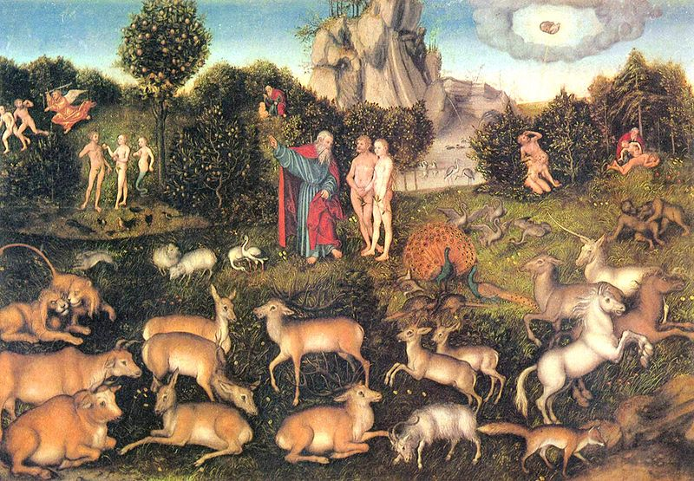
Cranach: The Garden of Eden (Yorck Project) http://commons.wikimedia.org/wiki/File:Lucas_Cranach_d._%C3%84._035.jpg

Romans 8.18-21

I consider that the sufferings of this present time are not worth comparing with the glory about to be revealed to us. For the creation waits with eager longing for the revealing of the children of God; for the creation was subjected to futility, not of its own will but by the will of the one who subjected it, in hope that the creation itself will be set free from its bondage to decay and will obtain the freedom of the glory of the children of God.

- What does this passage tell us about God’s intention for the creation?

- What do you think is our role in bringing about God’s purpose for the creation?

- How do you think the creation has been ‘subjected to futility’?

Psalm 8

To the leader: according to The Gittith. A Psalm of David.
O Lord, our Sovereign,
how majestic is your name in all the earth!
You have set your glory above the heavens.
Out of the mouths of babes and infants
you have founded a bulwark because of your foes,
to silence the enemy and the avenger.
When I look at your heavens, the work of your fingers,
the moon and the stars that you have established;
what are human beings that you are mindful of them,
mortals that you care for them?
Yet you have made them a little lower than God,
and crowned them with glory and honour.
You have given them dominion over the works of your hands;
you have put all things under their feet,
all sheep and oxen,
and also the beasts of the field,
the birds of the air, and the fish of the sea,
whatever passes along the paths of the seas.
O Lord, our Sovereign,
how majestic is your name in all the earth!

- What do think the psalmist understands to be the purpose of human life?

- How do you feel when you look at the natural world?

- What might this psalm tell us about the relationship between human beings and the world around us?



http://hubblesite.org/newscenter/archive/releases/2004/20/image/a//%22/

Genesis 6.11-21

Now the earth was corrupt in God’s sight, and the earth was filled with violence. And God saw that the earth was corrupt; for all flesh had corrupted its ways upon the earth. And God said to Noah, ‘I have determined to make an end of all flesh, for the earth is filled with violence because of them; now I am going to destroy them along with the earth. Make yourself an ark of cypress wood; make rooms in the ark, and cover it inside and out with pitch. This is how you are to make it: the length of the ark three hundred cubits, its width fifty cubits, and its height thirty cubits. Make a roof for the ark, and finish it to a cubit above; and put the door of the ark in its side; make it with lower, second, and third decks. For my part, I am going to bring a flood of waters on the earth, to destroy from under heaven all flesh in which is the breath of life; everything that is on the earth shall die. But I will establish my covenant with you; and you shall come into the ark, you, your sons, your wife, and your sons’ wives with you. And of every living thing, of all flesh, you shall bring two of every kind into the ark, to keep them alive with you; they shall be male and female. Of the birds according to their kinds, and of the animals according to their kinds, of every creeping thing of the ground according to its kind, two of every kind shall come in to you, to keep them alive. Also take with you every kind of food that is eaten, and store it up; and it shall serve as food for you and for them.’

- How do you think God feels about the creation in this passage?

- What do you think God intends by such destruction?

- Why do you think God asks Noah to save living things?
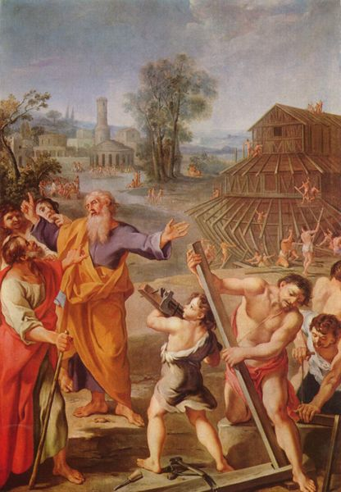

http://creationwiki.org/File:FranzMeister_Noahs_ark.jpg (Yorck Project)

You can also download ten exercises in contemplative bible study on creation and environment issues from Earth Abbey at
http://www.earthabbey.com/blog/post/christ_and_creation_a_contemplative_resource
Each exercise can be printed out and folded into a leaflet for use individually or within a group
You can also download a free resource of five Bible Studies on Christianity, Climate Change and Sustainable Living from the Jubilee Centre, in association with Tearfund at
http://www.jubilee-centre.org/uploaded/files/resource_267.pdf

You might want to record your thoughts about these bible studies in your notebook, journal or blog, or add your own drawings or poems to your rucksack as part of what you take from this space.
Where would you like to go now? Where else will your journey take you?
Yellow journey 1, 2,3,4 – text based exploration
Green journey 1,2, 3, 4 more things to do, research, look at
Blue journey 2,3,4 prayers, music, reflection
Pink journey 1,2,3,4 spirituality based activities, following Jesus, changing our lives

